Group Details:-

Name:
Imran Khan S

College Name: Gandhi Arts and Science College

Contact:imranssathy786@gmail.com
Project details

Title: Integrate Zscaler with Identity Providers (IdPs) such as Azure AD, Okta, and Active Directory for seamless authentication and authorization.

This project outlines the strategy and implementation plan for integrating the Zscaler security platform with our organization's core Identity Providers (IdPs): Microsoft Entra ID (Azure AD), Okta, and on-premises Active Directory (AD). The primary objective is to create a seamless, secure, and automated framework for user authentication and authorization across all Zscaler services.

By moving away from disparate local user management and leveraging these centralized identity sources, we aim to establish a true Zero Trust architecture where access is continuously verified based on user identity and context. This initiative will consolidate authentication into a single source of truth, enforce consistent security policies like Multi-Factor Authentication (MFA), and streamline the user experience through Single Sign-On (SSO).

Ultimately, this integration will serve as the critical link between our identity infrastructure and our security enforcement point, ensuring that the right users have the right level of secure access to the internet and applications, regardless of their location.

Abstract:
This project details the integration of the Zscaler Internet security platform with leading Identity Providers (IdPs), including Microsoft Entra ID (Azure AD), Okta, and on-premises Active Directory (AD). The primary objective is to establish a unified identity framework that enables seamless Single Sign-On (SSO) and centralized authorization for all Zscaler services. By consolidating authentication into trusted corporate directories, this initiative eliminates the need for disparate credentials and provides a foundational element for a modern Zero Trust security architecture.
By leveraging industry-standard protocols such as SAML, OIDC, and SCIM, this integration ensures that user authentication is delegated to trusted corporate directories while enforcing consistent security policies, including Multi-Factor Authentication (MFA). This approach not only enhances the user experience by reducing password fatigue but also strengthens the organization's security posture by ensuring that every access request is verified by the identity provider before reaching Zscaler's security enforcement points.
Furthermore, the implementation of automated user provisioning via SCIM streamlines lifecycle management, reducing administrative overhead and enhancing security posture. The outcome is a robust, identity-centric security model that aligns with Zero Trust principles, ensuring that only authenticated and authorized users gain secure access to internet and cloud applications from any location. This integration effectively bridges the gap between identity governance and network security, creating a dynamic and responsive access control environment.

Use Case Scenarios:

Use Case Scenario 1: Remote Faculty Access to Research Data
A research professor is working from an off-campus conference and needs secure access to sensitive research data stored on an internal server. Instead of connecting to the full campus network via VPN, ZPA grants access only to the specific research server. The professor authenticates via the university's identity provider, and access is granted based on their role.

Output:
- User identity verified: Research_Faculty_Group
- Context-aware access enforced: Access allowed only from non-campus IP ranges
- Connection restricted: Limited to specific Research File Server (R&D_Server)
- Security enforcement: Multi-Factor Authentication (MFA) required due to off-network location
- No lateral movement: User cannot access other internal systems such as HR or student records

Use Case Scenario 2: Student Access to Library Resources
A graduate student is off-campus and needs access to licensed academic journals and databases hosted internally. Instead of requiring a full VPN tunnel, ZPA provides direct access to the library application portal. The student authenticates via the identity provider, ensuring only enrolled students can access paid subscription content.

Output:
- User identity verified: Enrolled_Student_Group
- Access scope defined: Limited to Library Portal and journal databases
- Policy enforcement: Access restricted to authorized users only, preventing credential sharing
- User experience: Seamless SSO without additional VPN client complexity
- No broad network access: Student cannot navigate to administrative systems or internal servers

Use Case Scenario 3: HR Administrator Access to Payroll System
An HR administrator requires access to the payroll system to process monthly salaries. Access must be restricted to specific work hours and require step-up authentication due to the sensitivity of the data. The administrator authenticates via the identity provider, and ZPA enforces time-based and MFA policies.

Output:
- User identity verified: HR_Payroll_Group
- Time-based restriction enforced: Access permitted only during business hours (8:00 AM –
6:00 PM)
- Step-up authentication: MFA triggered upon accessing the payroll application
- Connection restricted: Limited to Payroll Application Server
- Audit trail: Full session logging maintained for compliance purposes

Use Case Scenario 4: IT Helpdesk Remote Troubleshooting
An IT support technician needs to remotely troubleshoot a server issue while working from home. ZPA provides Just-in-Time (JIT) access to the specific server requiring maintenance. The technician authenticates via the identity provider, and administrative privileges are granted only for the duration of the task.

Output:
- User identity verified: IT_Helpdesk_Group
- Just-in-Time access granted: Admin rights elevated only for the active session
- Connection restricted: Limited to the specific target server (Server-X)
- Privilege boundaries enforced: No access to other infrastructure components (databases, domain controllers)
- Session monitoring: Real-time activity logging for security review

Use Case Scenario 5: Contractor Access to Project Management Tool
An external project manager contracted for a specific initiative needs access to the university's project management tool (e.g., Jira or SharePoint). Access must expire automatically upon contract completion. The contractor authenticates via the identity provider, and ZPA provisions time-limited access based on group membership synchronized from Azure AD.

Output:
- User identity verified: External_Contractor_Group
- Time-bound access policy enforced: Account deprovisioned automatically after contract end date
- Connection restricted: Limited to Project Management Application only
- Segmentation enforced: Contractor cannot discover or access internal resources like finance systems or student databases

Stage-1

Title Of the Project: -

Replace and modernize legacy VPN architectures with a cloud-native Zscaler Zero Trust solution to reduce attack surface and lateral movement.

Overview: -

The integration of Zscaler with enterprise Identity Providers (IdPs) represents a fundamental shift in how organizations approach secure access to applications and resources. Traditional network security models relied on VPNs and perimeter-based defenses, which often granted excessive access and created lateral movement risks. By contrast, this project leverages Zscaler's Zero Trust Exchange platform to verify identity at the application layer rather than the network layer. The integration with leading IdPs such as Microsoft Entra ID, Okta, and on-premises Active Directory establishes a unified identity fabric across the organization. This ensures that users are authenticated consistently regardless of their location or device. The project eliminates the need for duplicate user directories and manual account management within Zscaler. It creates a seamless experience where users authenticate once and gain access to authorized resources. Security teams benefit from centralized control over authentication policies and user lifecycle management. The integration supports modern authentication standards including SAML, OIDC, and SCIM protocols. Ultimately, this foundation enables true Zero Trust security where identity becomes the primary control plane.
Microsoft Entra ID integration serves as a cornerstone of this identity strategy for organizations heavily invested in the Microsoft ecosystem. The integration leverages SAML 2.0 to establish federated trust between Zscaler and Azure AD for seamless Single Sign-On. Users accessing Zscaler Internet Access or Zscaler Private Access portals are redirected to Azure AD for authentication. This allows organizations to enforce Azure AD Conditional Access policies during the authentication flow. Policies can require compliant devices, specific locations, or risk-based access controls before granting access to Zscaler. The integration extends beyond authentication to include automated user provisioning via the SCIM protocol. User accounts and group memberships are synchronized in real-time from Azure AD to Zscaler. This automation eliminates manual provisioning errors and ensures immediate deprovisioning when users leave the organization. Azure AD's extensive reporting and auditing capabilities provide visibility into authentication attempts. The result is a tightly integrated security posture that leverages Microsoft's identity capabilities to protect Zscaler-enforced resources.
Okta integration provides a flexible and vendor-agnostic approach to identity management for Zscaler deployments. As a leading independent Identity Provider, Okta connects Zscaler to a wide ecosystem of applications and directories. The integration utilizes OpenID Connect (OIDC) for modern, API-friendly authentication to Zscaler services. This approach supports rich user context

including profile attributes and group memberships for policy enforcement. Okta's Universal Directory serves as the authoritative source for user identities synchronized from various HR systems and directories. The Okta Integration Network (OIN) simplifies setup with pre-built connectors and configuration guides for Zscaler. Automated provisioning via SCIM ensures that user changes in Okta are reflected in Zscaler within minutes. Lifecycle management events such as user onboarding, role changes, and terminations trigger automatic updates in Zscaler. Okta's adaptive MFA policies add an additional security layer during Zscaler authentication requests. This integration delivers a seamless experience for users while providing administrators with centralized identity governance across all Zscaler services.
On-premises Active Directory integration addresses scenarios where organizations are not ready for full cloud identity migration. Many institutions maintain extensive on-premises infrastructure with complex group policies and nested organizational units. The Zscaler Authentication Bridge (ZAB) enables secure LDAP communication between Zscaler cloud services and on-premises AD. This lightweight connector sits behind the firewall and initiates outbound connections to Zscaler, eliminating the need for inbound firewall rules. User authentication requests are securely proxied through ZAB to validate credentials against the on-premises domain controllers. Group membership information is synchronized to Zscaler for use in policy definitions and access decisions. This approach preserves investments in existing Active Directory infrastructure while enabling cloud-delivered security. Organizations can maintain strict access controls based on on-premises group memberships and organizational hierarchies.

List of Vulnerability Table:

Practice Website:

S.no | Vulnerability Name | CWE - No
1 | Improper Sanitization of File Paths | CWE- 284: Improper Access  Control
2 | Invalid Certificate | CWE-395: Improper  Certificate Validation
3 | Missing X-Frame-Options Header | CWE-1021: Design Improper Restriction of  Rendered UI Layers or Frames
4 | X-Content-Type Options Header Missing | CWE -918: Server-Side  Request Forgery (SSRF)
5 | Drupal Ajax API shows JSONP not disabled by default | CWE-937,1035: OWASP  Top Ten 2013,2017 Category A9 - Using Components with Known Vulnerabilities

6 | Drupal Api Vulnerability | CWE-20: Improper Input  Validation
7 | Improper API Filtration | CWE-79: Improper Neutralisation of Input During Web Page Generation  ('Cross-site Scripting')
8 | Denial of Service | CWE -400: Uncontrolled  Resource Consumption
9 | TLS Version 1.0 Protocol Detection | CWE-327: Use of a Broken  or Risky Cryptographic Algorithm
10 | web.config File Information Disclosure | CWE-497: Exposure of Sensitive System Information to an Unauthorised Control  Sphere

Main Website:

S.no | Vulnerability Name | CWE - No
1 | SL Medium Strength Cipher Suites Supported (SWEET32) | CWE-200: Exposure of  Sensitive Information to an Unauthorised Actor
2 | Cookie SERVERID created without secure flag | CWE-79: Improper  Neutralisation of Input During Web Page Generation
3 | X-Content-Type Options Header Missing | CWE-918: Server-Side  Request Forgery (SSRF)
4 | Denial of Service | CWE -400: Uncontrolled  Resource Consumption
5 | OS Identification | CWE-200: Exposure of Sensitive Information to an  Unauthorised Actor

REPORT: -
Practice Website: http://www.itsecgames.com/

Vulnerability Name: Improper Sanitization of File Paths

CWE- 284: Improper Access Control

OWASP Category: A01:2021-Broken Access Control

Description: The product does not restrict or incorrectly restricts access to a resource from an unauthorized actor.
Business Impact: This vulnerability is significant, as it can lead to unauthorized access to sensitive data or files, potentially causing data breaches, privacy violations, and loss of user trust. Affected sites may also require configuration changes after applying a security release.
Steps to Reproduce: https://www.shodan.io/host/31.3.96.40
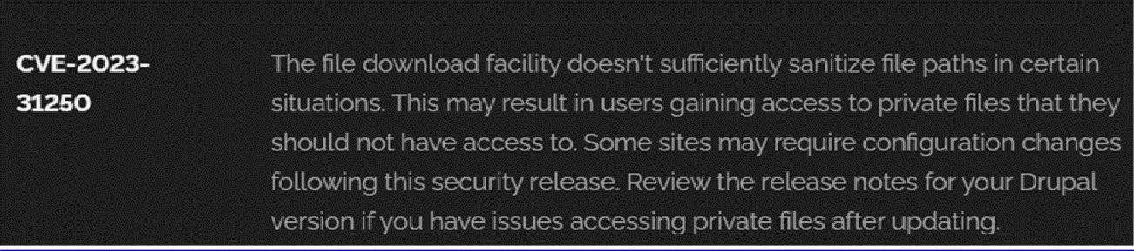

Recommendation:

- Apply Security Updates: The primary recommendation is to apply the security update provided by Drupal as soon as it becomes available. Security updates typically include fixes for known vulnerabilities like this one.
- Review Configuration: After applying the update, review your Drupal site's configuration to ensure that private files remain protected as intended. Make any necessary adjustments to your site's file permissions or access controls.
- Regular Audits: Conduct regular security audits and vulnerability assessments to identify and address potential security issues in your Drupal site.
- Access Control: Implement strong access controls to ensure that only authorized users can access private files. Review and restrict file access permissions as needed.
- Data Minimization: Minimize the amount of sensitive data stored on your Drupal site. Only store data that is necessary for your site's functionality.

Vulnerability Name: Invalid Certificate

CWE-395: Improper Certificate Validation

OWASP Category: A07:2021 – Identification and Authentication Failures

Description: When a certificate is invalid or malicious, it might allow an attacker to spoof a trusted entity by interfering in the communication path between the host and client. The product might connect to a malicious host while believing it is a trusted host, or the product might be deceived into accepting spoofed data that appears to originate from a trusted host.
Business Impact: Improper certificate validation can lead to a range of security threats which includes Man-in-the-middle attacks(Attackers can intercept communication between two parties and read or modify the data exchanged between them),Data breaches:(Attackers can gain unauthorized access to sensitive information or sensitive systems, leading to data breaches),Malware distribution(Attackers can use fake digital certificates to distribute malicious software or infect systems with malware)
Steps to Reproduce: https://www.ssllabs.com/ssltest/analyze?d=www.itsecgames.com
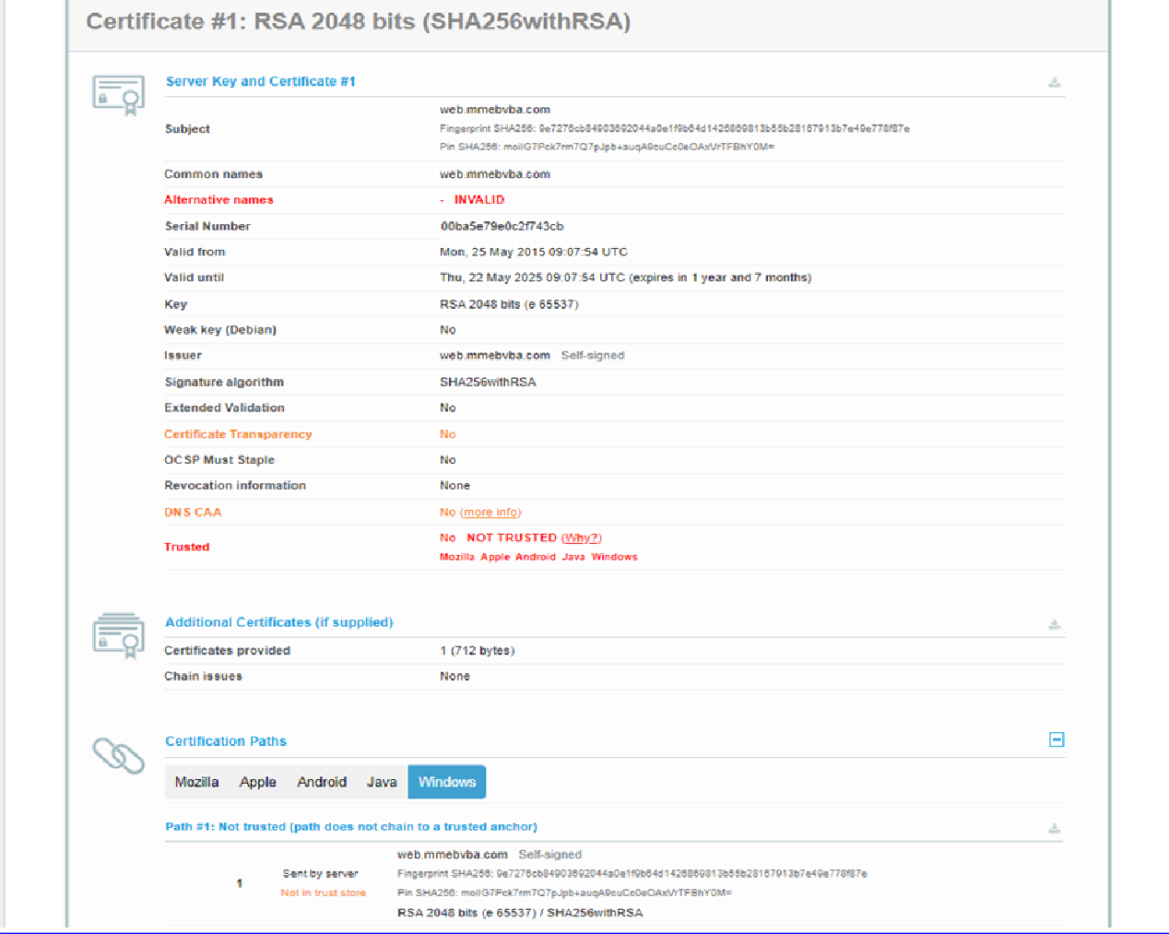

Recommendation:

- Use trusted certificate authorities: Only trust digital certificates issued by well-known and trusted certificate authorities.
- Verify certificate chains: Verify that the certificate presented by the remote party is valid and issued by a trusted certificate authority. Verify the entire certificate chain, including intermediate certificates.
- Check certificate revocation status: Check the revocation status of the certificate presented by the remote party to ensure that it has not been revoked.
- Use certificate pinning: Implement certificate pinning to ensure that the communication only occurs with the exact certificate or certificate authority specified.
- Keep software up to date: Keep software and security protocols up to date, as new vulnerabilities and security patches are regularly released.

Vulnerability Name: Missing X-Frame-Options Header

CWE-1021: Design Improper Restriction of Rendered UI Layers or Frames

OWASP Category: A04:2021-Insecure Design

Description: A web application is expected to place restrictions on whether it is allowed to be rendered within frames, iframes, objects, embed or applet elements. Without the restrictions, users can be tricked into interacting with the application when they were not intending to.
Business Impact: This enables path to the attackers to manipulate or gain unauthorized access to user interface elements, potentially leading to deceptive or malicious user interactions. This can result in data leakage, fraud, user distrust, and reputational damage, undermining the integrity and trustworthiness of the application and causing financial losses.
Vulnerability Path: http://www.itsecgames.com/

Steps to Reproduce:

- Open the practice website to inspect

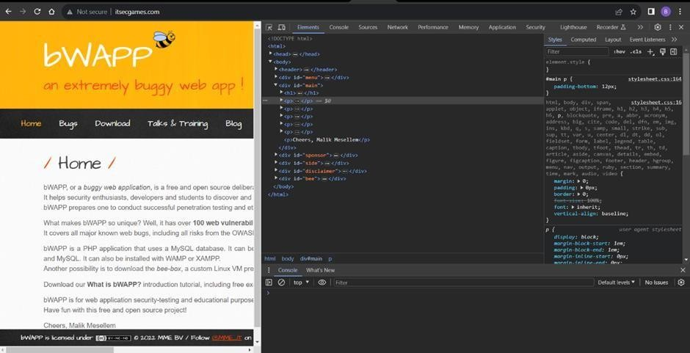

- Go to network and start capturing using F5 or Ctrl+R

- Go to html document and see if x-frame-options present in response headers or not

- If not the absence of this header indicates that the website may not have protection against embedding its content within an iframe on other domains, potentially leaving it vulnerable to clickjacking attacks.
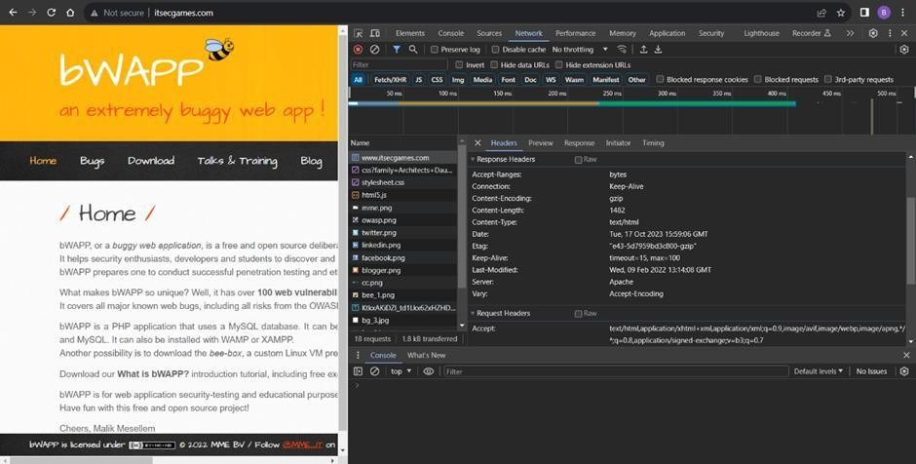

Recommendation:

- Implement Proper UI Layer Access Controls: Enforce access controls to restrict access to UI layers or frames based on user privileges.
- Use Session and Authentication Management: Ensure robust session management and user authentication mechanisms to prevent unauthorized access.
- Implement Content Security Policies (CSP): Use CSP headers to control where resources can be loaded from and mitigate against frame-based attacks.
- Keep Software and Libraries Updated: Stay current with software updates and patches to address known security issues.

  - Vulnerability Name: X-Content-Type Options Header Missing CWE -918: Server-Side Request Forgery (SSRF)
OWASP Category: A10:2021 – Server-Side Request Forgery (SSRF)

Description: The web server receives a URL or similar request from an upstream component and retrieves the contents of this URL, but it does not sufficiently ensure that the request is being sent to the expected destination.

Business Impact: The header missing impact Data Exposure(Attackers might force the server to render sensitive data as HTML, leading to data exposure),Security Risks(Content type manipulation can increase security risks, potentially leading to breaches, data leaks, and unauthorized access), Brand and Reputation Damage(Successful attacks that exploit SSRF vulnerabilities can harm the organization's reputation and trustworthiness)
Vulnerability Path : https://securityheaders.com/?q=http%3A%2F%2Fwww.itsecgames.com%2F&followRedirects= on

Steps to Reproduce:

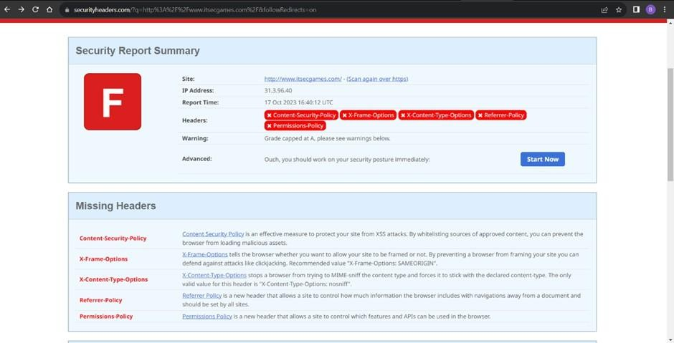
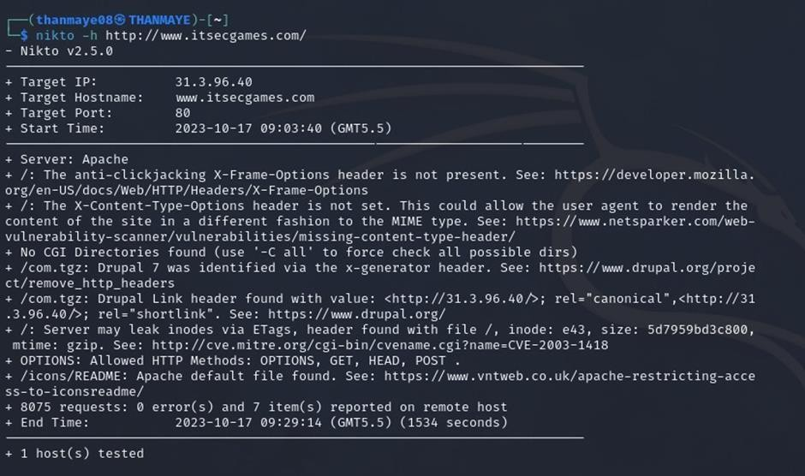
Recommendation:

- Implement "X-Content-Type-Options" Header: Configure the "X-Content-Type-Options" header with the value "nosniff" in your web server or application to prevent content type sniffing.

- Secure SSRF: To directly mitigate SSRF vulnerabilities, ensure proper input validation, access controls, and allow-list-based URL validation to prevent attackers from making unauthorized requests to internal resources.
- Security Headers: Implement other security headers like "X-Frame-Options" and "Content-Security-Policy" to further enhance security and mitigate various types of web-based attacks.
While the "X-Content-Type-Options" header may not be a direct countermeasure to SSRF, it is a valuable security control that, when configured correctly, can help protect against content type-based attacks that may be exploited in SSRF scenarios.

Vulnerability Name: Drupal Ajax API shows JSONP not disabled by default

CWE-937,1035: OWASP Top Ten 2013,2017 Category A9 - Using Components with Known Vulnerabilities
OWASP Category: A06:2021-Vulnerable and Outdated Components

Description: Vulnerable and outdated components refer to using software libraries, modules, or dependencies within a web application that have known security issues or are not updated to the latest secure versions. This can include plugins, frameworks, or APIs that are no longer maintained or have publicly documented vulnerabilities.
Business Impact: The presence of vulnerable and outdated components in a web application poses significant security risks. Attackers can exploit these weaknesses to gain unauthorized access, inject malicious code, steal sensitive data, or disrupt the system's operation. The potential business impacts include compromised user data, damaged reputation, legal consequences, and financial losses due to breach recovery and remediation efforts.
Vulnerability Path: https://www.shodan.io/host/31.3.96.40

Steps to Reproduce:
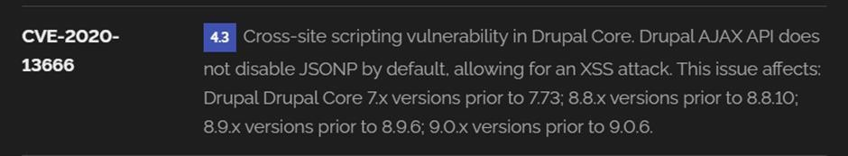

Recommendation:

- Regular Updates: Keep all components, libraries, and dependencies up to date by applying security patches and upgrades.
- Vulnerability Scanning: Conduct periodic vulnerability assessments to identify and address potential issues.
- Dependency Management: Implement a strategy for managing third-party dependencies, including continuous monitoring of their security status.
- Security Testing: Perform regular security testing, including penetration testing and code review, to identify and remediate vulnerabilities.
- Change Control: Maintain a change management process to assess the impact of new components and ensure they don't introduce new vulnerabilities.

  - Vulnerability Name: Drupal Api Vulnerability CWE-20: Improper Input Validation
OWASP Category: A03:2021 – Injection

Description: The product receives input or data, but it does not validate or incorrectly validates that the input has the properties that are required to process the data safely and correctly.
Business Impact: The impact of a successful SQL injection attack can be devastating for businesses. It can result in unauthorized access to sensitive information, data theft, financial losses, damage to reputation, and legal consequences. Depending on the nature of the application and data involved, SQL injection can lead to compliance violations, customer trust erosion, and operational disruption.
Vulnerability Path: https://www.shodan.io/host/31.3.96.40

Steps to Reproduce:
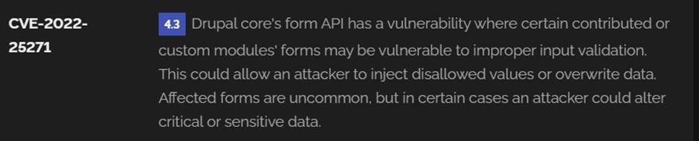

Recommendation:

- Input Validation: Implement rigorous input validation on all user inputs and ensure that only safe, sanitized data is passed to the database.
- Parameterized Queries: Use parameterized queries or prepared statements to separate SQL code from user input, preventing malicious injections.
- Escaping User Input: If parameterized queries are not feasible, escape user input before incorporating it into SQL queries to neutralize special characters.
- Least Privilege Principle: Limit the permissions and access rights of database accounts to the minimum required for specific tasks to minimize the potential damage of an attack.
- Web Application Firewalls (WAF): Employ WAFs to filter and block malicious SQL injection attempts.
- Regular Security Testing: Conduct regular security assessments, including penetration testing, to identify and address vulnerabilities.

Vulnerability Name: Improper API Filtration

CWE-79: Improper Neutralization of Input During Web Page Generation ('Cross-site Scripting')

OWASP Category: A07-2017: Cross-site Scripting (XSS)

Description: The product does not neutralize or incorrectly neutralizes user-controllable input before it is placed in output that is used as a web page that is served to other users.
Business Impact: If exploited, this vulnerability allows attackers to inject malicious scripts into web pages, which can be viewed by other users. The potential business impacts include data theft, unauthorized access, compromised user accounts, damaged reputation, and financial losses. Attackers can use XSS to steal sensitive information, such as user credentials, personal data, or financial details, leading to regulatory compliance violations and legal liabilities. Additionally, defacement or manipulation of website content can erode customer trust and result in lost revenue.
Vulnerability Path: https://www.shodan.io/host/31.3.96.40

Steps to Reproduce:

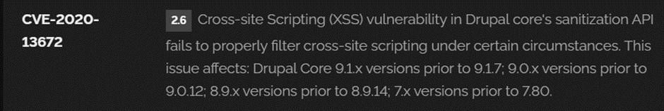

Recommendation:

- Update and Patch: Ensure that Drupal and all related modules and components are up to date with the latest security patches to mitigate known vulnerabilities.
- Input Validation: Implement strong input validation and output encoding to sanitize user inputs and prevent the injection of malicious scripts.
- Content Security Policy (CSP): Implement CSP headers to restrict the sources from which content can be loaded, reducing the risk of XSS.
- Secure Coding Practices: Train developers in secure coding practices, emphasizing the importance of validating and escaping user inputs.
- Security Scanning: Conduct regular security scans and penetration tests to identify and address XSS vulnerabilities.

Vulnerability Name: Denial of Service

CWE -400: Uncontrolled Resource Consumption

OWASP Category:

Description: The Denial of Service (DoS) attack is focused on making a resource (site, application, server) unavailable for the purpose it was designed. There are many ways to make a service unavailable for legitimate users by manipulating network packets, programming, logical, or resources handling vulnerabilities, among others. If a service receives a very large number of requests, it may cease to be available to legitimate users. In the same way, a service may stop if a programming vulnerability is exploited, or the way the service handles resources it uses.
Sometimes the attacker can inject and execute arbitrary code while performing a DoS attack in order to access critical information or execute commands on the server. Denial-of-service attacks significantly degrade the service quality experienced by legitimate users. These attacks introduce large response delays, excessive losses, and service interruptions, resulting in direct impact on availability.

Business Impact: If successfully exploited, it involves overwhelming a system or application with excessive demands on its resources. This can lead to a range of disruptive consequences. The targeted system may experience significant slowdowns, or even complete unresponsiveness, making it difficult or impossible for legitimate users to access. Critical resources like CPU, memory, and network bandwidth can become depleted, causing further degradation in performance. In severe cases, the exploited vulnerability may lead to system crashes or failures, potentially resulting in data loss. This disruption not only impacts business productivity and financial stability but also risks reputational damage, eroding customer trust and confidence.
Additionally, organizations may face regulatory compliance issues if the uncontrolled resource consumption leads to violations of service level agreements or industry standards. Mitigating this vulnerability requires proactive resource management practices and a well-prepared incident response plan to minimize the potential impacts on business operations and customer satisfaction.
Steps to Reproduce: exploit open ports 80 to perform SQL injections, cross-site request forgeries and DDoS attacks.
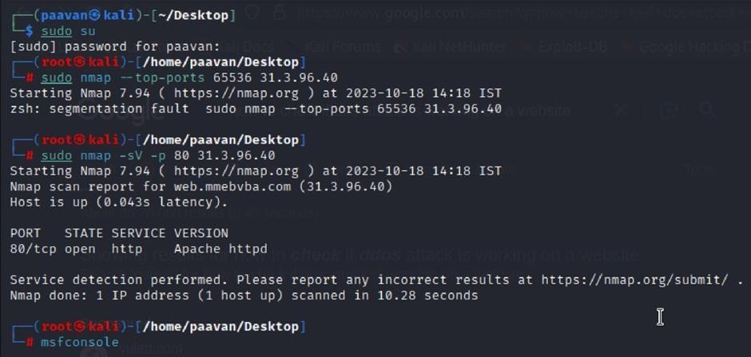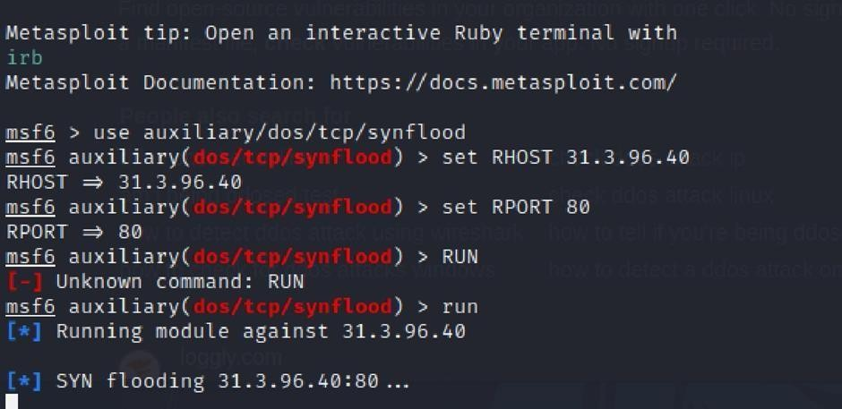

Recommendation: Employ a robust Web Application Firewall (WAF) capable of filtering and mitigating suspicious traffic targeting port 80. Configure it to block excessive requests or patterns indicative of an attack. Utilise load balancing techniques to distribute traffic across multiple servers, ensuring no single server becomes overwhelmed. Additionally, implement rate limiting and throttling mechanisms to restrict the number of requests a single IP address can make within a defined time frame. Regularly monitor traffic patterns and set up alerts to detect unusual spikes in activity, enabling rapid response to potential attacks. Finally, keep software and systems up-to-date with the latest security patches to address known vulnerabilities that attackers may exploit.

  - Vulnerability Name: TLS Version 1.0 Protocol Detection CWE-327: Use of a Broken or Risky Cryptographic Algorithm OWASP Category: A02:2021-Cryptographic Failures
Description: The product uses a broken or risky cryptographic algorithm or protocol.

Business Impact: TLS 1.0 is an outdated and vulnerable encryption protocol, and its use can expose sensitive data to potential security threats. This not only jeopardizes the integrity of customer information and payment details but also tarnishes the company's reputation. The business may face legal consequences, loss of customer trust, and decreased revenue as security-conscious users avoid the site due to its security vulnerabilities. Immediate action is necessary to upgrade to a more secure TLS version to safeguard data, ensure compliance, and maintain customer confidence.

Steps to Reproduce:

- Open a terminal or command prompt

- Type the Command: openssl s_client -connect 31.3.96.40:443 -tls1

- The connection is successfully means the server supports TLS 1.0

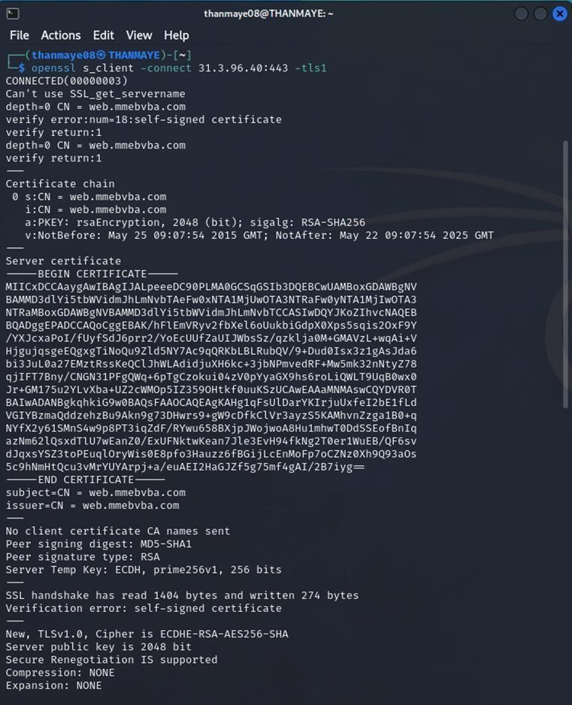

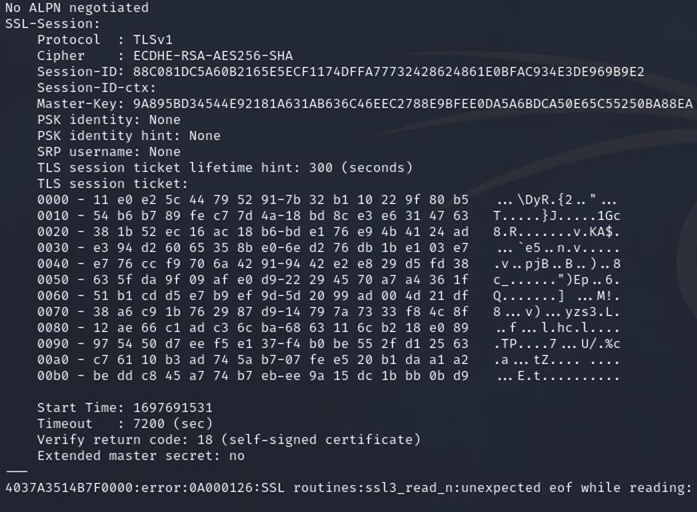

Recommendation:

- Upgrade to a Secure TLS Version: Transition to a more secure TLS version, such as TLS 1.2 or TLS 1.3. This will provide stronger encryption and improved security against modern threats.
- Regularly Update SSL/TLS Configuration: Keep your SSL/TLS configuration up to date to ensure it aligns with the latest security best practices and vulnerabilities.
- Implement a Strong Cryptographic Suite: Use strong cipher suites and secure configurations to further enhance security. Disable weak ciphers and outdated protocols.
- Compliance Checks: Ensure that your website complies with relevant data protection regulations and industry standards (e.g., GDPR, PCI DSS) to avoid legal issues.

Vulnerability Name: web.config File Information Disclosure

CWE-497: Exposure of Sensitive System Information to an Unauthorized Control Sphere

OWASP Category: A3:2017-Sensitive Data Exposure

Description: An information disclosure vulnerability exists in the remote web server due to the disclosure of the web.config file. An unauthenticated, remote attacker can exploit this, via a simple GET request, to disclose potentially sensitive configuration information.
Business Impact: It exposes sensitive configuration details, including database connection strings and encryption keys, to potential attackers. This could lead to unauthorized access, data breaches, and system compromise. The impact includes financial losses, damage to reputation, and legal liabilities as the organization's security and customer trust are compromised.

Steps to Reproduce:
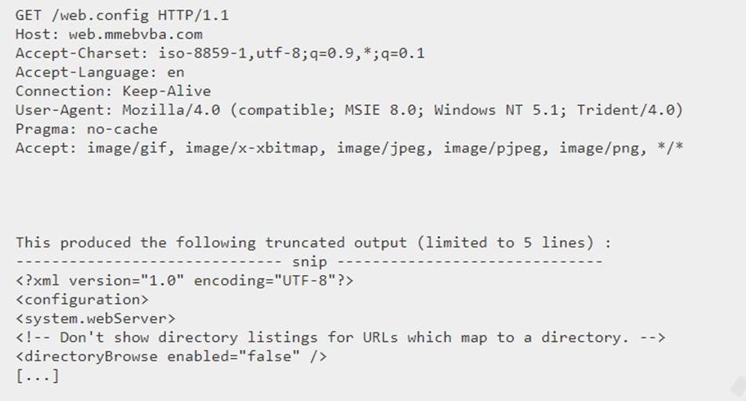

Recommendation:

- Implement proper access controls to restrict access to the web.config file.
- Prevent directory traversal and ensure the web.config file cannot be directly accessed through the web server.
- Encrypt sensitive data within the configuration file.
- Regularly review and update the web.config file, removing any unnecessary sensitive information.
- Ensure that the web.config file is properly secured and not accessible to unauthorized users.

Main Website: vtop.vit.ac.in

- Vulnerability Name: SL Medium Strength Cipher Suites Supported (SWEET32) CWE-200: Exposure of Sensitive Information to an Unauthorised Actor
OWASP Category: Broken access control

Description: The remote host supports the use of SSL ciphers that offer medium strength encryption. Nessus regards medium strength as any encryption that uses key lengths at least 64 bits and less than 112 bits, or else that uses the 3DES encryption suite.
Note that it is considerably easier to circumvent medium strength encryption if the attacker is on the same physical network.
Business Impact: The vulnerability known as SWEET32 (Short for Sweet 32 Birthday Attack) relates to the continued use of legacy cryptographic cipher suites with 64-bit block sizes in TLS and SSL protocols. These suites are susceptible to birthday attacks, which exploit the probability of two blocks colliding after a certain number of transactions. If an organisation's systems are vulnerable to SWEET32, it means they're potentially at risk of having encrypted communications intercepted or manipulated. This could lead to unauthorised access, data theft, or even the injection of malicious code. As a result, businesses face a significant risk to the confidentiality and integrity of their sensitive information. Remediation involves updating systems to support more secure cipher suites with larger block sizes, which would effectively mitigate this vulnerability and enhance the overall security posture. Failure to address SWEET32 could leave an organisation exposed to increasingly sophisticated attacks and legal consequences due to potential data breaches.
Vulnerability Path : The Sweet32 vulnerability when detected with a vulnerability scanner will report it as a CVSS 7.5.

Steps to Reproduce:

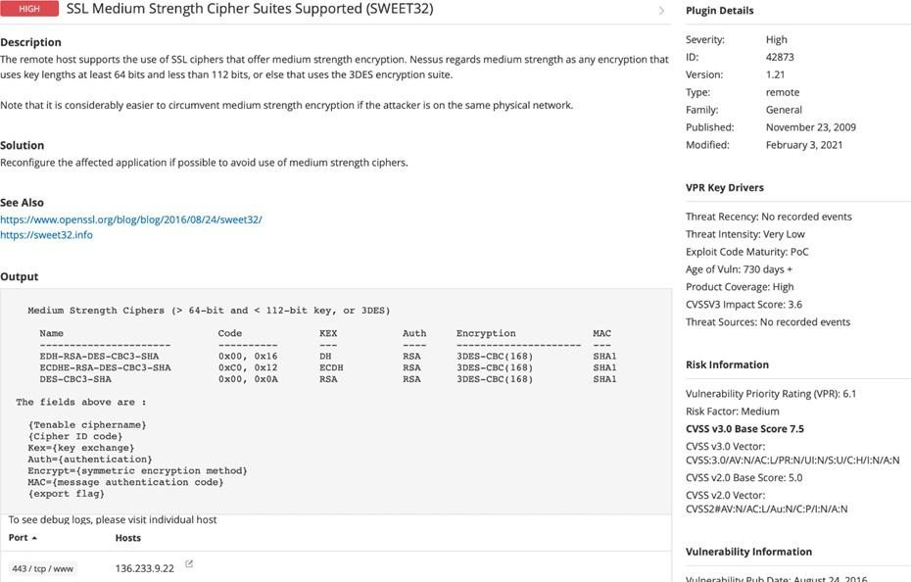
Recommendation: organisations should take several proactive steps. Firstly, it is crucial to update and configure cryptographic libraries, web servers, and any network devices to disable support for cipher suites with 64-bit block sizes. This can be achieved by ensuring that only modern and secure cipher suites are enabled in the TLS/SSL configurations. Additionally, organizations should regularly monitor and assess their systems for any outdated or vulnerable protocols and promptly apply security patches and updates. Implementing strong, unique encryption keys and employing forward secrecy protocols can further bolster security. It's also recommended to utilize intrusion detection systems and perform regular security audits to identify and address any potential vulnerabilities promptly. Lastly, organizations should stay informed about emerging security threats and best practices in cryptographic protocols to proactively adapt their security measures. By taking these measures, businesses can significantly reduce the risk of falling victim to SWEET32 attacks and enhance the overall security of their digital infrastructure.

- Vulnerability Name: Cookie SERVERID created without secue flag CWE-79: Improper Neutralization of Input During Web Page Generation OWASP Category: A07-2017: Cross-site Scripting

Description: The vulnerability allows an attacker to inject malicious code into a WordPress website, which can then be executed by visitors to the website.
To exploit this vulnerability, an attacker would simply need to trick a user into clicking on a malicious link or opening a malicious attachment. Once the user clicks on the link or opens the attachment, the attacker's code would be executed, giving the attacker control over the user's account and potentially the entire WordPress website.
Business Impact: The business consequences of XSS can be severe, ranging from reputational damage due to compromised customer trust, to legal repercussions in cases of data breaches.
Moreover, it can lead to financial losses through fraud or the cost of remediation efforts. Beyond the immediate impacts, long-term harm may occur if customers abandon the platform due to security concerns. To mitigate CWE-79, businesses must implement rigorous input validation and output encoding practices, as well as stay vigilant for emerging threats in web application security. Failure to address XSS vulnerabilities could result in significant harm to both the business's reputation and its bottom line.
Vulnerability Path: https://securityheaders.com/

q=http%3A%2F%2Fvtop.vit.ac.in%2F&followRedirects=on

Steps to Reproduce:
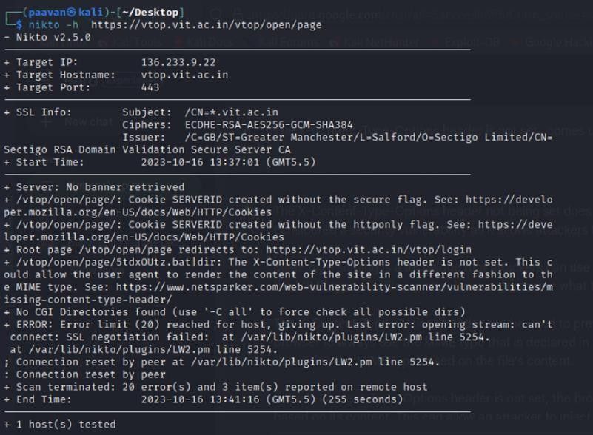

Recommendation:

- Update and Patch: Ensure that Drupal and all related modules and components are up to date with the latest security patches to mitigate known vulnerabilities.
- Input Validation: Implement strong input validation and output encoding to sanitize user inputs and prevent the injection of malicious scripts.
- Content Security Policy (CSP): Implement CSP headers to restrict the sources from which content can be loaded, reducing the risk of XSS.
- Secure Coding Practices: Train developers in secure coding practices, emphasizing the importance of validating and escaping user inputs.
- Security Scanning: Conduct regular security scans and penetration tests to identify and address XSS vulnerabilities.

- Vulnerability Name: X-Content-Type Options Header Missing CWE-918: Server-Side Request Forgery (SSRF)
OWASP Category: A10:2021 – Server-Side Request Forgery (SSRF)

Description: The absence of the "X-Content-Type-Options" header poses a notable security risk for web applications. This header is a crucial security feature that instructs the browser to interpret files with a MIME type as declared in the Content-Type header, rather than trying to guess the type. When this header is missing, the browser may attempt to infer the content type, leaving room for potential misinterpretation and security vulnerabilities like MIME-sniffing attacks. This could enable attackers to disguise malicious content, such as scripts or executable files, as benign content, leading to Cross-Site Scripting (XSS) or other types of attacks.
Implementing the "X-Content-Type-Options" header with the value "nosniff" is a fundamental security measure that helps prevent these risks. It ensures that browsers strictly adhere to the declared content type, enhancing the overall security posture of the web application and safeguarding against potential exploitation stemming from content misinterpretation.
Business Impact: The header missing impact Data Exposure(Attackers might force the server to render sensitive data as HTML, leading to data exposure),Security Risks(Content type manipulation can increase security risks, potentially leading to breaches, data leaks, and unauthorized access), Brand and Reputation Damage(Successful attacks that exploit SSRF vulnerabilities can harm the organization's reputation and trustworthiness)

Vulnerability Path :
https://securityheaders.com/?q=http%3A%2F%2Fvtop.vit.ac.in%2F&followRedirects=on

Steps to Reproduce:

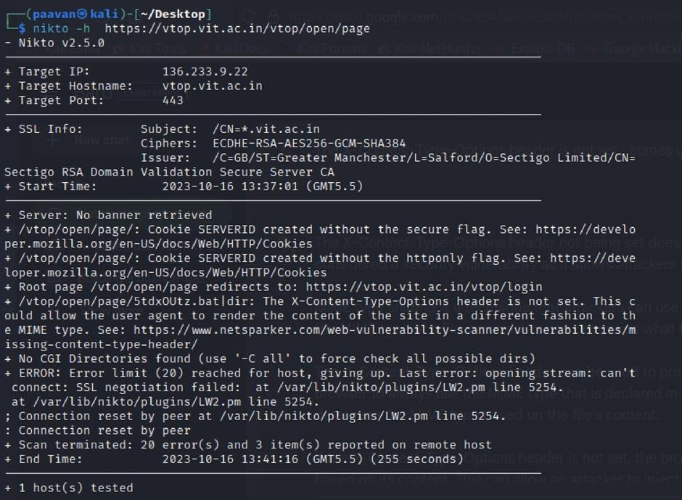

Recommendation:

- Implement "X-Content-Type-Options" Header: Configure the "X-Content-Type-Options" header with the value "nosniff" in your web server or application to prevent content type sniffing.
- Secure SSRF: To directly mitigate SSRF vulnerabilities, ensure proper input validation, access controls, and allow-list-based URL validation to prevent attackers from making unauthorized requests to internal resources.
- Security Headers: Implement other security headers like "X-Frame-Options" and "Content-Security-Policy" to further enhance security and mitigate various types of web-based attacks.
While the "X-Content-Type-Options" header may not be a direct countermeasure to SSRF, it is a valuable security control that, when configured correctly, can help protect against content type-based attacks that may be exploited in SSRF scenarios.

Vulnerability Name: Denial of Service

CWE - 400: Uncontrolled Resource Consumption

Description: The Denial of Service (DoS) attack is focused on making a resource (site, application, server) unavailable for the purpose it was designed. There are many ways to make a service unavailable for legitimate users by manipulating network packets, programming, logical, or resources handling vulnerabilities, among others. If a service receives a very large number of requests, it may cease to be available to legitimate users. In the same way, a service may stop if a programming vulnerability is exploited, or the way the service handles resources it uses.
Sometimes the attacker can inject and execute arbitrary code while performing a DoS attack in order to access critical information or execute commands on the server. Denial-of-service attacks significantly degrade the service quality experienced by legitimate users. These attacks introduce large response delays, excessive losses, and service interruptions, resulting in direct impact on availability.
Business Impact: If successfully exploited, it involves overwhelming a system or application with excessive demands on its resources. This can lead to a range of disruptive consequences. The targeted system may experience significant slowdowns, or even complete unresponsiveness, making it difficult or impossible for legitimate users to access. Critical resources like CPU, memory, and network bandwidth can become depleted, causing further degradation in performance. In severe cases, the exploited vulnerability may lead to system crashes or failures, potentially resulting in data loss. This disruption not only impacts business productivity and financial stability but also risks reputational damage, eroding customer trust and confidence.
Additionally, organizations may face regulatory compliance issues if the uncontrolled resource consumption leads to violations of service level agreements or industry standards. Mitigating this vulnerability requires proactive resource management practices and a well-prepared incident response plan to minimize the potential impacts on business operations and customer satisfaction.
Steps to Reproduce: exploit open ports 443 to perform SQL injections, cross-site request forgeries and DDoS attacks.

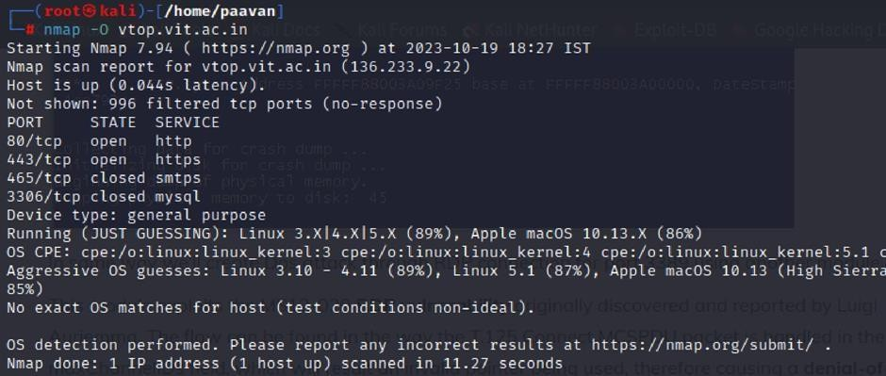
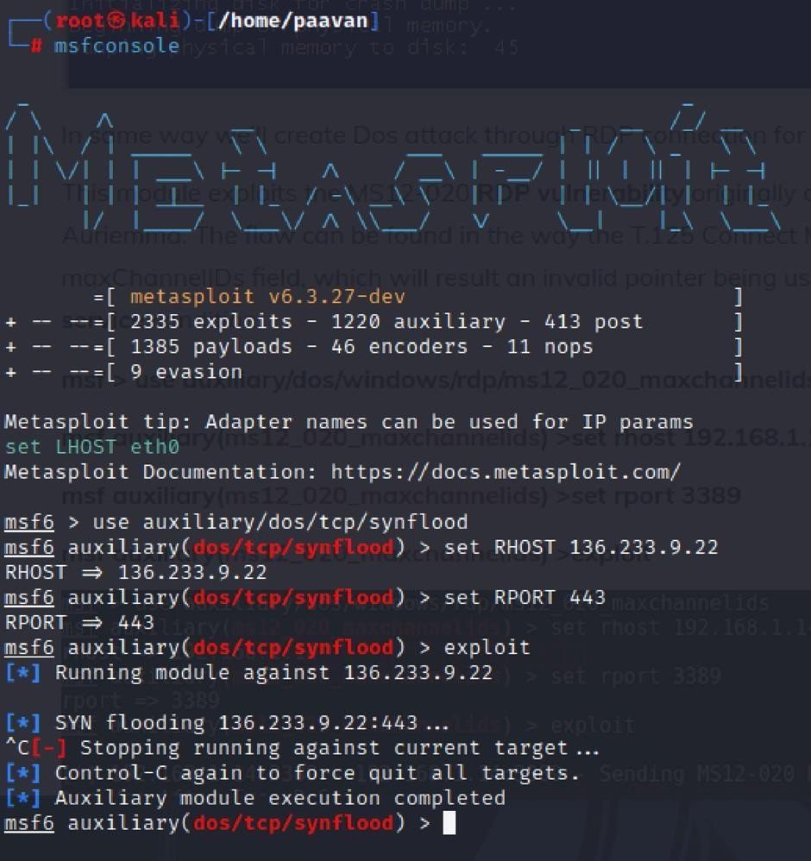

Recommendation: employ a robust Web Application Firewall (WAF) capable of filtering and mitigating suspicious traffic targeting port 80. Configure it to block excessive requests or patterns indicative of an attack. Utilise load balancing techniques to distribute traffic across multiple servers, ensuring no single server becomes overwhelmed. Additionally, implement rate limiting and throttling mechanisms to restrict the number of requests a single IP address can make within a defined time frame. Regularly monitor traffic patterns and set up alerts to detect unusual spikes in activity, enabling rapid response to potential attacks. Finally, keep software and systems up-to-date with the latest security patches to address known vulnerabilities that attackers may exploit.

Vulnerability Name: OS Identification

CWE-200: Exposure of Sensitive Information to an Unauthorised Actor

OWASP Category: A02:2021-Cryptographic Failures

Description: Using a combination of remote probes (e.g., TCP/IP, SMB, HTTP, NTP, SNMP, etc.), it is possible to guess the name of the remote operating system in use. It is also possible sometimes to guess the version of the operating system.
Business Impact: If sensitive information is improperly handled or inadequately protected, it can lead to financial losses, regulatory penalties, and damage to reputation. Customers may lose trust in the organization's ability to safeguard their data, potentially resulting in a loss of business and market share. Legal consequences and compliance issues may arise, leading to additional costs. Moreover, intellectual property theft or exposure can compromise a company's competitive edge. Remediation efforts, including implementing stronger security measures and compensating affected parties, can also entail substantial expenses. Overall, CWE-200 highlights the critical importance of robust data protection measures to safeguard an organization's financial health, reputation, and long-term viability.
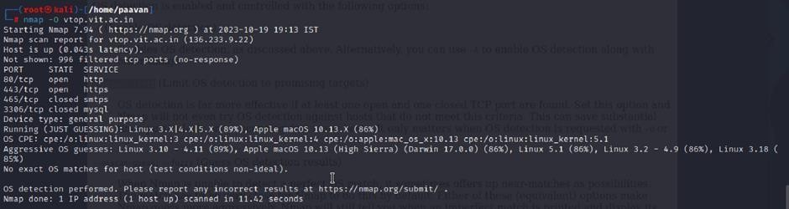
Steps to Reproduce: use nmap -O TARGET to enable os detection

Recommendation: implementing robust encryption protocols for data both in transit and at rest, coupled with stringent access controls and strong authentication measures. Regular vulnerability assessments and penetration testing should be conducted to identify and rectify potential weak points. Educating employees through comprehensive security awareness training is vital, emphasising proper data handling practices and recognition of potential threats. Employing data masking techniques for non-production environments and utilising advanced Data Loss Prevention (DLP) solutions can further fortify defences. Additionally, maintaining compliance with relevant data protection laws and regulations, as well as establishing a well-defined incident response plan, are crucial components of a comprehensive strategy to safeguard against sensitive information exposure.

This is stage 1 in the context of web application testing and security we take help from
OWASP top 10 to understand them. The OWASP Top 10 is a widely recognized list of the most critical web application security risks. Understanding these risks is essential for ensuring the security of web applications.

Stage 2

Overview :-

Nessus is a vulnerability scanner developed by Tenable, Inc. It is a remote scanner, meaning that it does not need to be installed on the target host to scan it. Nessus works by sending a variety of probes to the target host in order to identify vulnerabilities. These probes can include network traffic, operating system commands, and application requests.

Nessus uses a plugin-based architecture. Plugins are small pieces of code that are designed to identify specific vulnerabilities. There are over 1200 plugins available for Nessus, covering a wide range of vulnerabilities in operating systems, applications, and network devices.

When Nessus scans a host, it first uses a discovery plugin to identify the operating system and services running on the host. Once the host has been discovered, Nessus runs a series of plugins to test for vulnerabilities. For each vulnerability that Nessus finds, it provides a detailed report that includes the severity of the vulnerability, the steps to reproduce the vulnerability, and the steps to remediate the vulnerability.

Nessus can be used to scan a variety of targets, including single hosts, networks, and web applications. It can also be used to scan specific ports and services. Nessus can be configured to run scans on a schedule or manually.

Here is a step-by-step explanation of how Nessus works:

- Nessus connects to the target host using a variety of protocols, including TCP, UDP, and ICMP.
- Nessus sends a series of probes to the target host in order to identify its operating system and services.
- Nessus runs a series of plugins to test for vulnerabilities.
- Nessus generates a report that includes the severity of each vulnerability, the steps to reproduce the vulnerability, and the steps to remediate the vulnerability.

Nessus is a valuable tool for security professionals who need to identify and remediate vulnerabilities in their networks. It is easy to use and provides comprehensive reports that can be used to prioritise remediation efforts.

Here are some of the benefits of using Nessus:

  - Comprehensive vulnerability coverage: Nessus has over 1200 plugins available, covering a wide range of vulnerabilities in operating systems, applications, and network devices.
  - Easy to use: Nessus has a user-friendly interface that makes it easy to configure and run scans.
  - Comprehensive reporting: Nessus provides detailed reports that include the severity of each vulnerability,the steps to reproduce the vulnerability, and the steps to remediate the vulnerability.
  - Scalability: Nessus can be used to scan a variety of targets, including single hosts, networks, and web applications.
  - Flexibility: Nessus can be configured to run scans on a schedule or manually.

Nessus is a powerful tool that can be used to improve the security of any network. It is a valuable asset for any security professional.

Target website :- http://testfire.net/
Target ip address:- 65.61.137.117

List of vulnerability:-

s.no | Vulnerability name | Severity | plugins
1 | TLS Version 1.0 Protocol  Detection | MEDIUM | 104743
2 | TLS Version 1.1 Protocol  Deprecated | MEDIUM | 157288
3 | SSL/TLS Diffie-Hellman Modulus  <= 1024 Bits (Logjam) | LOW | 83875
4 | ICMP Timestamp Request Remote  Date Disclosure | INFO | 10114
5 | Additional DNS Hostnames | INFO | 46180
6 | Apache Tomcat Detection | INFO | 39446
7 | Common Platform Enumeration  (CPE) | INFO | 45590
8 | Device Type | INFO | 54615
9 | HSTS Missing From HTTPS Server | INFO | 84502
10 | HTTP Server Type and Version | INFO | 10107

REPORT: -

- Vulnerability Name: - 104743 - TLS Version 1.0 Protocol Detection Severity: - MEDIUM
Plugin: - 104743

Port: - 443
Description: - The remote service accepts connections encrypted using TLS 1.0. TLS 1.0 has a number of cryptographic design flaws. Modern implementations of TLS 1.0 mitigate these problems, but newer versions of TLS like 1.2 and 1.3 are designed against these flaws and should be used whenever possible.

As of March 31, 2020, Endpoints that aren’t enabled for TLS 1.2 and higher will no longer function properly with major web browsers and major vendors.
PCI DSS v3.2 requires that TLS 1.0 be disabled entirely by June 30, 2018, except for POS POI terminals (and the SSL/TLS termination points to which they connect) that can be verified as not being susceptible to any known exploits.
Solution: - Enable support for TLS 1.2 and 1.3, and disable support for TLS 1.0.
Business Impact: -Continued use of TLS 1.0's encryption, known for its inherent cryptographic flaws, exposes the organization to heightened security risks, increasing the likelihood of data breaches and cyberattacks. This vulnerability jeopardizes compliance with industry standards, specifically PCI DSS v3.2, which mandates the complete cessation of TLS 1.0 use. Noncompliance risks regulatory penalties and erodes customer trust. Moreover, endpoints that lack support for TLS 1.2 and higher will experience impaired functionality with major web browsers and vendors, potentially leading to lost business opportunities and damage to the organization's reputation. Addressing this vulnerability is imperative to mitigate these multifaceted risks and maintain a secure and trustworthy online presence.

Vulnerability Name: - 157288 - TLS Version 1.1 Protocol Deprecated Severity: - MEDIUM
Plugin: - 157288

Port: - 443
Description: - The remote service accepts connections encrypted using TLS 1.1. TLS 1.1 lacks support for current and recommended cipher suites. Ciphers that support encryption before MAC computation, and authenticated encryption modes such as GCM cannot be used with TLS 1.1 As of March 31, 2020, Endpoints that are not enabled for TLS 1.2 and higher will no longer function properly with major web browsers and major vendors.
Solution: - Enable support for TLS 1.2 and/or 1.3, and disable support for TLS 1.1.

Business Impact: -The continued use of TLS 1.1 with its lack of support for modern cipher suites and advanced encryption methods jeopardizes the organization's security posture, increasing vulnerability to cyber threats and potential data breaches. Additionally, endpoints not upgraded to support TLS 1.2 and higher will encounter compatibility issues with major web browsers and vendors, impacting user experience and potentially leading to missed business opportunities. Swift remediation of this vulnerability is essential to mitigate security risks and ensure seamless interactions with web browsers and vendors, preserving the organization's reputation and operational efficiency.

Vulnerability Name: - 83875 - SSL/TLS Diffie-Hellman Modulus <= 1024 Bits (Logjam) Severity: - LOW
Plugin: - 83875

Port: - 443
Description: - The remote host allows SSL/TLS connections with one or more Diffie-Hellman moduli less than or equal to 1024 bits. Through cryptanalysis, a third party may be able to find the shared secret in a short amount of time (depending on modulus size and attacker resources). This may allow an attacker to recover the plaintext or potentially violate the integrity of connections.
Solution: - Reconfigure the service to use a unique Diffie-Hellman moduli of 2048 bits or greater.
Business Impact: - Allowing SSL/TLS connections with weak Diffie-Hellman moduli raises security concerns. An attacker with sufficient resources and computing power could compromise the shared secret relatively quickly, potentially leading to the decryption of sensitive data or the violation of connection integrity. While the severity is low, the risk of data breaches and integrity compromise should not be underestimated, and it is essential to address this vulnerability to maintain data security and user trust.

Vulnerability Name: - 10114 - ICMP Timestamp Request Remote Date Disclosure Severity: - INFO
Plugin: - 10114

Port: - 0
Description: - The remote host answers to an ICMP timestamp request. This allows an attacker to know the date that is set on the targeted machine, which may assist an unauthenticated, remote attacker in defeating time-based authentication protocols.
Timestamps returned from machines running Windows Vista / 7 / 2008 / 2008 R2 are deliberately incorrect, but usually within 1000 seconds of the actual system time.
Solution: - Filter out the ICMP timestamp requests (13), and the outgoing ICMP timestamp replies (14).
Business Impact: -This does not pose an immediate threat to business operations or data security. This vulnerability allows external parties to request the system's date and time information remotely. While it does not present a significant risk, it could potentially be used by attackers for reconnaissance purposes. Therefore, it is advisable to address this vulnerability as part of a broader security posture to reduce the risk of unauthorized data gathering and protect against potential future threats.

Vulnerability Name: - 46180 - Additional DNS Hostnames Severity: - INFO
Plugin: - 46180

Port: - 0
Description: - Hostnames different from the current hostname have been collected by miscellaneous plugins. Nessus has generated a list of hostnames that point to the remote host. Note that these are only the alternate hostnames for hosts discovered on a web server.

Different web servers may be hosted on name-based virtual hosts.
Solution: - If you want to test them, re-scan using the special vhost syntax, such as : www.example.com [192.0.32.10]
Business Impact: -This does not pose an immediate threat to business operations or data security. It indicates the discovery of hostnames that are associated with the remote host, particularly in cases of web servers utilizing name-based virtual hosts. While not a security risk on its own, it could be useful for understanding the server's configuration and infrastructure.
Organizations should consider this information as part of their network documentation but do not need to take immediate action to mitigate it as a security threat.

Vulnerability Name: - 39446 - Apache Tomcat Detection Severity: - INFO
Plugin: - 39446

Port: - 80
Description: -Nessus was able to detect a remote Apache Tomcat web server.

Solution: - n/a
Business Impact: -Is an informational finding that identifies the presence of a remote Apache Tomcat web server. While this information itself does not indicate a security threat or impact on business operations, it can be useful for network administrators and security professionals to be aware of the technologies in use on their network. Understanding the presence of an Apache Tomcat server can be valuable for maintaining and securing web applications, but it does not require immediate action to mitigate a security risk.

Vulnerability Name: - 45590 - Common Platform Enumeration (CPE) Severity: - INFO
Plugin: - 45590

Port: - 0
Description: - By using information obtained from a Nessus scan, this plugin reports CPE (Common Platform Enumeration) matches for various hardware and software products found on a host.
Note that if an official CPE is not available for the product, this plugin computes the best possible CPE based on the information available from the scan.

Solution: - n/a
Business Impact: - This provides insights into hardware and software products identified on a host through a Nessus scan. It reports CPE matches, which are standardized identifiers for these products. This information is valuable for asset management and inventory purposes. While it doesn't signify a security threat, it aids administrators in understanding the components within their network, contributing to effective resource management and facilitating future system maintenance.

Vulnerability Name: - Device Type Severity: - INFO
Plugin: - 54615

Port: - 0
Description: - Based on the remote operating system, it is possible to determine what the remote system type is (eg: a printer, router, general-purpose computer, etc).

Solution: -
Business Impact: - It allows for the identification of the remote system type, such as a printer, router, or general-purpose computer, based on the remote operating system. While this doesn't pose a direct security threat, it offers valuable insights for network administrators to better understand and classify the devices in their network. This information aids in network

management, optimization, and ensures that the right security measures are in place for each device type.

Vulnerability Name: - 84502 - HSTS Missing From HTTPS Server Severity: - INFO
Plugin: - 84502

Port: - 443
Description: -The remote HTTPS server is not enforcing HTTP Strict Transport Security (HSTS). HSTS is an optional response header that can be configured on the server to instruct the browser to only communicate via HTTPS. The lack of HSTS allows downgrade attacks, SSL-stripping man-in-the-middle attacks, and weakens cookie-hijacking protections.
Solution: - Configure the remote web server to use HSTS.
Business Impact: -Indicates that the remote HTTPS server does not enforce HTTP Strict Transport Security (HSTS). HSTS is a crucial security feature that, when configured on the server, instructs web browsers to communicate exclusively via HTTPS, enhancing security. The absence of HSTS potentially exposes the server to downgrade attacks, SSL-stripping man-in-the-middle attacks, and weakens protections against cookie hijacking, posing risks to data confidentiality and user security. Enabling HSTS is essential to ensure a higher level of protection for data transmitted between clients and the server.

Vulnerability Name: - 10107 - HTTP Server Type and Version Severity: - INFO
Plugin: - 10107

Port: - 443

Description: - This plugin attempts to determine the type and the version of the remote web server.

Solution: - N/A
Business Impact: -This relates to the identification of the remote web server's type and version. While this issue doesn't pose an immediate security threat, it can provide valuable information to potential attackers about the server's software stack. Knowledge of the server type and version may aid attackers in exploiting known vulnerabilities specific to that software, making it important to restrict such information from being easily accessible to enhance the server's overall security posture.

Stage-3

Title: - Integrate Zscaler with Identity Providers (IdPs) such as Azure AD, Okta, and Active Directory for seamless authentication and authorization.

Legacy Authentication Challenges

Before implementing Zscaler-IdP integration, organizations typically face significant challenges with legacy authentication models. Traditional VPN architectures operate on an "authenticate once, trust indefinitely" principle, granting users network-level access upon successful authentication. This creates several critical issues including over-permissioned access where users can discover and attack other systems through lateral movement. VPN concentrators must be exposed to the public internet with open ports, making them visible targets for port scanning, brute-force attacks, and vulnerability exploitation. User experience suffers from traffic hair-pinning where remote traffic is routed through the data center before reaching the internet, causing latency. Hardware VPN appliances have hard capacity limits requiring manual upgrades during peak usage periods. IT staff must constantly patch, upgrade, and maintain physical VPN appliances. Most critically, legacy models lack integration with modern identity providers, forcing administrators to manage duplicate user accounts across multiple systems. These challenges create an urgent need for a modern identity-centric approach where authentication is delegated to enterprise IdPs and access is granted based on identity rather than network location.

Zero Trust Identity Principles

The integration of Zscaler with Identity Providers is fundamentally rooted in Zero Trust Architecture principles that transform how authentication and authorization are handled. The core principle of "never trust, always verify" means every access request is fully authenticated and authorized regardless of whether the user is in the office or working remotely. "Least privilege access" ensures users are granted only the minimum access necessary to perform their job functions, enforced through identity-based policies rather than network location. "Assume breach" guides the design as if attackers are already present, requiring continuous verification of every session. "Micro-segmentation" isolates users and applications from one another to prevent lateral movement, achieved by connecting users to specific applications rather than the entire network. Identity becomes the new perimeter, replacing the traditional castle-and-moat model where the internal network was considered trusted. Authentication must be explicit and contextual, incorporating user identity, device health, location, and behavior patterns. Authorization decisions are made dynamically based on realtime risk assessments rather than static rules. These principles directly inform how Zscaler integrates with IdPs to create a security model where identity is the primary control plane and access is granted application-by-application rather than network-by-network.

Supported Identity Providers and Protocols

Zscaler supports integration with a comprehensive range of identity providers through standardized protocols, ensuring flexibility for diverse enterprise environments. Microsoft Entra ID (Azure AD) integration utilizes SAML 2.0 for federated authentication and SCIM for automated user provisioning, enabling organizations to leverage Azure AD's Conditional Access policies and extensive reporting capabilities. Okta integration leverages OpenID Connect (OIDC) for modern API-friendly authentication and SCIM for lifecycle management, with pre-built connectors available through the Okta Integration Network (OIN) for streamlined setup. On-premises Active Directory integration is achieved through the Zscaler Authentication Bridge (ZAB), a lightweight connector that enables secure LDAP communication between Zscaler cloud services and internal domain controllers without requiring inbound firewall rules. The ZAB connector sits behind the firewall and initiates outbound connections to Zscaler, proxying authentication requests and synchronizing group membership information. Additional supported IdPs include Ping Identity, OneLogin, and generic SAML 2.0 providers, ensuring organizations can maintain their existing identity investments. Protocol support encompasses SAML 2.0 for browser-based SSO, OIDC for mobile and modern application scenarios, LDAP for on-premises directory integration, and SCIM 1.1/2.0 for automated user provisioning. This multi-protocol approach ensures comprehensive coverage across all access scenarios and user device types.

Prerequisites and Licensing Requirements

Successful implementation of Zscaler-IdP integration requires specific prerequisites and licensing to be in place before beginning the project. Zscaler Internet Access (ZIA) and/or Zscaler Private Access (ZPA) subscriptions must be active with appropriate user count licensing that includes SSO and SCIM provisioning capabilities. Administrative access to the Zscaler Admin Portal with Super Admin or appropriate delegated admin roles is required to configure authentication settings and identity provider configurations. For cloud IdP integration, administrative access to Azure AD or Okta with permissions to create enterprise applications, configure SAML endpoints, and manage API permissions for SCIM provisioning is essential. For on-premises Active Directory integration, a Windows Server environment is required to host the Zscaler Authentication Bridge (ZAB) with outbound internet access to connect to Zscaler cloud services. Network prerequisites include firewall rules allowing outbound HTTPS (TCP 443) connections from ZAB servers to Zscaler cloud endpoints, and from user devices to Zscaler enforcement nodes. DNS resolution must be properly configured for Zscaler cloud services and internal domain controllers. Certificate management requires valid SSL certificates for SAML assertion signing if custom certificates are preferred over Zscaler-generated options. User attribute planning must identify which directory attributes (email, UPN, group memberships) will be used for policy enforcement and application segmentation.

Discovery and Requirements Gathering
The discovery phase establishes the foundation for successful integration by documenting current identity infrastructure and access requirements. Begin by cataloging all internal applications currently accessed via legacy VPN, including student information systems, ERP platforms, library resources, research computing clusters, internal file servers, and administrative portals. For each application, document the protocol (HTTP/HTTPS, RDP, SSH, SMB), port numbers, IP addresses or hostnames, and user populations requiring access. Conduct user segmentation workshops to define logical groups based on job functions and access needs, such as faculty requiring access to research servers, students needing library resources, staff accessing administrative portals, IT administrators managing server infrastructure, and external collaborators requiring limited application access. Document existing identity sources including which directories (Azure AD, Okta, on-premises AD) are authoritative for each user population. Identify current authentication methods including MFA requirements, password policies, and any existing SSO implementations.

Identity Source Architecture Planning

Planning the identity source architecture requires careful consideration of which directories will serve as authoritative sources for different user populations. For organizations with hybrid identity infrastructure, determine whether Azure AD will be the primary authentication source with synchronization from on-premises AD via Azure AD Connect, or if direct on-premises AD integration via ZAB is preferred for specific use cases. Document the directory synchronization topology including which user attributes are synchronized, how group memberships are managed, and the frequency of directory updates. Plan attribute mapping between identity provider directory schemas and Zscaler user attributes, ensuring critical fields such as userPrincipalName, email, givenName, sn, and group memberships are properly mapped. For Azure AD integration, decide whether to use SAML-based authentication with optional SCIM provisioning, or OIDC for modern authentication scenarios. For Okta integration, plan the Okta Universal Directory schema and determine which profile attributes will be passed to Zscaler during authentication and provisioning. For on-premises AD integration via ZAB, document domain controller locations, network latency between sites, and high availability requirements for the ZAB connector deployment. Consider disaster recovery scenarios including failover between identity providers and offline access capabilities. Plan for phased migration of user populations from legacy authentication to Zscaler-IdP integration, starting with pilot groups and expanding to full production.

Application Discovery and Categorization

Comprehensive application discovery ensures all resources requiring protected access are properly identified and categorized before policy configuration. Deploy network discovery tools or analyze firewall logs to identify all internal applications and services accessed by remote users over the past 90 days. For each discovered application, capture the fully qualified domain name (FQDN) or IP address, transport protocol (TCP/UDP), port number, and application type (web, RDP, SSH, SMB, database). Interview application owners and department heads to validate discovered applications and identify any shadow IT resources not captured in logs. Categorize applications by sensitivity level, such as public information, internal use only, confidential, and restricted, to inform policy stringency. Document application dependencies, such as applications that require access to backend databases or authentication services, to ensure proper segmentation without breaking functionality. Identify applications that share common infrastructure but require different access policies, such as multiple virtual hosts on the same web server. Create an application inventory spreadsheet with columns for application name, description, owner department, technical contact, protocol, port, destination IP/FQDN, user populations, sensitivity level, and any special access requirements. Validate application discovery findings with IT operations teams to ensure no critical systems are missed. Prioritize applications for initial ZPA configuration based on business criticality and current VPN dependency.

User Group Definition and Attribute Planning

Defining user groups and planning directory attributes is essential for creating granular access policies in Zscaler. Work with HR and department leaders to identify functional roles within the organization that require distinct access profiles, such as faculty, adjunct faculty, staff, student workers, graduate researchers, undergraduate students, IT administrators, and external consultants. Document the relationship between organizational roles and directory groups, noting whether groups are synchronized from on-premises AD, managed directly in Azure AD, or maintained in Okta. Plan group nesting strategies to simplify policy management, such as creating an "All Faculty" parent group that includes nested subgroups for specific departments. Identify critical user attributes needed for policy enforcement, including department, title, location, employee type, manager, and start/end dates for temporary workers. Document multi-valued attributes such as group memberships that will be used for dynamic policy assignment.

Plan for just-in-time provisioning scenarios where users are created in Zscaler upon first authentication rather than pre-provisioned. Define attribute transformation rules if directory attributes require modification before use in Zscaler, such as converting domain\username format to user@domain format. Create a group-to-application mapping matrix that documents which user groups require access to which applications, including read-only versus read-write permissions where applicable. Validate group definitions with application owners to ensure planned access aligns with business requirements.

Infrastructure Readiness Assessment

Assessing infrastructure readiness ensures the underlying environment can support Zscaler-IdP integration without performance or reliability issues. Evaluate network bandwidth and latency between user locations and the nearest Zscaler data centers using Zscaler's data center lookup tool, identifying any regions that may require optimized routing. Review firewall and proxy configurations to ensure outbound HTTPS traffic to Zscaler cloud endpoints (*.zscloud.net, *.zscaler.net, *.zscaler.com) is permitted without SSL inspection that could break authentication flows. Assess existing DNS infrastructure to ensure reliable resolution of Zscaler FQDNs and internal application hostnames, considering split-brain DNS if internal applications use the same DNS names internally and externally. Evaluate virtual infrastructure capacity for deploying Zscaler App Connectors, including CPU, memory, and storage requirements for the expected connection load. Review high availability requirements and plan for deployment of multiple App Connectors across failure domains. Assess identity provider infrastructure capacity, including Azure AD authentication throughput, Okta rate limits, and on-premises domain controller capacity for handling ZAB authentication requests. Evaluate endpoint readiness by inventorying user devices and their operating systems to ensure compatibility with Zscaler Client Connector. Test network paths from representative user locations to Zscaler cloud services using connectivity troubleshooting tools. Document any network proxies, firewalls, or security tools that may interfere with Zscaler traffic and plan for necessary exceptions.

Azure AD Integration: SAML Configuration

Configuring SAML-based federation between Azure AD and Zscaler establishes the trust relationship for user authentication. Begin by logging into the Azure AD portal and navigating to Enterprise Applications, then select "New Application" and search for "Zscaler" in the gallery. Select the appropriate Zscaler application based on your Zscaler cloud name (Zscaler, Zscaler2, Zscaler3, etc.) and click Create. On the application overview page, select "Single sign-on" and choose "SAML" as the sign-on method. In the Basic SAML Configuration section, enter the Identifier and Reply URL provided by your Zscaler Admin Portal under Administration > Authentication > SAML Configuration. The Identifier typically follows the format https://<tenant>.zscloud.net/samlsp/metadata and the Reply URL is https://<tenant>.zscloud.net/samlsp/acs. Configure the User Attributes & Claims section to map Azure AD attributes to SAML assertions, ensuring the Name Identifier format is set to "Persistent" and the Source attribute is user.userprincipalname. Add additional claims as required by Zscaler, including givenname, surname, emailaddress, and group memberships. For group claims, select "Security groups" as the source and configure the group claim to include groups the user is a member of. Download the Federation Metadata XML file from Azure AD after saving the SAML configuration, as this will be uploaded to Zscaler to complete the trust configuration. Test the SAML configuration using the Azure AD test capability before proceeding to Zscaler-side configuration.

Azure AD Integration: SCIM Provisioning Setup

Configuring SCIM provisioning between Azure AD and Zscaler automates user lifecycle management, ensuring accounts are created, updated, and deprovisioned automatically. From the same Zscaler enterprise application in Azure AD, select "Provisioning" from the left navigation menu and click "Get Started." Set Provisioning Mode to "Automatic" and configure the Tenant URL using the SCIM endpoint provided in your Zscaler Admin Portal under Administration > Authentication > SCIM Configuration, typically https://<tenant>.zscloud.net/scim. Obtain the Secret Token from the same Zscaler SCIM configuration page and enter it in Azure AD. Click "Test Connection" to validate connectivity between Azure AD and Zscaler, resolving any errors before proceeding. Configure attribute mappings by expanding "Mappings" and selecting "Provision Azure Active Directory Users." Review and modify the default attribute mappings to ensure Azure AD attributes correctly map to Zscaler user schema, paying special attention to userPrincipalName mapping to userName, email mapping to emails[type eq "work"].value, and group memberships. Configure group provisioning by expanding group mappings and ensuring Azure AD groups are properly mapped to Zscaler groups for policy enforcement. Set the provisioning scope to "Sync only assigned users and groups" for controlled rollout, then assign pilot users and groups to the application under "Users and groups." Configure provisioning settings including notification emails for failures and the provisioning interval (typically 40 minutes). Start the initial provisioning cycle by clicking "Start provisioning" and monitor the provisioning logs for any errors. Validate that test users appear in the Zscaler Admin Portal with correct attributes and group memberships before expanding scope.

Okta Integration: OIDC Application Configuration

Configuring Okta as an identity provider for Zscaler using OpenID Connect provides modern, API-friendly authentication for Zscaler services. Log into the Okta Admin Console and navigate to Applications > Applications, then click "Create App Integration." Select "OIDC - OpenID Connect" as the sign-in method and "Web Application" as the application type. Name the application "Zscaler" and click Next. Configure the Sign-in redirect URIs with the Zscaler OIDC callback URL provided in your Zscaler Admin Portal under Administration > Authentication > OIDC Configuration, typically https://<tenant>.zscloud.net/oidc/callback. Configure Sign-out redirect URIs if desired for single logout functionality. Under Assignments, control access by assigning the application to specific user groups or individual users for pilot testing. Grant API access by navigating to the "Okta API Scopes" tab and granting the following scopes: openid, profile, email, groups, and offline_access. Navigate to the "Sign On" tab and note the Client ID and Client Secret, which will be entered in Zscaler during OIDC provider configuration. Under "General Settings," configure the application's login flow, ensuring "Initiate login URI" points to your Zscaler tenant URL. Optionally configure authentication policies to enforce MFA for Zscaler access. Download the Okta metadata or note the Okta domain URL (https://<okta-domain>.okta.com) for configuration in Zscaler. Test the OIDC configuration by accessing the application's sign-on URL and verifying successful authentication with MFA if configured. Validate that user attributes including name, email, and group memberships are properly passed in the ID token for Zscaler policy enforcement.

Okta Integration: SCIM Provisioning Configuration

Implementing SCIM provisioning between Okta and Zscaler automates user and group synchronization for consistent identity management. In the Okta Admin Console, navigate to the Zscaler application created earlier and select the "Provisioning" tab. Click "Configure API Integration" and check "Enable API integration." Enter the SCIM connector base URL from your Zscaler Admin Portal under Administration > Authentication
- SCIM Configuration, typically https://<tenant>.zscloud.net/scim. Enter the API Token from the same Zscaler configuration page and click "Test API Credentials" to validate connectivity.

Under "Provisioning to App," configure the following settings based on your requirements:
"Create Users" enabled for automatic account creation, "Update User Attributes" enabled for profile synchronization, and "Deactivate Users" enabled for automatic deprovisioning. Configure the "Push Profile" settings to ensure user attributes including firstName, lastName, email, and displayName are synchronized. Under "Push Groups," enable group push to Zscaler for policy-based access control, selecting specific groups to synchronize. Configure attribute mappings by expanding "Attribute Mappings" and reviewing how Okta profile attributes map to Zscaler user schema, making adjustments as needed for custom attributes. Set the provisioning frequency under "Settings," typically every few hours for incremental synchronization. Import existing users and groups by clicking "Import" and selecting which users to assign to the application. Test provisioning by creating a test user in Okta, assigning them to the Zscaler application, and verifying automatic creation in Zscaler. Validate deprovisioning by removing the test user assignment and confirming the user is deactivated in Zscaler. Monitor the provisioning logs for errors and adjust mappings as necessary to ensure clean data synchronization.

On-Premises AD Integration: ZAB Deployment

Deploying the Zscaler Authentication Bridge (ZAB) enables secure LDAP communication between Zscaler cloud services and on-premises Active Directory without requiring inbound firewall rules. Begin by downloading the ZAB installer from the Zscaler Admin Portal under Administration > Authentication > ZAB Configuration. Provision Windows Server virtual machines (minimum two for high availability) with the following specifications: Windows Server 2016 or later, 4 vCPUs, 8 GB RAM, 100 GB disk, and outbound internet access on TCP 443 to Zscaler cloud endpoints. Ensure the servers are domain-joined and can communicate with domain controllers on LDAP ports (389 for LDAP, 636 for LDAPS). Run the ZAB installer with administrative privileges, accepting the license agreement and selecting the installation directory. During installation, specify the Zscaler cloud name (e.g., zscloud.net) and provide the authentication token generated in the Zscaler Admin Portal. The installer configures the ZAB service to run under Network Service account by default; for accessing domain controllers, configure the service to run under a domain service account with appropriate LDAP read permissions. After installation, verify the ZAB service is running and has established outbound connectivity to Zscaler by checking the zab.log file in the installation directory. In the Zscaler Admin Portal, navigate to Administration > Authentication > ZAB Configuration and verify the new connector appears with status "Connected." Configure LDAP directory settings by specifying domain controller FQDNs or IPs, LDAP port (389 or 636 for LDAPS), and base DN for user searches. Test LDAP connectivity by performing a test user search from the Zscaler Admin Portal. Configure high availability by deploying additional ZAB connectors; Zscaler automatically load balances across all connected connectors. Monitor connector health using the Zscaler Admin Portal dashboard and configure alerts for connector disconnections.

On-Premises AD Integration: Directory Connector Configuration

Configuring the on-premises Active Directory connector in Zscaler establishes the directory synchronization and authentication settings for ZAB. In the Zscaler Admin Portal, navigate to Administration > Authentication
- Directory Connectors and click "Add Directory Connector." Select "Active Directory" as the directory type and provide a descriptive name such as "Primary Campus AD." Configure the LDAP connection settings using the ZAB connector deployed earlier, specifying the domain controller FQDNs and LDAP port. For secure LDAP, select LDAPS (port 636) and ensure the domain controller certificate is trusted by the ZAB server. Specify the search base DN for user objects, such as "OU=Users,DC=campus,DC=edu," and configure search filters to include only relevant user objects, excluding disabled accounts or service accounts. Configure group search settings with appropriate base DN and filters to synchronize security groups and distribution lists needed for policy enforcement.

Set synchronization schedule options including full sync intervals (typically daily) and delta sync intervals (typically every few hours). Under attribute mapping, configure how Active Directory attributes map to Zscaler user fields, ensuring userPrincipalName maps to username, mail maps to email, and memberOf maps to group memberships. Test the directory connection by performing a test synchronization and validating that expected users and groups appear in Zscaler. Configure authentication settings to enable LDAP authentication via ZAB for user login to Zscaler services. Set password validation options including support for expired password changes if required. Enable detailed logging for troubleshooting during initial deployment, adjusting log levels after validation. Monitor synchronization statistics in the Zscaler Admin Portal to verify successful imports and identify any users or groups that failed to synchronize.

Conclusion: -

In conclusion, exploring the realm of AI for web security using IBM QRadar has been an insightful journey through various stages.

In Stage 1, understanding web application testing unveiled the critical importance of assessing vulnerabilities and ensuring the security of web-based systems. This foundational knowledge served as a cornerstone for comprehending the subsequent stages.

Stage 2 delved into the intricacies of Nessus reports, emphasising the significance of detailed vulnerability assessments. Analysing these reports provided valuable insights into potential threats, enabling informed decision-making for robust security measures.

Stage 3 The replacement of the legacy VPN architecture with a cloud-native Zscaler Zero Trust solution marks a pivotal transformation in the organization's security posture. By shifting from a network-centric to an application-centric model, this project successfully eliminates the expanded attack surface inherent in publicly exposed VPN concentrators and completely eradicates the risk of lateral movement. The implementation of Zscaler Private Access (ZPA) ensures that users are connected only to specific applications after rigorous identity and device verification, rendering the internal network invisible. This modernization not only fortifies defenses against sophisticated cyber threats but also delivers a superior, low-latency experience for the hybrid workforce, establishing a future-ready security foundation..

Considering the future scope, Stage 1 illuminated the evolving landscape of web application testing. With advancements in AI, there is a promising avenue for more sophisticated testing methodologies, ensuring even higher levels of security for web applications.

Stage 2 highlighted the future trajectory of the testing process, indicating a shift towards more automation and integration of AI-driven tools. This evolution promises quicker, more accurate vulnerability assessments, enhancing overall cybersecurity postures.

Stage 3 The integration of Zscaler with enterprise Identity Providers successfully establishes a unified identity framework that replaces legacy VPN architectures with a modern Zero Trust security model. This project delivers seamless Single Sign-On capabilities across all Zscaler services while enforcing consistent security policies including Multi-Factor Authentication and conditional access based on user identity and context. Automated user provisioning via SCIM significantly reduces administrative overhead by eliminating manual account management and ensuring immediate deprovisioning when users leave the organization. The implementation of identity-based micro-segmentation effectively prevents lateral movement by connecting users to specific applications rather than the entire network. By leveraging industry-standard protocols including SAML, OIDC, and LDAP, the integration preserves existing investments in identity infrastructure while enabling cloud-delivered security. User experience is transformed through frictionless authentication and reduced latency from Zscaler's global cloud footprint. Security posture is enhanced through real-time policy enforcement and comprehensive audit logging of all access attempts. This integration lays a robust foundation for future identity-centric security initiatives aligned with Zero Trust principles

Future Scope: -

Future of web application testing

The future of WAT is bright, as web applications become increasingly complex and sophisticated. Organizations are increasingly reliant on web applications to conduct business, and they need to be confident that their web applications are secure and reliable.

Here are some of the key trends that are expected to shape the future of WAT:

  - Increased focus on security: Security is a top priority for all organizations, and WAT is essential for identifying and mitigating security vulnerabilities. In the future, we can expect to see even more emphasis on security testing, as web applications become increasingly targeted by cyberattacks.
  - Rise of artificial intelligence (AI) and machine learning (ML): AI and ML are already being used in WAT, and their role is expected to grow in the future. AI and ML can be used to automate repetitive tasks, such as test case generation and execution. They can also be used to identify complex patterns and anomalies that may be difficult to detect with traditional testing methods.
  - Shift to cloud-based testing: More and more organizations are moving their web applications to the cloud. This trend is driving the growth of cloud-based WAT platforms. Cloud-based testing platforms offer a number of advantages, such as scalability, flexibility, and cost-effectiveness.
  - Increased focus on user experience (UX) testing: UX testing is essential for ensuring that web applications are easy to use and meet the needs of users. In the future, we can expect to see more focus on UX testing, as organizations increasingly recognize the importance of providing a positive user experience.

Future scope of the testing process

The future scope of the testing process is bright, as software becomes increasingly complex and sophisticated. Organisations are increasingly reliant on software to conduct business, and they need to be confident that their software is high-quality and reliable.

Here are some of the key trends that are expected to shape the future of the testing process:

  - Increased focus on continuous testing: Continuous testing is a methodology that involves testing software throughout the SDLC, from development to deployment. This helps to identify defects early and prevent them from causing problems later in the development process.
  - Rise of AI and ML: AI and ML are already being used in the testing process, and their role is expected to grow in the future. AI and ML can be used to automate repetitive tasks, such as test case generation and execution. They can also be used to identify complex patterns and anomalies that may be difficult to detect with traditional testing methods.
  - Shift to cloud-based testing: Cloud-based testing platforms offer a number of advantages, such as scalability, flexibility, and cost-effectiveness. This is driving the growth of cloud-based testing platforms.
  - Increased focus on testing automation: Testing automation is the use of software to execute test cases without human intervention. Testing automation can help to save time and resources, and it can also help to improve the quality and efficiency of testing.

Future scope of SOC / SEIM:-

The successful integration of Zscaler with enterprise Identity Providers opens numerous avenues for future enhancement and expansion of the security ecosystem. Integration with additional Identity Providers such as Ping Identity, OneLogin, and Google Workspace can be implemented to support diverse user populations including affiliates, contractors, and research collaborators from partner institutions. Advanced conditional access policies leveraging real-time risk scores from integrated threat intelligence platforms like MISP can enable dynamic, context-aware authentication decisions that adapt to changing threat landscapes. Expansion of device posture checks to include deeper integration with endpoint detection and response (EDR) tools such as CrowdStrike, SentinelOne, and Microsoft Defender for Endpoint will enable more granular access decisions based on real-time device health indicators. Implementation of privileged access management (PAM) workflows for temporary administrative access can provide just-in-time elevation with automated approval workflows and session recording for compliance. Integration with identity governance and administration (IGA) platforms like SailPoint or Saviynt can enable automated access certification campaigns and policy violation remediation. Expansion of Zscaler Internet Access (ZIA) policies to include more sophisticated data loss prevention rules based on user attributes and sensitive content detection will protect against data exfiltration. Integration with security orchestration, automation, and response (SOAR) platforms can enable automated incident response workflows triggered by Zscaler authentication anomalies. Deployment of Zscaler for branch locations with SD-WAN integration can extend identity-based policies to all network edges. Implementation of user behavior analytics (UBA) to detect anomalous access patterns and trigger adaptive authentication responses will enhance threat detection capabilities. Integration with HR systems for authoritative user lifecycle events can further automate joiner, mover, leaver processes without manual intervention.

Expansion to support Internet of Things (IoT) and operational technology (OT) device authentication through certificate-based identity will extend Zero Trust principles to non-user entities. Continuous policy optimization through machine learning analysis of access patterns will ensure policies remain effective as organizational needs evolve.

Topics explored: -

Data Collection and Aggregation, Standardization and Normalisation, Enrichment and Analysis, Sharing and Distribution, Integration with Security Tools, Customization and Flexibility, Automation and Orchestration, Community Involvement, Incident Response Support, Threat Intelligence Feeds, Soc and Siem

Tools explored: -

Nmap, Metasploit, Nessus, Kali Linux, OWASP ZAP, Burp Suite

THE END

