**Program for the 31st Annual Conference of the Ethiopian Society of Obstetricians and Gynecologists (ESOG) and pre-conference Virtual CME Courses**

**Has been organized in collaboration with the following institutions**

**MOH, Zucker School of Medicine at Hofstra/ Northwell Health, University of Maryland, Baylor College of Medicine, IAPM (International Academy of Prenatal Medicine), WAPM (World Association of Perinatal Medicine), IDS (Ian Donald Inter-University School of Medical Ultrasound), SMFM (Society of Maternal Fetal Medicine), SPHMMC ( St. Paul Hospital Millennium Medical College, AAU (Addis Ababa University -OBGYN department ), Jimma University and Mindray**

**Date: February 10-12, 2023 (CME sessions)**

**Date:February 13-14, 2023 (opening of annual conference, panel discussion and scientific papers presentation)**

**Hilton Addis Ababa Hotel**

**Addis Ababa, Ethiopia**

**Theme: " Health Service redesigning to reduce maternal and perinatal mortality in Ethiopia Searching for alternative models "**

**The topics to be discussed at the plenary session on February 13, 2023, include:**

**1.**

**Partners**

|  |  |  |  |  |
| --- | --- | --- | --- | --- |
| E:\ESOG\Preconference CME\ACOG meeting\Annual conference 2022\Stakeholders\index.jpg FMOH.jpg | E:\ESOG\Preconference CME\ACOG meeting\Annual conference 2022\Stakeholders\index.png1.png | E:\ESOG\Preconference CME\ACOG meeting\Annual conference 2022\Stakeholders\index.jpg | E:\ESOG\Preconference CME\ACOG meeting\Annual conference 2022\Stakeholders\index.pngSPHMMC.png | |
|  |  |  |  | |
| E:\ESOG\Preconference CME\ACOG meeting\Annual conference 2022\Stakeholders\images.png | E:\ESOG\Preconference CME\ACOG meeting\Annual conference 2022\Stakeholders\index.png SMFM.png | E:\ESOG\Preconference CME\ACOG meeting\Annual conference 2022\Stakeholders\index.png AAU.png | | E:\ESOG\Preconference CME\ACOG meeting\Annual conference 2022\Stakeholders\index.png  IGCS.png |
|  |  |  |  | |
| E:\ESOG\Preconference CME\ACOG meeting\Annual conference 2022\Stakeholders\index.png | C:\Users\user\Downloads\index.png Internationa society of the fetus as aptient (1).png | C:\Users\user\Downloads\index.png  WAPM.png | C:\Users\user\Downloads\index.jpg  IDS.jpg | |
|  |  |  |  | |
| E:\ESOG\Preconference CME\ACOG meeting\Annual conference 2022\Stakeholders\index.png UIC.png | E:\ESOG\Preconference CME\ACOG meeting\Annual conference 2022\Stakeholders\index.png  FIGO.png | C:\Users\user\AppData\Local\Microsoft\Windows\INetCache\Content.Word\index.jpg jimma university.jpg | E:\ESOG\Preconference CME\ACOG meeting\Annual conference 2022\Stakeholders\index.png Mindray.png | |
| Northwell Health Logo |  | St. Paul Institute for Reproductive Health and Rights | |  | |

**CME Courses in Obstetrics and Gynecology**

**Introduction**

Obstetricians and gynecologists in Ethiopia must maintain, update and enhance their knowledge, skills, and attitude to adequately deliver quality health care. There is a need for Continuing Professional Development (CPD) to maintain professional competence in an environment of numerous challenges, rapid organizational changes, information technology, increasing public expectations, and demand for quality and greater accountability. The Ethiopian Society of Obstetricians and Gynecologists (ESOG) has been in practice for the last 30 years for the betterment of women’s and girls’ health in Ethiopia. The society has been at the forefront in the professional development of its members since its establishment and is currently the leading body in delivering CMEs in reproductive and sexual health.

ESOG as a professional society ensures that its members are up to date with the latest evidence-based medical practice through delivering CMEs by local and international distinguished speakers. As part of its CME program activities, ESOG has organized virtual preconference CME sessions and hands-on experiences at this year’s 31st annual conference. The society strongly believes that the CME participants from different institutions will take full advantage of the sessions offered and will be offered an excellent opportunity for learning and getting back together. We wish all participants of the CME an excellent and enjoyable stay.

**Message from the President**

ESOG president’s picture and message

**CPD Unit CME committee members**

The CME committee would like to welcome you to the virtual CME course that will be held from February 10-12, 2023. The Committee has created an exciting virtual CME course and hands-on experience events that highlight Ob-Gyn sciences with important and relevant topics.

Dr. Ferid Abbas Chairman, CME Committee

Dr. Abdulfetah Abdulkadir CME Committee Member

Dr. Shiferaw Negash CME Committee Member

Dr. Eyasu Mesfin CME Committee Member

Dr Fikremelekot Temesgen CME Committee Member

Dr. Genet G.Medhin CME Committee Member

Dr. Dawit Worku CME Committee Member

Dr. Kiflome Tesfaye CME Committee Member

Dr. Biruck Gashawbeza CME Committee Member

Dr. Tesfaneh Fikre CME Committee Coordinator/CPD Unit

Coordinator

**CME Moderators**

**Practical skill in Advanced Operative Obstetric:**

*Elham Baghestan, Ass. Professor, Consultant, MD PhD*

*Sindre Grindheim, Consultant, MD*

*Jörg Kessler, Professor, MD PhD (convener)*

*Torvid Kiserud, Professor, MD PhD (convener)*

*Ferenc Macsali, Consultant, MD PhD*

*Fikremelekot Temesgen, Professor, MD*

**Advanced ultrasound course OGSS-ESOG**

**Lecture session:**

*Dr. Yacoub A/Magid,*

*Dr. Sami Mahmoud*

*Dr. Omer El Jazar*

*Prof. Hisham Mirghani*

*Dr. Omer El Jazar*

*Dr. Abukhalid Mirghani*

*Dr. Hanan Abdel Aziz*

*Dr. Siddig Adam*

*Dr. Salma Gerais*

*Dr. A/Mahmoud Eltahir*

**Hands-on session:**

*Dr Berhanu Kebede*

*Dr Anteneh Mersha*

*Dr Aida Tilahun*

*Dr Eyob Gelan*

*Dr Sintayehu Debas*

*Dr Tesfaye Dires*

**Laparoscopy**

*Dr Eyasu Mesfin,*

*Dr Eskinder Kebede*

*Dr Mahlet Yigeremu*

*Dr Abdu Mengesha*

**Zoom virtual lecture session I-Room I:** *Dr Abdulfetah Abdulkadir and Dr Rahel Demissew*

**Zoom virtual lecture session II-Room I:** *Dr Fikremelekot Temesgen and Dr Sisay Petros*

**Zoom virtual lecture session III-Room I:** *Dr Ferid Abbas and Dr Berhanu Kebede*

**Zoom virtual lecture session IV-Room I:** *Dr Abel Teshome, Dr Abdu Mengesha and Dr Feiruz Surur/Dr Ayalew Mariye*

**Zoom virtual lecture session V-Room I:** *Dr Tadesse Urgie and Dr Tesfaye Hurisa*

**Zoom virtual lecture session VI-Room I:** *Prof. Washington C. Hill, Dr Abdulfetah Abdulkadir and Dr Delayehu Bekele*

**Bios of the speakers**

**Frank A. Chervenak, MD** 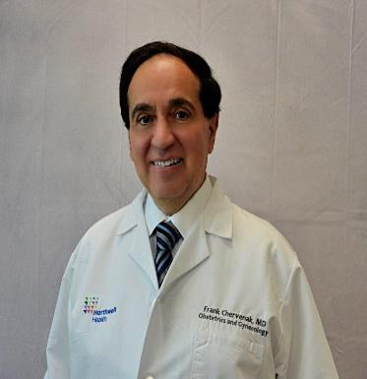

Frank A. Chervenak, MD currently serves as Chair of Obstetrics and Gynecology, Lenox Hill Hospital; Chair of Obstetrics and Gynecology and Associate Dean of International Medicine, Zucker School of Medicine at Hofstra/Northwell. He received his Bachelor of Science degree from Pennsylvania State University with highest distinction, and his medical degree from Thomas Jefferson University where he was elected a member of Alpha Omega Alpha Medical Honor Society. Dr. Chervenak served his internship in Internal Medicine at New York Medical College, residency in Obstetrics and Gynecology at New York Medical College in St. Luke’s Roosevelt Hospital Center, and a fellowship in Maternal Fetal Medicine at Yale University School of Medicine. He was Assistant Professor of Obstetrics and Gynecology at Mt. Sinai Medical Center, where he was also Director of Perinatal Research and received the Dr. Solomon Silver Award for application of advances in research to the practice of Clinical Medicine. He had served as the Given Foundation Professor and Chairman of the Department of Obstetrics and Gynecology, as well as Obstetrician and Gynecologist-in-Chief and the Director of Maternal Fetal Medicine at the New York Presbyterian Hospital, Weill Medical College of Cornell University from 1999 to 2018.

Dr. Chervenak was appointed Associate Professor of Obstetrics and Gynecology and Director of Obstetric Ultrasound and Ethics at New York Hospital-Cornell Medical Center in 1987. In 1991 he was named Director of Maternal Fetal Medicine and Director of Obstetrics. In 1992 he was made Full Professor with tenure, in 1998 he was named Vice Chairman of the Department of Obstetrics and Gynecology, and in 1999 was named Acting Chairman of that department. Dr. Chervenak was named Chairman and Obstetrician and Gynecologist-in-Chief in 2000. He received his Master in Medical Management degree from Carnegie Mellon University in 2001 and earned fellowship status from the American College of Physician Executives in 2008.

Dr. Chervenak has published 342 papers in peer review literature and has co-authored or coedited 43 textbooks. Research interests include ultrasound and ethics in obstetrics & gynecology and physician leadership. He has been named a member of The National Academy of Medicine of the National Academies. Dr. Chervenak has served on the Board of Governors of the American Institute in Ultrasound and Medicine and the Society of Perinatal Obstetricians. He has served as President of the World Association of Perinatal Medicine, International Fetal Medicine in Surgery Society, the New York Perinatal Society and the New York Academy of Medicine Section of Obstetrics and Gynecology, and the New York Obstetrical Society. Currently, Dr. Chervenak serves as President of the International Society of the Fetus as a Patient, Vice-president of the International Academy of Perinatal Medicine, and Codirector of The Ian Donald Inter-University School of Medicine and Ultrasound and serves on the ethics and professionalism committee of FIGO. He has been awarded doctor honoris causa from Semmelweis University in Budapest, Hungary; University of Athens, Greece; Carol Davila University of Medicine, Bucharest, Romania; University of The Republic, Montevideo, Uruguay; Siberian State University, Tomsk, Russia; University of Buenos Aries, Argentina; Dubrovnik International University, Croatia; Ott Scientific Research University of Obstetrics and Gynecology, St Petersburg; Pirogov Russian National Research Medical University, Moscow; Center for Obstetrics, Gynecology and Perinatology, Moscow and Surgut University, Russia, Kuban State University Krasnodar, Russia. He has been admitted as a fellow ad eundem of the Royal College of Obstetricians and Gynaecologists of Great Britain and as a Foreign Member of the Russian Academy of Sciences. He has been named an Honorary Member of the Mexican Academy of Pediatrics and a “Knight of Medicine” by the University of Georgia. He was named an Adjunct Professor at the Medical University of Vienna.

**PETER A. SCHWARTZ, M.D.**

Dr. Schwartz graduated from the Roxbury Latin School, received his Bachelor’s Degree from Harvard College, and his MD from Boston University. After two years in the United States Peace Corps in Western Samoa, he did his Residency in Obstetrics and Gynecology at Yale University.

He spent thirteen years in private practice in Northampton Massachusetts, where he was a member of the Council of the Massachusetts Section of the American College of Obstetricians and Gynecologists (ACOG) and was also on the Executive Committee of the Massachusetts Medical Society.

From 1987 until November 2005, and again from November 2012 until September 2014 he was Chair of the Department of Ob Gyn at Reading Health System. From 2005-2012 he served as Senior Medical Consultant at Stevens & Lee, a 220 attorney law firm, in a division dedicated to improving quality of obstetrical care and the quality of the physician patient relationship.

Dr. Schwartz served on the Council of the Obstetrical Society of Philadelphia, eventually becoming its President; on the Council of the Pennsylvania Section of the ACOG, eventually becoming its Chair; on the Ethics Committee of ACOG, eventually becoming its Chair; and on the Ethics Committees of the American Society of Reproductive Medicine and the American Academy of Pediatrics. He served two terms on the Council for Resident Education in ObGyn (CREOG) and three terms on the Ob Gyn Residency Review Committee, was an Examiner for the American Board of Obstetrics and Gynecology for ten years and was elected to ACOG’s Executive Committee as both Assistant Secretary and Vice President. He was on the faculty and board of CREOG’s School for New Residency Program Directors for over 20 years.

Dr. Schwartz has been the recipient of the CREOG National Faculty Award on multiple occasions, the J. Robert Willson Award from the Obstetrical Society of Philadelphia for long and meritorious service to the Society and the profession, and ACOG's Distinguished Service Award from District III.

He currently serves on the Boards of the Frontier Nursing University and Sorry Works!.

In June 2016 he was nominated and elected to a seven year term as one of the eight physicians on the AMA Council on Ethical and Judicial Affairs, with the responsibility to maintain and update the 165-year-old American Medical Association [Code of Medical Ethics](http://www.ama-assn.org/ama/pub/physician-resources/medical-ethics/code-medical-ethics.page?)*,* He is currently the Council’s Vice Chair

He was Professor of Clinical Obstetrics and Gynecology at the University of Pennsylvania and is currently a Professor of Obstetrics and Gynecology at Drexel University. He is currently Chair of the American Medical Association Council on Ethical and Judicial Affairs

**Joan M. Mastrobattista, MD**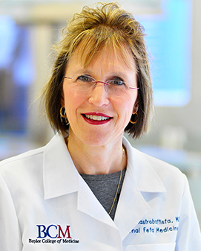

Professor of Obstetrics and Gynecology at Baylor College of Medicine in Houston, Texas in the Division of Maternal-Fetal Medicine. Medical school was completed at UMDNJ-New Jersey Medical School in Newark, New Jersey, residency training at The New York Hospital-Cornell Medical Center in New York City, and fellowship in Maternal-Fetal Medicine at the University of Texas Health Science Center in Houston. Clinical and research endeavors have focused on prenatal ultrasound, prenatal diagnosis and medical complications of pregnancy, and I have been very involved in ultrasound education. My teaching efforts over my career include education of medical students, residents, genetic counseling master's students, fellow and clinicians. Since moving to Baylor College of Medicine in 2011, my clinical focus continues with ultrasound and various fetal abnormalities including neural tube defects. I serve as the Ultrasound Clinic Chief for Texas Children’s Hospital/Baylor College of Medicine and Co-direct the Ultrasound Quality Program for our department.

**Professor Washington Hill**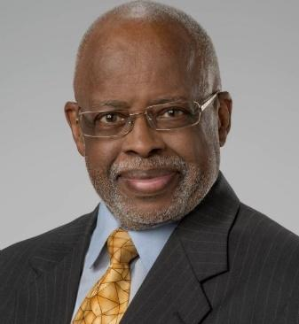

Dr. Washington Hill has been a member of the Florida Pregnancy-Associated Mortality Review PAMR) Committee for many years. He received his M.D. from Temple University School of Medicine and completed residency at William Beaumont Army General

Hospital in El Paso, Texas. After 12 years in private practice, he completed a Fellowship in Maternal–Fetal Medicine. He holds, academic appointments at a number of prestigious schools of medicine including USF and FSU. Dr. Hill is the founding Director of the Maternal Fetal Medicine at Sarasota Memorial Hospital. He has a strong interest in maternal mortality an preventing it, education, patient care, and clinical practice, and is a regular participant at conferences throughout the country. Recently, he completed two years in Rwanda teaching African medical students, residents, faculty and staff "Safe Motherhood". Dr. Hill is a senior physician in Women's Health at CenterPlace Health and has practiced at SMH 29 years and delivered babies 55 years. Today, Dr. Hill is involved daily in the care of high-risk obstetrical patients including those with substance use disorders, promoting Safe Motherhood throughout Florida, diversity, equity and inclusion, perinatal/community education and reviewing obstetrical medical-legal issues

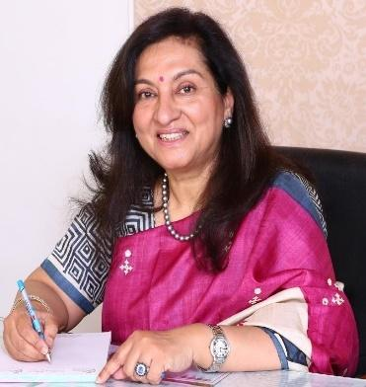

**Dr Jaideep Malhotra**

*MD, FICOG, FICS, FIUMB, FICMCH, FMAS, FRCPI, FRCOG*

* Managing Director of ART Rainbow IVF
* Vice President Indian Society of Aesthetic and Regenerative Gynaecology (InSARG)
* Chair FIGO Committee of Reproductive Endocrinology & Infertility
* Imm. Past President South Asian Federation of Menopause Societies (SAFOMS) & ISPAT
* Regional Director South Asia Ian Donald School of Ultrasound
* Professor Dubrovnik International University, Croatia
* Past Member of FIGO Working Group on RDEH
* Member of Accountability Group of PMNCH (WHO)
* Editor-in-Chief SAFOG & SAFOMS Journals & many books
* President Rotary Club of Agra Grace
* Past President FOGSI, ISAR, ASPIRE, IMS
* Past Secretary & Vice Chairman ICOG

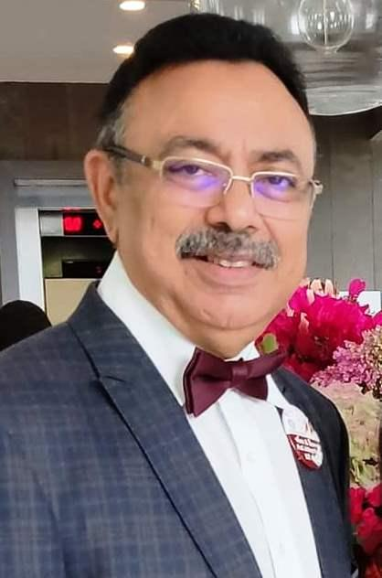 **Prof. Narendra Malhotra**

M.B.B.S, M.D., F.I.A.J.A.G.O., F.I.C.M.U., F.I.C.O.G., F.I.C.M.C.H, F.R.C.O.G.,F.I.C.S., F.M.A.S., A.F.I.A.P.

Managing Director Global Rainbow Healthcare

Director ART Rainbow IVF

Director Manyata CSE

Director Project Positive Health Rotary Distt 3110

Director International Relations SAFOG

Director Ian Donald School of USG

Professor Sarajevo School of Science and Technology, Croatia

Professor Dubrovnik International University, Croatia

President InSARG

Past Vice President SAFOG & WAPM

Imm. Past President Rotary Club Agra Taj City

Past President ISAR / ISPAT / IFUMB / FOGSI / AOGS / ICMU (Dean)

Founder Editor SAFOG Journal

Member of FIGO Guidelines Committee (2014-2017)

Chairman SMRITI (NGO) - *New Level of Care*

## **Shifa (Sifa) Turan M.D**.E:\ESOG\Preconference CME\ACOG meeting\Annual conference 2022\Hands on training on obstetrics ultrasound\Shifa\Turan_Shifa.jpg

I received my medical education and my MD degree from the University of Istanbul Medical School in Istanbul, Turkey. Subsequently, I received specialty training in Obstetrics and Gynecology in Istanbul. Afterwards, I completed my fellowship training on Fetal Medicine under the supervision of Prof. Kypros Nicolaides in Fetal Medicine at the Harris Birthright Research Center, King's College Hospital, UK. Following my fellowship, I joined the Division of Maternal and Fetal Medicine at Yale University. Thereafter, I joined the University of Maryland School of Medicine, Department of Obstetrics, Gynecology and Reproductive Sciences, Maternal Fetal Medicine working as the Director of the Fetal Heart Program. My clinical interests include prenatal diagnosis of fetal abnormalities and cardiac defects. I have extensive experience on the diagnosis of fetal heart defects using 3 and 4 dimensional ultrasound methods. Accordingly, I have developed a new 4 dimensional ultrasound method to diagnose fetal heart defects during the first trimester of the pregnancy.

**Dr. Peter Finamore** is the Chair of the Department of Obstetrics and Gynecology and Division Chief of Urogynecology, at South Shore University Hospital of Northwell Health in Bay Shore, New York. He is also an Associate Professor for Zucker School of Medicine Hofstra/Northwell. He is board certified in Urogynecology and Obstetrics and Gynecology. 

Dr. Finamore created the first Obstetrics and Gynecology residency program at South Shore University Hospital and Huntington Hospitals in 2017 and was the residency program director up until June 2021. He spearheaded unique collaboration with several other departments to foster a variety of clinical and non-clinical residency training opportunities and develop skills in communication, professional development and resident wellness. In addition to being a mentor to many faculty, fellows, residents and medical students throughout his career, he is also involved in faculty development.

Prior to his career in clinical medicine, he worked in basic science as a laboratory technician and obtained a master’s degree in molecular biology. His urogynecology fellowship was jointly accredited by the American Board of Ob/Gyn and American Board of Urology. His surgical emphasis is on minimally invasive approaches to treat of pelvic organ prolapse. He offers Da Vinci Robotic pelvic reconstructive surgery as well as vaginal reconstructive procedures. In addition to the surgical expertise Dr. Finamore has he is also an expert at the diagnosis and treatment of various problems that affect the female pelvis and bladder such as, urinary incontinence, over active bladder, interstitial cystitis, pelvic floor muscle dysfunction and other conditions.

Dr. Finamore is a reviewer for several journals, authored a text book chapter and published many papers in various peer-reviewed journals. He has presented numerous posters and abstracts at local and national society meetings for Urogynecologists, Ob/Gyn’s and Urologists.

**Prof. Cihat Şen, M.D.**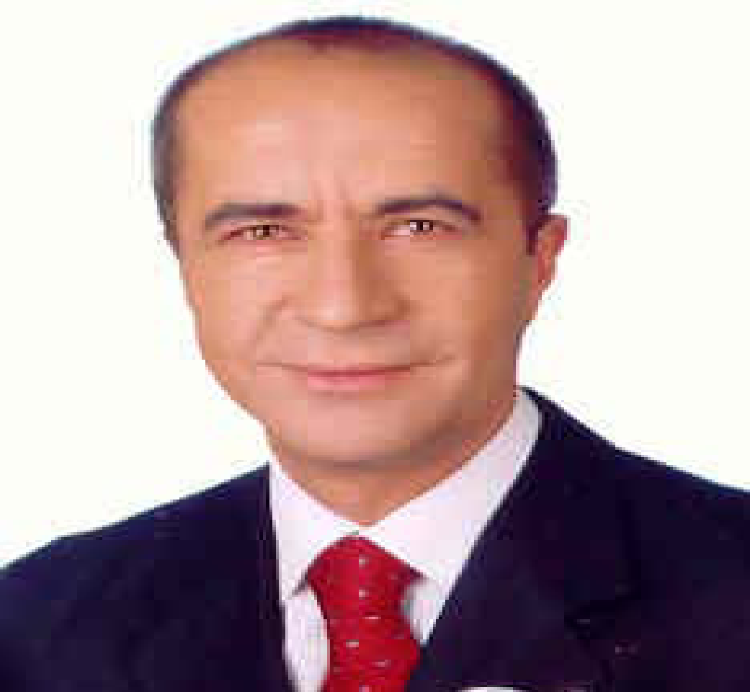

Specialist in Obstetrics and Gynaecology

Subspecialist in Perinatal Medicine

**Profession:**

1986 lecturer at the department of Obstetrics and Gynecology,

Cerrahpaşa Medical School

1989 charter member of the department of perinatology (the first perinatology department in Turkey)

1989-1990 (for one year) Harris birthright research center for fetal medicine

King’s college hospital, school of medicine

1990 sept: lecturer at the department of perinatology, obstetrics/gynecology,

Cerrahpaşa medical school, university of Istanbul

1992 associate professor in the department of perinatology, obstetrics/ gynecology, Cerrahpaşa medical school

2001: professor in the department of perinatology, obstetrics and

Gynecology, Cerrahpasa medical school, university of Istanbul

**2002: fetal medicine diploma**

**Appointments:**

* President of world association of perinatal medicine 2019-2021
* President of world congress of perinatal medicine-2019
* Director of perinatal medicine foundation
* Regular fellow of international association of perinatal medicine
* Board member of the international society of fetus as a patient
* Director of Ian Donald ultrasound school-turkey branch
* Editor of Turkish journal of perinatology
* Editor of perinatal journal
* Member of editorial board, journal of perinatal medicine
* Former president of Turkish perinatology society
* Former president of Turkish society of ultrasound in obstetrics and gynecology

**Societies:**

Perinatal medicine foundation

Turkish perinatology society

Turkish society of ultrasound in obstetrics and gynecology

Turkish society of obstetrics and gynecology

Istanbul gynecology society

Ian Donald inter-university school for medical ultrasound

European association of perinatal medicine

World association of perinatal medicine

International society fetus as a patient

International society of ultrasound in obstetrics and gynecology

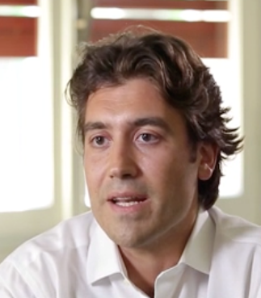**Nicola Volpe, MD PhD**

Consultant in Obstetrics and Gynecology – Parma University Hospital, Parma, ITALY, since

April 2013 (current)

Member of the editorial board of the Journal of Perinatal Medicine, as Social Media Editor,

SINCE 2020

Editor in chief of the Perinatal Journal, since 2021

Vice-President of the national society of ultrasound in obstetrics and gynecology (SIEOG) for the years 2021-2023

Deputy-Secretary general of the World Association of Perinatal Medicine (WAPM) since 2021

Professor for the II level Master Degree in “Advanced Fetal Echocardiography

and Neurosonography”. Academic Years 2016/2017; 2017/2018 and 2018/2019. Parma University. Parma.

Professor for the Speciality Training in Obstetrics and Gynecology – Teaching: Ultrasound in Obstetrics. Academic Years since 2016 to date. Parma University. Parma.

Temporary Professor for the School of Midwifery, University of Parma – Teaching: Ultrasound in Obstetrics in the Academic Year 2014/2015; Office ultrasound in the Academic years 2016/2017, 2017/2018 and 2018/2019

Temporary Professor for the Master Degree in “Obstetric Ultrasound and Prenatal Medicine” for Midwives. – Academic Years 2013/2014, 2018/2019 and 2019/2020. Modena and Reggio Emilia University. Modena.

Professor for the Italian Academy for Speciality Training Entry Test (AIMS – Accademia Italiana Medici aspiranti Specializzandi) – Teaching: Obstetrics and Gynecology, 2015 - 2018.

Temporary Professor for the School of Nursing, University of Parma – Teaching: Obstetrics. Academic Year 2013/2014

Research Fellow in Fetal Medicine for the Fetal Medicine Foundation - Harris Birthright Research Centre, King's College Hospital; Antenatal Ultrasound Unit, University College Hospital and Fetal Medicine Centre, London, UK, from May 2008 to April 2009 and from February 2011 to June 2012

Fetal Medicine Foundation Certified Operator – number 45132, since September 2008

Specialist in Obstetrics and Gynaecology – specialist Training completed in the university of

Bari on the 28/10/2010

UK General Medical Council Full Registration as Medical Practitioner - number

7120540, since 22/02/2011, until 22/02/2013

State Medical Licensure in Italy since 09/03/2006

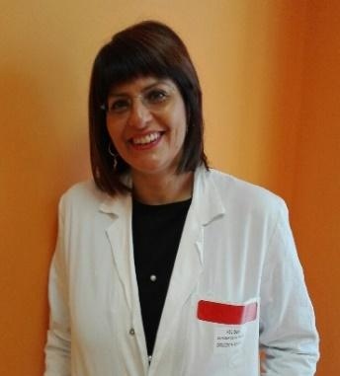

**Valentina De Robertis**

**Consultant in Fetal Medicine, Di Venere Hospital, Bari, Italy** (December 2007 to current date)

**General Education**

* 2001 Graduate in Medicine and Surgery at the Univerity of Bari
* 2006 Specialization in Obstetrics and Gynecology

**Training:**

* 2005-2006 fellowship of Fetal Cardiology in Di Venere Hospital (tutor Paolo Volpe).

**Certificates**

* FMF Certificates of competence in the measurement of nuchal translucency,assessment of nasal bone, ductus venosus flow, tricuspid flow, preeclampsia screening.

**Professional membership**

* Member of the board of the Italian Society of Ultrasound in OB&GYN (SIEOG) in: 2010-2012, 2015-2017 and 2017-2019.
* Member of the WAPM (World Association of Perinatal Medicine) board in 2019-2021.

Author of several scientific publications

**Petya Chaveeva**

**2007**

* Graduation in Medicine, November: Medical University of Sofia.

**2015**

* Specialist in Obstetrics and Gynecology, June, 2015: Medical University of Sofia.

**2018**

* PhD in Obstetrics and Gynecology, Medical University of Pleven.
* Dissertation: “Optimal method and timing of intrauterine fetal surgery in monochorionic pregnancies complicated with TRAP sequence.”

**2019**

* Master degree in Public Health and Health management.

**2019**

* Associated Professor: Medical University-Pleven.
* Known Languages: Bulgarian and English

**Current position**

Associated Professor: Medical University- PlevenHead of Fetal Medicine Department “OB/GYN Dr Shterev Hospital”. Sofia, Bulgaria

**Clinical experience**

**2010-2013**

* Research and Clinical fellowship at Harris Birthright Research Centre for Fetal Medicine, King’s College Hospital, London (Director: Prof. Kypros Nicolaides): 2010-2013.
* Diploma in Fetal Medicine

**2013 - present**

* Associated Professor: Medical University- Pleven. Research Institute.
* Head of Fetal Medicine Department “OB/GYN Dr Shterev Hospital”. Sofia, Bulgaria

**Educational activities**

* Lecturer in national and international courses and congresses.
* Deputy at SIG Early Pregnancy, ESHRE

**2016-2022**

* President of Maternal Fetal Medicine Association, Bulgaria (MFMA).
* Board Member of World Association of Perinatal Medicine

#### Research interest

* Multiple pregnancies
* Fetal surgery
* Screening for chromosomal abnormalities
* Maternal-fetal complicacions during pregnancy
* Author and co-author of 85 peer-review papers published in national and international scientific journals.
* Co-Author of chapter at text book: Twining's Textbook of Fetal Abnormalities, 3rd Edition. Chapter: Fetal aneuploidies

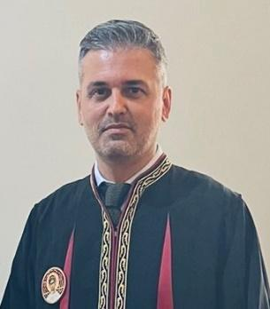

**THEMISTOKLIS I DAGKLIS**

Dr Themistoklis Dagklis is currently serving as an Assistant Professor in Obstetrics and Gynecology, in the 3rd University Clinic of Obstetrics and Gynecology, Thessaloniki, Greece.

He has graduated with honors from the Medical School of Aristotle University (AUTh), Thessaloniki, Greece (2000).

He completed his PhD in Physiology and Pharmacology, AUTh, entitled: “Leptin’s effect on gonadotropin release and the gonads - stereotactic study in rats’’ (Degree: Excellent, 2006).

He specialized in Obstetrics and Gynecology, in the 4th University Clinic of Obstetrics and Gynecology, Thessaloniki, Greece (2007-2011).

He holds two MSc titles, one in “Management of Health Units”, by the Open University of Greece (2011) and one in “Reproduction and Development”, by the University of Bristol, UK (2014).

He subspecializedin Maternal – Fetal Medicine, receiving the Diploma in Fetal Medicine, by the Harris Birthright, King’s College Hospital and the Fetal Medicine Foundation, London, UK. (2005-2007, 2011-2012).

Between 2011 and 2018 he worked as a Consultant in Maternal-Fetal Medicine, in the 3rd University Clinic of Obstetrics and Gynecology, Thessaloniki, Greece, until his appointment as an Assistant Professor in the same clinic (10/2018-present).

His special interests are prenatal diagnosis, perinatal epidemiology and high-risk pregnancy.

He speaks English fluently and has a basic knowledge of the German language.

He has extensive teaching experience in both undergraduate and postgraduate students, both in Greece and the UK.

He has published more than 100 papers in international peer-reviewed journals (Pubmed) receiving more than 3000 citations (Google Scholar).

He has given more than 70 lectures in congresses and seminars.

He is a member of the working group for the development of guidelines by the World Association of Perinatal Medicine, being the first author in one of the most recent ones on antenatal use of corticosteroids.

He is also a member of the coordinating committee for the update in Guidelines in Obstetrics and Gynecology of the Hellenic (Greek) Society of Obstetricians & Gynecologists.

Thessaloniki, November 2022

**María del Mar Gil Mira** 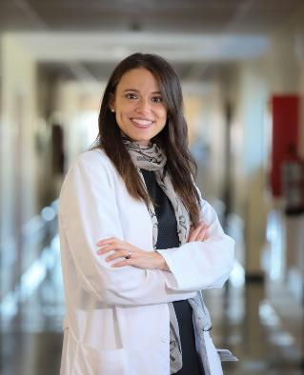

**Academic qualification**:

***2009:*** Bachelor of Medicine in Universidad de Alcalá in Madrid, Spain.

***2015:*** Fellowship in Fetal Medicine in King’s College Hospital – Fetal Medicine Foundation in London, UK.

***2016:*** Ph.D in Medicine and Surgery in Universidad Autónoma de Madrid in Madrid, Spain.

***2022:*** MSc in Bioestatistics in Universidad Complutense de Madrid in Madrid,

Spain.

**Previous academic positions held**:

***2016-2017:*** Assistant Professor, Department of Obstetrics & Gynecology, Faculty of

Medicine, Universidad Francisco de Vitoria, UFV, Madrid, Spain.

***2009-2013:*** Lecturer, Department of Obstetrics & Gynecology, Faculty of Medicine, Universidad Autónoma de Madrid.

**Present academic position**:

***2015 - Now***: Coordinator of the Obstetrics Clinical and Research Unit, Hospital Universitario de Torrejón, Madrid, Spain.

***2017 - Now:*** Associate Professor, Department of Obstetrics & Gynecology, Faculty of Medicine, Universidad Francisco de Vitoria, UFV, Madrid, Spain.

***2018 - Now:*** Co-Founder, iMaterna Foundation

***2021-now:*** Board member, World Association in Perinatal Medicine

***2021-now:*** Editor Scientific Journal, Perinatal Journal

***2022-now:*** Editorial board member Scientific Journal: Ultrasound in Obstetrics and Gynecology

**Elham Baghestan**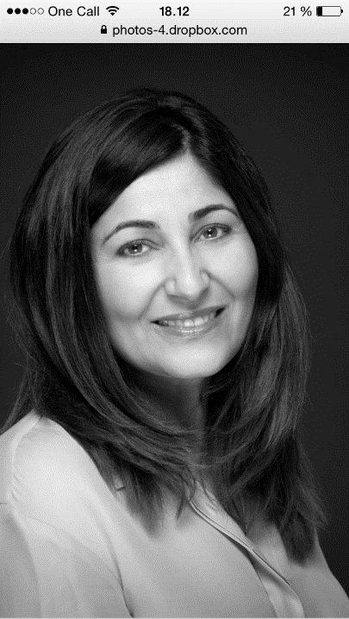

Prof. Elham Baghestan is Consultant and the head of Department of Obstetrics and Gynecology, Haukeland University Hospital, Bergen, Norway, and Assistant Professor at Department of Clinical Science, University of Bergen. Based on her interest and experience in obstetrics, and her thesis “Epidemiological aspects of obstetric anal sphincter injuries in Norway”, she has since continued with research on pelvic floor injuries, epidemiology and pregnancy complications, both as supervisor in PhD projects, member of the Nordic research group for rare pregnancy complications, and co-author of Norwegian guidelines on the repair of perineal injuries. In addition to national graduate teaching, Professor Baghestan contributes in organizing and teaching in national and international post graduate courses as well as in international congresses, mainly within her field of interest. Publications confer: [Baghestan elham - Google Scholar](https://scholar.google.com/scholar?hl=en&as_sdt=0%2C5&q=Baghestan+elham&oq=)

**

Ferenc Macsali is a senior Consultant and co-head of Department of Obstetrics and Gynecology, Haukeland University Hospital, Bergen, Norway, and senior consultant at the Norwegian Medical Birth Register in Norway. His field of interest is based on his interest and experience in obstetrics and gynecology, but also in epidemiology.

His thesis was Hormonal and metabolic determinants of women's respiratory health. Research done since has been connected to this thesis but also epidemiology connected to obstetrics and covid disease.

He is head-author and co-author of several Norwegian guidelines.

Ferenc Macsali contributes in organizing and teaching in national and international post graduate courses in practical obstetrics.

**Jörg Kessler**

Dr Jörg Kessler is a Senior Consultant at the Department of Obstetrics and Gynecology, Haukeland University Hospital, Bergen, Norway and Professor at the Department of Clinical Science, University of Bergen. He started his research pioneering the portal venous flow in human fetuses, and focused on the fetal venous liver circulation and its impact on fetal growth. He has continued this path by research on the fetal circulation in diabetic pregnancies, in addition to studies on intrapartum fetal monitoring and the fetal circadian rhythm using fetal ECG. Prof Kessler has contributed as an author and co-author to the Norwegian guidelines in Obstetrics and the European Postgraduate Textbook in Obstetrics and Gynecology. He has also extensive experience in teaching manual skills in obstetrics and Doppler techniques to trainees and consultants.

**Sindre Grindheim**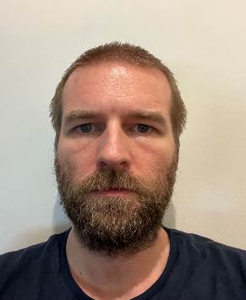

Sindre Grindheim is a physician specialized in obstetrics and gynecology and works as a consultant obstetrician at Haukeland University Hospital in Bergen, Norway. He is associated with the University of Bergen and is currently the lead researcher in Bergen birth study, a large prospective observational trial assessing maternal and neonatal outcome after operative vaginal delivery with focus on maternal pelvic floor injuries. He has over the last years, attended several courses in practical obstetrics as instructor. He has for nearly a decade participated in creating national guidelines in managing high risk pregnancies in Norway. His main field of interest is management of high-risk pregnancies due to maternal conditions, and management of complicated labour.

**Torvid Kiserud**

Torvid Kiserud, MD PhD, Senior Professor (University of Bergen); obstetrician-gynecologist; fetal medicine specialist; fistula surgeon. Ian Donald Gold Medal laureate for his lifetime scientific achievements (ISUOG 2015). WHO external adviser. Pioneered Doppler ultrasound of the fetal ductus venosus as a clinical tool, and provided essential new insights in its fluid-dynamic, physiological and functional-anatomical foundation. Recognized as a world leader in clinical ultrasound diagnostics and research (Keywords: Fetal Growth, Biometry, Doppler Ultrasound, Fetal Physiology, Fetal Circulation, Hemodynamics, Cardiac Function, Cardiovascular Abnormalities, Fetal Liver Function, Fetal Growth Restriction, Fetal Macrosomia, Diabetes, DOHaD).

As fistula surgeon, Dr. Kiserud established and headed the National Centre for Gynecological Fistula in Norway. He has been committed to global health during his entire career, holds a diploma in tropical diseases, and has particularly engaged in emergency obstetrics (Keywords: obstetric care, obstetric fistula, fistula repair, catheter treatment, uterine rupture, pelvic abscess, fertility). Publications confer: [Kiserud T Google Scholar](https://scholar.google.no/citations?user=tn7zZ1YAAAAJ&hl=en)

**Christine Mullin**

Dr. Mullin is currently the Interim System Chief of Northwell Health Fertility.  Dr. Mullin first joined the Reproductive Endocrinology and Infertility Division at Northwell in 2011 after completing her fellowship in Reproductive Endocrinology and Infertility at NYU Fertility Center-Langone Medical Center. She was selected by The American Society of Reproductive Medicine as a Clinical Research/Reproductive Scientist Training Scholar, and successfully completed the Northwell Health Physician Leadership Development Program in 2020 and Northwell’s Executive Leadership Development Program in 2022.

In her time at Northwell, Dr. Mullin has continually demonstrated a strong devotion to patient care, education, and leadership. She has excelled in prior leadership roles including IVF Director, Preimplantation Genetic Testing Director and Fertility Preservation Director at Northwell Health Fertility. In addition to these administrative roles, she is deeply committed to medical education and teaching. Dr. Mullin leads initiatives for improving resident and fellow education, and promotes academic enrichment activities for the REI Attending physicians. She has held a faculty appointment at the Donald and Barbara Zucker School of Medicine at Hofstra/Northwell as an Assistant Professor since 2011. Dr. Mullin maintains a busy REI practice and has been recognized as one of Newsday's Top Doctors on Long Island, Castle Connolly Regional Top Doctors and US News and World Reports Top Doctors.

**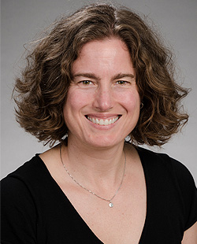Sarah Ward Prager, M.D., M.A.S.**

Dr. Prager is a Professor in the University of Washington (UW) Department of Obstetrics and Gynecology and Adjunct Professor of Health Services at the UW School of Public Health. She is the Director of the Family Planning Division and the Fellowship in Family Planning. She teaches family planning to medical students, residents, fellows and other allied health professionals at the University of Washington Medical Center. Her research interests include immediate postpartum LARC, post abortion contraception and early pregnancy loss management, with a focus on implementation of EPL services in outpatient settings. She has 39 publications in peer-reviewed journals and has co-authored three chapters and two UpToDate topics. Dr. Prager was part of the working group that updated the most recent CDC Medical Eligibility Criteria for Contraception Use and Selected Practice Recommendations, both published in 2016. She has done work with ACOG since 2001 and is the immediate past Chair of the Washington Section, as well as past Chair of the Committee for Healthcare for Underserved Women, and the current Co-Chair of the Abortion Access and Training Work Group. Since 2009, she has participated in global family planning projects or trainings in Nepal, Pakistan, Uganda, Zambia and Zimbabwe, and is currently on sabbatical from the University of Washington and spending this academic year on faculty in the OBGYN department at St. Paul Hospital and Millennium Medical College in Addis Ababa, Ethiopia. Her specific focus is supporting and growing the family planning fellowship and program here.

Dr. Prager received her undergraduate degree *summa cum laude* in Romance Languages and Literature from Princeton University in 1993. She received her medical degree from the University of Texas Southwestern Medical School in 2000 and completed her residency at the University of Vermont in 2004. She completed a Family Planning Fellowship and a Masters in Advanced Studies (MAS) in Clinical Research in 2006 at the University of California, San Francisco. She has been on faculty at UW since August, 2006 and on faculty at SPHMMC since September, 2019.

**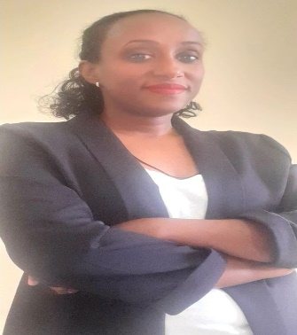Hanna Teklu G/Egziabher**

MD, obstetrician and gynecologist graduated from BLH in 2015

Served as assistant professor of obstetrics and gynecology at Dire Dawa university  for 2years and as senior medical specialist at ALERT center

I am now FP fellow at SPHMMC

Am an active member of ECSACOG-FIGO Community of practice

Working on research inclined on SRH

Am also principal investigator of some clinical trials done in Ethiopia

**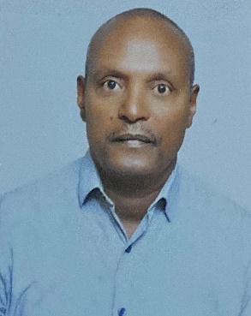Dr. Zewdu Terefework**

Received both his MSc and Ph.D. in Microbiology from the department of Applied Chemistry and Microbiology at the University of Helsinki. He also holds a diploma in psychology and received several certificates on genomics in medicine and genomic technologies in clinical diagnostics and genetic counseling. He runs a genetic testing laboratory in Addis Ababa. He is currently an adjunct associate professor at Addis Ababa University School of Laboratory Medicine and teaches at Myunsung Christian Medical College (Korea Hospital). He has published several articles in scientific peer-reviewed journals and authored chapters in books. He is an accomplished Research scientist and educator specializing in microbiology, molecular biology, and genetic testing. His research activities include plant-microbe interaction for sustainable agriculture, molecular fingerprints for the identification of microbes and molecular diagnostics of congenital anomalies & inherited diseases, genetic testing, and counseling.

**General Information:**

ESOG will be offering online registration on the ESOG website and Facebook page and will send the online registration form and Zoom invitation to ESOG members, partners, speakers, trainers etc. via personal e-mail addresses. The ZOOM webinar link will also be available to access the CME topics

**CME Credit:**

ESOG designates this virtual activity with a maximum of 20 Continuing Educational Units (CEU)/Credits toward the CME *(See below the details)*. Physicians should only claim credit commensurate with the extent of their participation in the activity.

* Hands-on training:
  + Advanced Ultrasonography course: 15 CEUs
  + Practical Skills in Advanced Operative Obstetrics: 12 CEUs
  + Laparoscopy course: 6 CEUs
* CME lecture sessions: 1 CEU per one contact hour with a maximum of 6 CEUs per day
* Main conference attendance: 0.25 CEU per one hour of attendance-Maximum of 2 CEU/day i.e., 4 CEU for the two main conference days
* Oral presentation (Abstract, scientific contents, etc.): 10 CEU per presentation
* Poster presentation: 5 CEU per presentation
* Moderating panel discussion: 0.5 CEU per hour of engagement

**Disclosure of faculty and any industrial relationships**

Speakers are expected to disclose any financial interest or other relations with the industry relative to topics they discuss during the CME course. Such disclosure allows participants to better evaluate the objectivity of the information presented in the lectures. Please report on your evaluation form any undisclosed conflict of interest you perceive.

**Learning objectives**

At the conclusion of the CME course participants should be able to:

* Learning objectives Review Pelvic Organ Prolapse (POP)
* Understand Pelvic Organ Prolapse Quantification Scale
* Discuss Treatment Options for POP
* Illustrate the pros and cons of lipid screening in pregnancy
* Highlight complications in pregnancy associated with dyslipidemia
* Understand when to treat and involve lipid specialists in the care of pregnant patients with dyslipidemia
* Apply the concepts of the fetus as a patient to ethical dimensions of abortion
* Distinguish between private conscience and professional ethics
* Appreciate the long history of intolerance in the western world
* To Discuss about the prevalence of congenital abnormalities in our country
* To demonstrate about the perceptions and acceptability of prenatal congenital anomalies screening methods among pregnant women
* To mention the available prenatal congenital anomalies screening methods in our set up & their utilization in clinical practice
* Fetal and maternal mortality
* Prioritizing admission by the pts condition
* To describe and identify the anatomic structures included in the standard ultrasound views to routinely evaluate the fetal brain at 11-13 weeks of gestation according to the recent WAPM guideline.
* To recognize anatomic features different than normal on such standard planes
* To recognize the most frequent structural anomalies of the fetal brain by ultrasound at 11-13 weeks of gestation.
* To describe and identify the anatomic structures included in the standard ultrasound views to routinely evaluate the fetal spine at 11-13 weeks of gestation according to the recent WAPM guideline.
* To recognize anatomic features different than normal on such standard planes
* To recognize the most frequent structural anomalies of the fetal spine by ultrasound at 11-13 weeks of gestation.
* To show the multiplanar approach for evaluating the normal aspect of the fetal face at the first trimester scan.
* To recognize the main abnormal findings in the sagittal, coronal and axial planes of the fetal face
* To discuss the potential detection of the main anomalies affecting the fetal face in the first trimester
* To identify appropriate acquisition of nuchal translucency and normal thorax structures by ultrasound at 11-13 weeks of gestation.
* To recognize the most frequent structural anomalies of the thorax structures by ultrasound at 11-13 weeks of gestation.
* To discuss possible associations of limb defects with genetic syndromes
* To show the normal anatomy of the fetal heart in the first trimester
* To share technical suggestions to improve the quality of the image and avoid artifacts
* To recognize the main abnormal findings when a congenital heart defect is present
* To describe how to perform US examination of urinary tract and genitalia at 11-13 weeks based on WAPM guideline.
* To discuss the US features of abnormalities of urinary tract and genitalia at 11-13 week.
* To provide updated counselling how to manage abnormalities of urinary tract and genitalia at 11-13 weeks.
* 1-To identify normal GIT and abdominal wall structures by ultrasound at 11-13 weeks of gestation.
* 2-To recognize the most frequent structural anomalies of the GIT
* 3-abdominal wall structures by ultrasound at 11-13 weeks of gestation.
* To identify normal limb structures by ultrasound at 11-13 weeks of gestation.
* To recognize the most frequent structural anomalies of the limbs by ultrasound at 11-13 weeks of gestation.
* To discuss possible associations of limb defects with genetic syndromes
* The importance of US examination of twin pregnancies at 11-13 weeks.
* How to determine chorionicity, labeling of twins, dating of pregnancy,
* Screening for aneuploidies and structural defects in twins
* To know the performance, indications, risks, and benefits of currently available methods of screening of aneuploidies.
* To learn the conditions that can potentially be included in the screening process.
* Combined test versus fetal-DNA
* identify the cause of deep implant
* able to localize deep implant and steps of diagnostic approaches for none palpable implant
* know the removal procedure for deep implant
* Review the hormones in combined oral contraceptives
* Introduce estetrol and how it fits with other contraceptive hormones
* Review side effect profile of estetrol/drospirenone and compare with other COCs
* Role of computer aided stimulation in IVF
* Role of Advance analytics in IVF
* Personalized treatment optimization
* Evaluation of infertile couples in proper steps
* Evaluation of infertile couples in cost effective way
* Dos and don'ts in the Initial management of infertile couples
* Discuss the ethical responsibilities of students/residents toward patients
* Discuss the ethical responsibilities of teachers toward patients
* Review the responsibilities of teaching institutions toward patients, students, and teachers
* Review the hormones in combined oral contraceptives
* Introduce estetrol and how it fits with other contraceptive hormones
* Review side effect profile of estetrol/drospirenone and compare with other COCs
* HUMAN BEINGS HAVE 23 PAIRS OF CHROMOSOMES AND 30 THOUSAND GENES
* THE HUMAN DNA CODES AND DECODE HOW PROTEINS ARE MADE IN CELLS WHICH DETERMINE THE FUNCTIONS OF OUR BODY
* MANY DISEASE ARE HEDITARY OF SEX CHROMOSOMES AND AUTOSOMES, AND THESE MAY BE DOMINAT HERIDITARY OR RECCESSIVE
* ITS VERY IMPORTANT FOR THE PRACTISING OBSTETRICIAN TO BE AWARE OF GENETICS OF HUMAN FUNCTION
* [IN](http://5.in/) THIS LECTURE WE WILL DISCUSS THE BASICS OF GENETICS AND PEDIGERE CHARTING AND TESTING FOR GENETIC DISEASE
* Emphasis on the importance of genetic testing in OB-GYN practices
* Highlight the successful implementation of genetic testing practice in Ethiopia and identify the challenges
* Underline the routine application of screening programs, informed consent, maintenance of family history,

**Virtual pre-conference CME talks/presentations timetable**

|  |  |  |  |
| --- | --- | --- | --- |
| February 10, 2023 | 31st Annual Conference of ESOG Preconference CME  Zoom room 1  Session I | | |
| Time | **Topic** | **Presenter** | **Moderator** |
|  | Northwell Health Logo | | |
| 8:50-9:00 | Opening remark |  | Northwell Health presentations  Dr Abdulfetah Abdulkadir and Dr Rahel Demissew |
| 9:00-9:20 | Pelvic Organ Prolapse | Peter Finamore |
| 9:20-9:40 | Gynecologic oncology | Karin Shih |
| 9:40-10:00 | Role of fertility in Ob/Gyn practice | Christine Mullin |
| 10:00-10:20 | Dyslipidemia in Pregnancy: Management and Future Directions | Shane Wasden |
| 10:20-10:40 | Short and Long-term Consequences of Fetal Growth Restriction for Mother and Child | Matthew Blitz |
| 10:40-11:00 | Topic on genetics | Madankumar Rajeevi |
| 11:00-11:20 | Ethical dimensions of abortion: A current worldwide controversy | Frank Chervenak |
| 11:20-11:40 | Pre-natal screening in Ethiopia | Anteneh Mersha |  |
| 11:40-12:10 | Incidence of ICU admission for pregnant and postpartum pts | Aida Tilahun |  |
| 12:10-12:30 | **Discussion** | | |
| 12:30-14:00 | **Lunch break** | | |
|  | **Zoom room I**  **Session II** | | |
| 14:00-14:20 |  |  |  |
| 14:20-14:40 |  |  |  |
|  | **Zoom room I** [**https://meet.perinatalmedicine.org/**](https://meet.perinatalmedicine.org/) for a recorded session  **Session II free of charge** | | |
|  |  | | |
| 15:00-15:20 | First trimester examination of fetal anatomy: Clinical practice guideline by WAPM/PMF | Cihat Şen | WSPM presentations  Dr Fikremelekot Temesgen and Dr Sisay Petros |
| 15:20-15:40 | Head and Brain: First trimester anatomy | Nicola Volpe |
| 15:40-16:00 | Spine: First trimester anatomy | Nicola Volpe |
| 16:00-16:20 | Face: First trimester anatomy | Valentina De Robertis |
| 16:20-16:40 | Neck and thorax: First trimester anatomy | Themis Dagklis |
| 16:40-17:00 | Heart: First trimester anatomy | Cihat Şen |
| 17:00-17:20 | How to do: Live examination | Cihat Şen |
|  |  |  |  |
| 17:20-17:50 | **Discussion** | | |
| 17:50 End of day one of the Preconference CME | | | |

|  |  |  |  |  |
| --- | --- | --- | --- | --- |
| February 11, 2023 | 31st Annual Conference of ESOG Preconference CME  ZOOM room 1  Session III | | | |
| Time | **Topic** | | **Presenter** | **Moderator** |
|  | **Zoom room I** [**https://meet.perinatalmedicine.org/**](https://meet.perinatalmedicine.org/) for a recorded session  **Session II free of charge** | | | |
|  |  | | | |
| 9:00-9:20 | Urinary tract and genitalia: First trimester anatomy | | Petya Chaveeva | WSPM presentations  Dr Ferid Abbas and Dr Berhanu Kebede |
| 9:20-9:40 | Gastro-intestinal tract and abdominal wall: First trimester anatomy | | Mar Gil |
| 9:40-10:00 | Limbs: First trimester anatomy | | Themis Dagklis |
| 10:00-10:20 | How to do: Live examination | | Themis Dagklis |
| 10:20-10:40 | First trimester examination in twins | | Petya Chaveeva |
| 10:40-11:00 | First trimester screening for aneuploidies: Where are we now? | | Mar Gil |
| 11:00-11:30 | Localization and Removal of nonpalpable contraceptive implants | | Hanna Teklu | FP presentations |
| 11:30-12:00 | Nextstellis: a novel combined oral contraceptive pill with estetrol and drospirenone | | Sarah Prager |
| 12:00-12:30 |  | |  |
| 12:30-13:00 | **Discussion** | | | |
|  |  | | | |
| 13:00-14:00 | **Lunch break** | | | |
|  | **ZOOM room 1**  **Session IV** | | | |
| 14:00-14:40 | PRP and stem cell in infertility | Nayana Patel | | REI presentations  Dr Abel Teshome, Dr Abdu Mengesha and Dr Feiruz Surur/Dr Ayalew Mariye |
| 14:40-15:10 | IVF Stimulation: Personalized, Optimized, and Simplified. | Urmila Diwekar | |
| 15:10-15:30 | Initial evaluation of infertile couples | Hassen Hussien | |
| 15:30-15:50 | Premature ovarian insufficiency | Jaideep Malhotra | |
| 15:50-16:10 | Environment and fertility | Jaideep Malhotra | |
| 16:10-16:30 | Demystifying the IVF Pandora’s Box | Dr Mugdha Amit Parasnis | |
|  |  |  | |
|  |  |  | |
|  |  |  | |
|  |  |  | |
|  |  |  | |
|  | **Discussion** | | | |
| End of day two of the preconference CME | | | | |

|  |  |  |  |
| --- | --- | --- | --- |
| February 12, 2023 | 31st Annual Conference of ESOG Preconference CME  ZOOM room 1  Session V | | |
| Time | **Topic** | **Presenter** | **Moderator** |
| 9:00-9:20 | Research/manuscript writing topic | Kwasi Torpey & Adom Manu | Dr Tadesse Urgie and Dr Tesfaye Hurisa |
| 9:20-9:50 | Update on the role of colposcopy in screening precancerous lesion of the cervix | Maximilian Klar |
| 9:50-10:10 | Ethical Challenges Faced by Learners in ObGyn | P. Schwartz |
| 10:10-10:30 | Pedigree charting | Narendra Malhotra |
| 10:30-10:40 | Genetic testing in OB-GYN care: the Ethiopian experience | Zewdu Terefework |
|  |  |  |
|  |  |  |
|  |  |  |
|  | **Discussion** | | |
|  | **Lunch break** | | |
|  | **ZOOM room 1**  **Session VI** | | |
|  | E:\ESOG\Preconference CME\ACOG meeting\Annual conference 2022\Stakeholders\index.png SMFM.png | | |
|  |  |  | SMFM presentations  Obstetric Anesthesia & Critical Care Management of the  High-Risk Parturient  Prof Washington C. Hill Dr Abdulfetah Abdulkadir Prof Delayehu Bekele |
|  |  |  |
|  |  |  |
|  |  |  |
|  |  |  |
|  |  |  |
|  |  |  |
|  |  |  |
|  |  |  |
|  |  |  |
|  |  |  |
|  | **Discussion** | | |
| End of day three of the preconference CME | | | |

**Residents State of the Art Lecture- Zoom room 2**

**February 13, 2023 afternoon at 13:30-15:30**

**Speaker:**

**Topic:**

**Learning Objectives:**

**Dr. Solomon Kumbi Memorial Lecture-Zoom room 2**

**Tuesday, February 14, 2023**

**Speaker: Peter A. Schwartz**

**Topic:** Conscientious objection in obstetrics and gynecology

At the conclusion of the discussion the learner should be able to

* 1. Understand the meaning of and be able to use the terms conscience, conscientious objection, conscientious refusal, tolerance
  2. Realize the need to balance potential harms to patients and physicians
  3. Understand that challenges to physician conscience may occur in reference to abortion, reproductive technologies, end of life care, transfusions, among others

**Friday, February 10-Saturday February 11, 2023**

**Hands-on Training I: Practical Skills in Advanced Operative Obstetrics**

**Venue: TAH Simulation/Skill laboratory**

**February 10-11, 2023 from 08:30-17:00**

**Tea Breaks 9:40-10:10/9:30-10:00 and 14:40-15:10/15:30-15:45**

**Lunch: 12:00-13:00**

**Morning: 08:30--12:00**

**Course faculty**

Elham Baghestan, Ass. Professor, Consultant, MD PhD

Sindre Grindheim, Consultant, MD

Jörg Kessler, Professor, MD PhD (convener)

Torvid Kiserud, Professor, MD PhD (convener)

Ferenc Macsali, Consultant, MD PhD

Fikremelekot Temesgen, Professor, MD

**February 10th**

|  |  |  |
| --- | --- | --- |
| 08:30-08:40 | Welcome/orientation | Torvid Kiserud/Jørg Kessler |
| 08:40-09:10 | The biomechanical fundament of normal delivery | Ferenc Macsali |
| 09:10-09:40 | Irregular cephalic presentation - diagnosis and biomechanics | Ferenc Macsali |
| 09:40-10:10 | Tea break |  |
| 10:10-10:50 | Non-rotational forceps, indications and technique | Elham Baghestan |
| 10:50-12:00 | Hands-on training, forceps (4-5 in each group)  Group 1: Macsali  Group 2: Baghestan  Group 3: Grindheim  Group 4: Kessler |  |
| 12:00-13:00 | Lunch |  |
| 13:00-13:30 | The choice of instruments - vacuum vs. forceps | Sindre Grindheim |
| 13:30-14:40 | Hands-on training, vacuum  Group 1: Baghestan  Group 2: Kessler  Group 3: Macsali  Group 4: Grindheim |  |
| 14:40-15:10 | Tea break |  |
| 15:10-16:05 | Evidence based caesarean techniques + discuss | Sindre Grindheim |
| 16:05-17:00 | Anal sphincter injury; diagnosis, treatment, counselling | Elham Baghestan |

**February 11th**

|  |  |  |
| --- | --- | --- |
| 08:30-09:00 | Vaginal breech delivery - when it gets difficult | Ferenc Macsali |
| 09:00-09:30 | Alternative birth positions in breech delivery | Jørg Kessler |
| 09:30-10:00 | Tea break |  |
| 10:00-11:00 | Hands-on training, breech  Group 1: Grindheim  Group 2: Macsali  Group 3: Kessler  Group 4: Baghestan |  |
| 11:00-11:30 | Symphysiotomy, technique/indication | Torvid Kiserud |
|  |  |  |
| 11:30-12:00 | Twin delivery - on the outlook for trouble | Jørg Kessler |
| 12:00-13:00 | Lunch |  |
| 13:00-14:00 | Hands-on training, twin (combined version, extraction)  Group 1: Kessler  Group 2: Grindheim  Group 3: Baghestan  Group 4: Macsali |  |
| 14:00-14:35 | Uterine rupture strategies | Torvid Kiserud |
| 14:35-15:30 | Placenta accreta/percreta - conservative or surgical treatment | Jørg Kessler/Fikremelekot Temesgen |
| 15:30-15:45 | Tea break |  |
| 15:45-16:45 | Choices; general discussion | Panel |
| 16:45-17:00 | Summing up; Closing remarks |

**Friday February 10-Sunday February 12, 2023**

**Hands-on Training II: Advanced ultrasound course-OGSS-ESOG**

**Venue: Lecture-St. Paul’s Hospital Millennium Medical College lecture hall Hands on experience-St. Paul’s Hospital Millennium Medical College -Ob/Gyn Department**

**February 10-12, 2023**

**Tea Breaks:**

**Lunch: 12:00-13:00**

**Morning: 09:00-12:00**

**Obstetrical & Gynecological Society of Sudan**

**In Collaboration with the Ethiopian Society of Obstetrics and Gynecology**

**Scientific Program for the Advanced Ultrasound Course**

**Venue: St Paul’s Hospital**

**Addis Ababa, Ethiopia**

**Moderators:** *Dr Berhanu Kebede Dr Anteneh Mersha Dr Aida Tilahun Dr Eyob Gelan Dr Sintayehu Debas and Dr Tesfaye Dires*

**Day 1**

**Friday, February 10, 2023**

|  |  |  |
| --- | --- | --- |
| **Duration** | **Topic** | **Speaker** |
| ***08:00-08:15*** | ***Registration*** | ***All Faculty*** |
| ***08:15 -08:45*** | ***Welcome and objectives*** | ***Dr. Yacoub A/Magid, Dr. Sami Mahmoud & Dr. Omer El Jazar*** |
| ***08:45-09:30*** | ***Plan your movements & Improve your image*** | ***Prof. Hisham Mirghani (sent to all candidates @ the Whatsapp application earlier*** |
| ***09:30-10:00*** | ***Obstetrics Ultrasound, How, Why & When?*** | ***Dr. Omer El Jazar*** |
| ***10:00 -10:45*** | ***Ultrasound in early pregnancy*** | ***Dr. Sami Mahmoud*** |
| ***10:45-11:00*** | ***Tea Break*** | ***ESOG*** |
| ***11:00-11:45*** | ***1st Trimester screening*** | ***Dr. Sami Mahmoud*** |
| ***11:45-12:15*** | ***Determining the gestational age*** | ***Dr. Sami Mahmoud*** |
| ***12:15-13:30*** | ***Lunch Break*** | ***ESOG*** |
| ***13:30-14:00*** | ***Growth Scan*** | ***Dr. Omer El Jazar*** |
| ***14:00-14:30*** | ***Multiple pregnancies*** | ***Dr. Abukhalid Mirghani*** |
| ***14:30-15:00*** | ***Sonographic assessment of the fetal CNS Anatomy*** | ***Dr. Omer El-Jazar*** |
| ***15:00-15:30*** | ***Discussion & Closing remarks*** | ***All Faculty*** |
| ***15:30-15:45*** | ***Tea Break*** |  |

**Day 2:**

**Saturday, February 11, 2023**

|  |  |  |
| --- | --- | --- |
| ***08:30-09:00*** | ***Fetal Renal system*** | ***Dr. Omer El Jazar*** |
| ***09:00-09:40*** | ***IUGR*** | ***Dr. Hanan Abdel Aziz*** |
| ***09:40-10:10*** | ***Fetal Chest*** | ***Dr. Omer El Jazar*** |
| ***10:10-10:30*** | ***Tea break*** | ***ESOG*** |
| ***10:30-11:00*** | ***Fetal heart*** | ***Dr. Siddig Adam*** |
| ***11:00-11:30*** | ***Ectopic pregnancy*** | ***Dr. Salma Gerais*** |
| ***11:30-12:00*** | ***Placenta & liquor*** | ***Dr. A/Mahmoud Eltahir*** |
| ***12:00-12:30*** | ***Discussion & Closing remarks*** | ***All faculty*** |
| ***12:30-14:00*** | ***Lunch Break*** | ***ESOG*** |
| ***14:00-17:00*** | ***Supplementary video presentation/demonstration*** | ***Joan Mastrobattista MD & Shifa Turan MD, RDMS*** |

**Day 3:**

**Hands-on training**

**Hands-on Training III: Laparoscopy**

**Venue: Lecture-TAH Ob/Gyn Department meeting hall Hands on experience-TAH Ob/Gyn OR**

**February 11, 2023 from 08:30-18:00**

**Tea Breaks 10:25-10:40 and 15:30-15:45**

**Lunch: 12:30-13:30**

**Morning: 08:30-12:30**

**Laparoscopy: Update and basic skills training**

**Facilitators:** *Dr Eyasu Mesfin, Dr Eskinder Kebede, Dr Mahlet Yigeremu, Dr Abdu Mengesha.*

**8:00:** Registration (ESOG)

**8:30 -10:30:** Theoretical session

**Learning Objectives:**

* Discuss the current status and advantages of laparoscopic surgery.
* Describe the set-up, instruments and equipment used in laparoscopic surgery
* Understand the principles and ergonomics in laparoscopic surgery
* Understand pelvic anatomy from the laparoscopic perspective
* Demonstrate knowledge of potential complications of laparoscopic surgery.

**Schedule:**

**8:30-8:40:** Welcome and introduction (ESOG)

**8:40-9:00:** History, the current status and advantages of laparoscopic surgery **(Dr Abdu)**

**9:00-9:20:** The set-up, instruments and equipment used in laparoscopic surgery **(Dr Mahlet)**

**9:20-9:40:** The principles and ergonomics in laparoscopic surgery **(Dr Eskinder)**

**9:40-10:00:** Potential complications of laparoscopic surgery and ways to prevent **(Dr Eyasu)**

**10:00-10:25: Discussion**

**10:25-10:40: Tea break**

**10:40-12:30:** Hands-on on advanced simulator

**Learning Objectives:**

* Demonstrate basic laparoscopic skills on simulators
  + Camera manipulation
  + Laparoscopic depth perception
  + Basic hand-eye coordination
  + Use two hands in a coordinated fashion to clip, grasp and cut
  + Translocation of objects

**12:30-13:30: Lunch break**

**13:30 -18:00:** Live laparoscopic surgery demonstration

* Two live surgery sessions for demonstrations will be arranged at TASH.
* Participants will be divided in two groups in the afternoon to rotate between simulation practice and live surgery.

**15:30-15:45: Tea break**

15:45-18:00: Live laparoscopic surgery demonstration continued

**18:00 End of session**

**Friday February 10, 2023**

**Virtual CME lectures**

**Session I**

**ZOOM virtual lectures-Room I**

**February 10, 2023 from 08:50-17:50**

**Discussion: 12:10-12:30**

**Lunch break: 12:30-14:00**

**Morning: 08:50-12:30**

**Moderators: Dr Abdulfetah Abdulkadir and Dr Rahel Demissew**

**Opening remark:**

1. Pelvic Organ Prolapse (POP)
2. Learning objectives Review Pelvic Organ Prolapse (POP)
3. Understand Pelvic Organ Prolapse Quantification Scale
4. Discuss Treatment Options for POP
5. -------------------

Learning objectives

1. -------------------

Learning objectives

1. Dyslipidemia in Pregnancy: Management and Future Directions by Shane Wasden from 10:00-10:20

Learning objectives

1. Illustrate the pros and cons of lipid screening in pregnancy
2. Highlight complications in pregnancy associated with dyslipidemia
3. Understand when to treat and involve lipid specialists in the care of pregnant patients with dyslipidemia
4. Short and Long-Term Consequences of Fetal Growth Restriction for Mother and Child by Matthew Blitz from 10:20-10:40

Learning objectives

1. --------------------

Learning objectives

1. Ethical dimensions of abortion: A current worldwide controversy by Frank Chervenak from 11:00-11:20

Learning objectives

1. Apply the concepts of the fetus as a patient to ethical dimensions of abortion
2. Distinguish between private conscience and professional ethics
3. Appreciate the long history of intolerance in the western world
4. Pre-natal screening in Ethiopia by Anteneh Mersha from 11:20-11:40

Learning objectives

1. To Discuss about the prevalence of congenital abnormalities in our country
2. To demonstrate about the perceptions and acceptability of prenatal congenital anomalies screening methods among pregnant women
3. To mention the available prenatal congenital anomalies screening methods in our set up & their utilization in clinical practice
4. Incidence of ICU admission for pregnant and postpartum pts by Aida Tilahun from 11:40-12:10

Learning objectives

1. Fetal and maternal mortality
2. Prioritizing admission by the pts condition

**Discussion 12:10-12:30**

**Lunch break 12:30-14:00**

**Session II**

**ZOOM virtual lectures-Room I**

**February 11, 2023 from 08:50-17:50**

**Discussion: 17:20-17:50**

**Afternoon: 14:00-17:50**

**Moderator: Dr Fikremelekot Temesgen and Dr Sisay Petros**

1. --------------------
2. ---------------------
3. First trimester examination of fetal anatomy: Clinical practice guideline by WAPM/PMF by Cihat Şen from 15:00-15:20

Learning objectives

1. Head and Brain: First trimester anatomy by Nicola Volpe from 15:20-15:40

Learning objectives

1. To describe and identify the anatomic structures included in the standard ultrasound views to routinely evaluate the fetal brain at 11-13 weeks of gestation according to the recent WAPM guideline.
2. To recognize anatomic features different than normal on such standard planes
3. To recognize the most frequent structural anomalies of the fetal brain by ultrasound at 11-13 weeks of gestation.
4. Spine: First trimester anatomy by Nicola Volpe from 15:40-16:00

Learning objectives

1. To describe and identify the anatomic structures included in the standard ultrasound views to routinely evaluate the fetal spine at 11-13 weeks of gestation according to the recent WAPM guideline.
2. To recognize anatomic features different than normal on such standard planes
3. To recognize the most frequent structural anomalies of the fetal spine by ultrasound at 11-13 weeks of gestation.
4. Face: First trimester anatomy by Valentina De Robertis from 16:00-16:20

Learning objectives

1. To show the multiplanar approach for evaluating the normal aspect of the fetal face at the first trimester scan.
2. To recognize the main abnormal findings in the sagittal, coronal and axial planes of the fetal face
3. To discuss the potential detection of the main anomalies affecting the fetal face in the first trimester
4. Neck and thorax: First trimester anatomy by Themis Dagklis from 16:20-16:40

Learning objectives

1. To identify appropriate acquisition of nuchal translucency and normal thorax structures by ultrasound at 11-13 weeks of gestation.
2. To recognize the most frequent structural anomalies of the thorax structures by ultrasound at 11-13 weeks of gestation.
3. To discuss possible associations of limb defects with genetic syndromes
4. Heart: First trimester anatomy by Cihat Şen from 16:40-17:00

Learning objectives

1. To show the normal anatomy of the fetal heart in the first trimester
2. To share technical suggestions to improve the quality of the image and avoid artifacts
3. To recognize the main abnormal findings when a congenital heart defect is present
4. How to do: Live examination by Cihat Şen from 17:00-17:20

Learning objectives

**Discussion 17:20-17:50**

**17:50 End of day one of Preconference CME**

**Saturday February 11, 2023**

**Virtual CME lectures**

**Session III**

**ZOOM virtual lectures-Room I**

**February 11, 2023 from 09:00-**

**Discussion: 12:00-12:30**

**Lunch break: 12:30-14:00**

**Morning: 9:00-12:30**

**Moderators: Dr Ferid Abbas and Dr Berhanu Kebede**

1. Urinary tract and genitalia: First trimester anatomy by Petya Chaveeva from 9:00-9:20

Learning objectives

1. To describe how to perform US examination of urinary tract and genitalia at 11-13 weeks based on WAPM guideline.
2. To discuss the US features of abnormalities of urinary tract and genitalia at 11-13 week.
3. To provide updated counselling how to manage abnormalities of urinary tract and genitalia at 11-13 weeks.
4. Gastro-intestinal tract and abdominal wall: First trimester anatomy by Mar Gil from 9:20-9:40

Learning objectives

1. 1-To identify normal GIT and abdominal wall structures by ultrasound at 11-13 weeks of gestation.
2. 2-To recognize the most frequent structural anomalies of the GIT
3. 3-abdominal wall structures by ultrasound at 11-13 weeks of gestation.
4. Limbs: First trimester anatomy by Themis Dagklis from 9:40-10:00

Learning objectives

1. To identify normal limb structures by ultrasound at 11-13 weeks of gestation.
2. To recognize the most frequent structural anomalies of the limbs by ultrasound at 11-13 weeks of gestation.
3. To discuss possible associations of limb defects with genetic syndromes
4. How to do: Live examination by Themis Dagkalis from 10:00-10:20

Learning objectives

1. First trimester examination in twins by Petya Chaveeva from 10:20-10:40

Learning objectives

1. The importance of US examination of twin pregnancies at 11-13 weeks.
2. How to determine chorionicity, labeling of twins, dating of pregnancy,
3. Screening for aneuploidies and structural defects in twins
4. First trimester screening for aneuploidies: Where are we now? By Mar Gil from 10:40-11:00

Learning objectives

1. To know the performance, indications, risks, and benefits of currently available methods of screening of aneuploidies.
2. To learn the conditions that can potentially be included in the screening process.
3. Combined test versus fetal-DNA
4. Localization and Removal of nonpalpable contraceptive implants by Hanna Teklu from 11:00-11:30

Learning objectives

1. identify the cause of deep implant
2. able to localize deep implant and steps of diagnostic approaches for none palpable implant
3. know the removal procedure for deep implant
4. Nextstellis: a novel combined oral contraceptive pill with estetrol and drospirenone by Sarah Prager from 11:30-12:00

Learning objectives

1. Review the hormones in combined oral contraceptives
2. Introduce estetrol and how it fits with other contraceptive hormones
3. Review side effect profile of estetrol/drospirenone and compare with other COCs

**Discussion 12:00-12:30**

**Lunch break 12:30-14:00**

**Session IV**

**ZOOM virtual lectures-Room I**

**February 20, 2023 from 14:00-**

**Discussion:**

**Afternoon: 14:00-**

**Moderators: Dr Abel Teshome Dr Abdu Mengesha and Dr Feiruz Surur/Dr Ayalew Mariye**

1. PRP and stem cell in infertility by Nayana Patel from 14:00-14:40

Learning objectives

1. IVF Stimulation: Personalized, Optimized, and Simplified by Urmila Dikewar from 14:40-15:10

Learning objectives

1. Role of computer aided stimulation in IVF
2. Role of Advance analytics in IVF
3. Personalized treatment optimization
4. Initial evaluation of infertile couples by Hassen Hussien from 15:10-15:30

Learning objectives

1. Evaluation of infertile couples in proper steps
2. Evaluation of infertile couples in cost effective way
3. Dos and don'ts in the Initial management of infertile couples
4. Premature ovarian insufficiency by Jaideep Malhotra from 15:30-15:50

Learning objectives

1. Environment and fertility by Jaideep Malhotra from 15:50-16:10

Learning objectives

1. **------------------------**
2. **-------------------------**
3. **-----------------------**

**Discussion time:**

**End of day two of pre-conference CME**

**Sunday February 12, 2023**

**Virtual CME lectures**

**Session V**

**ZOOM virtual lectures-Room I**

**February 12, 2023 from 09:00-**

**Discussion: 12:40-12:55**

**Lunch break: 12:55-14:00**

**Morning: 9:00-12:55**

**Moderators: Dr Tadesse Urgie and Dr Tesfaye Hurisa**

1. ----------------
2. Update on the role of colposcopy in screening precancerous lesion of the cervix by Maximilian Klar from 9:20-9:50

Learning objectives

1. Ethical Challenges Faced by Learners in ObGyn by Peter Schwartz from 9:50-10:10

Learning objectives

1. Discuss the ethical responsibilities of students/residents toward patients
2. Discuss the ethical responsibilities of teachers toward patients
3. Review the responsibilities of teaching institutions toward patients, students, and teachers
4. Genetics for the obstetrician-Pedigree charting by Narendra Malhotra from 10:10-10:30

Learning objectives

* + - 1. HUMAN BEINGS HAVE 23 PAIRS OF CHROMOSOMES AND 30 THOUSAND GENES

1. 2.THE HUMAN DNA CODES AND DECODE HOW PROTEINS ARE MADE IN CELLS WHICH DETERMINE THE FUNCTIONS OF OUR BODY
2. 3.MANY DISEASE ARE HEDITARY OF SEX CHROMOSOMES AND AUTOSOMES, AND THESE MAY BE DOMINAT HERIDITARY OR RECCESSIVE
3. 4.ITS VERY IMPORTANT FOR THE PRACTISING OBSTETRICIAN TO BE AWARE OF GENETICS OF HUMAN FUNCTION
4. [5.IN](http://5.in/) THIS LECTURE WE WILL DISCUSS THE BASICS OF GENETICS AND PEDIGERE CHARTING AND TESTING FOR GENETIC DISEASE

Learning objectives

1. Genetic testing in OB-GYN care: the Ethiopian experience by Zewdu Terefework from 10:30-10:40

Learning objectives

* + - 1. Emphasis on the importance of genetic testing in OB-GYN practices
      2. Highlight the successful implementation of genetic testing practice in Ethiopia and identify the challenges
      3. Underline the routine application of screening programs, informed consent, maintenance of family history,

1. -----------------
2. -------------------
3. ------------------

**Discussion:**

**Lunch break:**

**Session VI**

**ZOOM virtual lectures-Room I**

**Obstetric Anesthesia & Critical Care Management of the**

**High-Risk Parturient-SMFM**

**February 20, 2022 from 14:00-**

**Discussion:**

**Afternoon: 14:00-**

**Moderators: Prof Washington C. Hill Dr Abdulfetah Abdulkadir and Prof Delayehu Bekele**

1. --------------------
2. --------------------
3. --------------------
4. -----------------------
5. -----------------------
6. -----------------------
7. -----------------------
8. -----------------------

**Discussion time:**

**End of day three of pre-conference CME**