**Railcards:** Railcards are money saving passes and it is basically used to get significant discounts on nearly all train tickets throughout Britain railways.

Most railcards are available as a one-year or three-year option and will help us to save at least 1/3 on train tickets – including journeys on the Trans Pennine Express network, which covers the North of England and Scotland.

**Railcards for TPE**

16-25 Railcard - **YNG**

HM Forces Railcard- **HMF**

Disabled Persons Railcard- **DIS**

Family and Friends Railcard- **FAM**

Senior Railcard- **SRN**

Two Together Railcard- **2TR**

26-30 Railcard-

**Railcard prices:**

|  |  |  |
| --- | --- | --- |
| Type | Price (one-year Railcard) | Price (three-year Railcard) |
| Disabled Persons Railcard | £20 | £54 |
| 16-25 Railcard | £30 | £70 |
| 26-30 Railcard | £30 | £70 |
| Senior Railcard | £30 | £70 |
| HM Forces Railcard | £21 | X |
| Family & Friends Railcard | £30 | £70 |
| Two Together Railcard | £30 | X |

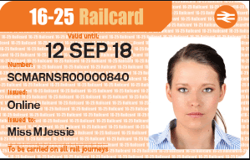

**16-25 Railcard:** The 16-25 Railcard was previously known as the Young Person’s Railcard.   
It save 1/3 on most tickets across Great Britain with a 16-25 Railcard, but if you book an advance ticket for TransPennine Express services on the TransPennine Express network in advance you’ll save 50%.  
As well as it helping people aged between 16 and 25 to save money on their rail journeys, the 16-25 Railcard is also available to people aged over 25 who are in full time education.

**Save on these types of tickets**

* Standard Anytime and Anytime Day Singles and Returns
* Standard Off-Peak and Off-Peak Day Singles and Returns
* Standard Super Off-Peak and Super Off-Peak Day Singles and Returns
* Standard and First Class Advance*
* Most Rail Rovers fares
* Gatwick Express, Stansted Express and Heathrow Express

**Minimum Fares & Time Restrictions**

* A £12 minimum fare applies for journeys starting between 4.30am-10am Monday to Friday excluding Advance Fares. This minimum fare does not apply on Public Holidays or throughout July and August.
* Journeys that commence at 10:00 will receive the Railcard discount
* If you travel regularly between 04:30 and 10:00 Monday to Friday, to work or your place of study for instance, a weekly or monthly season ticket could be the best way for you to save money. Railcards do not give discounts on season tickets.
* The £12 minimum fare DOES NOT apply at weekends, on Public Holidays and during July and August. For full details of minimum fares, please ask at your local staffed station and some National Rail-licensed Travel Agents.

**Your 16-25 Railcard WON'T apply to:**

* Season tickets including Travel card Season tickets
* Eurostar tickets
* First Class fares (except First Class Advance and Weekend First for some train companies, as mentioned above)
* Some Train Company specific promotional offers
* Tickets for special excursion or Charter trains and some coach/bus links, including Railair services
* Most London Underground and Docklands Light Railway tickets (unless using Oyster pay as you go)

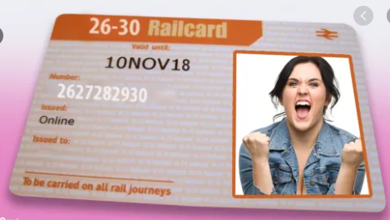

**26-30 Railcard:** The 26-30 Railcard, also known as the ‘millennial railcard’ is now available across the entire national rail network.

If you’re aged between 26 and 30, you will save 1/3 on train tickets across Great Britain, however there are some minimum fares before 10am on weekdays for anytime and Off-Peak Singles and Returns.

**Eligibility:**

To be eligible you must be between 26 and 30. You can buy a 26-30 Railcard any time before your 31st birthday and keep using it for a whole year, until its expiry date.

* The 26-30 Railcard is digital only and it’s available to buy online. All you need is
* A valid passport or UK driving licence to verify your identity
* A digital passport-style photo saved to your computer, tablet or mobile phone
* A debit or credit card.

**Save on these types of tickets**

* Standard Anytime and Anytime Day Singles and Returns
* Standard Off-Peak and Off-Peak Day Singles and Returns
* Standard Super Off-Peak and Super Off-Peak Day Singles and Returns
* Standard and First Class Advance*
* Most Rail Rovers fares

**Minimum Fares & Time Restrictions**

* A £12 minimum fare applies on all journeys made between 04:30 and 10:00 Monday to Friday
* Journeys that commence at 10:00 will receive the Railcard discount
* If you travel regularly between 04:30 and 10:00 Monday to Friday, to work or your place of study for instance, a weekly or monthly season ticket could be the best way for you to save money. Railcards do not give discounts on season tickets.
* The £12 minimum fare DOES NOT apply at weekends and on Public Holidays.

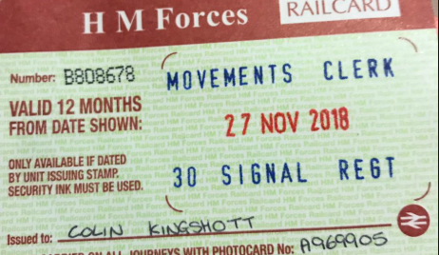

**HM Forces Railcard**: You can save 1/3 off most train journeys if you have a HM Forces Railcard, which is available to members of the Regular Forces or Volunteer Reserves, as well as spouses, civil partners, dependent children, widows and widowers.

**Eligibility**

The following are eligible to be issued with the HM Forces Railcard -

1. All members of the Regular Forces wherever they are stationed.
2. All members of the Volunteer Reserve.
3. Members of the Regular Reserve during periods of full time service of at least 3 months.
4. Commissioned Officers of the RAF Reserve carrying out full time duties in uniform in peacetime.
5. Members of other Government Defence Forces serving in official exchange appointments.
6. Spouses/civil partners of those above.

**Minimum fares**

For journeys made before 10am Monday to Friday, a minimum fare of £12 applies (except in July or August, or on public holidays). This applies to all Anytime, Off-Peak and Super Off-Peak tickets.

There are no minimum fares for all Advance tickets.

**Off-Peak Day Travelcard**--A minimum fare applies on adult Off-Peak Day Travelcards at all times (including July and August). The minimum fare is £8.00.

The minimum fare also applies to a discounted Zones 1-6 'Inboundary' Off-Peak Day Travelcard.

Note - Railcard discounts are not available on any other zonal combinations of Day Travelcards.

**Anytime Day Travelcard**--Railcard discounts are available on Anytime Day Travelcards from stations outside the London Fare Zones 1-9 area. These are subject to the normal rules applicable to the Railcard, but in addition an adult minimum fare also applies at all times (including July and August). The minimum fare is currently £17.20.

No discounts are available on Anytime Day Travelcards issued for journeys within Zones 1-9.

**Conditions of issue and use of reduced priced tickets ('discounted tickets') bought with the HM Forces Railcard**

1. Tickets for your journey should be purchased before boarding the train. You must present your Railcard and Photocard whenever you purchase a discounted ticket. You must have your Railcard (and Photocard) with you on your journey and always show the valid Railcard and ticket to rail staff at their request.

If you do not show both the Railcard and the ticket, you will be required to pay the full price

2. In the case of some low price tickets the actual discount with a Railcard may be slightly lower than that advertised.

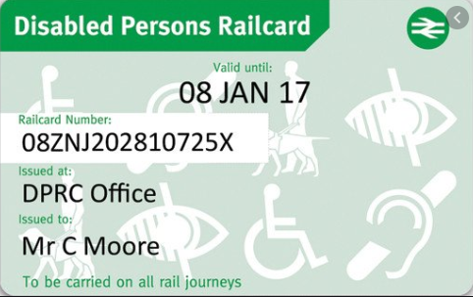  
**Disabled Persons Railcard:** If you have a disability that makes travelling difficult – such as a visual or hearing impairment – or you receive a disability-related benefit, you may be able to get a Disabled Persons Railcard.

Disabled Persons Railcard holders can save 1/3 on all train tickets at any time or day of the week – there are no restrictions.

**Eligibility:**

You must provide proof that you qualify for the Disabled Persons Railcard. You might qualify if you have a visual impairment or a hearing impairment or have epilepsy or are in receipt of a disability related benefit.

The Disabled Person's Railcard can either be purchased online, through telesales or by completing the form available on the Disabled Person's Railcard website and send to the address given in the Rail Travel Made Easy leaflet with proof of your entitlement.

**Benefits:**

Get **1/3 off** adult rail fares for travel on the National Rail network in Great Britain.

If you're travelling with another adult they will also get 1/3 off their rail fare, so you can save money for a friend or family member too!

There are **no time restrictions** on the Disabled Persons Railcard, so you can use it to get a discount on tickets at any time of the day.

**Get 1/3 off the following tickets:**

Standard and First Class Anytime and Anytime Day Singles and Returns

Standard and First Class Off-Peak and Off-Peak Day Singles and Returns

Standard and First Class Super Off-Peak and Super Off-Peak Day Singles and Returns

Standard and First Class Advance Singles

Anytime Day Travelcard when bought as part of your ticket to London from outside London Zones 1-9 (subject to a minimum fare of £19.10)

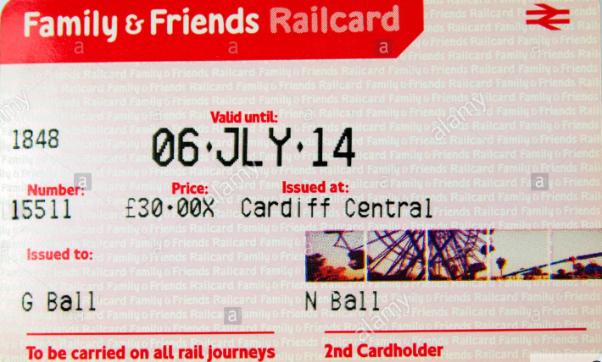

**Family and Friends Railcard:** The Family and Friends Railcard can be used for up to four adults and four children – so it’s great for big groups going on days out or holidays.

Up to two adults can be named as cardholders – and as long as one of the named cardholders is traveling with at least one child aged between five and 15, you can save 1/3 on adult fares and 60% off kids’ train tickets.

**Eligiblity:**

Any adult can buy a Family & Friends Railcard. To use it, at least one of the group travelling must be named on the Railcard and there must also be at least one child travelling on a child rate ticket. The named Railcard holder must travel for the entire journey with any passengers who have been bought discounted tickets.

**General conditions of use of the Railcard**

2.1 If you have a physical Railcard, your Railcard is not valid, and you cannot use it, until you have signed it. If your Railcard covers more than one person, the second cardholder must also sign the physical Railcard before use.

2.2. The Railcard does not become your property and, if requested: You must hand it to a representative of any of the Train Companies, if you have a physical Railcard.

2.3. The Railcard and tickets bought with it are not transferable to anyone else and you must not give, lend, or resell them. Only the named cardholder(s) can use the Railcard.

2.4. Train Companies will not issue refunds on unused/unwanted Railcards, or extend their validity period.

2.5. You may be asked to show your Railcard when purchasing discounted tickets.

**Conditions of use of the Family & Friends Railcard**

4.1. One Railcard will be issued to up to two people aged 16 years or over. The names of the cardholders must be provided at the time of purchase – if you purchase a Railcard for one person, you cannot add a second name later.

4.2. If you buy a physical Railcard, each cardholder must sign the Railcard before use to show acceptance of the Railcard Conditions (see condition 2.1).

4.3. To purchase discounted tickets, at least one cardholder and at least one child aged 5 to 15 years must be travelling together.

4.4. The maximum group size is four adults (aged 16 years and over) including the named cardholder(s) and four children aged between 5 and 15 years. The group must travel with the Railcard holder throughout the journey.

4.5. If the named Railcard holders travel separately, only one cardholder may use the Railcard for discounted tickets as the Railcard must be produced for inspection together with the discounted tickets.

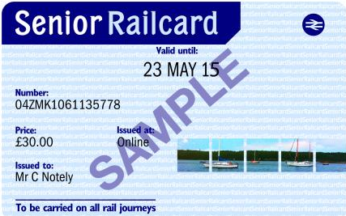

**Senior Railcard: I**f you’re aged 60 or over, you can get a Senior Railcard and save 1/3 off train tickets for routes across Great Britain – including First Class train tickets.

**Eligibility:**

You're eligible for a Senior Railcard if you are 60 years old or over.

You can buy one up to two weeks before your 60th birthday if you buy online, but it’ll only be valid from your birthday onwards. If you buy from a station, you’ll have to be 60 or over on the day you do it.

Buying online is easy. All you need is a valid debit or credit card and one of the items below:

A valid passport number

A valid UK driving licence

If you’d prefer to buy your Railcard at a staffed rail station, you can also use your birth certificate to prove your identity and age.

**Conditions of use of the Senior Railcard**

4.1. You must be aged 60 years or over to purchase a Senior Railcard.

4.2. Discounts are not available on tickets for travel on morning peak services for journeys that start and end within the London & South East area (defined by the Network Railcard area – network-railcard.co.uk/map) on Monday to Friday (except on public holidays). The time when off-peak services start can vary by station. Use nationalrail.co.uk to plan your journey to identify when off-peak services start or ask rail staff for details.

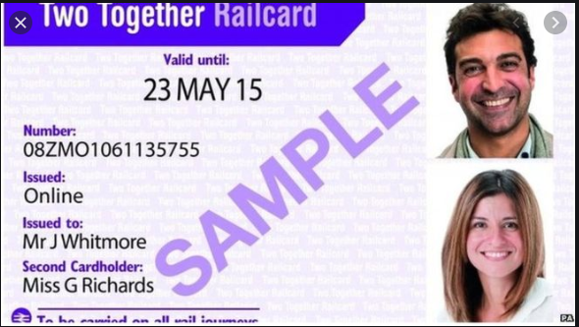

**Two Together Railcard:** If you regularly travel with the same person, such as a relative, friend or colleague? If so, the Two Together Railcard could help both of you save 1/3 off your train tickets.

**Conditions of use of the Two Together Railcard**

**4.1. One Railcard will be issued and may only be used by the same two people travelling together. You must provide your names and photos at the time of purchase. Each of you must be aged 16 or over.**

**4.2. If you have a physical Railcard, each of you must sign the Railcard before use to show acceptance of the Railcard Conditions (see condition 2.1).**

**4.3. If you have a physical Railcard that you bought at a rail station, you must carry your separate Two Together Photocard that was issued at the time of purchase and you must present this in any circumstance where you present your physical Railcard (i.e. when buying tickets and travelling with Railcard discounted tickets).**

**4.4. Discounted tickets must be bought for both cardholders at the same time, and you must travel together.**

**4.5. Discounted tickets are not valid for travel between 04:30 – 09:29 hours, Monday to Friday, except on Public Holidays.**

**We can see the railcards in TOM and in DB as well**

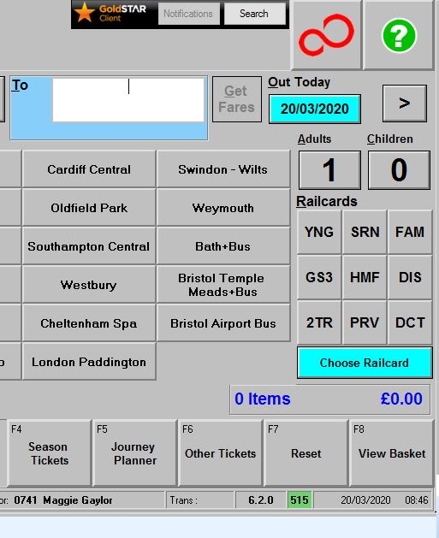

**We can check star 180 special configuration to get the railcard details for any specific station.**

