Software Requirements Specification
(SRS)
Expense Tracker
A Mobile Application for Personal Expense Management
Project Name | Expense Tracker
Document Type | Software Requirements Specification (SRS)
Prepared By | Imran 231071054. Rabeya Akter 241071049
Course | CSE 3107 – Software Engineering
Institution | Shanto-Mariam University of Creative Technology
Session | Winter 2026
Version | 1.0

1. Introduction

1.1 Purpose
The purpose of this application is to help individuals track, categorize, and manage their daily personal expenses through a simple and intuitive mobile interface. Many users struggle to keep an accurate record of their spending habits, which makes budgeting difficult and leads to poor financial decisions.
The Expense Tracker app solves this problem by allowing users to quickly log expenses, view spending summaries, and identify where their money is going. It is intended for students, working professionals, and anyone who wants a lightweight tool to monitor personal finances without the complexity of full accounting software.
The app is useful because it promotes financial awareness, encourages consistent budgeting habits, and gives users a clear, visual breakdown of their income versus expenditure over time.

1.2 Scope
The Expense Tracker app will allow users to record, edit, and delete individual expense entries, each tagged with an amount, category, date, and optional note. The app will organize expenses by category (e.g., Food, Transport, Bills, Entertainment) and provide daily, weekly, and monthly summaries.
- The app allows users to add, edit, and delete expense (and income) entries.
- The app allows users to categorize transactions and view category-wise spending breakdowns.
- The app displays visual summaries (charts/graphs) of spending over selectable time periods.
- The app allows users to set a monthly budget and sends alerts when nearing or exceeding it.
- The app stores user data securely using Firebase, with data synced across sessions.
- The app will not include multi-currency conversion in this phase.
- The app will not include bank account integration or automatic transaction import in this phase.
- The app will not include a web version in this phase.

1.3 Objectives
- To design a user-friendly mobile application for tracking personal expenses using Flutter.
- To implement Firebase authentication and a real-time database for secure data storage.
- To provide clear visual summaries (charts) of spending patterns by category and time period.
- To implement a monthly budgeting feature with limit alerts.
- To ensure data synchronization across devices and reasonable offline access.

1.4 Target Users
The primary target users are students and young professionals who want a simple, no-frills way to track daily spending without the overhead of full accounting or budgeting suites. This includes:
- University students managing a limited monthly allowance or part-time income.
- Working professionals who want quick visibility into monthly spending habits.
- Anyone new to budgeting who needs an easy entry point into tracking personal finances.

1.5 Definitions, Acronyms, and Abbreviations
Term | Definition
SRS | Software Requirements Specification
UI | User Interface
UX | User Experience
Firebase | Google's cloud platform used for authentication and real-time database storage
Flutter | Google's open-source UI toolkit for building natively compiled mobile applications
Expense Entry | A single recorded transaction representing money spent, including amount, category, date, and note
Budget Limit | A user-defined maximum spending threshold set for a given period (e.g., monthly)

2. Overall Description

2.1 Product Perspective
The Expense Tracker app is a standalone mobile application developed using Flutter, targeting Android as the primary platform with iOS support considered optional. It will use Firebase Authentication for user login/registration and Firebase Firestore (or Realtime Database) for storing expense records and user profile data. It does not integrate with external banking systems or third-party accounting software in this phase.

2.2 Product Functions
- User registration and login (email/password, with optional Google sign-in).
- Profile management (name, email, currency preference).
- Adding, editing, and deleting expense and income entries.
- Category management and category-wise spending breakdown.
- Monthly budget setting with limit alerts/notifications.
- Visual reports (pie charts, bar charts) summarizing spending trends.
- Data synchronization with Firebase across devices.

2.3 User Classes and Characteristics
User Class | Characteristics
Regular User | A registered individual who logs expenses, views summaries, and manages their own budget. Has access to all personal data and reports.
Admin | Manages application-level data and configuration (e.g., default categories), and may access aggregated, anonymized usage data for maintenance purposes.

2.4 Operating Environment
- Platform: Android (primary), iOS (optional/secondary).
- Framework: Flutter (Dart).
- Backend: Firebase (Authentication, Firestore/Realtime Database, Cloud Messaging for alerts).
- IDE: Android Studio / Visual Studio Code.
- Minimum OS Version: Android 10 (API level 29) and above.

2.5 Design and Implementation Constraints
- Must be developed using the Flutter framework.
- Must run on Android 10 or above.
- Must use Firebase for authentication and data storage.
- Limited development time (11-week project timeline) and a small development team.
- No offline-first architecture; internet connectivity is required for data sync.

2.6 Assumptions and Dependencies
- The user must have an internet connection to sync data with Firebase.
- The Firebase backend server must be active and reachable.
- The app assumes a valid email address is provided during registration.
- The user's device meets the minimum OS and hardware requirements for Flutter apps.

3. Specific Requirements

3.1 Functional Requirements
ID | Requirement Description | Priority
FR1 | The system shall allow users to register using email and password. | High
FR2 | The system shall allow registered users to log in and log out securely. | High
FR3 | The system shall allow users to add a new expense entry with amount, category, date, and optional note. | High
FR4 | The system shall allow users to edit or delete an existing expense entry. | High
FR5 | The system shall allow users to assign a category to each expense (e.g., Food, Transport, Bills). | High
FR6 | The system shall display a list of all expense entries, filterable by date range and category. | High
FR7 | The system shall generate a visual summary (chart) of spending by category for a selected period. | Medium
FR8 | The system shall allow users to set a monthly budget limit. | Medium
FR9 | The system shall notify the user when spending approaches or exceeds the set budget limit. | Medium
FR10 | The system shall synchronize user data with Firebase whenever an internet connection is available. | High
FR11 | The system shall allow users to update their profile information (name, currency preference). | Low

3.2 Non-Functional Requirements
ID | Requirement Description | Type
NFR1 | The app should load within 3 seconds on a standard Android device. | Performance
NFR2 | The app shall encrypt user credentials and sensitive data in transit and at rest. | Security
NFR3 | The app shall provide a consistent and intuitive UI across all supported screen sizes. | Usability
NFR4 | The system shall maintain 99% uptime for Firebase-dependent features. | Reliability
NFR5 | The app shall support future addition of new categories and features without major redesign. | Maintainability
NFR6 | The app shall handle at least 1,000 expense entries per user without noticeable performance degradation. | Scalability

3.3 External Interface Requirements
User Interface: The app will provide a clean, mobile-first interface with a dashboard (spending summary), an entry form (add/edit expense), a reports screen (charts), and a settings/profile screen. Navigation will follow standard Android Material Design guidelines.
Hardware Interface: The app requires a smartphone or tablet running Android 10+ (or iOS, optional) with internet connectivity (Wi-Fi or mobile data).
Software Interface: The app will interface with Firebase Authentication and Firebase Firestore/Realtime Database via the official Firebase SDK for Flutter. Push notifications will use Firebase Cloud Messaging.

4. System Models (Recommended)

4.1 Use Case Diagram
The use case diagram below shows the major interactions between the User, the Admin, and the Expense Tracker system.
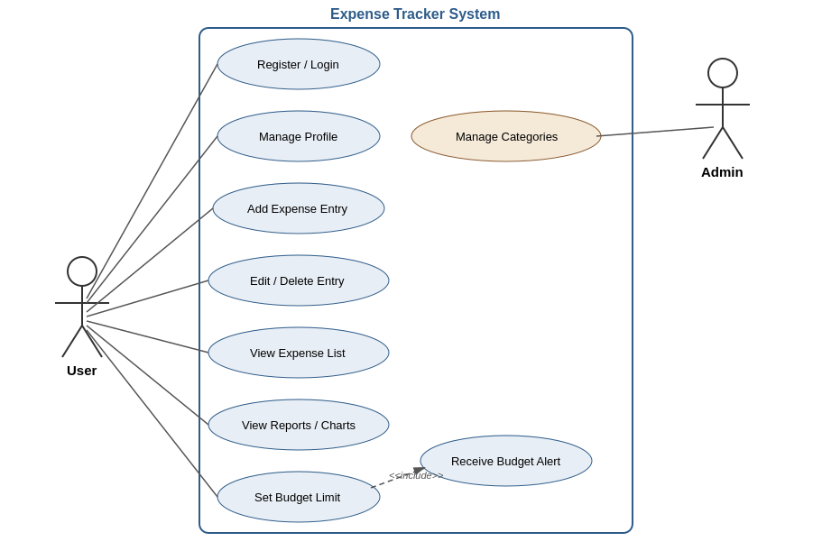
Figure 1: Use Case Diagram — Expense Tracker

4.2 ER Diagram
The entity-relationship diagram below shows the core data entities — User, Expense, Category, and Budget — and how they relate to one another.
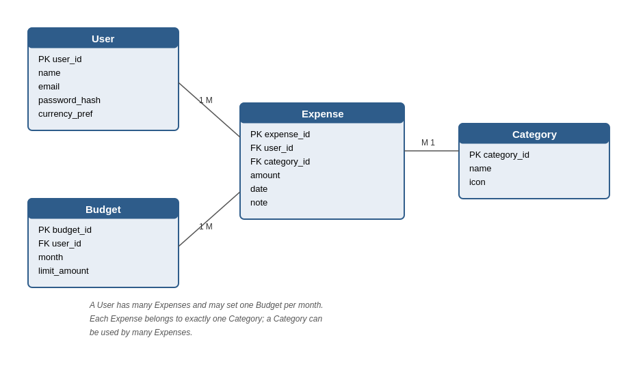
Figure 2: Entity-Relationship Diagram — Expense Tracker

4.3 Sequence Diagram
The sequence diagram below illustrates the process flow for adding an expense entry, including the optional budget-alert check that follows.
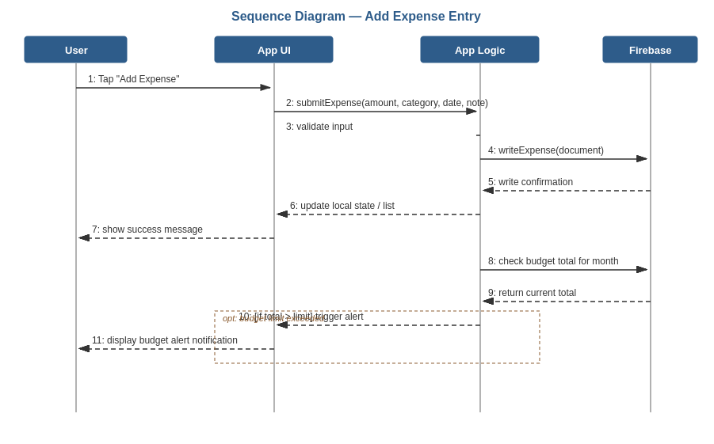
Figure 3: Sequence Diagram — Add Expense Entry

5. Project Management

5.1 Development Tools
- Flutter (Dart) — application development framework
- Firebase — Authentication, Firestore/Realtime Database, Cloud Messaging
- Android Studio / Visual Studio Code — IDE
- Git & GitHub — version control and collaboration
- Figma — UI/UX design and prototyping

5.2 Timeline
The project is planned across an 11-week timeline, as outlined below.
Week No. | Team Member A | Team Member B
Week 1 | Requirement gathering and analysis | Requirement gathering and analysis
Week 2 | SRS documentation | Use case and ER diagram design
Week 3 | UI/UX wireframing (Figma) | UI/UX wireframing (Figma)
Week 4 | Project setup: Flutter environment & Firebase config | Firebase Authentication setup
Week 5 | Login/Registration screen implementation | Profile management implementation
Week 6 | Add/Edit/Delete expense entry feature | Category management feature
Week 7 | Expense list & filtering screen | Dashboard summary screen
Week 8 | Charts/reports implementation | Budget setting feature
Week 9 | Budget alert/notification integration | Firebase data sync & testing
Week 10 | Integration testing & bug fixing | Integration testing & bug fixing
Week 11 | Final testing, documentation, and presentation prep | Final testing, documentation, and presentation prep

6. Appendix

6.1 References
- Flutter official documentation — https://docs.flutter.dev
- Firebase official documentation — https://firebase.google.com/docs
- Material Design guidelines — https://m3.material.io
- IEEE SRS Standard (IEEE 830 / ISO/IEC/IEEE 29148) — used as a general structural reference

