RESULTS

Neural Network for Chronic Kidney Disease Dataset
50 epochs were run on the dataset after preprocessing it, to get the following results:

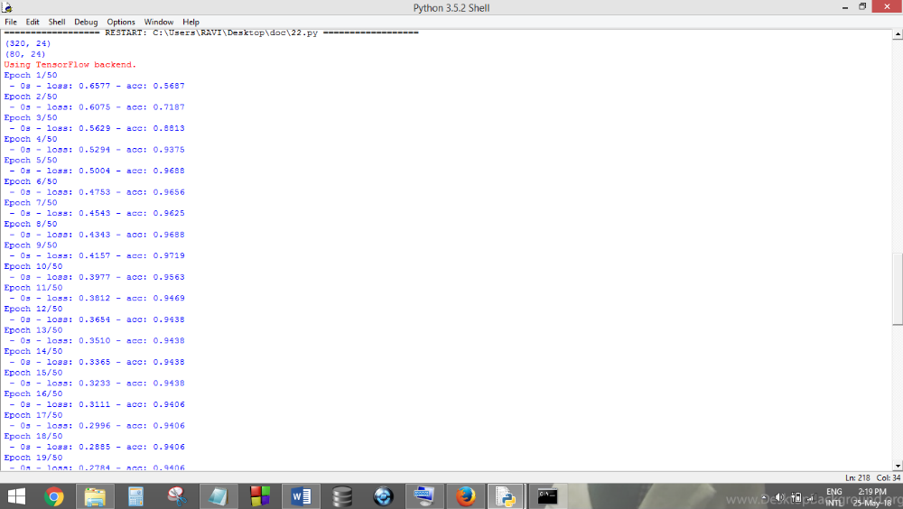

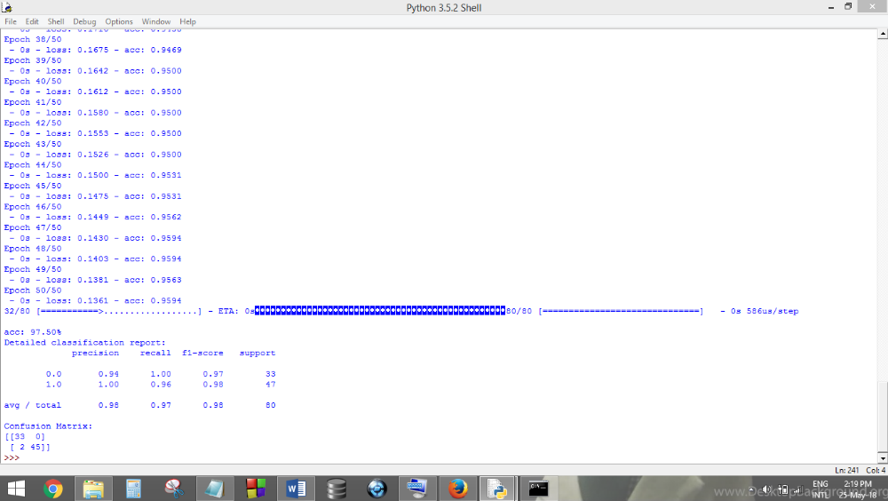

As can be seen, the final training accuracy was achieved as 95.94%, and the validation accuracy obtained was 97.50%. The training and validation accuracy and loss graphs are shown below
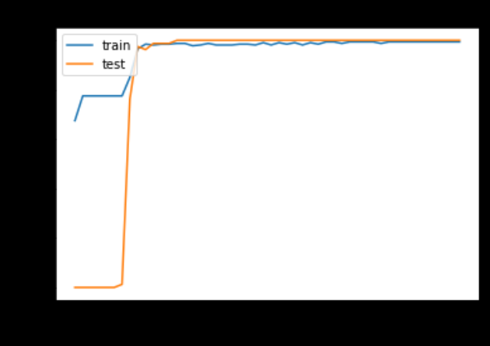
HOG along with SVM on the Tuberculosis Dataset
After feature extraction using HOG, classification was done using SVM.
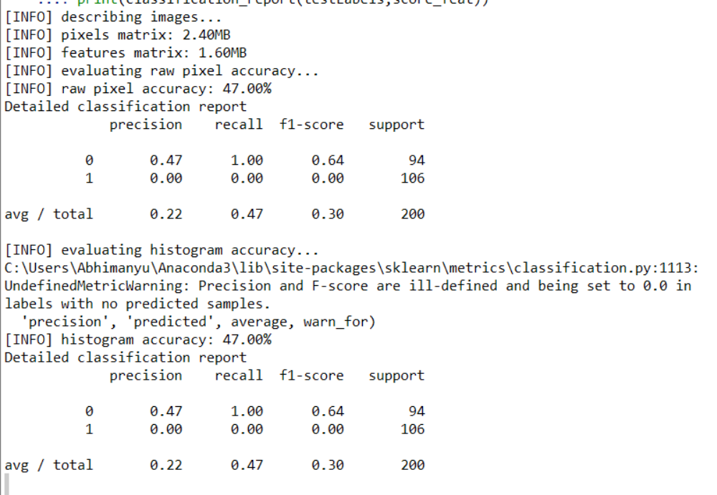
An accuracy of 47% was obtained, along with the precision and recall values as shown, which are not good at all. Thus, we tried other algorithms like KNN and Neural networks to improve the accuracy.
HOG along with KNN on the Tuberculosis Dataset
Now, classification on the HOG features was implemented using a KNN model. The results are as follows.
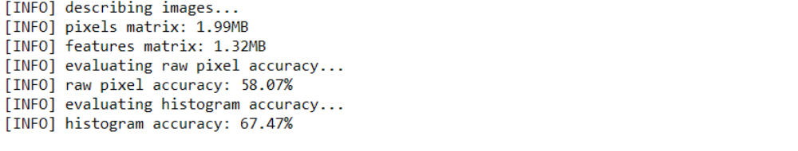
As seen, the accuracy improved to a 67.47% by using KNN as the classifier. We also passed the raw pixels as our feature set, which was obtained after flattening the image into a 1-D vector, to observe the difference between the effect of not using HOG v/s using it, and clearly, using HOG features improves the accuracy.
HOG along with Neural Network on the Tuberculosis Dataset
We also used Neural network as the classifier and checked the model accuracy for it. The following results were obtained.
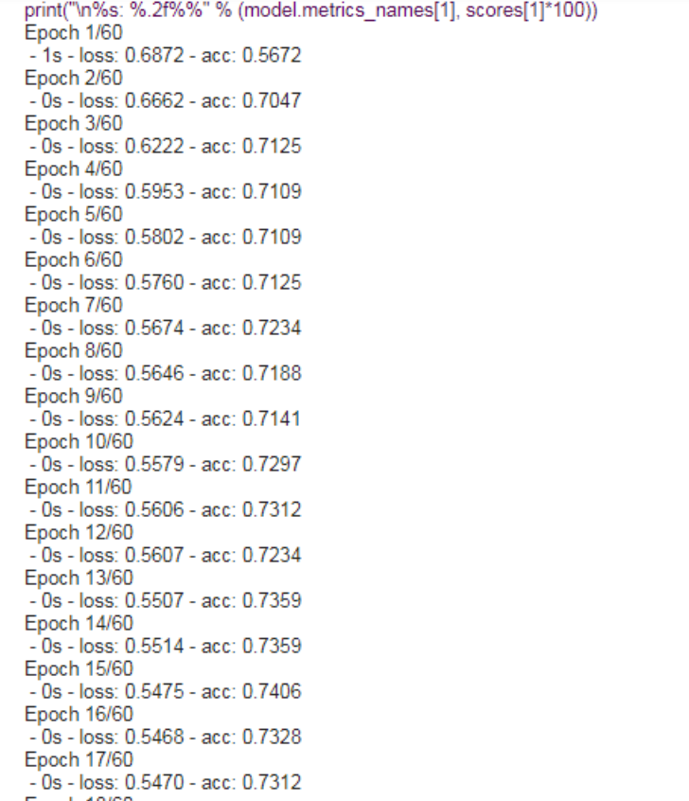
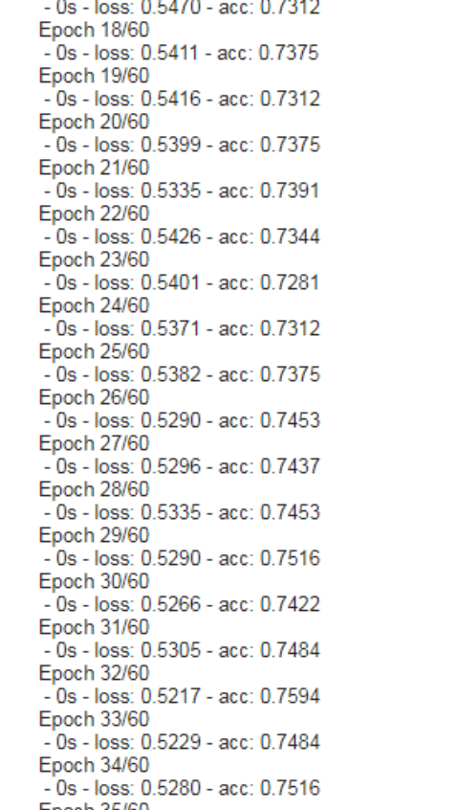
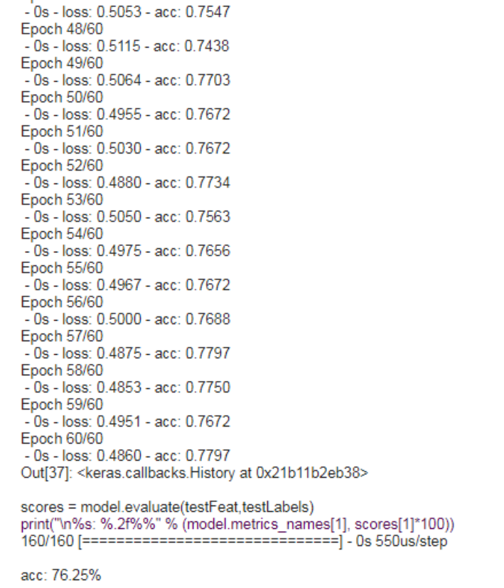
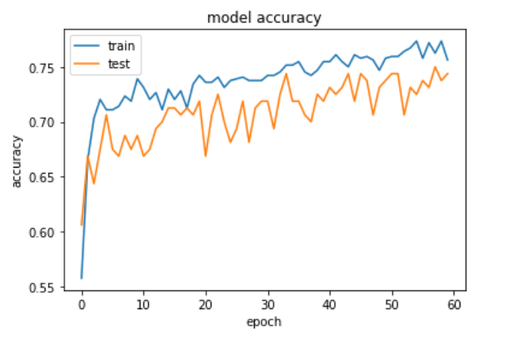
Application of CNN on the Tuberculosis Dataset
On applying Convolutional Neural Network on the said dataset, the following results were obtained.
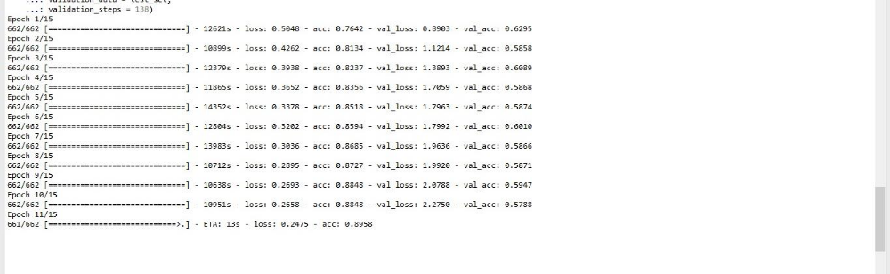
As seen, the training accuracy is obtained as 88.48%, while the validation accuracy is coming out to be 57.88%. Since there is a huge gap in the training and testing accuracy, and no tuning in the model was changing this scenario, this model was discarded, as the data is being overfitted.

SUMMARY
S.No. | Model | Accuracy
Chronic Kidney Disease Dataset
1. | Neural Network | Training: 95.94%  Testing: 97.50%
Tuberculosis Dataset
1. | HOG with SVM | Testing: 47%
2. | HOG with KNN | Testing: 67.47%
3. | HOG with Neural Network | Training: 77.97%  Testing: 76.25%
4. | CNN | Training: 88.48%  Testing: 57.88%

