The Lord of the Rings: The Battle for Middle-earth II: The Rise of the Witch-king
Dark Enforcer Mod - Detailed Description

Mod Overview

Hello and thank you for downloading this mod

This project started with a simple idea: to take the gameplay framework of The Lord of the Rings: The Battle for Middle-earth II – The Rise of the Witch-king and use it as a foundation for something entirely new.

The mod introduces a new type of Custom Create a Hero and gameplay elements that are not part of Tolkien's world. While the project is built around the mechanics and visual language of The Battle for Middle-earth II, its new content is driven by original ideas and its own creative direction.

Rather than attempting to recreate or extend Tolkien's lore, the goal is to create something new within a familiar game framework — giving a completely original character a place in a game that was never originally designed for them.

At its core, the mod is an experiment in creativity: What happens when an entirely new idea is given the mechanics, atmosphere, and possibilities of The Battle for Middle-earth II?

About Dark Enforcers

Dark Enforcer is a hero designed around a simple but demanding concept: power always comes at a price.

Unlike conventional heroes, Dark Enforcer can only be recruited by the forces of evil. His abilities do not consume a traditional power or resource — they consume his own health.

Every ability therefore comes with a decision. Using an ability can give Dark Enforcer a significant advantage in battle, but every use brings him closer to the point where his abilities become unavailable.

Once his health falls below 25%, Dark Enforcer can no longer use any of his abilities. However, this restriction is not permanent. If he manages to regenerate and his health rises above the 25% threshold again, his abilities become available once more.

This creates a constant risk-and-reward cycle. The player must decide how much of Dark Enforcer's health is worth sacrificing for a stronger ability, while always keeping enough health in reserve to remain effective.

Since every ability carries a real and immediate cost, Dark Enforcer's abilities are slightly more powerful than those of a typical hero. His strength comes from accepting risks that other heroes simply do not have to take.

Playing Dark Enforcer therefore requires more than simply knowing when to use an ability. The player must constantly evaluate whether the potential reward is worth sacrificing a portion of the hero's own life.

Greater risk. Greater skill. Greater reward.

Dark Enforcer is not designed to be an easy hero to master. His abilities can turn the tide of a battle, but careless use can leave him vulnerable at exactly the wrong moment.

The better the player understands the situation, the more effectively Dark Enforcer can convert his own health into devastating power.

Two Paths, Two Playstyles

Dark Enforcer has two distinct subclasses: Shadowborn and Hunter.
Both subclasses share the same core ability set, but this does not mean that they play the same way. Each ability is fundamentally reinterpreted depending on the chosen subclass, resulting in completely different effects, mechanics, and applications.

In other words, the ability names may be shared, but the way those abilities function can be radically different.
Choosing a subclass therefore effectively determines which version of the hero the player is creating. Although both paths originate from the same set of abilities, they offer such different mechanics and combat approaches that they can feel like two entirely different heroes.
The Shadowborn and Hunter are not simply two variations of Dark Enforcer — they represent two different interpretations of the same idea.

Subclasses

Shadowborn

Warrior-mage hero adept at Martial Arts and Shadow Magic. They use dual twin blade-like weapons in melee combat.

The visual design and voice were inspired by the imposing presence of dark lords and dark samurais. The intention was to create a character who feels powerful and intimidating without relying on excessive ornamentation — someone whose presence alone suggests discipline, authority, and danger.

The combat style, however, draws inspiration from the Sith warriors of Star Wars. Their aggressive yet controlled fighting style, combined with the use of overwhelming force and deliberate movements, served as the foundation for Shadowborn's approach to combat.

Shadowborns fight at melee combat most of the time but can defend themself against air targets or ships throwing their left hand blade and summoning another one after. When sent to a tower they will also use this ranged attack as well.

Hunter

The Hunter represents a completely different approach to combat. The Hunter is capable of fighting effectively at both melee and ranged distances, allowing him to adapt to changing situations without being locked into a single combat style.

In close combat, the Hunter uses wrist-mounted claws. These weapons allow him to attack quickly and aggressively while keeping both hands free.

This is an important part of his design. Rather than carrying a conventional melee weapon that would have to be put away before switching to ranged combat, the Hunter's claws remain attached to his arms.

This allows him to seamlessly transition into ranged combat, where he uses throwing spears as his primary ranged weapon.
The design of the Hunter was inspired by two distinct concepts: the stealth, mobility, and precision of ninjas, and the weapon arsenal of the Predator. These influences shaped both his appearance and, more importantly, his approach to combat.

Abilities

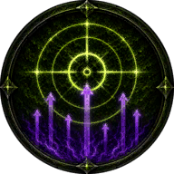
- Presence (Lvl1) / Influence (Lvl3) / Dominance (Lvl7) / Supremacy (Lvl10)
Hero Cost: 100 (Lvl1) – 100 (Lvl3) – 300 (Lvl7) – 500 (Lvl10)
Health Cost: 400 (Lvl1) – 600 (Lvl3) – 800 (Lvl7) – 1000 (Lvl10)
Refresh Time: 3 minutes

Shadowborn: Allies troops receive bonus experience on the selected area. Similar to "Train Allies" but has 3 minutes of refresh time instead of 4 minutes and each level gives more experience compared to the same level of Train Allies. The final level can instantly level up troops to level 5.

Hunter: Reveal a 200 / 250 / 300 / 400 radius area anywhere on the map including stealthed units for 90 / 120 / 150 / 180 seconds

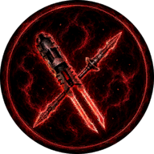
- Empower (Lvl3) / Transcend (Lvl7)
Hero Cost: 400 (Lvl3) – 600 (Lvl7)
Health Cost: from 100 to 300 per basic attack
Refresh Time: instant (Toggle based ability)

The weapons of the Hero starts glowing red and receive extra damage, but each attack will cost health. Automatically cancelled when below 25% health.
This ability can affect certain abilities based on the subclass selected, but increases their health cost too.

Shadowborn: Each melee attack deals extra damage and can also strike multiple opponents in front of the Hero – about 2-4 enemies max. The hero loses his ability to attack air targets or ships but receive a 20% chance to perform a special front flip strike for increased damage and bigger area of effect damage.

Hunter: Each melee attack and thrown spear will deal extra damage. These Empowered thrown spears can detonate Isengard explosive mines.

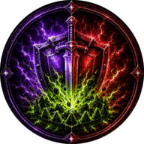
- Dark Talent (Lvl1) / Mastered Dark Talent (Lvl3)
Hero Cost: 200 (Lvl1) – 300 (Lvl3)
Health Cost: 600 both levels
Refresh Time: 30 seconds

Shadowborn: Allied troops on the selected area receive +50% armor and damage while enemies on the same area suffer -25% armor and damage for 30 / 45 seconds.
Level 2 has infinite range, works on monsters too and the debuff is -30% instead of 25%. This cannot be empowered.

Hunter: Place a basic trap to the selected area that reveals a 200 / 300 radius area max and detonates when enemies step on it dealing area damage. The trap is stealthed but can be revealed and destroyed by enemies. Every trap can be selected and detonated manually and also has a scout mode / offensive mode toggle button. In scout mode traps will not explode but reveal invisible units as well.
Empowered effect: For Hunter Only – Dark Talent traps can be empowered. While empower is active the Hunter will place a Shadow mine instead of basic mine. This version will deal more damage but reveals a smaller area, does not have a scout mode trigger but a stasis detonation auto-ability that detects heroes/mosters and catch them for maximum 40 seconds (based on Empower and Dark Talent level). The Health cost can be up to 1200.
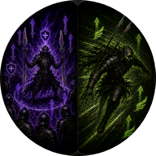
- Elite Training
Hero Cost: 300 (Lvl1)
Health Cost: 0 (Passive ability)
Refresh Time: 0 (Passive ability)
Shadowborn: Allies around the hero receive +50% armor and damage and earn experience twice as fast (same as leadership)
Hunter: Permanently increases the movement speed of the Hunter by 30%

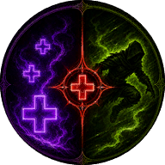
- Way of the Enforcer
Hero Cost: 300 (Lvl1)
Health Cost: 0 (Passive ability)
Refresh Time: 0 (Passive ability)
Both Subclasses receive increased health regeneration when out of combat.
Shadowborn: Will also heal allied non mechanical units around slowly when out of combat.
Hunter: Can cammouflage himself when moving or standing still, but gets revealed when enemies get too close or if he attacks someone. A red light will appear around the Hunter when he is stealthed and nobody can see him.

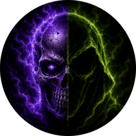
- Beyond the Veil
Hero Cost: 300 (Lvl1)
Health Cost: 900
Refresh Time: 120 seconds

Shadowborn: Start meditating for maximum 30 seconds reviving fallen allied hordes members around every 2 seconds. Enemies that die around the Hero during this time will become lesser wights.

Hunter: The Hero becomes completely invisible when activated. It works the same way as elven cloak so enemies will not see you even if you are standing next to them. The Hero cannot attack or use offensive abilities while invisibility is acive.
Press the ’U’ key on keyboard to cancel invisibility.
When revealed or cancelled the refresh time of 120 seconds will start immidiatelly so you have to wait before using the ability again.

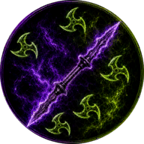
- Bladestorm (Lvl1) / Bladecyclone (Lvl3) / Bladecataclysm (Lvl7)
Hero Cost: 100 (Lvl1) – 100 (Lvl3) – 300 (Lvl7)
Health Cost: 400 (Lvl1) – 500 (Lvl3) – 600 (Lvl7)
Refresh Time: 40 seconds

Shadowborn: Perform a tornado blade spin attack towards the selected area dealing damage to every enemy on the way.
Damage:
Level 1: same as current melee damage.
Level 3: 2x current melee damage
Level 7: 3x current melee damage
Empowered effect: increased damage + dealing damage to enemy heroes will weaken their armor and damage by up to 60% (based on bladestorm and empower level). The health cost can be twice more.
Hunter: Throw a single razor shuriken towards the selected area flying a fixed distance and dealing damage to any enemy on the way. Level 3 will throw 3 shurikens in a cone, while the final level will throw 5 shurikens in a cone.
Empowered effect: shurikens deal more damage and fly back to the direction where they were thrown dealing the same damage again. The health cost can be twice more.

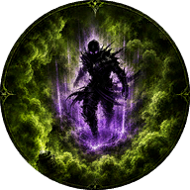
- Art of Shadows (Lvl 1) / Mastery of Shadows (Lvl3)
Hero Cost: 200 (Lvl1) – 300 (Lvl3)
Health Cost: 300 (Lvl1) – 500 (Lvl3)
Refresh Time: 120 seconds
Shadowborn: A moderate / good distance teleport that activates life draining melee attacks after for a short time, plus gives 30% movement speed for the duration. Life drain percentage is based on your current melee damage. Does not affect bladestorm.
Empowered effect: Empowered melee attacks can also drain life and since they deal more damage, the drained amount can be much higher. For the life drain duration all the empowered strikes lose their health cost and instead heal the Shadowborn.
Hunter: Throw a smoke bomb that generates a blinding detonation at first blinding soldiers for 10 / 20 seconds. The detonation generates a smoke for 45 / 90 seconds reducing enemy troops damage and armor by 25% and stealthing the Hunter and his allies while they are in the smoke. This cannot be empowered.

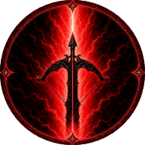
- The Enforcer's Wrath (Lvl3) / The Enforcer's Terror (Lvl7 / The Enforcer's Massacre (Lvl10)
Hero Cost: 300 (Lvl3) – 400 (Lvl7) – 800 (Lvl10)
Health Cost: 1000 every level
Refresh Time: 10 seconds
Shadowborn: A shadow ray that deals damage to enemies / heal on your allies on the selected area. Damage increases per level.
Hunter: Use your crossbow to shoot a Crushing Arrow dealing damage to buildings but less effective against units. Damage increases per level.

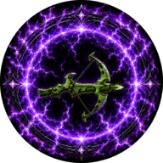
- Infusion (Lvl7) / Overinfusion (Lvl10)
Hero Cost: 400 (Lvl7) – 600 (Lvl10)
Health Cost: 500 every level
Refresh Time: 40 seconds
Shadowborn: Activate a shadow shield for a short time that absorbs excellent damage.
Hunter: Load 1 Hunting Arrow (max: 6) to your crossbow.
These arrows can score trophies on Heroes/Monsters. Trophies can be collected to heal the hero.
Press the 'I' key on keyboard to toggle crossbow.
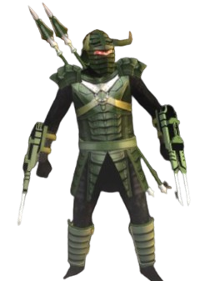
The number of ammunition is shown above the Hunter.

Yes, I have a ranged weapon!
But what about a second ranged weapon?

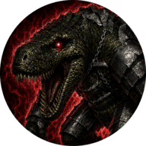

- Summon Weredragon (Lvl10)
Hero Cost: 1000 (Lvl10)
Health Cost: 1300
Refresh Time: 10 minutes
Summon a powerful ridable Weredragon to fight for you. Unlike other summoning abilities the beast doesn't have a 90 seconds of time limit but only one can be summoned at a time, and the refresh time starts when it dies.
There are 5 different types of Weredragons: Green, Brown, Black, Blue and Red and only one comes randomly. Their main weakness is pikemen, so watch out!
Abilities:
Devour: Eat the selected non-hero soldier regaining 50% max health back
Unmount Hero: Unmount your Dark Enforcer Hero. Only works when mounting the Beast. Isengard’s ranged hero: Lurtz can also mount Weredragons.
Howl of Terror: Scare away enemies
Fireball: Green and Brown Weredragon only – Same as Saruman Fireball
Iceball: Blue Weredragon only – Shoot a ball of ice dealing smaller damage but slowing down enemies in a bigger area. Can also freeze a building
Acidball: Black Weredragon only – Shoot a ball of acid dealing smaller damage but dealing damage over time and reducing armor and damage of enemies by 25%
Lightning ball – Red Weredragon only – A lightning strike dealing area damage – weaker vs buildings but strong vs Heroes.
Green and Brown Weredragon are resistant to fire, Ice Weredragon is resistant to frost based attacks, Black Weredragon is resistant to poision while Red Weredragon takes reduced damage from Heroes.
Bonus - New Olog-hai subclass: Attack Troll

I always liked the health and armor scaling of the Hill Troll but not it's appearance!

The Great Troll subclass however is the opposite of this example - awesome design but worse stats.

This is why I added a fourth subclass, which is basically the same as the Great Troll but with much better health and armor stats for the cost of weak health regeneration and less selection from helmets, weapons etc...

I also added a non editable or deletable system Olog-hai Attack Troll Hero.

