Abstract Title
First Author¹, Second Author¹, Third Author², Forth Author¹, Last Author¹
¹Awesome Hospital, City Name, State, Country, ²Great University, City Name, State, Country

Purpose
State the clinical, scientific, or technical problem and briefly explain why it is important. Clearly describe the specific objective, hypothesis, or question addressed by the study. Do not include methods or results; keep the section concise and focused on the study’s motivation.

Material and Methods
Describe the overall study design, including whether the work is experimental, clinical, simulation-based, or retrospective, and specify the setting or environment. Identify the subjects, samples, datasets, or models used, including key inclusion criteria or relevant characteristics where appropriate. Summarize the equipment, devices, software, imaging protocols, or algorithms used, highlighting important configurations or parameters. Outline the main procedures or workflow in a logical order, focusing on the steps necessary to understand how the study was conducted. Clearly define the primary and secondary outcome measures or evaluation metrics used to assess performance or effectiveness. Briefly describe the statistical or analytical methods applied, and avoid including results or detailed interpretation.

Results
Summarize the main findings that directly address the study objective, emphasizing the most important outcomes. Provide quantitative results with appropriate metrics and statistical significance where applicable.
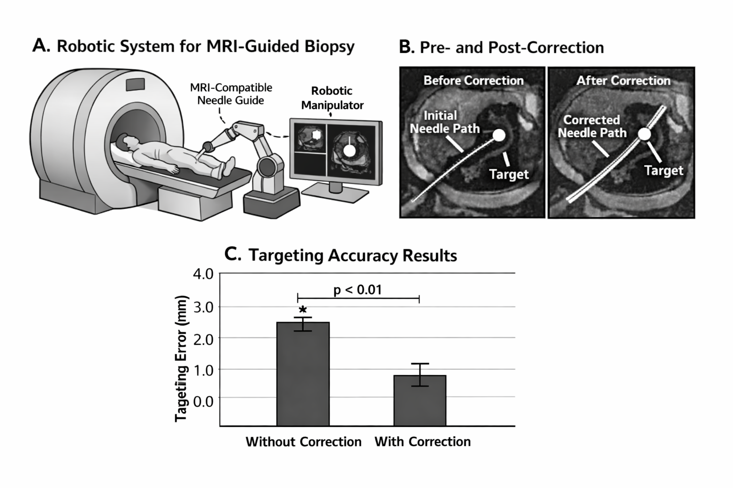
Fig 1: Provide a clear and concise description of the figure that explains what is shown without requiring reference to the main text. Define all symbols, abbreviations, labels, and color codings used in the figure. Ensure the caption highlights the key message or takeaway illustrated by the figure.

Conclusion
State the primary conclusion supported by the results and clearly answer the study objective or hypothesis. Briefly describe the significance or potential impact of the findings in clinical, scientific, or technical terms. Avoid repeating detailed results or introducing new information.

Acknowledgements
List funding sources, grant numbers, institutional support, and any required disclaimers. Acknowledge individuals or organizations who contributed to the work but do not meet authorship criteria.

References
- Author F, et al. J Title. 2023;68(10):12-18.
- Author S, et al. J Title. 2025;42(1):63-71.

