The economic pressures shaping the 2026 midterms
Research draft for a professional finance audience • Data available October 21 2026
The midterms combine a purchasing-power squeeze with weak hiring. Energy and tariff pressures have eroded wage gains, although unemployment and claims show no broad collapse. For investors, the key is where those pressures intersect with races that could shift congressional control.

Prices and voter priorities
The Iran war has pushed up energy costs, while tariffs have raised imported-goods prices. Shelter and services also contribute: the evidence does not support attributing most of the entire price increase since January 2025 to war and tariffs alone. [1,2]
Consumer prices were 6.1% higher in September than in January 2025. Over the equivalent first 20 months, prices rose 13.5% under Biden, 4.0% in Trump’s first term and 3.4% in Obama’s second. These cumulative, unadjusted CPI comparisons reflect different inherited conditions and shocks; they do not measure presidential responsibility. [1,5,6]
The latest acceleration is energy driven. September CPI rose 0.6% month on month and 3.7% year on year, with gasoline accounting for more than half the monthly increase. Energy prices rose 20.4% annually, contributing 1.35 percentage points, or about 36%, of annual inflation; food contributed 0.34 points and core categories 2.05. These contributions cover the latest year, not the full period since January 2025. [1,7]
Spillover is visible but difficult to isolate. Airfares rose 22.4% annually, while core CPI increased 2.6%. Minneapolis Fed researchers estimate tariffs added 0.2–0.4 percentage points to core PCE inflation as of July, a different measure and period. The electoral stakes are clear: 47% of registered voters in an August 28–31 Reuters/Ipsos poll named cost of living the single most important factor in their midterm vote. [1,2,8]
Price relief is politically urgent. The October 9 Russian diesel agreement envisaged an initial 300,000 tonnes, followed by 500,000 in November and another million thereafter. The first tranche is small relative to global needs. Washington also offered loans of up to 315,000 barrels from its Northeast heating-oil reserve, with deliveries expected by November 13, limiting relief before the November 3 vote. [3,4]
City CPI offers local proxies: annual inflation was 3.7% in Detroit and 4.2% in Philadelphia in August, versus 3.0% in Dallas and 3.6% in Minneapolis–St. Paul in September. These are metro-area readings with different reference months, not statewide estimates. [22]

Employment and layoffs
National unemployment reached 4.2% in September, up just 0.2 percentage points since January 2025. Payrolls increased by 29,000, following average monthly gains of 45,000 over the preceding year. Hiring is weak even without a pronounced rise in unemployment. [9,10]
Conditions vary across Senate battlegrounds. Since January 2025, unemployment fell 1.4 points in Ohio, 0.3 in Michigan and Iowa, and 0.2 in Alaska; it was unchanged in Maine and Kansas and rose 0.3 in Texas. Elsewhere, it increased 1.1 points in Minnesota, 0.9 in Florida and 0.7 in Arizona, but fell 0.4 in North Carolina. Participation and labor supply also influence these rates. [11,12]
Unemployment insurance claims show little evidence of widespread layoffs. Initial claims were 199,000 in the week ended October 10, against 207,000 in late January 2025; continuing claims were 1.710 million in the week ended October 3, versus 1.858 million. These weekly snapshots exclude many new entrants and ineligible workers, so low claims can coexist with difficult job searches. [16,17]
Young workers illustrate that gap: RBC Economics’ May report, Frozen job ladder, put recent graduates’ unemployment near 5.6% and underemployment above 41%. [13]

Income and purchasing power
Average hourly and weekly earnings rose 3.0% and 3.6% over the year to September, but fell 0.7% and 0.1% after inflation. Since January 2025, nominal gains were about 5.5% and 6.4%; seasonally adjusted real hourly earnings were essentially unchanged and real weekly earnings only 0.9% higher. Longer hours have cushioned weekly pay. [14,15]
BEA’s quarterly state personal income captures earnings, property income and transfers. In Q2 2026, the latest quarter, nominal income rose in 49 states and DC. Annualized quarterly growth ranged from 6.4% in Wisconsin to −4.2% in North Dakota, against 4.7% nationally. Wisconsin’s transfer receipts rose 13.0%, underscoring that income growth need not reflect stronger wages. [23]

Races to watch
Democrats need a net four Senate seats to overturn the 53–47 division. Cook’s October 6 toss-ups were Alaska, Iowa, Kansas, Maine, Michigan, Ohio and Texas. Also watch North Carolina, rated Likely Democratic, and Democratic defenses in New Hampshire and Minnesota; Cook moved Minnesota to Lean Democratic on October 20. [18,20]
The House requires a district lens. Cook’s October 16 ratings identified 21 toss-ups, including three in Michigan and two each in Florida, North Carolina, Ohio, Texas and Virginia. State economic averages provide context, but local polling and turnout remain essential. Changes in control would reshape fiscal negotiations without automatically reversing energy disruptions or tariff pass-through. [19]

State unemployment and congressional competition
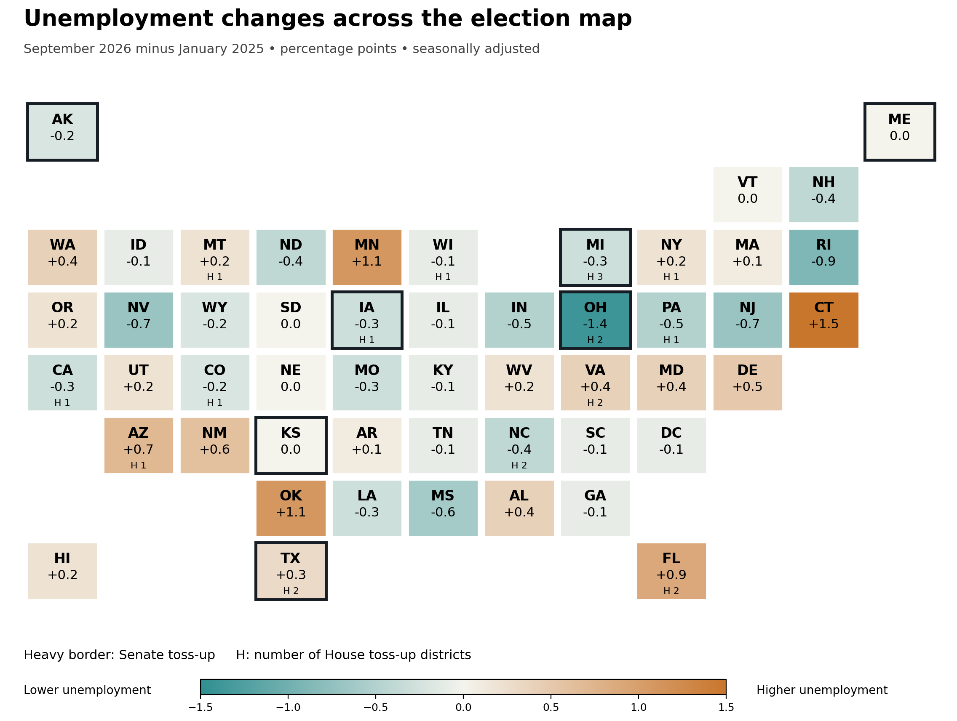
Sources: BLS LAUS; Cook Senate ratings October 6 and House ratings October 16, reproduced by Kalshi and 270toWin. September 2026 unemployment estimates are preliminary.

Sources and calculation notes
1. BLS September 2026 CPI and 12 month contribution table
2. Minneapolis Fed tariff pass through research
3. Council on Foreign Relations Russian diesel agreement October 19
4. Reuters heating oil reserve offer October 21
5. BLS January 2025 CPI baseline
6. BLS historical CPI series via FRED
7. BLS September 2026 CPI contributions Table 7
8. Reuters Ipsos cost of living poll August 28 to 31
9. BLS September 2026 employment report
10. BLS unemployment rate history
11. BLS January 2025 state rates revised April 2026 Table 1
12. BLS September 2026 state rates Table 1
13. RBC Frozen job ladder May 29 2026
14. BLS September 2026 real earnings Table A1
15. BLS January 2025 earnings revised February 2026 Table A1
16. Department of Labor weekly claims October 15 2026
17. Department of Labor weekly claims January 30 2025
18. Cook Senate ratings October 6 reproduced by Kalshi
19. Cook House ratings October 16 reproduced by 270toWin
20. Cook October 20 rating changes
21. BLS CPI geographic coverage
22. BLS September 2026 local CPI Table 4
23. BEA quarterly state personal income September 30 2026 release

Cumulative CPI comparisons
Formula: 100 × (ending index / starting index − 1). CPI-U, not seasonally adjusted: Jan 2025 317.671 to Sep 2026 336.940; Jan 2021 261.582 to Sep 2022 296.808; Jan 2017 242.839 to Sep 2018 252.439; Jan 2013 230.280 to Sep 2014 238.031. Each interval is 20 months. The comparison uses the same calendar endpoints; January includes days before inauguration.
Earnings calculations use the revised January 2025 baseline in the February 2026 release: hourly $35.84, weekly $1,222.14, real hourly $11.24 and real weekly $383.16. September 2026: $37.81, $1,300.66, $11.24 and $386.76. Real earnings use seasonally adjusted CPI and therefore should not be deflated again using the 6.1% unadjusted CPI comparison. Energy’s annual contribution share is 1.353 / (1.353 + 0.338 + 2.046), approximately 36%.

