Household Formation and the Housing Market
RBC Economics | U.S. Housing Formation — August 2026
KEY TAKEAWAYS
- A durable plateau, not a turning point. The living-with-parents share for 25–35 year-olds sits around 22% (2025), down from a 2017 peak near 24% but still above pre-2006 norms. We expect it to stay elevated rather than snap back in either direction.
- This is a behavior story, not a demographics story. Changing propensity — people within a group becoming more or less likely to live at home — explains ~71% of the 2006–2019 rise and more than the entirety of the 2019–2024 decline. Population mix is the minor player both times.
- Every subgroup moved together. Married, divorced, disabled, in-school, employed and unemployed adults alike shifted in the same direction at the same time — the signature of a shared affordability and labor-market shock, not a generational lifestyle change.
- The financing math has structurally worsened. Home prices are up ~58% since 2019 and mortgage rates have moved from ~3.9% to ~6.7%; combined, the cost of carrying an average home is up on the order of 115%+, against ~30% cumulative wage growth.
- Net for housing: modest and rental-skewed. Incremental formation from this cohort should track income growth and completions, not arrive as a pent-up “wave” — and what does form will keep leaning rental over owned, until financing costs ease more decisively.
A growing housing narrative holds that young adults — priced out and underemployed — are stuck living at home with parents, implying latent housing demand via delayed household formation. Weighing today’s entry-level unemployment backdrop against the staying power of hybrid work, we set out to test whether this cohort would keep living in parental households at a higher rate than past generations did at the same age. The data says yes, for younger Millennials and Gen Z, who roughly make up the cohort we assess here.
Using the most recent American Community Survey (ACS) data, we estimate about 22% of young adults aged 25–35 were living with a parent, grandparent, or parent-in-law in 2025. That’s below the pre-pandemic peak of nearly 24%, but still slightly above the average of the past five years.
EXHIBIT 1
Living-with-parents share has retreated from 2017 peak
[Insert existing chart / live Bloomberg-Macrobond exhibit here]
Source: American Community Survey, RBC Economics.
Looking ahead, we expect the living-with-parents share to stay elevated but remain below its 2017 peak. The data makes a clear case that this is a symptom of affordability and the labor market rather than life events: every subgroup of young adults became more likely to live at home between 2006 and 2019, so longer schooling or delayed marriage on their own can’t explain the move. The post-2019 decline coincided with genuine structural relief — remote work enabled moves to cheaper geographies, a tight labor market pulled the national unemployment rate down, pandemic-era transfers boosted savings, and mortgage rates sat near record lows into 2022.
Most of that relief has since gone into reverse. The Fed’s 2022 hiking cycle took the 30-year mortgage rate from just above 3% to over 7% in under a year, and rates broke above 8% in October 2023 — the highest since 2000. Three rate cuts in late 2024 and three more through 2025 brought the Fed funds rate down about 175 basis points to a 3.50%–3.75% target range, and mortgage rates eased with it, briefly dipping under 6% in February 2026 for the first time since 2022. That relief proved partial: renewed bond-market volatility since has pushed the 30-year back into the mid-6% range through the summer, last near 6.7% in late August. Financing costs today are still nearly double their 2019 level, and layered on top of home prices that are up roughly 58% cumulatively over the same stretch, that gap — not demographics — is doing most of the work in keeping this cohort at home (more on the math below).
That’s also our forward read on what matters most: from here, we’d expect the overarching labor-market and rate backdrop to drive this series far more than any further shift in the population’s makeup. Directionally, we expect the young-adult homeownership rate to recover only gradually and to stay below its pre-bubble norm until financing costs ease more decisively, and we expect rental household formation to keep outpacing owner-occupied formation for this cohort — extending a two-decade-old pattern — until that affordability gap narrows meaningfully.
EXHIBIT 2
Never-married employed adults now the largest share of 25–35 year-olds
[Insert existing chart / live Bloomberg-Macrobond exhibit here]
Source: Macrobond, American Community Survey, RBC Economics.
Structural drivers of co-living
Delayed milestones — later marriage, more time in school — don’t come close to explaining the pre-pandemic increase on their own. We split the ACS into nine subgroups of interest: adults with disabilities, the recently divorced, those enrolled in school, the divorced/separated, never-married adults not in the labor force, never-married unemployed adults, never-married employed adults, married adults, and everyone else.
The living-with-parents rate for this age group rose about 8 percentage points between 2006 and 2019. Decomposing that move, changing propensity — people within a given group becoming more or less likely to live at home — explains roughly 71% of the increase, versus 22% from shifts in the population’s group composition and 7% from the interaction between the two.
On the composition side, the standout swing was the rising share of never-married, employed adults (+2.5pp) — coming largely at the expense of married adults and divorced/separated adults (−0.4pp and −0.5pp) and, to a smaller degree, students (−0.2pp). Every other subgroup’s share moved by less than half a point.
Composition, though, is the smaller half of the story. Never-married, employed adults were also the single largest contributor to the propensity-driven increase — meaning people in that group became meaningfully more likely to live at home, independent of the group simply getting bigger. Tellingly, married adults — the group whose population share fell the most — saw the second-largest propensity increase of any group, becoming notably more likely to move in with a parent or in-law even as there were proportionally fewer of them. Behavior changing broadly, not just within the fastest-growing group, is the signature of a shared affordability shock rather than a demographic one. That conclusion holds whether or not we exclude the disabled subgroup, pointing to structural and cyclical drivers — housing costs and the broader labor-market backdrop — rather than compositional shifts in who these young adults are.
One demographic wrinkle worth flagging for the medium term: Census projections have this age segment’s population roughly flattening by 2030 and beginning to decline by 2035. Even a stable living-with-parents share, then, implies slowing growth in the sheer number of new households this cohort can generate over time — pointing to steady but unspectacular housing absorption from here, one likely skewed toward rental demand while financing costs stay elevated.
Fiscal and labor conditions supported independence
The 2006–2019 rise and the smaller 2019–2024 decline share the same fingerprint: both were overwhelmingly propensity-driven, and in neither case was the move concentrated in one or two groups.
Period | Composition | Propensity | Interaction | Total change
2006–2019 (the rise) | +1.8 pp (22%) | +5.7 pp (71%) | +0.5 pp (7%) | +8.0 pp
2019–2024 (the decline) | +0.5 pp (offset) | −2.3 pp | −0.1 pp | −1.9 pp
Shift-share decomposition of the change in the living-with-parents rate, ages 25–35. Source: American Community Survey, RBC Economics calculations.
Propensity effects alone would have produced a 2.3-point decline in the living-with-parents rate between 2019 and 2024 — larger than the 1.9-point decline actually observed — with population-mix changes offsetting a little under a quarter of that (+0.5pp). That’s a mirror image of 2006–2019, when propensity (+5.7pp) outweighed composition (+1.8pp) by more than three to one.
The 2019–2024 decline’s largest single-group contributors were students (−0.5pp, as both their propensity to live at home and their share of the population fell), never-married employed adults (−0.4pp), married adults (−0.4pp), and divorced/separated adults (−0.3pp) — together explaining roughly 90% of the total move. Tellingly, the two groups least tied to employment moved least at the aggregate level: adults with disabilities and never-married adults not in the labor force contributed a combined −0.01pp — essentially nothing. For never-married adults out of the labor force, that’s because very little happened at all: their propensity to live at home barely budged (45.7% to 44.0%). For the disabled subgroup, it’s more of a wash — their propensity to live at home actually fell sharply (38.3% to 30.5%), but that was almost entirely offset by disabled young adults becoming a meaningfully larger share of the population (6.7% to 8.4%). Either way, the group with the weakest tie to a paycheck saw the least net movement, consistent with employment-linked channels — jobs, wages, remote work — carrying most of the weight, more than channels like fiscal transfers that would have reached working and non-working households alike.
The underlying labor-market and household-finance data back this up. Pandemic-era fiscal transfers boosted savings for lower-income earners, record-tight labor markets through 2022–2023 improved wage bargaining power broadly, and remote work enabled moves away from the expensive metros where young adults had previously stayed near parents. That cushion has since eroded on both fronts. The personal saving rate has fallen to about 2.7% as of mid-2026 — down from 4.6% a year earlier and well below its longer-run average near 8% — as pandemic-era buffers have been drawn down and rent inflation (shelter CPI is up roughly 38% cumulatively since 2019, even after cooling from an 8%-plus year-over-year peak in 2023) keeps eating into take-home pay.
Meanwhile, the entry-level labor market that helped pull this cohort out of parental homes in 2021–2022 has itself turned. Unemployment among young college graduates has risen from a 4.0% low in mid-2023 to roughly 5.3%–5.7% today — now running above the overall unemployment rate (about 4.3%) for the first time in decades — while young workers without a degree face unemployment near 7%. That’s a fresh headwind working against further declines in the living-with-parents share, and it’s exactly why the propensity story above matters: the same employment-linked channels that pulled this rate down can just as easily stall or partially reverse it if the entry-level market keeps softening.
Mortgage affordability remains stretched by historical standards
EXHIBIT 3
Mortgage payment as a share of income remains near cycle highs
[Insert existing chart / live Bloomberg-Macrobond exhibit here]
Source: Macrobond, RBC Economics.
The chart above actually understates how fast the ground has shifted underneath this cohort. Since 2019, the S&P Case-Shiller U.S. National Home Price Index is up roughly 58% (from an index value of about 209 to roughly 331), while the 30-year fixed mortgage rate has moved from an average of about 3.9% to around 6.7% today — even after roughly 175 basis points of Fed cuts since late 2024. Put the two together and the monthly principal-and-interest payment on a similarly financed, similarly priced home has climbed on the order of 115%–120% since 2019 (holding the down-payment share and loan term constant — an illustrative, national-average calculation, not a specific-market estimate). Cumulative wage growth over the same stretch: roughly 30%.
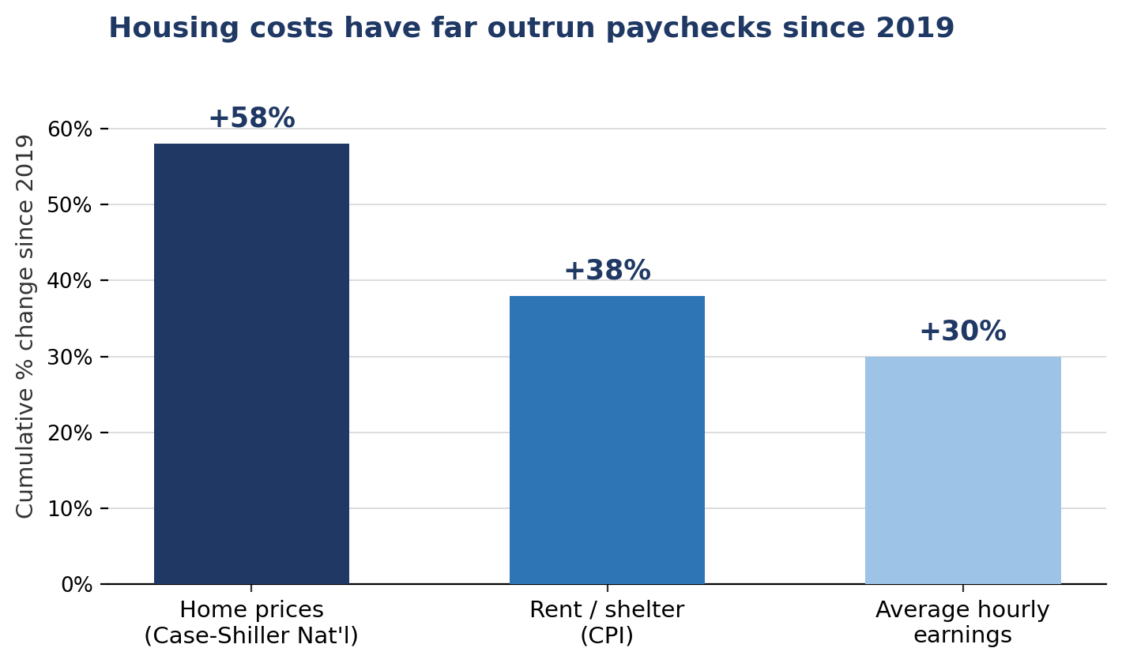
Source: S&P Cotality Case-Shiller U.S. National HPI (FRED); BLS CPI (shelter); BLS CES (average hourly earnings, all employees); RBC Economics calculations.
Rent has been the relatively less-stretched option by comparison — shelter CPI is up about 38% cumulatively since 2019, faster than wages but only about two-thirds the pace of home prices — consistent with the rental-versus-ownership tenure trend later in this note.
To be clear, none of this points to runaway price growth from here. Case-Shiller National appreciation has slowed to roughly 1% year-over-year as of early 2026 — the softest pace since mid-2023 and below inflation, meaning real home prices are effectively flat to down. The affordability problem for this cohort is a stock problem — a decade of cumulative price and rate increases — rather than a flow problem, since prices are no longer running away.
Could pent-up demand continue to push up housing prices?
For housing demand, the key implication is that the roughly 22% living-with-parents share likely represents a durable plateau rather than a springboard for either a wave of household formation or a further retreat. Remote work and delayed-but-eventual household formation are the structural supports that pulled the rate down from its 2017 peak, and they look sticky — but the fiscal tailwind that helped fund the move is fading, and cost burdens remain elevated. Because the living-with-parents rate tracks real affordability rather than moving on a fixed clock, we’d expect it to move with real earnings growth, housing and financing costs, inflation, and labor-market slack from here — more than with any further shift in the population’s makeup. On net, this cohort looks like neither a source of large pent-up demand nor a drag on the housing market.
Roughly three-quarters of 25–35 year-olds have already formed independent households. Incremental formation from here is more likely to track income growth and housing completions than to arrive as a discrete wave.
A rough way to size the remaining room: the under-35 homeownership rate has run between about 35% and 38% over the past year (Census HVS) — not far off, and currently a touch below, the ~38%–39% rate this age group posted in the mid-1990s, the last time mortgage rates sat in a broadly similar 7%–8% range. That comparison is telling: financing costs alone don’t explain today’s shortfall, since rates are actually a little lower now than they were then. The gap looks more like a price-to-income story than a rate story.
Suppose, illustratively, that the living-with-parents share eases by one further percentage point over the next couple of years as the labor market normalizes — broadly in line with the propensity sensitivity in the data above, and assuming the recent softening in entry-level unemployment doesn’t deepen. Applied to the roughly 47 million Americans aged 25–35 (Census), that’s about 470,000 additional young adults leaving a parent’s home. If most pair up or double up rather than each forming a stand-alone household — consistent with the pattern across the rest of this cohort — that’s on the order of 250,000–300,000 net new households, phased in over a couple of years. Given the financing math above, we’d expect most of that to land in rental rather than owner-occupied stock. Against completions running near 1.3–1.4 million units annualized, that’s a modest add to demand, not a wave — consistent with the “durable plateau” framing above. (Illustrative, order-of-magnitude math built on the assumptions stated — not a formal forecast.)
The cost of actually setting up a household is a smaller consideration by comparison: CPI household furnishings & operations is up only about 2% over the past year — a much gentler pace than housing itself — so it’s a secondary drag at most on the pace of formation.
Homeownership rate still below its pre-bubble norm
EXHIBIT 4
Homeownership rate still below its pre-bubble norm
[Insert existing chart / live Bloomberg-Macrobond exhibit here]
Source: Macrobond, Census Bureau, RBC Economics.
New mortgage payments remain well above their long-run share of income, and the national homeownership rate — currently 65.0%–65.7% — has yet to reclaim its pre-bubble average, sitting below the 25-year average of 66.3% and more than 3.5 points under the 2004 peak of 69.2%. Real (inflation-adjusted) wage growth, which ran positive for most of the first half of 2026, has turned negative again more recently (−0.2% to −0.3% year-over-year in April and July). Together, these keep the financing hurdle to buying a meaningful factor in this cohort renting rather than owning, even once they do leave home.
Rental household growth has been outpacing owner-occupied formation
EXHIBIT 5
Rental household growth has been outpacing owner-occupied formation
[Insert existing chart / live Bloomberg-Macrobond exhibit here]
Source: Macrobond, RBC Economics.
That financing gap shows up directly in the tenure mix of new households: renter-occupied household growth has outpaced owner-occupied growth for most of the past two decades, with the gap widening sharply around the most recent rate cycle. Combined with the mortgage-affordability picture above, we’d expect this pattern — most incremental formation from this cohort landing in rental rather than owned housing — to persist until financing costs ease more decisively.
Reconciling with the supply picture
[TO COMPLETE — housing supply model] Overlay this demand read-through against the housing-unit-shortage / completions model: plot the shortage against the price delta, and infer the incremental shortage implied by the additional demand from these groups under our forecast.

