**Part 3:**

* 3.1: Json checks: (printing using helper function + __repr__ function)
  + T0.json:
    - -----
    - DiGraph:
    - Nodes: (Total of 4 nodes.
    - 0, 1, 2, 3,
    - Edges: (Total of 5 edges.
    - edge src: 0, dest: 1, w: 1
    - edge src: 2, dest: 3, w: 1.1
    - edge src: 1, dest: 2, w: 1.3
    - edge src: 1, dest: 0, w: 1.1
    - edge src: 1, dest: 3, w: 1.8
    - Num of MC: 9
    - -----
  + A0:
    - -----
    - DiGraph:
    - Nodes: (Total of 11 nodes.
    - 0, 1, 2, 3, 4, 5, 6, 7, 8, 9, 10,
    - Edges: (Total of 22 edges.
    - edge src: 9, dest: 8, w: 1.4575484853801393
    - edge src: 0, dest: 1, w: 1.4004465106761335
    - edge src: 0, dest: 10, w: 1.4620268165085584
    - edge src: 1, dest: 0, w: 1.8884659521433524
    - edge src: 1, dest: 2, w: 1.7646903245689283
    - edge src: 8, dest: 9, w: 1.8526880332753517
    - edge src: 2, dest: 3, w: 1.1435447583365383
    - edge src: 2, dest: 1, w: 1.7155926739282625
    - edge src: 3, dest: 2, w: 1.0980094622804095
    - edge src: 10, dest: 0, w: 1.1761238717867548
    - edge src: 3, dest: 4, w: 1.4301580756736283
    - edge src: 4, dest: 3, w: 1.4899867265011255
    - edge src: 7, dest: 6, w: 1.0176531013725074
    - edge src: 4, dest: 5, w: 1.9442789961315767
    - edge src: 9, dest: 10, w: 1.022651770039933
    - edge src: 5, dest: 4, w: 1.4622464066335845
    - edge src: 10, dest: 9, w: 1.0887225789883779
    - edge src: 5, dest: 6, w: 1.160662656360925
    - edge src: 6, dest: 5, w: 1.6677173820549975
    - edge src: 6, dest: 7, w: 1.3968360163668776
    - edge src: 8, dest: 7, w: 1.6449953452844968
    - edge src: 7, dest: 8, w: 1.354895648936991
    - Num of MC: 33
    - -----
  + A1:
    - -----
    - DiGraph:
    - Nodes: (Total of 17 nodes.
    - 0, 1, 2, 3, 4, 5, 6, 7, 8, 9, 10, 11, 12, 13, 14, 15, 16,
    - Edges: (Total of 36 edges.
    - edge src: 12, dest: 11, w: 1.0666986438224981
    - edge src: 14, dest: 15, w: 1.118950355920981
    - edge src: 12, dest: 13, w: 1.5484109702862576
    - edge src: 5, dest: 6, w: 1.734311926030133
    - edge src: 10, dest: 11, w: 1.4962204797190428
    - edge src: 15, dest: 16, w: 1.8726071511162605
    - edge src: 16, dest: 0, w: 1.4418017651347552
    - edge src: 9, dest: 10, w: 1.2861739185896588
    - edge src: 13, dest: 12, w: 1.823489852982211
    - edge src: 13, dest: 14, w: 1.011071987085077
    - edge src: 14, dest: 13, w: 1.3207562671517605
    - edge src: 16, dest: 15, w: 1.5677693324851103
    - edge src: 8, dest: 7, w: 1.2817370911337442
    - edge src: 3, dest: 4, w: 1.2539385028794277
    - edge src: 11, dest: 10, w: 1.3784147388591739
    - edge src: 4, dest: 5, w: 1.1422264879958028
    - edge src: 9, dest: 8, w: 1.9855087252581762
    - edge src: 8, dest: 9, w: 1.5328553219807337
    - edge src: 6, dest: 2, w: 1.8474047229605628
    - edge src: 15, dest: 14, w: 1.635946027210021
    - edge src: 10, dest: 9, w: 1.5815006562559664
    - edge src: 0, dest: 16, w: 1.3118716362419698
    - edge src: 2, dest: 6, w: 1.7938753352369698
    - edge src: 11, dest: 12, w: 1.9316059913913906
    - edge src: 0, dest: 1, w: 1.232037506070033
    - edge src: 6, dest: 5, w: 1.4964304236123005
    - edge src: 1, dest: 0, w: 1.8635670623870366
    - edge src: 7, dest: 8, w: 1.3717352984705653
    - edge src: 1, dest: 2, w: 1.8015954015822042
    - edge src: 5, dest: 4, w: 1.5855912911662344
    - edge src: 2, dest: 1, w: 1.5784991011275615
    - edge src: 7, dest: 6, w: 1.5786081900467002
    - edge src: 2, dest: 3, w: 1.0631605142699874
    - edge src: 6, dest: 7, w: 1.237565124536135
    - edge src: 4, dest: 3, w: 1.8418222744214585
    - edge src: 3, dest: 2, w: 1.440561778177153
    - Num of MC: 53
    - -----
  + A2:
    - -----
    - DiGraph:
    - Nodes: (Total of 31 nodes.
    - 0, 1, 2, 3, 4, 5, 6, 7, 8, 9, 10, 11, 12, 13, 14, 15, 16, 17, 18, 19, 20, 21, 22, 23, 24, 25, 26, 27, 28, 29, 30,
    - Edges: (Total of 80 edges.
    - edge src: 26, dest: 1, w: 1.0266053576264493
    - edge src: 12, dest: 13, w: 1.5484109702862576
    - edge src: 21, dest: 22, w: 0.9339136351151504
    - edge src: 13, dest: 12, w: 1.823489852982211
    - edge src: 22, dest: 21, w: 0.77503542792348
    - edge src: 4, dest: 5, w: 1.1422264879958028
    - edge src: 17, dest: 18, w: 1.1057039393606207
    - edge src: 8, dest: 26, w: 1.2039873817393092
    - edge src: 19, dest: 18, w: 0.6852429593105193
    - edge src: 6, dest: 2, w: 1.8474047229605628
    - edge src: 22, dest: 23, w: 1.0711518190132492
    - edge src: 4, dest: 28, w: 1.1730460536148573
    - edge src: 25, dest: 24, w: 1.0426737796145
    - edge src: 20, dest: 18, w: 1.4193627816078853
    - edge src: 23, dest: 22, w: 1.016805672689567
    - edge src: 9, dest: 10, w: 1.2861739185896588
    - edge src: 23, dest: 24, w: 1.2304170123117533
    - edge src: 10, dest: 9, w: 1.5815006562559664
    - edge src: 23, dest: 9, w: 1.4962903880836746
    - edge src: 10, dest: 11, w: 1.4962204797190428
    - edge src: 20, dest: 19, w: 0.878753604473191
    - edge src: 6, dest: 5, w: 1.4964304236123005
    - edge src: 19, dest: 20, w: 1.2004731394998582
    - edge src: 7, dest: 6, w: 1.5786081900467002
    - edge src: 2, dest: 3, w: 1.0631605142699874
    - edge src: 17, dest: 14, w: 1.0657493401365328
    - edge src: 5, dest: 4, w: 1.5855912911662344
    - edge src: 27, dest: 7, w: 0.8675447814837128
    - edge src: 5, dest: 6, w: 1.734311926030133
    - edge src: 14, dest: 17, w: 0.7167080826867309
    - edge src: 15, dest: 14, w: 1.635946027210021
    - edge src: 5, dest: 28, w: 1.1029613695942861
    - edge src: 20, dest: 11, w: 1.4195513987476474
    - edge src: 7, dest: 8, w: 1.3717352984705653
    - edge src: 20, dest: 30, w: 1.0252508738027712
    - edge src: 1, dest: 2, w: 1.8015954015822042
    - edge src: 21, dest: 0, w: 0.9532629885558567
    - edge src: 28, dest: 29, w: 1.2961326237960644
    - edge src: 13, dest: 30, w: 1.2074225999744648
    - edge src: 3, dest: 4, w: 1.2539385028794277
    - edge src: 16, dest: 0, w: 1.4418017651347552
    - edge src: 7, dest: 27, w: 1.0687354408357501
    - edge src: 16, dest: 15, w: 1.5677693324851103
    - edge src: 8, dest: 7, w: 1.2817370911337442
    - edge src: 25, dest: 8, w: 0.7216646454371419
    - edge src: 11, dest: 10, w: 1.3784147388591739
    - edge src: 8, dest: 9, w: 1.5328553219807337
    - edge src: 29, dest: 28, w: 0.92393101248433
    - edge src: 13, dest: 14, w: 1.011071987085077
    - edge src: 28, dest: 5, w: 1.1032214727491811
    - edge src: 18, dest: 17, w: 1.5681055954289413
    - edge src: 2, dest: 1, w: 1.5784991011275615
    - edge src: 18, dest: 19, w: 0.550880804160341
    - edge src: 1, dest: 26, w: 1.2579255647223926
    - edge src: 18, dest: 20, w: 1.0584450243907368
    - edge src: 6, dest: 7, w: 1.237565124536135
    - edge src: 2, dest: 6, w: 1.7938753352369698
    - edge src: 25, dest: 26, w: 0.7084860462408276
    - edge src: 11, dest: 12, w: 1.9316059913913906
    - edge src: 4, dest: 3, w: 1.8418222744214585
    - edge src: 24, dest: 25, w: 1.3090485093357531
    - edge src: 11, dest: 20, w: 1.2330298625884384
    - edge src: 0, dest: 16, w: 1.3118716362419698
    - edge src: 26, dest: 8, w: 1.0227987431412882
    - edge src: 14, dest: 13, w: 1.3207562671517605
    - edge src: 1, dest: 0, w: 1.8635670623870366
    - edge src: 30, dest: 20, w: 1.1539640587451867
    - edge src: 14, dest: 15, w: 1.118950355920981
    - edge src: 30, dest: 13, w: 1.001001008098316
    - edge src: 15, dest: 16, w: 1.8726071511162605
    - edge src: 0, dest: 21, w: 0.915443564766393
    - edge src: 24, dest: 23, w: 0.8356693500627063
    - edge src: 8, dest: 25, w: 1.025149439083266
    - edge src: 0, dest: 1, w: 1.232037506070033
    - edge src: 28, dest: 4, w: 1.249725662250064
    - edge src: 9, dest: 8, w: 1.9855087252581762
    - edge src: 26, dest: 25, w: 0.5713405300617479
    - edge src: 9, dest: 23, w: 1.0350683385093797
    - edge src: 3, dest: 2, w: 1.440561778177153
    - edge src: 12, dest: 11, w: 1.0666986438224981
    - Num of MC: 111
    - -----
  + A3:
    - -----
    - DiGraph:
    - Nodes: (Total of 49 nodes.
    - 0, 1, 2, 3, 4, 5, 6, 7, 8, 9, 10, 11, 12, 13, 14, 15, 16, 17, 18, 19, 20, 21, 22, 23, 24, 25, 26, 27, 28, 29, 30, 31, 32, 33, 34, 35, 36, 37, 38, 39, 40, 41, 42, 43, 44, 45, 46, 47, 48,
    - Edges: (Total of 136 edges.
    - edge src: 11, dest: 12, w: 1.9316059913913906
    - edge src: 12, dest: 11, w: 1.0666986438224981
    - edge src: 7, dest: 44, w: 0.9256686133980039
    - edge src: 9, dest: 23, w: 1.0350683385093797
    - edge src: 12, dest: 13, w: 1.5484109702862576
    - edge src: 9, dest: 10, w: 1.2861739185896588
    - edge src: 13, dest: 12, w: 1.823489852982211
    - edge src: 13, dest: 14, w: 1.011071987085077
    - edge src: 13, dest: 30, w: 1.2074225999744648
    - edge src: 10, dest: 9, w: 1.5815006562559664
    - edge src: 9, dest: 8, w: 1.9855087252581762
    - edge src: 8, dest: 7, w: 1.2817370911337442
    - edge src: 5, dest: 28, w: 1.1029613695942861
    - edge src: 7, dest: 6, w: 1.5786081900467002
    - edge src: 10, dest: 11, w: 1.4962204797190428
    - edge src: 11, dest: 20, w: 1.2330298625884384
    - edge src: 11, dest: 10, w: 1.3784147388591739
    - edge src: 5, dest: 6, w: 1.734311926030133
    - edge src: 7, dest: 8, w: 1.3717352984705653
    - edge src: 7, dest: 27, w: 1.0687354408357501
    - edge src: 3, dest: 31, w: 0.8465236925717722
    - edge src: 5, dest: 4, w: 1.5855912911662344
    - edge src: 8, dest: 9, w: 1.5328553219807337
    - edge src: 8, dest: 25, w: 1.025149439083266
    - edge src: 8, dest: 26, w: 1.2039873817393092
    - edge src: 0, dest: 16, w: 1.3118716362419698
    - edge src: 4, dest: 3, w: 1.8418222744214585
    - edge src: 3, dest: 4, w: 1.2539385028794277
    - edge src: 6, dest: 2, w: 1.8474047229605628
    - edge src: 6, dest: 5, w: 1.4964304236123005
    - edge src: 6, dest: 7, w: 1.237565124536135
    - edge src: 2, dest: 32, w: 0.7992806960296981
    - edge src: 2, dest: 6, w: 1.7938753352369698
    - edge src: 2, dest: 3, w: 1.0631605142699874
    - edge src: 4, dest: 5, w: 1.1422264879958028
    - edge src: 4, dest: 28, w: 1.1730460536148573
    - edge src: 5, dest: 48, w: 1.3611067637577299
    - edge src: 2, dest: 1, w: 1.5784991011275615
    - edge src: 2, dest: 31, w: 1.774243634770626
    - edge src: 3, dest: 32, w: 1.7538398881711483
    - edge src: 3, dest: 2, w: 1.440561778177153
    - edge src: 0, dest: 1, w: 1.232037506070033
    - edge src: 0, dest: 21, w: 0.915443564766393
    - edge src: 1, dest: 0, w: 1.8635670623870366
    - edge src: 1, dest: 2, w: 1.8015954015822042
    - edge src: 1, dest: 26, w: 1.2579255647223926
    - edge src: 35, dest: 36, w: 1.5114775979866468
    - edge src: 38, dest: 39, w: 1.237726996290076
    - edge src: 38, dest: 37, w: 1.4524481904211108
    - edge src: 39, dest: 14, w: 1.3994119025153162
    - edge src: 39, dest: 15, w: 0.9297057000540317
    - edge src: 40, dest: 39, w: 1.0743206354913015
    - edge src: 32, dest: 31, w: 1.848799365042101
    - edge src: 36, dest: 35, w: 1.7159724943248913
    - edge src: 35, dest: 34, w: 1.51378094276167
    - edge src: 39, dest: 17, w: 0.9047036140136345
    - edge src: 39, dest: 38, w: 1.1099571166057973
    - edge src: 42, dest: 41, w: 1.2596245635170051
    - edge src: 39, dest: 40, w: 1.9021945457731455
    - edge src: 33, dest: 32, w: 1.7556302519129656
    - edge src: 16, dest: 15, w: 1.5677693324851103
    - edge src: 44, dest: 45, w: 1.8516401510889553
    - edge src: 32, dest: 33, w: 1.557184935504692
    - edge src: 36, dest: 37, w: 1.3286046556630244
    - edge src: 37, dest: 36, w: 1.2220121679023612
    - edge src: 37, dest: 38, w: 1.3491411111500056
    - edge src: 32, dest: 2, w: 0.8432173228818776
    - edge src: 32, dest: 3, w: 1.5966990774818273
    - edge src: 30, dest: 20, w: 1.1539640587451867
    - edge src: 31, dest: 32, w: 1.0486461183111824
    - edge src: 30, dest: 31, w: 1.7297963940666716
    - edge src: 33, dest: 34, w: 1.322603559487933
    - edge src: 34, dest: 33, w: 1.8516602487351483
    - edge src: 34, dest: 35, w: 1.2041931171992681
    - edge src: 27, dest: 44, w: 1.0059210746297647
    - edge src: 30, dest: 13, w: 1.001001008098316
    - edge src: 25, dest: 24, w: 1.0426737796145
    - edge src: 28, dest: 4, w: 1.249725662250064
    - edge src: 27, dest: 7, w: 0.8675447814837128
    - edge src: 31, dest: 2, w: 1.6612373533804206
    - edge src: 31, dest: 3, w: 0.5656172711181081
    - edge src: 31, dest: 30, w: 1.2898445534494622
    - edge src: 14, dest: 17, w: 0.7167080826867309
    - edge src: 25, dest: 26, w: 0.7084860462408276
    - edge src: 41, dest: 40, w: 1.5155871616263505
    - edge src: 25, dest: 8, w: 0.7216646454371419
    - edge src: 28, dest: 5, w: 1.1032214727491811
    - edge src: 28, dest: 29, w: 1.2961326237960644
    - edge src: 29, dest: 28, w: 0.92393101248433
    - edge src: 22, dest: 21, w: 0.77503542792348
    - edge src: 14, dest: 15, w: 1.118950355920981
    - edge src: 23, dest: 22, w: 1.016805672689567
    - edge src: 26, dest: 1, w: 1.0266053576264493
    - edge src: 26, dest: 8, w: 1.0227987431412882
    - edge src: 26, dest: 25, w: 0.5713405300617479
    - edge src: 23, dest: 24, w: 1.2304170123117533
    - edge src: 22, dest: 23, w: 1.0711518190132492
    - edge src: 19, dest: 20, w: 1.2004731394998582
    - edge src: 46, dest: 45, w: 1.6964695604676825
    - edge src: 20, dest: 11, w: 1.4195513987476474
    - edge src: 20, dest: 19, w: 0.878753604473191
    - edge src: 48, dest: 47, w: 1.17320865579806
    - edge src: 23, dest: 9, w: 1.4962903880836746
    - edge src: 24, dest: 23, w: 0.8356693500627063
    - edge src: 42, dest: 43, w: 1.5808749834718303
    - edge src: 24, dest: 25, w: 1.3090485093357531
    - edge src: 17, dest: 14, w: 1.0657493401365328
    - edge src: 41, dest: 42, w: 1.6609749569621497
    - edge src: 20, dest: 18, w: 1.4193627816078853
    - edge src: 46, dest: 47, w: 1.8733756590210846
    - edge src: 45, dest: 46, w: 1.028611150325791
    - edge src: 14, dest: 13, w: 1.3207562671517605
    - edge src: 18, dest: 17, w: 1.5681055954289413
    - edge src: 44, dest: 43, w: 1.1968560530623895
    - edge src: 17, dest: 39, w: 0.8676293017022988
    - edge src: 20, dest: 30, w: 1.0252508738027712
    - edge src: 43, dest: 44, w: 1.0003505133267032
    - edge src: 21, dest: 0, w: 0.9532629885558567
    - edge src: 43, dest: 42, w: 1.768646879191735
    - edge src: 44, dest: 7, w: 1.3513660982595654
    - edge src: 21, dest: 22, w: 0.9339136351151504
    - edge src: 15, dest: 16, w: 1.8726071511162605
    - edge src: 47, dest: 48, w: 1.9273928654667412
    - edge src: 14, dest: 39, w: 0.9997351435441093
    - edge src: 47, dest: 46, w: 1.2089585462379895
    - edge src: 48, dest: 5, w: 0.9689060180408651
    - edge src: 15, dest: 14, w: 1.635946027210021
    - edge src: 18, dest: 19, w: 0.550880804160341
    - edge src: 44, dest: 27, w: 1.2923052836191715
    - edge src: 18, dest: 20, w: 1.0584450243907368
    - edge src: 19, dest: 18, w: 0.6852429593105193
    - edge src: 45, dest: 44, w: 1.9895952625234825
    - edge src: 17, dest: 18, w: 1.1057039393606207
    - edge src: 40, dest: 41, w: 1.7971708222626166
    - edge src: 16, dest: 0, w: 1.4418017651347552
    - edge src: 15, dest: 39, w: 0.5580852205035133
    - Num of MC: 185
    - -----
  + A4:
    - -----
    - DiGraph:
    - Nodes: (Total of 40 nodes.
    - 0, 1, 2, 3, 4, 5, 6, 7, 8, 9, 10, 11, 12, 13, 14, 15, 16, 17, 18, 19, 20, 21, 22, 23, 24, 25, 26, 27, 28, 29, 30, 31, 32, 33, 34, 35, 36, 37, 38, 39,
    - Edges: (Total of 102 edges.
    - edge src: 16, dest: 15, w: 1.0913562448992056
    - edge src: 18, dest: 19, w: 1.5927402586330097
    - edge src: 21, dest: 22, w: 1.8457046682315756
    - edge src: 19, dest: 18, w: 1.809592242888764
    - edge src: 22, dest: 0, w: 0.44931229584749066
    - edge src: 22, dest: 21, w: 1.7149845299642799
    - edge src: 22, dest: 23, w: 1.0956665867713435
    - edge src: 19, dest: 20, w: 1.763756279531104
    - edge src: 19, dest: 16, w: 1.2406524918828385
    - edge src: 17, dest: 16, w: 1.380583524414519
    - edge src: 14, dest: 13, w: 1.7334336008841222
    - edge src: 15, dest: 14, w: 1.350338856626182
    - edge src: 20, dest: 19, w: 1.4313420158759202
    - edge src: 20, dest: 21, w: 1.1472916434588263
    - edge src: 21, dest: 20, w: 1.4108678669726202
    - edge src: 14, dest: 17, w: 1.30672526242022
    - edge src: 16, dest: 17, w: 1.275567351461944
    - edge src: 16, dest: 19, w: 1.6032568850637063
    - edge src: 11, dest: 10, w: 1.8878405720440825
    - edge src: 13, dest: 14, w: 1.8985651437927196
    - edge src: 17, dest: 18, w: 1.895783214212016
    - edge src: 17, dest: 14, w: 1.280709814240381
    - edge src: 18, dest: 17, w: 1.3638435750384605
    - edge src: 6, dest: 5, w: 1.560477950671761
    - edge src: 11, dest: 12, w: 1.6627775783718608
    - edge src: 10, dest: 11, w: 1.7841169947193596
    - edge src: 14, dest: 15, w: 1.996989332206076
    - edge src: 15, dest: 16, w: 1.8312618692355023
    - edge src: 15, dest: 6, w: 1.32134381322386
    - edge src: 8, dest: 35, w: 1.130370301760947
    - edge src: 9, dest: 8, w: 1.2340510488941445
    - edge src: 8, dest: 9, w: 1.2827103384274627
    - edge src: 12, dest: 11, w: 1.668568602308967
    - edge src: 12, dest: 13, w: 1.3618252445279904
    - edge src: 13, dest: 12, w: 1.2199921006106256
    - edge src: 3, dest: 2, w: 1.827752726467304
    - edge src: 8, dest: 7, w: 1.228339449624865
    - edge src: 5, dest: 6, w: 1.9446655683736058
    - edge src: 3, dest: 4, w: 1.9908441205772092
    - edge src: 2, dest: 30, w: 1.3013251948418596
    - edge src: 9, dest: 10, w: 1.3573438076507416
    - edge src: 10, dest: 39, w: 0.5657504395294557
    - edge src: 10, dest: 9, w: 1.867530854380139
    - edge src: 5, dest: 25, w: 1.3874752630258282
    - edge src: 6, dest: 7, w: 1.5464614947923163
    - edge src: 0, dest: 1, w: 1.0835435956906543
    - edge src: 4, dest: 3, w: 1.6284986709004998
    - edge src: 4, dest: 5, w: 1.1712767410444496
    - edge src: 5, dest: 4, w: 1.0131908397905627
    - edge src: 6, dest: 15, w: 1.134232756788375
    - edge src: 0, dest: 22, w: 0.3433607693232187
    - edge src: 7, dest: 32, w: 1.4794484033472592
    - edge src: 7, dest: 6, w: 1.9337075379943074
    - edge src: 7, dest: 8, w: 1.7158358413722645
    - edge src: 2, dest: 1, w: 1.7247835531480924
    - edge src: 2, dest: 3, w: 1.9578538886727144
    - edge src: 1, dest: 0, w: 1.260431259778731
    - edge src: 1, dest: 2, w: 1.0123064430949418
    - edge src: 27, dest: 28, w: 1.5757658838715223
    - edge src: 38, dest: 37, w: 1.493642552290904
    - edge src: 35, dest: 8, w: 1.180655161883633
    - edge src: 38, dest: 39, w: 1.6111110787665157
    - edge src: 37, dest: 39, w: 0.8728663213495164
    - edge src: 23, dest: 22, w: 1.20813159861614
    - edge src: 36, dest: 35, w: 1.9573831475558512
    - edge src: 35, dest: 36, w: 1.8365475807719966
    - edge src: 39, dest: 37, w: 0.9832912320283205
    - edge src: 39, dest: 38, w: 1.6032641568791934
    - edge src: 39, dest: 10, w: 0.7421323463930005
    - edge src: 33, dest: 32, w: 1.633561638256882
    - edge src: 24, dest: 25, w: 1.9409302255351337
    - edge src: 33, dest: 35, w: 1.097054390982287
    - edge src: 36, dest: 37, w: 1.1918019631569365
    - edge src: 37, dest: 36, w: 1.1439761461732751
    - edge src: 37, dest: 38, w: 1.1004358793841362
    - edge src: 34, dest: 33, w: 1.304814668643914
    - edge src: 33, dest: 34, w: 1.8111759305323711
    - edge src: 30, dest: 29, w: 1.1134294319752716
    - edge src: 31, dest: 30, w: 1.961523838549256
    - edge src: 31, dest: 32, w: 1.3935717941599135
    - edge src: 34, dest: 35, w: 1.665073852199095
    - edge src: 35, dest: 33, w: 1.1355123315390185
    - edge src: 35, dest: 34, w: 1.8300333272322125
    - edge src: 28, dest: 30, w: 1.531973599491279
    - edge src: 30, dest: 31, w: 1.5505858880979928
    - edge src: 24, dest: 23, w: 1.366805158502689
    - edge src: 29, dest: 28, w: 1.3870892671587354
    - edge src: 28, dest: 29, w: 1.5978560015720404
    - edge src: 32, dest: 33, w: 1.3524096594998078
    - edge src: 32, dest: 7, w: 1.1072198955013588
    - edge src: 32, dest: 31, w: 1.9566531707928996
    - edge src: 25, dest: 5, w: 1.5302621186016696
    - edge src: 23, dest: 24, w: 1.9244056090500044
    - edge src: 26, dest: 27, w: 1.5971039511349687
    - edge src: 29, dest: 30, w: 1.320315386625936
    - edge src: 30, dest: 2, w: 1.4857584689137417
    - edge src: 30, dest: 28, w: 1.0201144759650802
    - edge src: 28, dest: 27, w: 1.54852926169781
    - edge src: 27, dest: 26, w: 1.814170129663763
    - edge src: 25, dest: 24, w: 1.526540220474201
    - edge src: 25, dest: 26, w: 1.8867184054487574
    - edge src: 26, dest: 25, w: 1.886708122591454
    - Num of MC: 142
    - -----
  + A5:
    - -----
    - DiGraph:
    - Nodes: (Total of 48 nodes.
    - 0, 1, 2, 3, 4, 5, 6, 7, 8, 9, 10, 11, 12, 13, 14, 15, 16, 17, 18, 19, 20, 21, 22, 23, 24, 25, 26, 27, 28, 29, 30, 31, 32, 33, 34, 35, 36, 37, 38, 39, 40, 41, 42, 43, 44, 45, 46, 47,
    - Edges: (Total of 166 edges.
    - edge src: 10, dest: 1, w: 0.8578002847689269
    - edge src: 10, dest: 7, w: 1.1592060632152783
    - edge src: 7, dest: 11, w: 1.5833907507569327
    - edge src: 8, dest: 10, w: 1.3992718791113394
    - edge src: 10, dest: 8, w: 1.3311874615637327
    - edge src: 9, dest: 1, w: 0.5391252787683732
    - edge src: 10, dest: 9, w: 1.501745227535202
    - edge src: 10, dest: 11, w: 1.1502834534021935
    - edge src: 10, dest: 12, w: 1.22989430243928
    - edge src: 9, dest: 2, w: 1.0193642059466665
    - edge src: 9, dest: 0, w: 1.5169870684820053
    - edge src: 8, dest: 0, w: 0.978973338700678
    - edge src: 5, dest: 13, w: 1.538260782642467
    - edge src: 7, dest: 6, w: 1.157482212671595
    - edge src: 9, dest: 8, w: 1.6547197089377548
    - edge src: 9, dest: 10, w: 1.3165977169718088
    - edge src: 9, dest: 11, w: 1.3018172915854134
    - edge src: 5, dest: 6, w: 1.7741153504040086
    - edge src: 7, dest: 8, w: 1.3327366105160003
    - edge src: 7, dest: 10, w: 1.069288137885289
    - edge src: 3, dest: 12, w: 1.6144436740062582
    - edge src: 5, dest: 4, w: 1.741663365681239
    - edge src: 8, dest: 1, w: 1.0075048224085617
    - edge src: 8, dest: 7, w: 1.1451676165794495
    - edge src: 8, dest: 9, w: 1.5294982862903077
    - edge src: 0, dest: 2, w: 1.4195069847291193
    - edge src: 3, dest: 13, w: 1.2054023793722415
    - edge src: 3, dest: 4, w: 1.3762856877574432
    - edge src: 6, dest: 5, w: 1.9849068329328654
    - edge src: 6, dest: 7, w: 1.527985551910803
    - edge src: 6, dest: 11, w: 1.5123170334795832
    - edge src: 1, dest: 9, w: 0.3036488046651732
    - edge src: 2, dest: 1, w: 1.1196068362092921
    - edge src: 2, dest: 0, w: 1.6233640426666327
    - edge src: 4, dest: 3, w: 1.0325537061811674
    - edge src: 4, dest: 5, w: 1.8112664253321413
    - edge src: 4, dest: 13, w: 0.8688885415846178
    - edge src: 1, dest: 10, w: 0.9029742168439744
    - edge src: 2, dest: 3, w: 1.047600284711248
    - edge src: 2, dest: 9, w: 0.9484993508901526
    - edge src: 3, dest: 2, w: 1.6404807737481097
    - edge src: 0, dest: 1, w: 1.0286816758196655
    - edge src: 0, dest: 8, w: 0.9046810940028001
    - edge src: 0, dest: 9, w: 1.350112459863696
    - edge src: 1, dest: 0, w: 1.0181033188594921
    - edge src: 1, dest: 2, w: 1.9597400789729786
    - edge src: 1, dest: 8, w: 0.922292376645709
    - edge src: 26, dest: 30, w: 1.5047795086351257
    - edge src: 28, dest: 29, w: 1.0275874254342312
    - edge src: 28, dest: 27, w: 1.36227998284734
    - edge src: 29, dest: 28, w: 1.7292718910955136
    - edge src: 29, dest: 14, w: 0.4049076043381138
    - edge src: 29, dest: 30, w: 1.7909921211692286
    - edge src: 25, dest: 16, w: 0.9988225469223265
    - edge src: 27, dest: 26, w: 1.52938931885858
    - edge src: 26, dest: 27, w: 1.7412081979582206
    - edge src: 28, dest: 14, w: 0.6930635766320317
    - edge src: 29, dest: 38, w: 1.4651527753379332
    - edge src: 31, dest: 32, w: 1.3390789447053093
    - edge src: 29, dest: 27, w: 1.4070251370265445
    - edge src: 25, dest: 17, w: 0.9396159841598516
    - edge src: 12, dest: 11, w: 1.0782611398160369
    - edge src: 32, dest: 31, w: 1.59014224465793
    - edge src: 24, dest: 23, w: 1.1841063098707765
    - edge src: 27, dest: 28, w: 1.4543534256813453
    - edge src: 27, dest: 29, w: 0.9536046338092429
    - edge src: 31, dest: 36, w: 0.982689589007769
    - edge src: 27, dest: 15, w: 0.7107048585807265
    - edge src: 24, dest: 25, w: 1.323585364227073
    - edge src: 24, dest: 31, w: 0.8220347722058235
    - edge src: 22, dest: 34, w: 1.4664843451799783
    - edge src: 45, dest: 44, w: 1.2808847437539053
    - edge src: 22, dest: 23, w: 1.7540194603765131
    - edge src: 43, dest: 42, w: 1.4286755773931743
    - edge src: 22, dest: 21, w: 1.216418520326696
    - edge src: 32, dest: 21, w: 0.2501423643989235
    - edge src: 45, dest: 46, w: 1.5768016138579601
    - edge src: 25, dest: 24, w: 1.4562642948651194
    - edge src: 25, dest: 26, w: 1.4755946792948635
    - edge src: 26, dest: 25, w: 1.5467483087385425
    - edge src: 20, dest: 21, w: 1.5323428393221055
    - edge src: 46, dest: 44, w: 1.7870260280212817
    - edge src: 22, dest: 19, w: 1.1881244419302595
    - edge src: 46, dest: 47, w: 1.0830397601476496
    - edge src: 18, dest: 17, w: 1.3812553716595573
    - edge src: 43, dest: 44, w: 1.381453826569428
    - edge src: 21, dest: 32, w: 0.25862974484668677
    - edge src: 40, dest: 39, w: 1.1634517513453932
    - edge src: 20, dest: 19, w: 1.0769170576729628
    - edge src: 46, dest: 45, w: 1.580936966996373
    - edge src: 23, dest: 22, w: 1.4048522751270207
    - edge src: 42, dest: 43, w: 1.102809825187329
    - edge src: 23, dest: 24, w: 1.6207265076534472
    - edge src: 47, dest: 46, w: 1.126130739877016
    - edge src: 23, dest: 31, w: 1.0637618251902718
    - edge src: 11, dest: 6, w: 1.5449135668700011
    - edge src: 18, dest: 19, w: 1.2288771708162884
    - edge src: 30, dest: 29, w: 1.7136443487110584
    - edge src: 17, dest: 25, w: 1.5221952669208463
    - edge src: 40, dest: 41, w: 1.8844002953775134
    - edge src: 39, dest: 15, w: 0.8816461149812365
    - edge src: 21, dest: 33, w: 0.4303080890843676
    - edge src: 21, dest: 20, w: 1.4221361625367788
    - edge src: 44, dest: 43, w: 1.991272093414738
    - edge src: 21, dest: 22, w: 1.8906745074897788
    - edge src: 44, dest: 45, w: 1.2177924643456808
    - edge src: 15, dest: 27, w: 1.0571048134347765
    - edge src: 44, dest: 46, w: 1.9231294994478854
    - edge src: 11, dest: 10, w: 1.838839221439318
    - edge src: 38, dest: 37, w: 1.0885502857669094
    - edge src: 16, dest: 17, w: 1.4751299479382745
    - edge src: 36, dest: 35, w: 1.4084797549223125
    - edge src: 19, dest: 18, w: 1.7385883632086174
    - edge src: 38, dest: 39, w: 1.4633161212399912
    - edge src: 19, dest: 20, w: 1.2462873901456768
    - edge src: 41, dest: 40, w: 1.6234430136750946
    - edge src: 19, dest: 22, w: 1.19196617015616
    - edge src: 41, dest: 42, w: 1.2686775729345499
    - edge src: 16, dest: 25, w: 1.0652505692760776
    - edge src: 42, dest: 41, w: 1.6919185227049218
    - edge src: 15, dest: 14, w: 1.2539493948301978
    - edge src: 38, dest: 29, w: 1.5594567865076616
    - edge src: 14, dest: 38, w: 1.1624037310803381
    - edge src: 33, dest: 21, w: 0.5467923517907014
    - edge src: 14, dest: 29, w: 0.5144256235463494
    - edge src: 36, dest: 37, w: 1.5690172998578196
    - edge src: 14, dest: 13, w: 1.420433846016373
    - edge src: 35, dest: 36, w: 1.1582862186800131
    - edge src: 38, dest: 14, w: 1.4492999852158956
    - edge src: 16, dest: 15, w: 1.849559706791502
    - edge src: 17, dest: 16, w: 1.8976550153516096
    - edge src: 39, dest: 38, w: 1.6299895522533827
    - edge src: 17, dest: 18, w: 1.476217280387361
    - edge src: 39, dest: 40, w: 1.058991898489301
    - edge src: 13, dest: 4, w: 0.8625859471230286
    - edge src: 30, dest: 31, w: 1.236460311353157
    - edge src: 14, dest: 28, w: 0.8881142417799636
    - edge src: 34, dest: 33, w: 1.8182715533786942
    - edge src: 33, dest: 34, w: 1.0859863153695013
    - edge src: 11, dest: 9, w: 0.9612526722520012
    - edge src: 36, dest: 31, w: 1.3237931484870435
    - edge src: 13, dest: 5, w: 1.0131889452602725
    - edge src: 37, dest: 36, w: 1.4424323460518078
    - edge src: 13, dest: 3, w: 1.0622048713208108
    - edge src: 37, dest: 38, w: 1.3207349411381886
    - edge src: 14, dest: 15, w: 1.4969695355104846
    - edge src: 31, dest: 24, w: 1.1564501886545782
    - edge src: 15, dest: 16, w: 1.820133518346724
    - edge src: 31, dest: 23, w: 1.1493968658163505
    - edge src: 15, dest: 39, w: 0.6830611418562124
    - edge src: 31, dest: 30, w: 1.887827531657794
    - edge src: 11, dest: 12, w: 1.7970499419188757
    - edge src: 34, dest: 35, w: 1.1709935404178515
    - edge src: 11, dest: 7, w: 1.473766674475559
    - edge src: 34, dest: 22, w: 1.18974585591212
    - edge src: 12, dest: 3, w: 0.9248020107816467
    - edge src: 35, dest: 34, w: 1.3112919927450934
    - edge src: 13, dest: 11, w: 1.118472924808075
    - edge src: 32, dest: 33, w: 1.0699930480801485
    - edge src: 13, dest: 12, w: 1.8634366911523141
    - edge src: 13, dest: 14, w: 1.591436701981711
    - edge src: 33, dest: 32, w: 1.5073810551411844
    - edge src: 12, dest: 13, w: 1.5820735518986457
    - edge src: 30, dest: 26, w: 1.7344187759639182
    - edge src: 12, dest: 10, w: 1.4227037805774765
    - edge src: 11, dest: 13, w: 1.21984879336453
    - Num of MC: 214
    - -----
* 3.2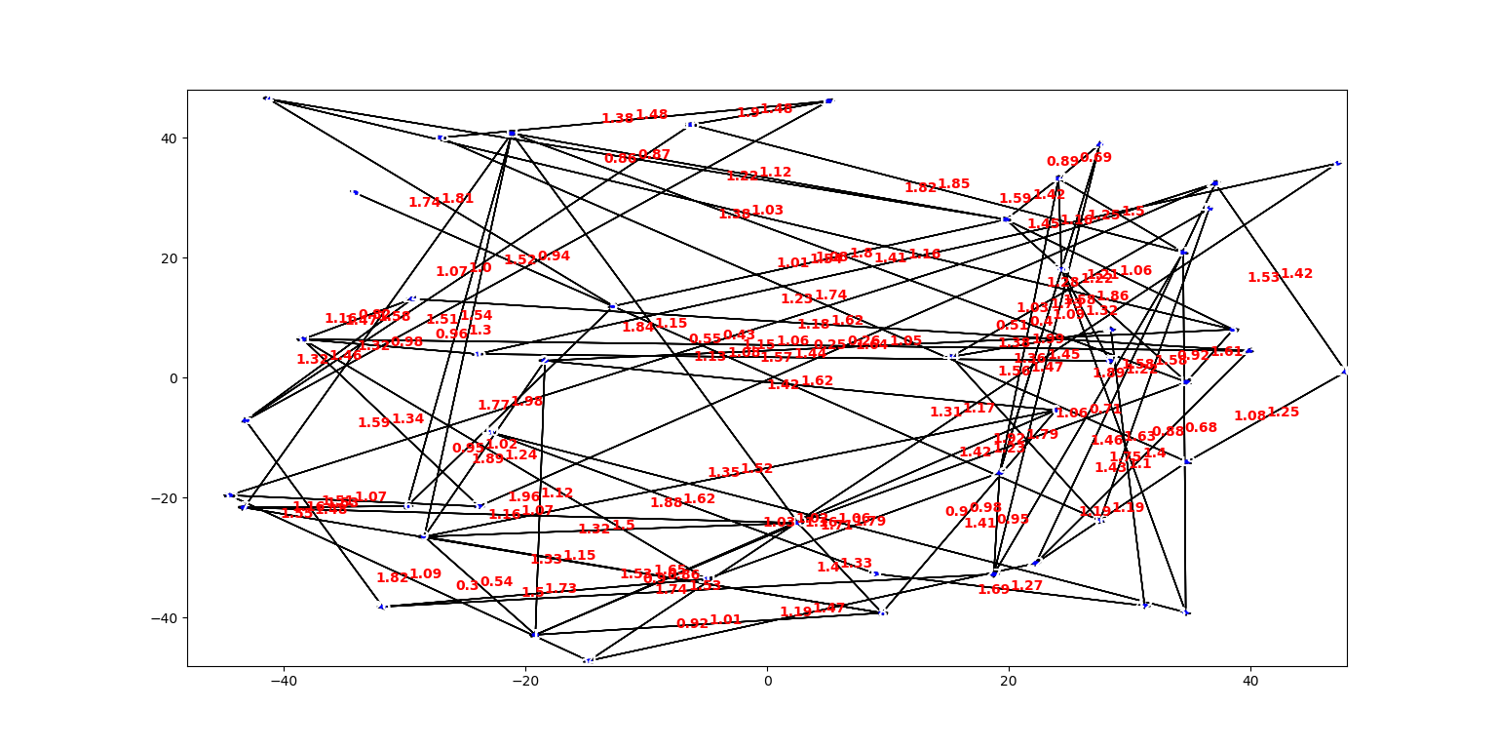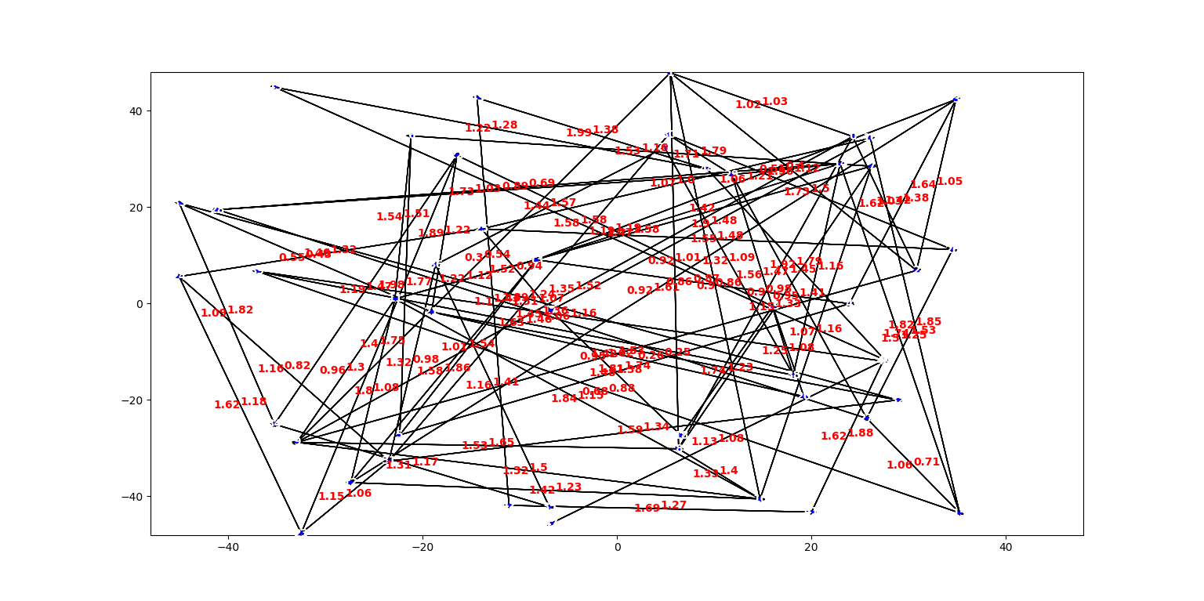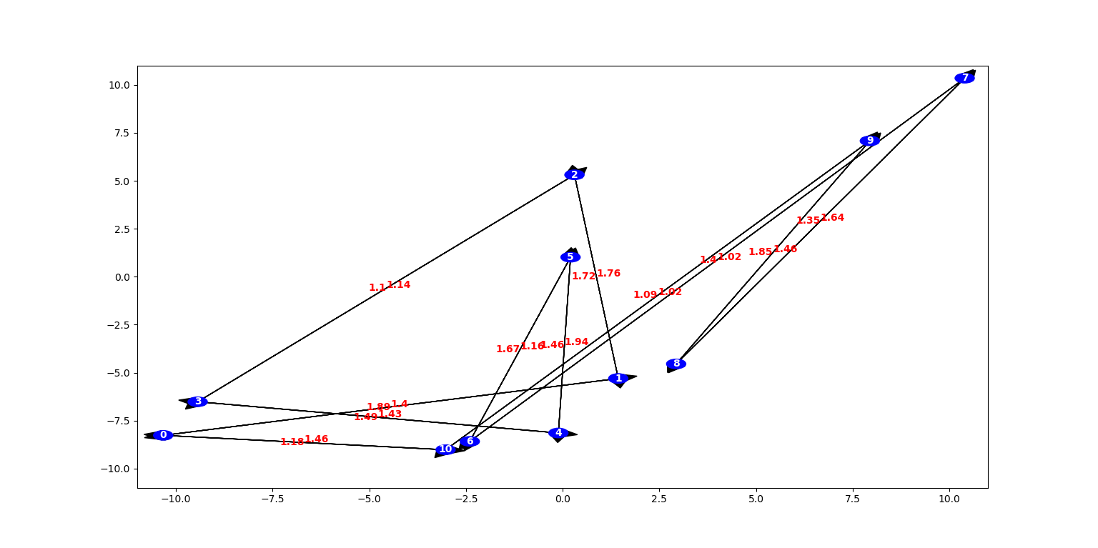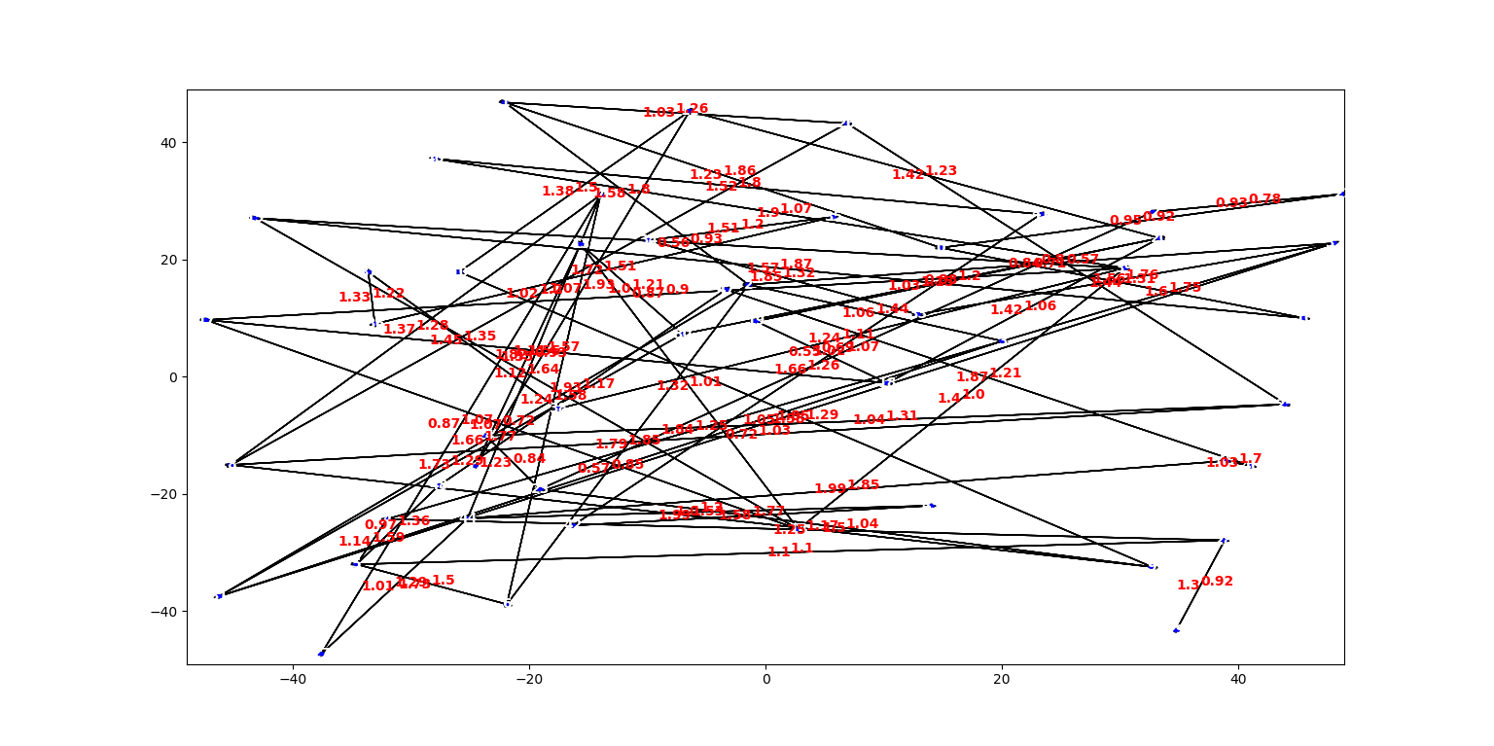

**Time measurement of plotting vs networkx:**

1. T0.json:

our plot: 0.15991926193237305

network x: 0.008995294570922852

1. A0:

our plot: 0.16976118087768555

network x: 0.01157999038696289

1. A1:

our plot: 0.6066973209381104

network x: 0.014991044998168945

1. A2:

our plot: 0.22149872779846191

network x: 0.022636890411376953

1. A3:

our plot: 0.2628467082977295

network x: 0.03498077392578125

1. A4:

our plot: 0.2359933853149414

network x: 0.026995420455932617

1. A5:

our plot: 0.2805962562561035

network x: 0.0349888801574707

Time measurement of functions:

Shortest_path:

Python - (average of 1000 calls): time: 0.0009853839874267578

Java - (average of 1000 calls): time: 0.005830237757

Connected_components:

Python – (average of 1000 calls): time: 0.0329890251159668

Java - (average of 1000 calls): time: 0.7758203941

Connected_component:

Python – (average of 1000 calls): time: 0.003997087478637695

Java - (average of 1000 calls): time: 0.069273428

**Computer Specs:**

CPU: i7-4720HQ @ 2.6GHz, 4 cores, 8 logical processors

RAM: 16GB

Windows 10 64bit