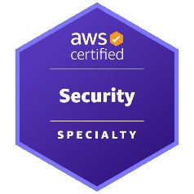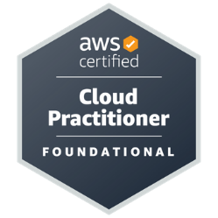

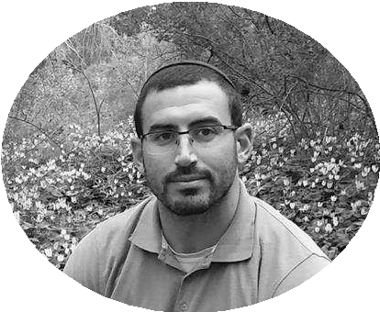

# PROFILE

# Experienced IT and System Administrator with a solid background in managing Windows and Linux environments, both on-premises and in the cloud. Skilled in setting up and maintaining monitoring solutions (Grafana, Prometheus, Dynatrace, Splunk), access management (IAM), secure remote access (VPN, MFA), and process automation using Bash, PowerShell, and Python. Recognized for independence, fast learning, high accountability, and strong interpersonal skills. Combines a systems-oriented mindset with hands-on problem-solving across complex infrastructures.

# Technologies & Skills Operating Systems & Server Management: Linux (Debian, Ubuntu), Windows Server, IIS, Active Directory

# Cloud & Infrastructure: AWS (EC2, S3, RDS, VPC, IAM, CloudWatch), Azure (AD, VMs), GCP (Basic), Terraform, CloudFormation

# Security & Access Management: IAM, MFA, VPN, Firewall, Security Groups, Load Balancer Rules, SSL/TLS, Vault

# Monitoring & Logging: Prometheus, Grafana, Splunk, Dynatrace, SolarWinds, CloudWatch

# Scripting & Automation: Python, Bash, PowerShell – automation, task scheduling, troubleshooting

# Networking & Protocols: TCP/IP, DNS, DHCP, HTTP/S, SSH, PKI

# Databases: MySQL, MSSQL

# Tools: Jenkins, Git, GitLab, VSCode CONTACT

PHONE: 0546-610754

[www.linkedin.com/in/imri-shorek](http://www.linkedin.com/in/imri-shorek)  
<https://imrishorek.github.io/imri-cv/>

Email: [Imrishorek1@gmail.com](mailto:Imrishorek1@gmail.com)

IMRI SHOREK

## EDUCATION Cyber and information security at HackerU

*August 2020 – December 2021*

I finished with a score of 93.2.

### B.A, M.A. in Arabic Language, Islam, and Literature, Bar-Ilan University

*2013 - 2016*

I finished with a score of 94.5.

## WORK EXPERIENCE

## Cloud Monitoring Engineer – Mizrahi Bank (via Comblack) *2024 – Present*

## Deployed and maintained observability platforms including Dynatrace, Splunk, and SolarWinds

## Configured advanced alerting in CloudWatch and integrated with SIEM systems (QRadar)

## Managed certificate infrastructure (PKI), IAM hardening, and access policy enforcement

## Collaborated closely with infrastructure, development, and security teams

## Gained deep insight into production traffic and proactively identified system bottlenecks Technologies: AWS, CloudWatch, Dynatrace, Splunk, SolarWinds, IAM, PKI, QRadar, Linux, Windows Server

## DevOps Engineer – Malam Team *2023 – 2024*

## Managed cloud and on-premises infrastructure (Windows/Linux) on AWS

## Provisioned services such as EC2, S3, RDS, IAM, CloudWatch, and VPC

## Automated system tasks using Bash, PowerShell, and Python

## Supported development teams with troubleshooting and environment configuration

## Integrated CI/CD pipelines with Jenkins and GitLab

## Led transition from manual scripting to structured infrastructure-as-code (IAC) approach Technologies: AWS, Terraform, Jenkins, GitLab, Bash, PowerShell, Prometheus, Grafana, IAM, Linux, Windows

## Support Engineer – Bank Leumi (via Malam Team) *2022 – 2023*

## Provided IT and DevOps support to 500+ developers and staff

## Managed user access, VPN configurations, and system troubleshooting

## Documented operational procedures and ensured issue resolution

## Improved incident response time by introducing templates and technical training Technologies: Active Directory, VPN, PowerShell, Windows, Linux, Helpdesk Systems

## SecOps Consultant – GRSee Consulting *2021 – 2022*

## Conducted vulnerability assessments and system hardening across AWS, Azure, and GCP

## Delivered security remediation plans and hands-on workshops for clients and teams

## Transformed technical findings into client-friendly reports and actionable insights Technologies: AWS, Azure, GCP, Linux, Bash, Security Scanners, IAM, SSL/TLS

## 