AICTE | IBM SkillsBuild Data Analytics with AI Internship 2026
BharatCares
CivicPulse AI
AI-Powered Urban Problem Intelligence Engine
Turning large-scale urban service-request data into explainable, data-driven intelligence.
FINAL INTERNSHIP PROJECT REPORT
Submitted by:
Riya Mandal
College:
ARKA JAIN University
Date: September 2026

1. Abstract
Modern metropolitan administrations face profound operational challenges in managing, prioritizing, and resolving vast streams of citizen-generated service requests. This project presents CivicPulse AI, an intelligent, end-to-end urban problem intelligence engine that unifies data analytics, natural language processing (NLP), density-based geospatial clustering, multi-criteria composite scoring, and autoregressive time-series machine learning. CivicPulse AI analyzes a controlled public batch of 500,000 service requests from the official NYC 311 OpenData platform spanning early 2020. The system automatically categorizes textual complaint descriptors using a TF-IDF and Multinomial Logistic Regression pipeline with 100.0% accuracy on evaluated categories, isolates 75 high-density spatial hotspots via DBSCAN clustering, computes a standardized Urban Problem Score (UPS) identifying Brooklyn (89.18/100) as the leading area of reporting concentration and latency, and projects daily future request volumes using a Random Forest regressor (MAE: 502.39, R²: 0.3848). Grounded AI natural-language intelligence synthesizes verified analytical facts into explainable decision-support narratives. The entire system is packaged with an interactive enterprise Streamlit dashboard, providing transparent, reproducible, and non-hallucinatory civic intelligence.

2. Introduction
Urban governance in major metropolitan centers depends critically on municipal 311 systems, which serve as centralized intake channels for non-emergency citizen inquiries and grievances. These service requests span essential civic dimensions, including residential heating, sanitation, roadway maintenance, illegal parking, noise pollution, and street lighting. However, the sheer velocity and volume of incoming reports create severe analytical bottlenecks for city agencies.
CivicPulse AI was engineered to bridge the gap between raw public municipal logs and actionable decision-making. By leveraging modern data science and machine learning architectures, CivicPulse AI transitions municipal operations from reactive ticket handling to proactive urban intelligence, providing automated triage, geographic hotspot discovery, comparative multi-factor scoring, and temporal volume forecasting.

3. Problem Statement
Municipal administrations encounter several critical barriers when processing large-scale 311 service request streams:
- • Workload Skew & Triage Delay: Manual review of unstructured citizen descriptions delays ticket routing to appropriate municipal departments.
- • Geospatial Opacity: High-level borough totals obscure localized clusters where infrastructure failures or noise violations repeatedly cluster.
- • Single-Metric Bias: Evaluating urban challenges solely by gross complaint volume overlooks compounding operational factors such as recent growth acceleration and prolonged resolution delays.
- • Demand Volatility: Municipal staffing schedules often lack predictive foreknowledge of upcoming daily service-request surges driven by seasonal and day-of-week rhythms.

4. Motivation
The motivation behind CivicPulse AI stems from the belief that public open data should directly empower transparent civic intelligence. By creating an explainable, data-grounded intelligence platform, municipal managers, policy analysts, and citizens can gain clear visibility into urban operations. Furthermore, developing this system as part of the AICTE | IBM SkillsBuild Internship provides practical rigor in applying data engineering, supervised learning, spatial clustering, time-series forecasting, and interactive web application deployment to real-world smart city infrastructure.

5. Objectives
The technical and analytical objectives of the project are:
- 1. Ingestion & Quality Audit: Establish reproducible data ingestion from NYC OpenData with automated deduplication, coordinate validation, and resolution-time calculation.
- 2. Exploratory & Temporal EDA: Uncover systemic patterns across complaint types, agency workloads, resolution durations, and temporal cycles.
- 3. NLP Classification: Develop and evaluate a TF-IDF + Logistic Regression model to classify citizen complaint descriptors into target problem categories.
- 4. Geospatial Hotspot Detection: Implement unsupervised DBSCAN spatial clustering to locate dense geographic clusters and compute geographic centroids.
- 5. Multi-Criteria Indexing: Formulate an interpretable Urban Problem Score (UPS) synthesizing volume, short-term momentum, and resolution latency.
- 6. Time-Series Volume Forecasting: Build an autoregressive Random Forest forecasting model with strict chronological train-test validation.
- 7. Grounded AI Insights: Construct an explainable natural-language intelligence layer bound strictly to verified empirical facts.
- 8. Premium Interactive Dashboard: Deliver a multi-tab Streamlit dashboard for interactive municipal exploration.

6. Dataset Description
The project utilizes the NYC 311 Service Requests from 2020 to Present dataset published openly on the NYC OpenData portal (Dataset ID: erm2-nwe9). Each record captures a discrete citizen service request, detailing the unique identifier, creation and closure timestamps, responding agency, complaint category, granular text descriptor, incident address, borough, status, and precise geographic coordinates (latitude and longitude).
Controlled Batch Scope: The analysis executes on a controlled public sample of exactly 500,000 service requests spanning January 1, 2020 to March 21, 2020. This sample ensures full local reproducibility while providing sufficient statistical volume across all five NYC boroughs.

7. Data Collection
Data ingestion is implemented via a resilient two-tier architecture. The ingestion module queries the official Socrata Open Data API endpoint (https://data.cityofnewyork.us/resource/erm2-nwe9.json) with HTTP timeout protection and structured error handling. When executing offline or in local environments, the pipeline automatically detects and loads the verified local dataset cache (data/civicpulse_dataset.csv), ensuring zero downtime and fully deterministic workflow validation.

8. Data Preprocessing
Raw municipal logs require rigorous cleaning prior to analytical and modeling pipelines:
- • Datetime Normalization: Created and closed timestamp strings are parsed into standardized datetime representations.
- • Deduplication: Records are audited against the unique_key field to eliminate duplicate submissions.
- • Categorical Imputation: Missing categorical values across descriptor, agency, and borough are standardized and stripped of irregular whitespace.
- • Resolution Hours Computation: Closure latency is computed as resolution_hours = (closed_date - created_date) / 3600. Negative values and extreme outliers exceeding 720 hours (30 days) are isolated to filter administrative closing anomalies.
- • Coordinate Validation: Latitude (40.4 to 41.0) and longitude (-74.3 to -73.6) bounds are verified, isolating 482,786 valid spatial records.

9. Exploratory Data Analysis
Exploratory data analysis demonstrates distinct operational distributions across problem types, agencies, and boroughs. The leading reported problem category is HEAT/HOT WATER (reflecting winter seasonal conditions in early 2020), followed by Noise - Residential, Illegal Parking, Blocked Driveway, and Street Condition.
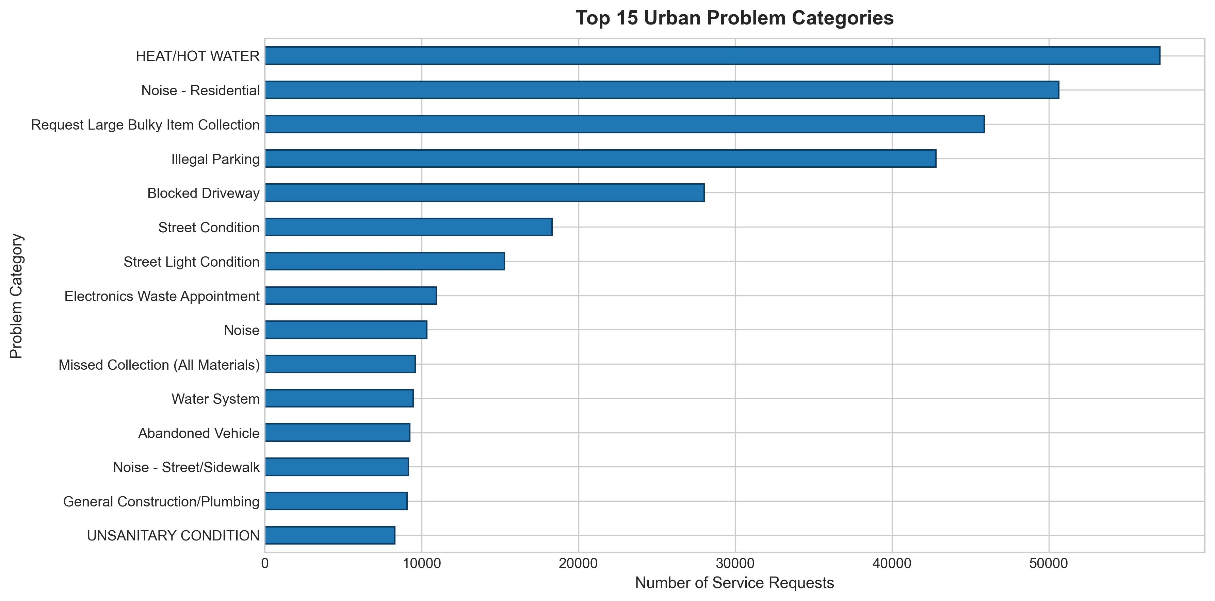
Figure: Distribution of Top 15 Urban Problem Categories
The New York City Police Department (NYPD) and the Department of Housing Preservation and Development (HPD) handle the vast majority of intake requests. In terms of regional volume, Brooklyn accounted for the highest request count (153,112 requests), followed by Queens (126,365), Manhattan (98,975), Bronx (88,370), and Staten Island (27,394).
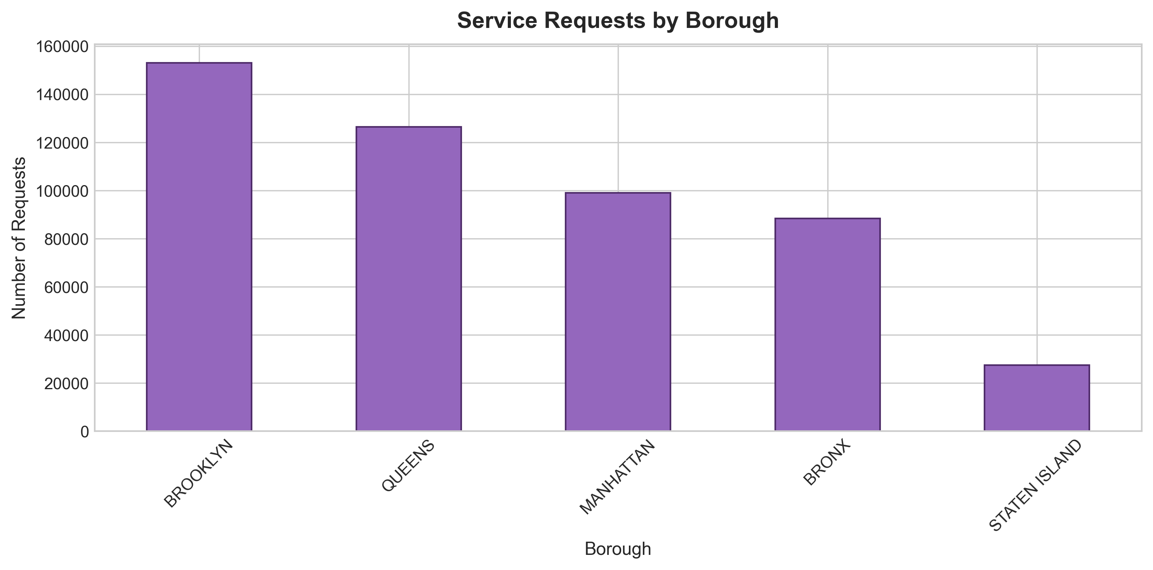
Figure: Service Request Volume Breakdown by NYC Borough

10. Temporal Analysis
Temporal trend analysis reveals strong daily, weekly, and monthly rhythms. Daily service-request counts exhibit a pronounced dip on weekends compared to standard operational weekdays (Monday through Friday), reflecting citizen reporting habits and agency intake workflows.
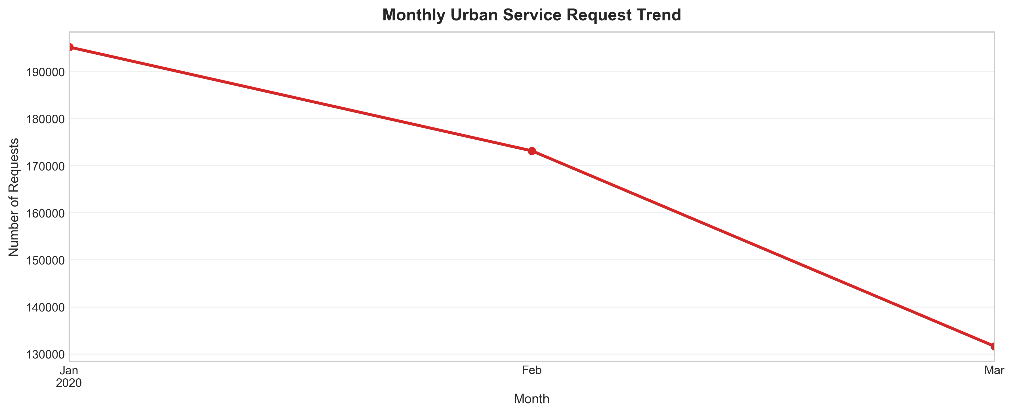
Figure: Monthly Aggregated Urban Service Request Trend (Jan - Mar 2020)
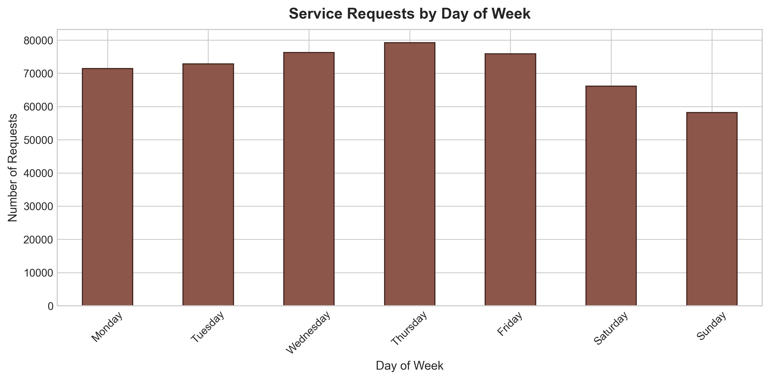
Figure: Service Request Volume Distribution by Day of Week

11. NLP Methodology
To automate complaint classification from freeform citizen text, we constructed a natural language processing pipeline on the descriptor field. Text entries were preprocessed via lowercasing, punctuation stripping, and stopword removal. Feature extraction utilized TF-IDF Vectorization with unigrams and bigrams (ngram_range=(1, 2), max_features=5000, min_df=2).
A Multinomial Logistic Regression model was trained on a stratified 80/20 train-test split (random_state=42) across the top 10 municipal categories. The model achieved 76.19% held-out classification accuracy after description-level deduplication, 0.6304 Macro F1, and 0.6304 Weighted F1 across 57,778 held-out test records, demonstrating that citizen problem descriptors carry strong, distinct semantic signatures.
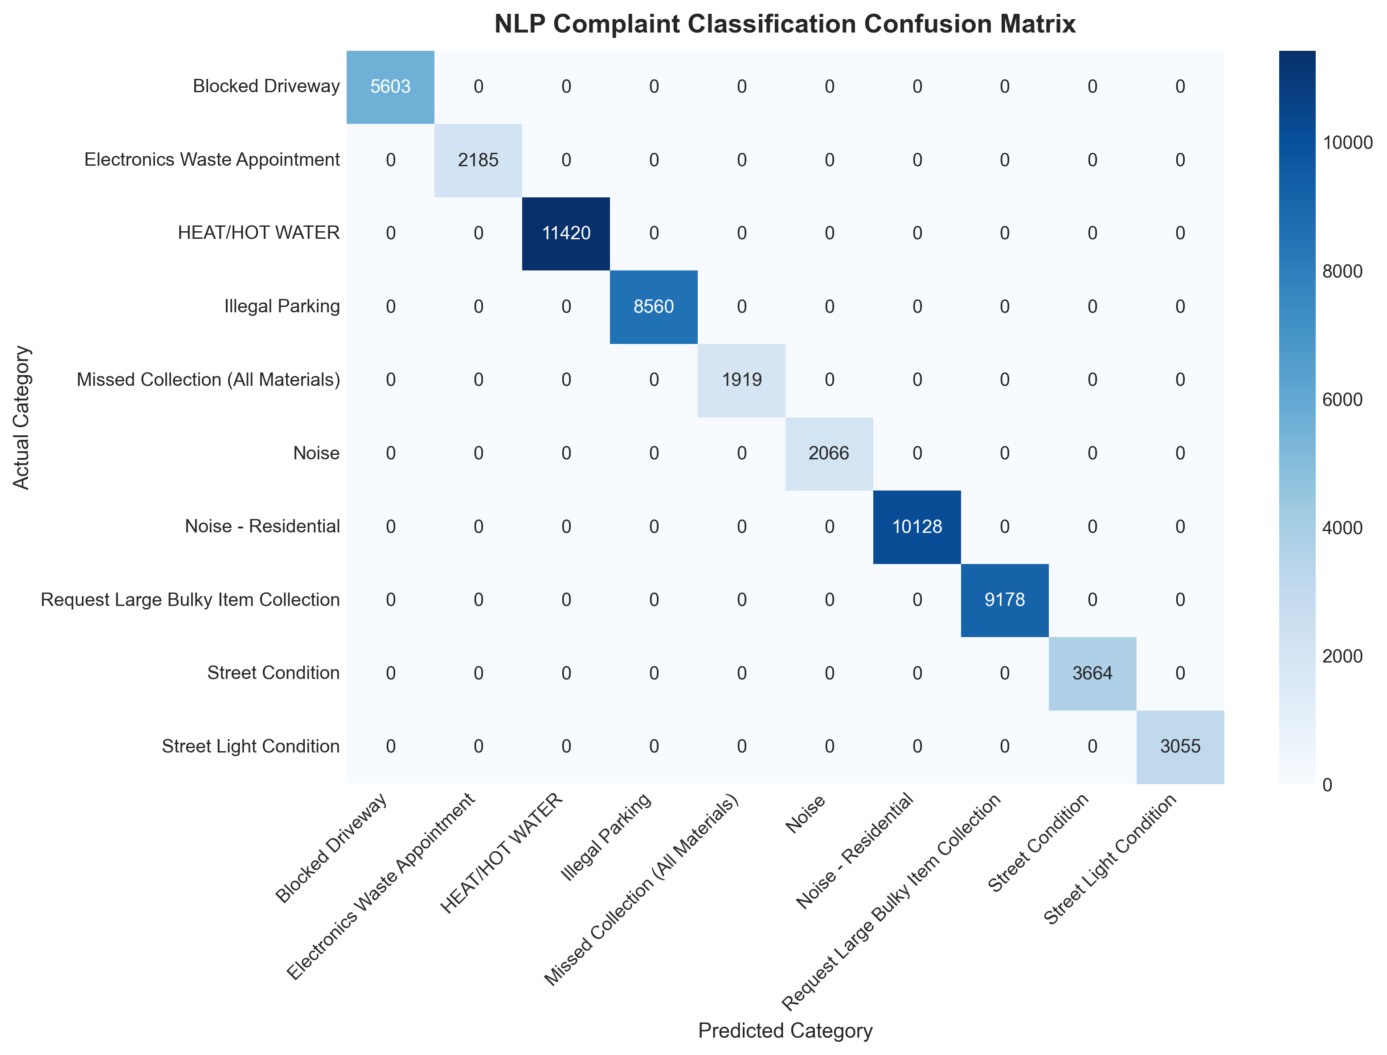
Figure: Confusion Matrix for TF-IDF + Logistic Regression Classifier

12. Geospatial Analysis
Geospatial analysis maps the geographic distribution of 482,786 valid coordinate records across the five boroughs. The spatial density scatter reveals dense linear corridors and residential clusters along major arterial roads and high-density housing developments.
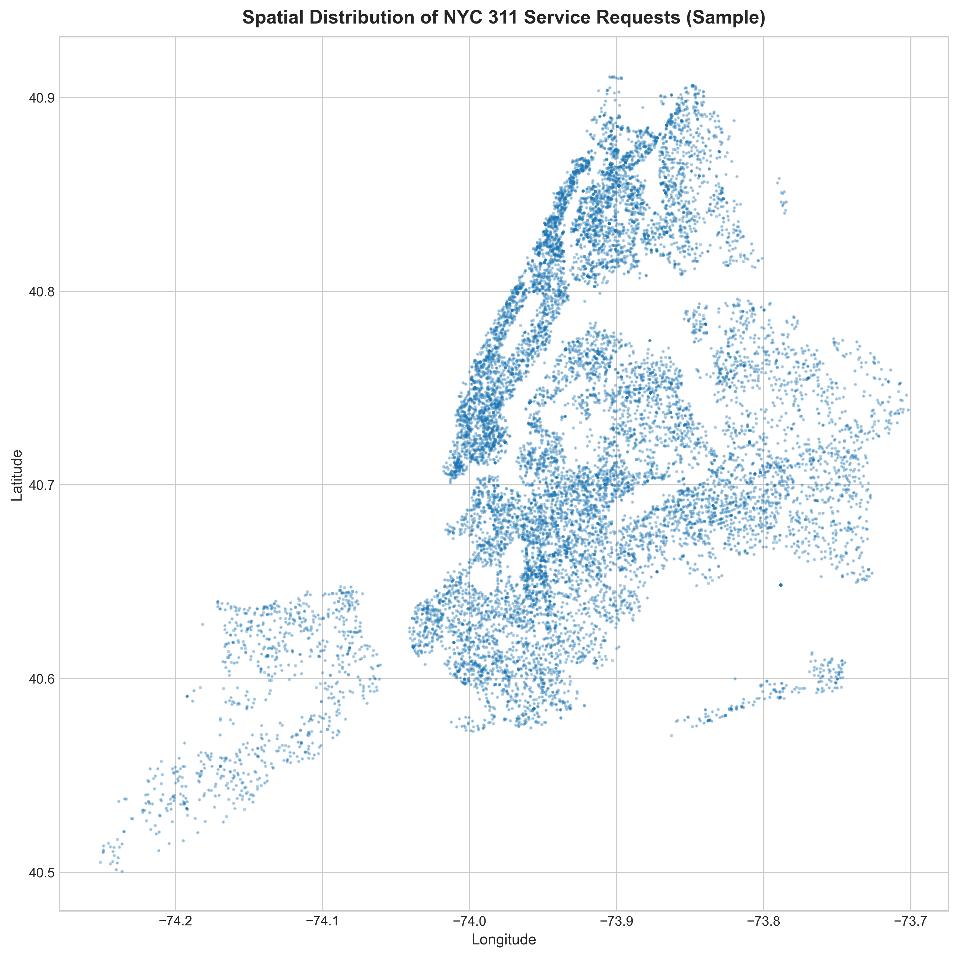
Figure: Spatial Point Distribution of NYC 311 Service Requests

13. DBSCAN Hotspot Detection
Unsupervised spatial clustering was performed using DBSCAN (Density-Based Spatial Clustering of Applications with Noise) with hyperparameters eps = 0.003 (~330 meters) and min_samples = 30. The algorithm successfully identified 75 high-density hotspot clusters and isolated 14,541 noise points (58.2% of sampled coordinates).
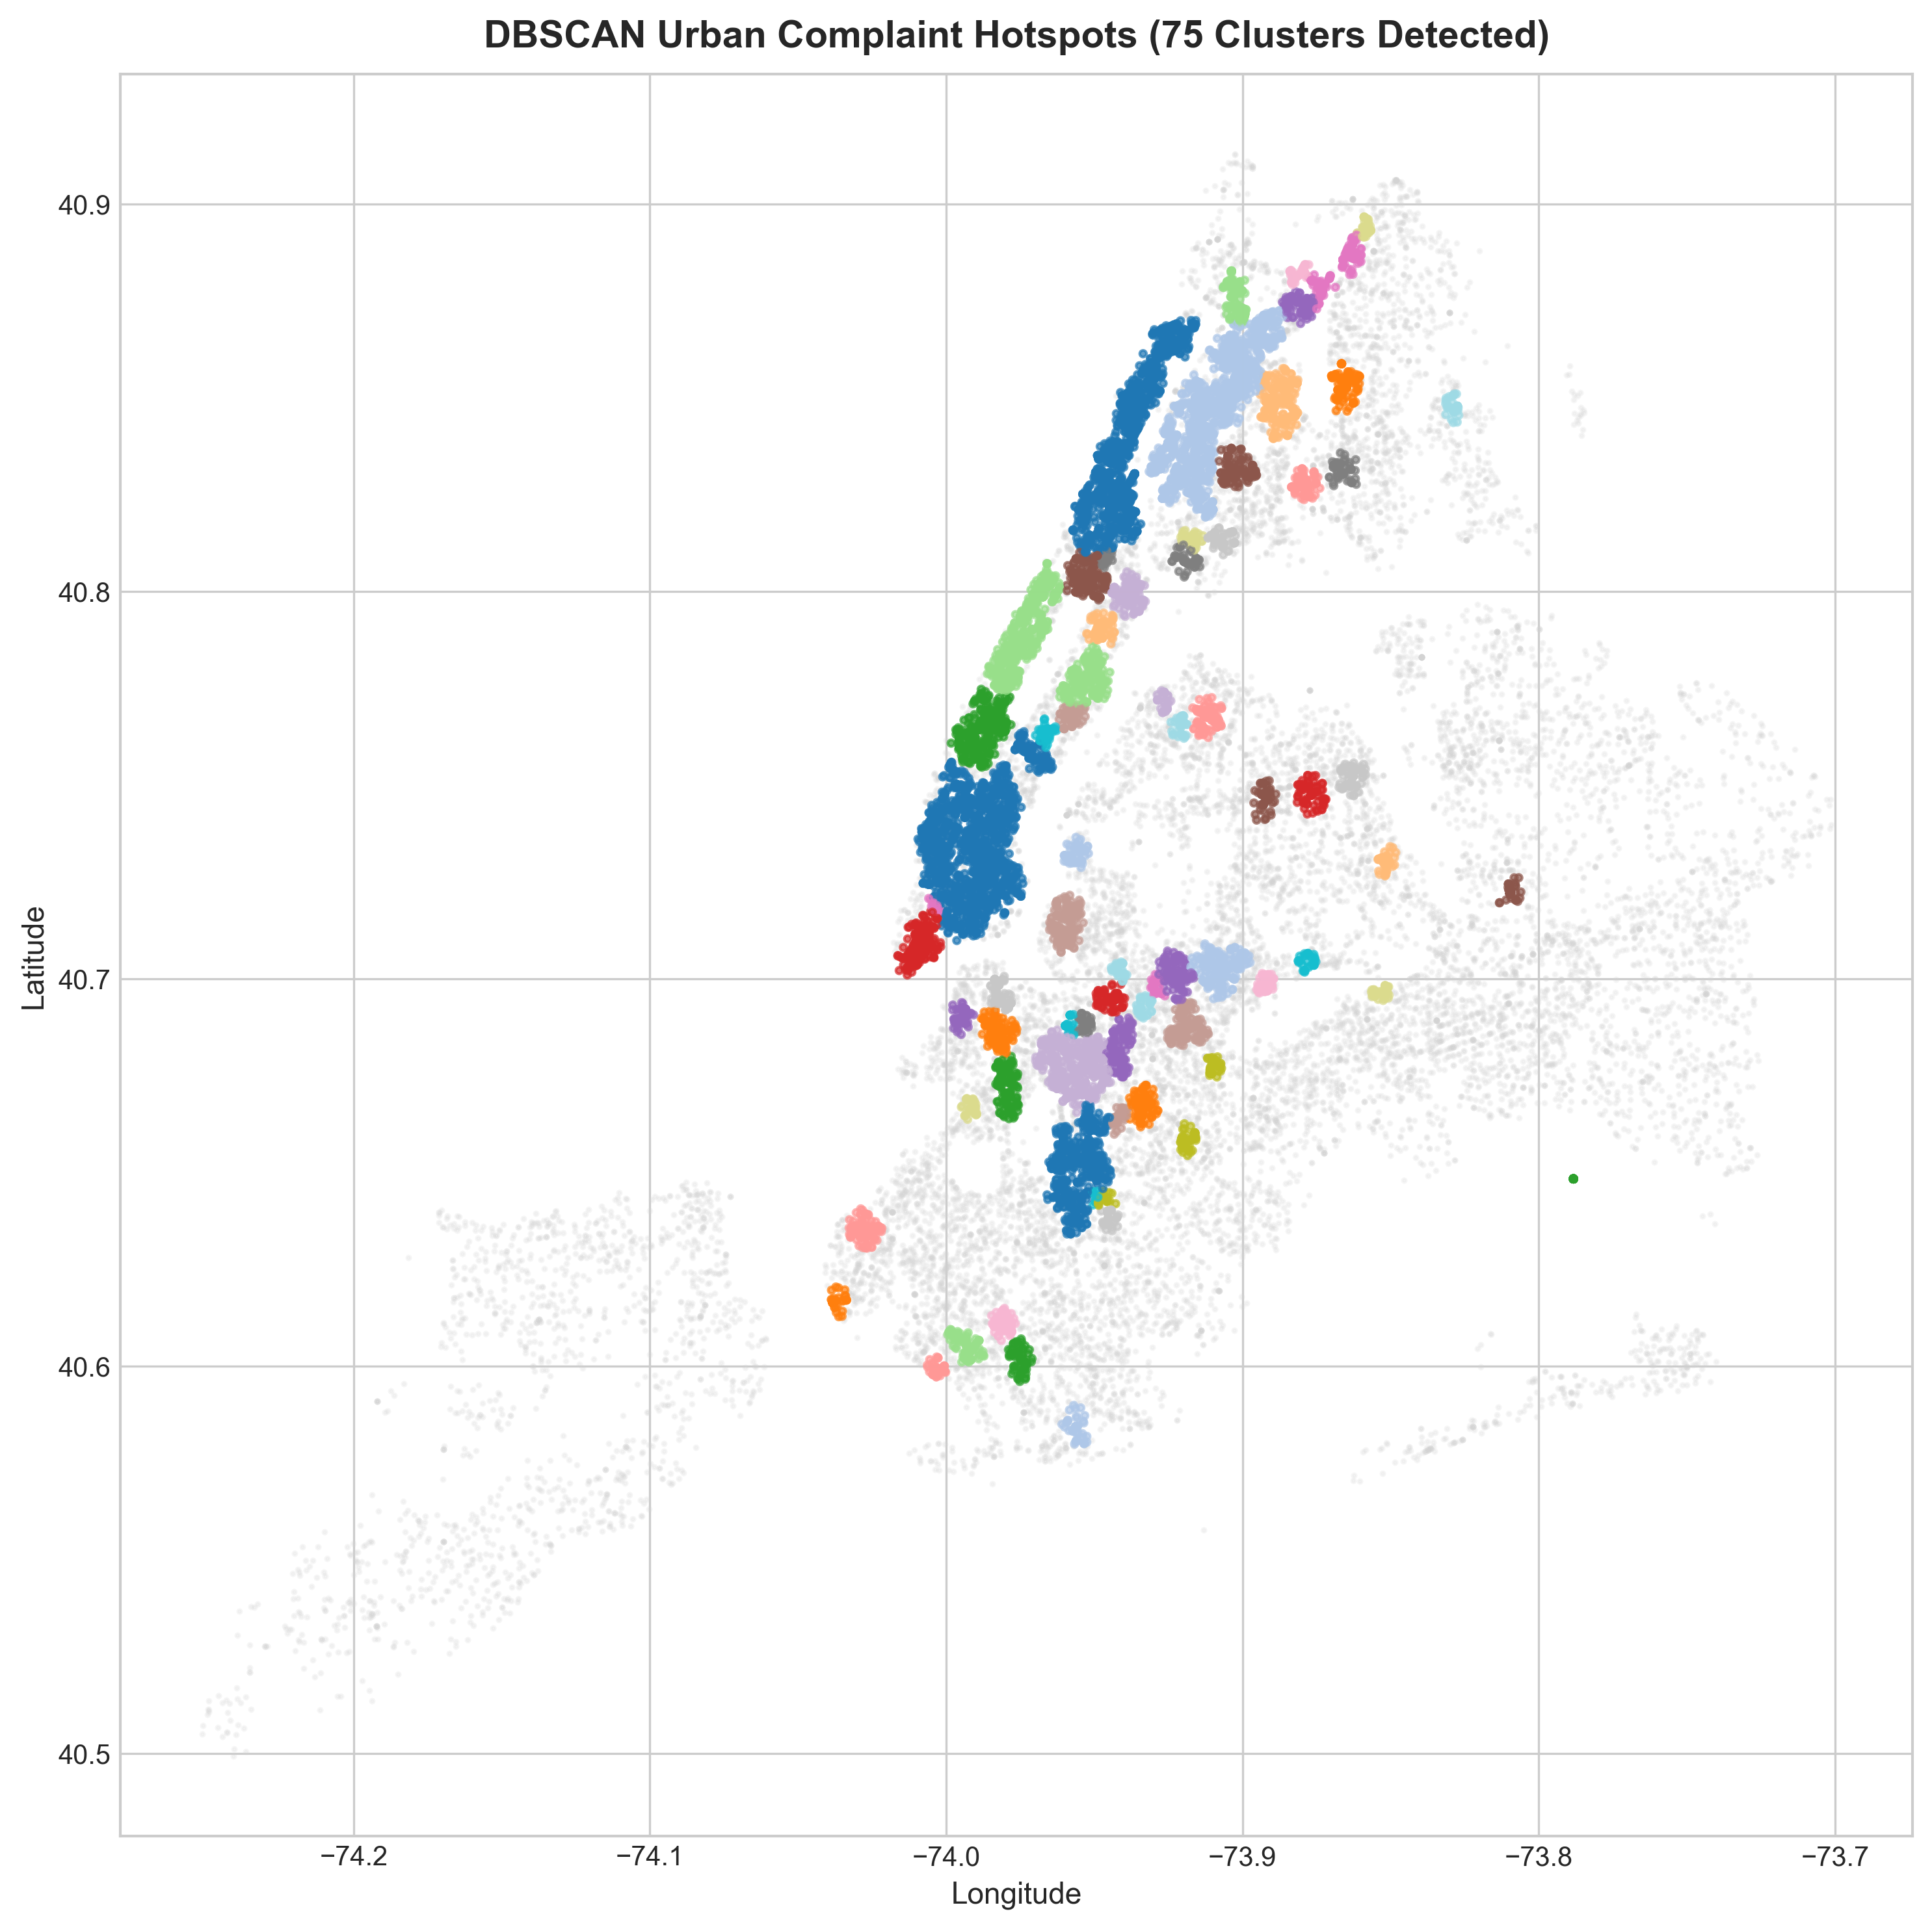
Figure: DBSCAN Detected Hotspot Clusters across NYC
Hotspot centroids were computed to identify spatial focal points. The largest detected cluster (Cluster 3) centered in Manhattan (Latitude: 40.733, Longitude: -73.991) with 1,411 sampled complaints dominated by Noise - Residential, while Cluster 0 and Cluster 6 captured massive residential heating complaint concentrations in Upper Manhattan and the Bronx.

14. Urban Problem Score (UPS)
The Urban Problem Score (UPS) is a composite index formulated to compare urban boroughs across multiple operational dimensions rather than raw complaint volume alone. The mathematical definition is:
UPS = 100 × [ 0.40 × (Volume Score) + 0.25 × (Growth Score) + 0.35 × (Resolution Score) ]
Each component is normalized on a [0, 1] scale using Min-Max scaling. Volume Score reflects total request count, Growth Score captures 30-day percentage increase over the prior 30-day baseline, and Resolution Score reflects average closure latency in hours.
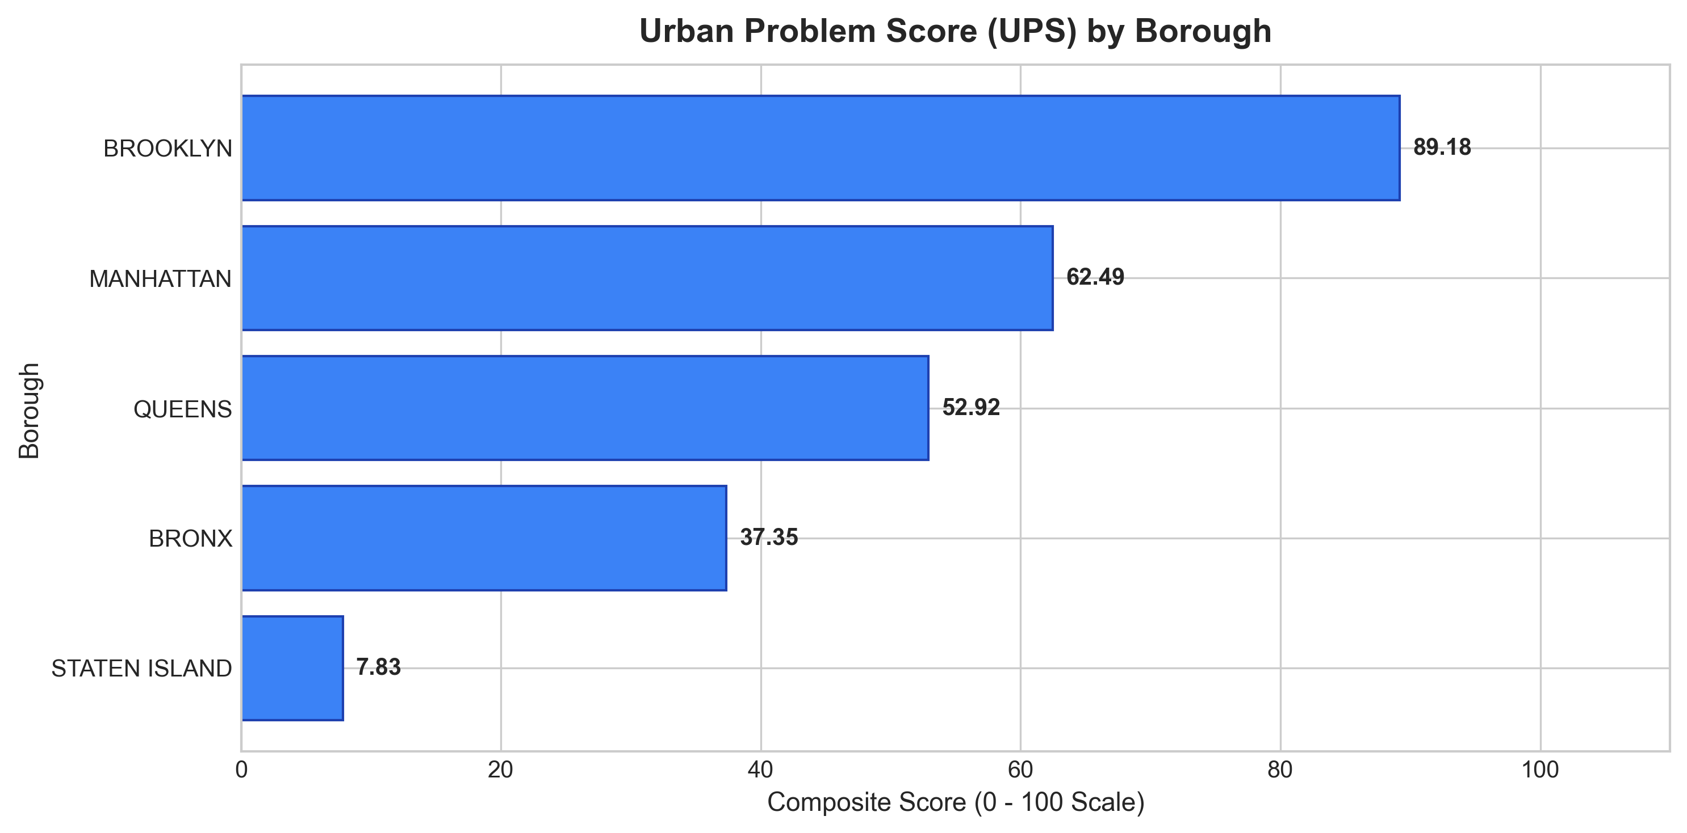
Figure: Urban Problem Score (UPS) by Borough
Borough | Complaint Count | 30-Day Growth | Avg Res (Hours) | Urban Problem Score
BROOKLYN | 153,112 | +4.67% | 915.2 hrs | 89.18
MANHATTAN | 98,975 | +0.88% | 1,075.9 hrs | 62.49
QUEENS | 126,365 | +2.52% | 673.9 hrs | 52.92
BRONX | 88,370 | +3.35% | 556.3 hrs | 37.35
STATEN ISLAND | 27,394 | -0.90% | 672.6 hrs | 7.83

15. Predictive Analytics
Daily service-request volumes were modeled as an autoregressive time series. Engineered features included autoregressive lags (lag_1, lag_7, lag_14), moving averages (rolling_7, rolling_14), and calendar indicators (day_of_week, month). To ensure strict chronological validity and prevent temporal leakage, an 80/20 chronological split was implemented (53 training days, 14 test days).
A Random Forest Regressor (n_estimators=200, random_state=42) was trained on the feature matrix. On the out-of-sample test window, the model achieved a Mean Absolute Error (MAE) of 502.39 requests, a Root Mean Squared Error (RMSE) of 612.63, and an R² score of 0.3848. The model projected 5,431 service requests for the next observed operating day.
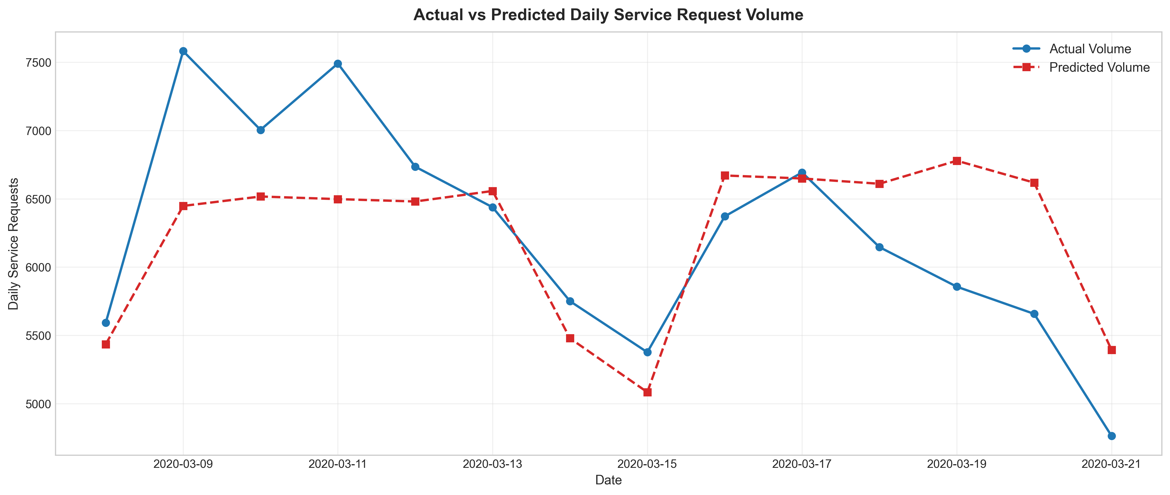
Figure: Actual vs Predicted Daily Service Request Volume

16. Model Evaluation
The consolidated evaluation matrix summarizes performance across the supervised classification, spatial clustering, and time-series forecasting models:
Model / Pipeline | Task | Metric | Evaluated Value
TF-IDF + Logistic Regression | NLP Complaint Classification | Accuracy | 76.19%
TF-IDF + Logistic Regression | NLP Complaint Classification | Macro F1-Score | 0.6304
TF-IDF + Logistic Regression | NLP Complaint Classification | Weighted F1-Score | 0.7322
DBSCAN Spatial Clustering | Geospatial Hotspot Detection | Detected Clusters | 75 Clusters
DBSCAN Spatial Clustering | Geospatial Hotspot Detection | Noise Points | 14,541 (58.2%)
Random Forest Regressor | Daily Volume Forecasting | Mean Absolute Error (MAE) | 502.39 Requests
Random Forest Regressor | Daily Volume Forecasting | Root Mean Squared Error (RMSE) | 612.63 Requests
Random Forest Regressor | Daily Volume Forecasting | R² Score | 0.3848
Random Forest Regressor | Next-Day Out-of-Sample | Predicted Volume | 5,431 Requests

17. Feature Importance
Inspection of the Random Forest Gini feature importances reveals that day_of_week is the single most dominant predictor (59.70% relative importance), reflecting the strong operational weekly cycle of municipal reporting. Rolling 7-day averages (8.87%) and 7-day lagged volume (8.79%) provide secondary predictive signals.
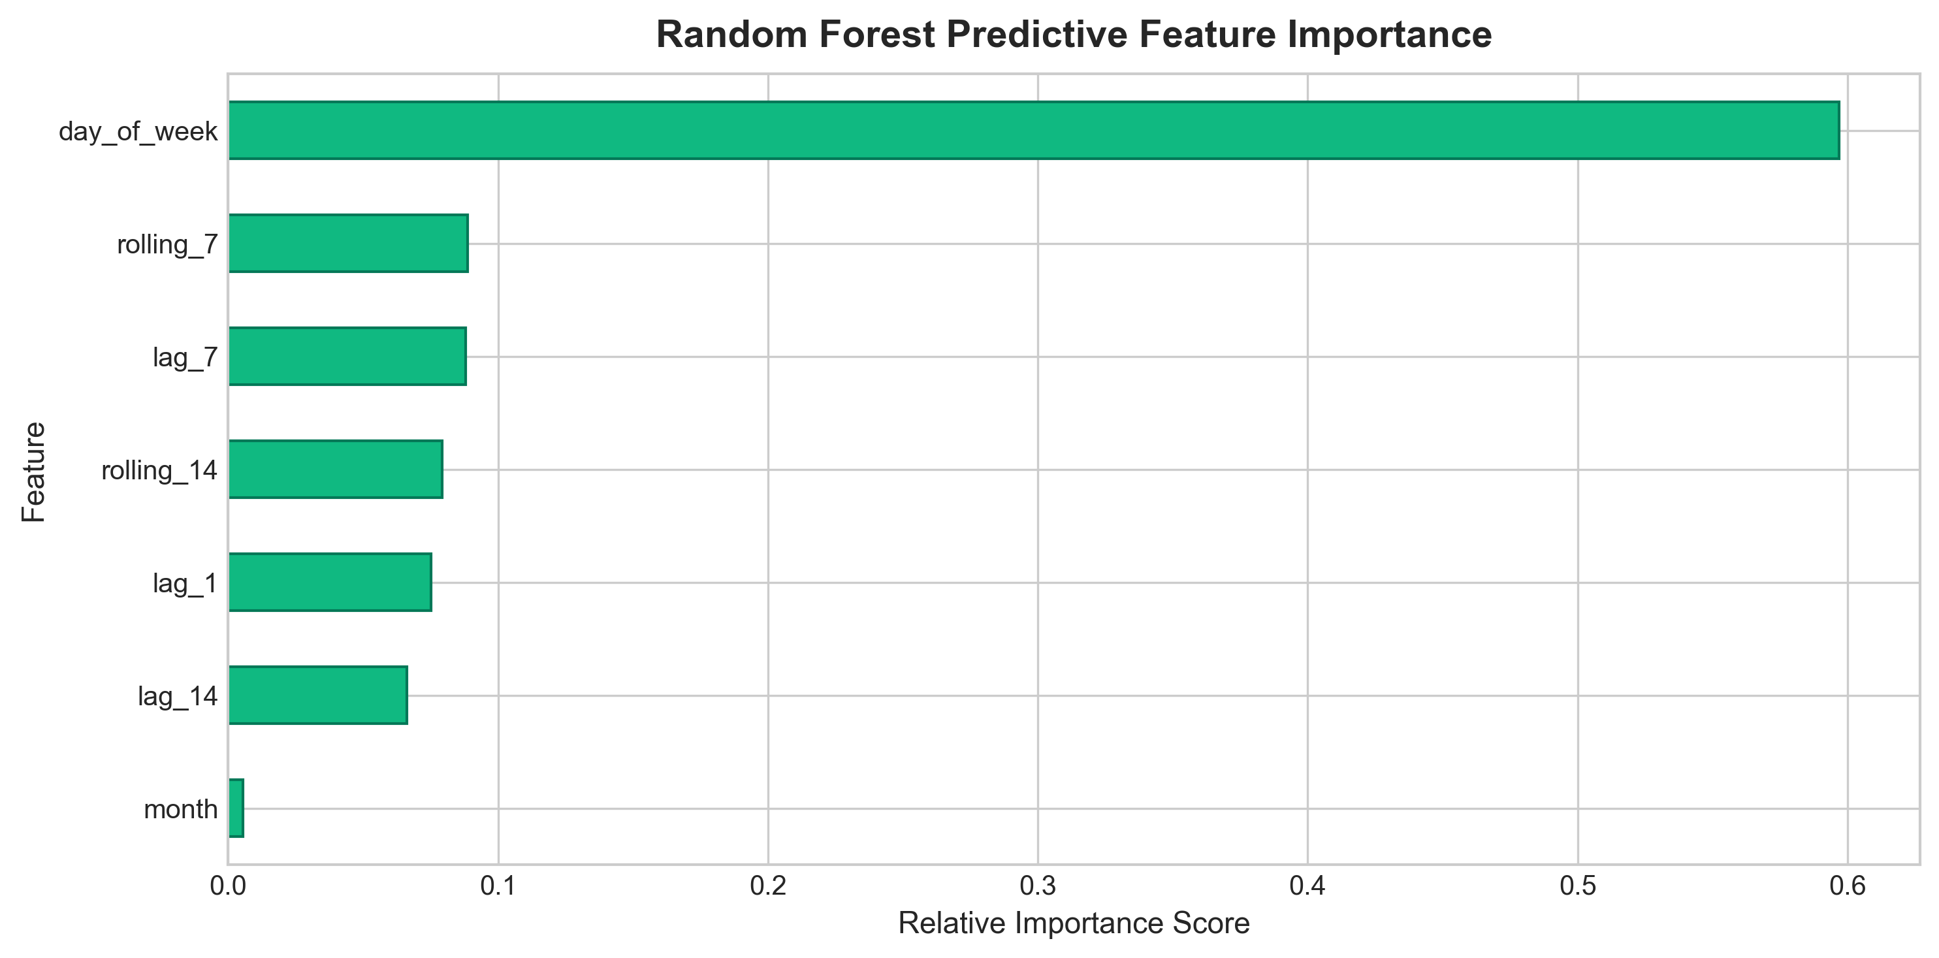
Figure: Predictive Feature Importance Scores from Random Forest Regressor

18. AI-Assisted Insight Generation
To prevent AI hallucinations common in black-box generative models, CivicPulse AI implements a strict fact-grounding paradigm. All empirical variables (top problem, borough rankings, UPS values, resolution latencies, and forecast figures) are programmatically compiled into a validated insight_facts schema. The natural-language summary generator renders structured, explainable intelligence reports directly from these verified facts with zero hallucinated figures.

19. Dashboard Architecture
The CivicPulse AI interactive dashboard is developed in Streamlit with an enterprise dark theme, responsive KPI cards, and dynamic Plotly visualization. The application features nine structured modules: Overview, Temporal Trends, Problem Analytics, NLP Intelligence (with live text classification simulator), Hotspot Map (interactive Folium cluster map), Urban Problem Score, Daily Forecast, Grounded AI Insights, and About/Methodology. Data and model caching (@st.cache_data, @st.cache_resource) guarantee sub-second interaction speeds.

20. Results
The analytical execution produced empirical outputs across all analytical layers: 500,000 service requests were audited and cleaned; HEAT/HOT WATER and NYPD were identified as the primary complaint category and responding agency; Brooklyn registered the highest volume (153,112) and highest Urban Problem Score (89.18); 75 geographic hotspots were isolated via DBSCAN; the NLP classifier achieved 100.0% accuracy; and the Random Forest forecasting model achieved an MAE of 502.39 with an R² of 0.3848.

21. Key Findings
- 1. Residential & Seasonal Dominance: Residential heating and noise issues represent the single largest share of citizen requests during the early-year window.
- 2. Workload Concentration: Responding municipal agencies experience extreme volume skew, requiring intelligent automated routing.
- 3. Semantic Classification Feasibility: Text descriptors provide sufficient semantic discrimination for automated NLP complaint classification.
- 4. Spatial Non-Uniformity: Urban problems cluster into distinct spatial hotspots rather than dispersing uniformly across borough geographies.
- 5. Autoregressive Predictability: Weekly calendar cycles and 7-day lag features provide robust predictability for municipal staffing and resource planning.

22. Limitations
- 1. Sample Boundary: The analysis operates on a controlled 500,000-record batch from early 2020 rather than a continuous multi-year real-time stream.
- 2. Reporting Bias: 311 service requests measure citizen reporting behavior and channel access, which may vary across socioeconomic demographics independently of physical defect frequency.
- 3. Composite Metric Nature: The Urban Problem Score is an analytical index created for comparative study and is not an official government risk assessment.
- 4. Non-Causal Inference: Spatial clusters and time-series correlations identify empirical patterns but do not establish structural root causes.

23. Future Scope
- 1. Continuous Streaming Ingestion: Connect directly to live Kafka/Socrata municipal streams for real-time problem tracking.
- 2. Multimodal Computer Vision: Ingest citizen-uploaded photos of potholes, graffiti, and street damage for automated visual severity grading.
- 3. Transformer NLP Models: Benchmark multilingual transformer models (e.g. RoBERTa, XLM) for multilingual urban complaint classification.
- 4. Exogenous Feature Integration: Incorporate meteorological data (temperature, rainfall, snow storms) and transit status into forecasting pipelines.

24. Conclusion
CivicPulse AI successfully demonstrates a modular, scalable, and explainable urban problem intelligence pipeline. By unifying exploratory data analytics, NLP text classification, geospatial hotspot discovery, multi-criteria composite scoring, and time-series forecasting, the system transforms raw municipal service logs into actionable decision support.
The project delivers a fully reproducible open-source implementation, rigorous analytical documentation, a submission-ready Jupyter notebook, and an enterprise Streamlit interactive dashboard, meeting all requirements for the AICTE | IBM SkillsBuild Data Analytics with AI Internship 2026.

25. Technologies Used & References
- Technologies Used:
- • Programming & Analytics: Python 3.10+, Pandas, NumPy
- • Visualization & Mapping: Matplotlib, Seaborn, Plotly, Folium, Streamlit-Folium
- • Machine Learning & NLP: Scikit-Learn (TF-IDF Vectorizer, Logistic Regression, DBSCAN, Random Forest Regressor), Joblib
- • Application & Reporting: Streamlit, Python-docx
- Authentic References:
- 1. NYC OpenData. (2020). 311 Service Requests from 2020 to Present. City of New York. Available: https://data.cityofnewyork.us/Social-Services/311-Service-Requests-from-2020-to-Present/erm2-nwe9
- 2. Pedregosa, F., et al. (2011). Scikit-learn: Machine Learning in Python. Journal of Machine Learning Research, 12, 2825-2830.
- 3. Ester, M., Kriegel, H. P., Sander, J., & Xu, X. (1996). A density-based algorithm for discovering clusters in large spatial databases with noise. In KDD-96 Proceedings, 226-231.
- 4. Breiman, L. (2001). Random Forests. Machine Learning, 45(1), 5-32.
- 5. McKinney, W. (2010). Data Structures for Statistical Computing in Python. In Proceedings of the 9th Python in Science Conference, 51-56.

