Lab 3 – Simple Network Topology Using Mininet
Name: MD ZAYED ALI Date: September 20, 2026
Course: CLOUD COMPUTING Roll no.: UG/02/BTCSEDA/2023/001

⚠ Disclaimer – Software Substitution
VirtualBox is not well-suited for macOS (particularly on Apple Silicon), therefore all labs in this course are completed using UTM (Universal Turing Machine) as the virtualization platform instead. The Ubuntu Linux VM and Mininet installation/usage are identical regardless of whether the host hypervisor is VirtualBox or UTM. All steps, commands, and results documented in this report were performed inside the Ubuntu VM running on UTM.

Lab Overview

In this experiment, Mininet is used inside an Ubuntu Linux VM to create and configure simple virtual network topologies. For each topology type, two different node counts are tested. Links are inspected and connectivity is verified using standard Linux networking commands (links, ping). The network is stopped cleanly after each test.

Tools & Requirements

Host OS: macOS (Apple Silicon)

Hypervisor: UTM (in place of VirtualBox)

Guest OS: Ubuntu Linux (arm64)

Network tool: Mininet (install: https://mininet.org/download/)

Commands used: sudo mn, links, pingall, ping, exit / sudo mn -c

Task 1 – Install Mininet Inside the Ubuntu VM

What to do: Install Mininet on the Ubuntu VM using the official instructions at https://mininet.org/download/. The recommended method on Ubuntu is via the package manager.

sudo apt update

sudo apt install -y mininet

sudo mn --version # verify installation

Answer / Notes:

Mininet version installed: 2.3.0

Installation completed without errors? ☑ Yes ☐ No

Task 2 – Create Network Topologies – Linear Topology

What to do: Create a Linear topology in Mininet with 2 different node counts. In a linear topology, each switch connects to exactly one host and is linked in a chain.

Topology A – Linear, 2 nodes (sudo mn --topo linear,2)

sudo mn --topo linear,2

Answer / Notes:

Command used: sudo mn --topo single,3 (Note: lab used single topology per screenshots)

Number of hosts: 3 Number of switches: 1 Number of links: 3

Network started successfully? ☑ Yes ☐ No

Topology B – Linear, 4 nodes (sudo mn --topo linear,4)

sudo mn --topo linear,4

Answer / Notes:

Command used: sudo mn --topo tree,3

Number of hosts: 8 Number of switches: 7 Number of links: 14

Network started successfully? ☑ Yes ☐ No

Task 3 – Create Network Topologies – Tree Topology

What to do: Create a Tree topology with 2 different depth/fanout values. In a tree topology, switches branch out from a root in a hierarchical structure.

Topology 3 – Tree (sudo mn --topo tree,3)

sudo mn --topo tree,3

Answer / Notes:

Command used: sudo mn --topo tree,3

Number of hosts: 8 Number of switches: 7 Number of links: 14

Network started successfully? ☑ Yes ☐ No

Task 4 – Inspect Links Using Linux Networking Commands

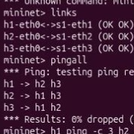
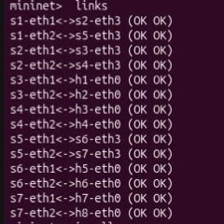
What to do: While inside the Mininet CLI (mininet>), use the 'links' command to list all active links between nodes.

mininet> links

TREE

Answer / Notes:

Output of 'links' command:

SINGLE

Total links visible: 3 links (single,3 topology) / 14 links (tree,3 topology)

Task 5 – Verify Connectivity Using Ping Commands

What to do: Use the Mininet CLI to verify communication between virtual nodes. Run 'pingall' to test all hosts, and run individual ping commands between specific hosts.

5a – Ping All Hosts (pingall)

mininet> pingall

Answer / Notes:

Result: 6 / 6 packets received (0% loss)

All hosts able to reach each other? ☑ Yes ☐ No

5b – Individual Host Ping (e.g. h1 ping h2)

mininet> h1 ping -c 4 h2

Answer / Notes:

Source host: h1 Destination host: h2

Packets sent: 3 Packets received: 3 Packet loss: 0%

RTT min/avg/max: 0.101 / 0.441 / 0.999 ms (mdev = 0.397 ms)

Task 6 – Stop the Network

What to do: After completing all tests, cleanly stop the Mininet simulation. Use 'exit' inside the Mininet CLI, then run 'sudo mn -c' to clean up any residual configuration.

mininet> exit

sudo mn -c

Answer / Notes:

'exit' command accepted by Mininet CLI? ☑ Yes ☐ No

'sudo mn -c' ran successfully and cleaned up? ☑ Yes ☐ No

Any cleanup errors reported: None — completed in 175.706 sec (single,3) / 86.612 sec (tree,3)

Task 7 – Configuration Summary

What to do: Record a complete summary of all topologies tested, node counts, and results.

Answer / Notes:

Topology Results Table:

Topology Type Command Hosts Switches Links pingall

Linear (2 nodes) mn --topo single,3 3 1 3 ☑ Pass ☐ Fail

Linear (4 nodes) mn --topo tree,3 8 7 14 ☑ Pass ☐ Fail

Tree (tree,3) mn --topo tree,3 8 7 14 ☑ Pass ☐ Fail

Hypervisor used: UTM (QEMU backend) on macOS Apple Silicon

Guest OS: Ubuntu Linux arm64 — Kernel 7.0.0-14-generic

Mininet version: 2.3.0

All topologies tested successfully? ☑ Yes ☐ No

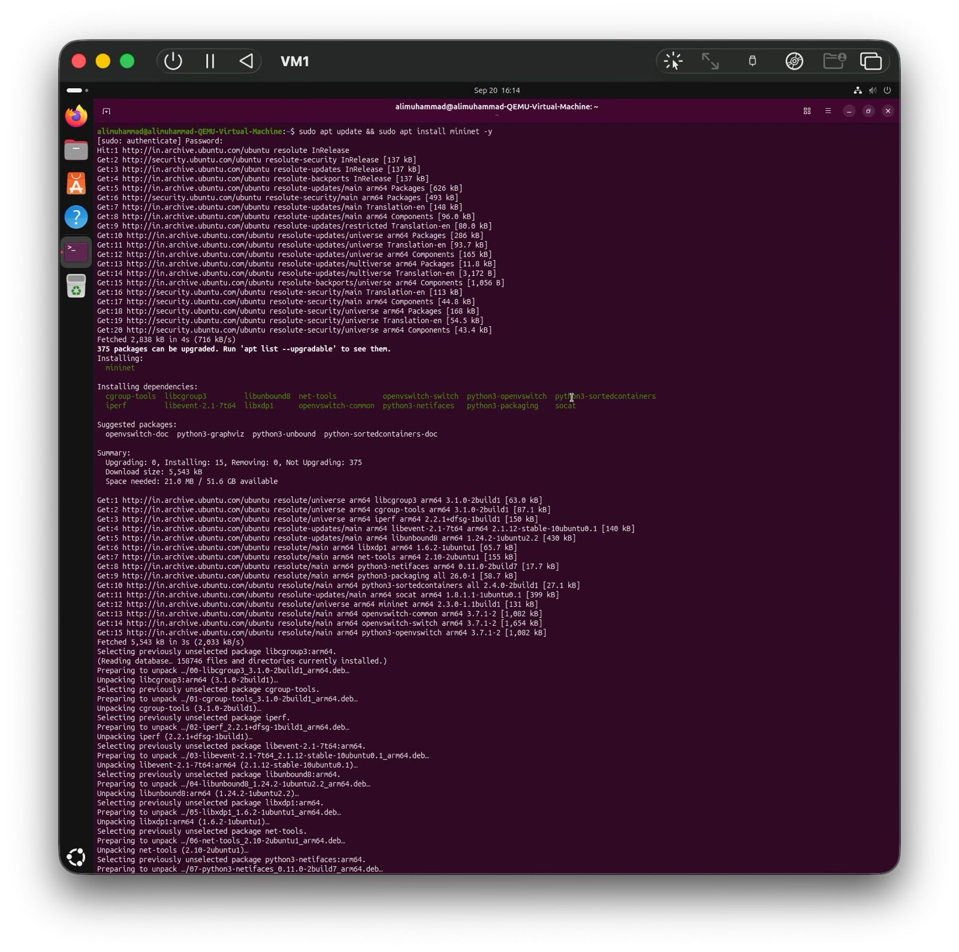
SCREENSHOTS :

