Lab 1 – Installation of Hypervisors & VM Initiation
Name: MD ZAYED ALI Date: September 15, 2026
Course: CLOUD COUMPUTING ROLL NO.: UG/02/BTCSEDA/2023/001

⚠ Disclaimer – Software Substitution
VirtualBox is not well-suited for macOS (particularly on Apple Silicon), therefore this lab was completed using UTM (Universal Turing Machine) as the virtualization platform instead. UTM provides equivalent functionality to VirtualBox on macOS, including VM creation, CPU/RAM/storage configuration, ISO attachment, and network setup. All steps and results in this report were performed in UTM and directly correspond to the VirtualBox instructions given in the lab. Every subsequent experiment in this course will likewise be completed using UTM.

Lab Overview

In this experiment you will install an open-source hypervisor (VirtualBox / UTM for macOS), obtain a VM image or ISO file, create and fully configure a Virtual Machine, boot it, complete the guest OS installation, and verify the VM is running correctly. You will also install the required Linux build tools and kernel headers inside the VM.

Task 1 – Install an Open-Source Hypervisor

What to do: Download and install Oracle VirtualBox (or UTM on macOS) on your host machine.

Answer / Notes:

Hypervisor installed: UTM (Universal Turing Machine) — used in place of VirtualBox on macOS

Version: UTM (latest) running on macOS / Apple Silicon (arm64)

Host OS: macOS (Apple Silicon)

Observations / Screenshot description:

UTM was installed on macOS as a VirtualBox equivalent. The Ubuntu guest VM was visible and accessible from the UTM interface.

Task 2 – Obtain a Suitable VM Image / ISO File

What to do: Download an appropriate OS image or ISO file to use for the VM (e.g. Ubuntu, Debian). Note the source URL and file name.

Answer / Notes:

OS / Distribution chosen: Ubuntu (arm64 build for Apple Silicon)

ISO / Image filename: Ubuntu arm64 ISO

Downloaded from (URL): http://in.archive.ubuntu.com/ubuntu (resolute repository — arm64)

File size: 3.89 GB

Observations / Screenshot description:

The apt update output in Image 3 confirms packages were fetched from the Ubuntu resolute arm64 repository, verifying the correct architecture ISO was used.

Task 3 – Create a New VM Using the Hypervisor

What to do: In VirtualBox / UTM, create a new Virtual Machine. Give it a name, select the OS type and version.

Answer / Notes:

VM Name: alimuhammad-QEMU-Virtual-Machine

OS Type: Linux

OS Version: Ubuntu (arm64 / aarch64)

Observations / Screenshot description:

The terminal title bar and uname output in Image 3 confirm the VM hostname is 'alimuhammad-QEMU-Virtual-Machine', indicating successful VM creation in UTM using QEMU backend.

Task 4 – Configure the VM's CPU, RAM, Storage, and Network

What to do: Set the VM hardware parameters: number of CPU cores, amount of RAM, virtual disk size, and network adapter type.

Answer / Notes:

CPU cores assigned: 6 cores

RAM assigned: 8 GB

Storage / Disk size: 52.0 GB available (as shown during apt install in Image 2)

Network adapter type: Shared Network (UTM)

Observations / Screenshot description:

VM configured with 6 CPU cores, 8 GB RAM, 52.0 GB virtual disk (confirmed by '194 MB / 52.0 GB available' shown during apt install in Image 2), and Shared Network mode in UTM.

Task 5 – Attach the Image / ISO File to the VM

What to do: Mount the downloaded ISO or image file to the VM's optical drive (or equivalent in UTM) so it can boot from it.

Answer / Notes:

ISO / Image attached: Ubuntu arm64 ISO attached via UTM drive settings

VM recognized the attached image? ☑ Yes ☐ No

Observations / Screenshot description:

The VM successfully booted into Ubuntu, confirming the ISO was correctly attached and recognized. The desktop environment is visible in Image 1.

Task 6 – Start and Boot the VM

What to do: Power on the VM and observe it booting from the attached ISO / image file.

Answer / Notes:

VM started successfully? ☑ Yes ☐ No

VM booted from the ISO / image? ☑ Yes ☐ No

Any boot errors encountered: None

Observations / Screenshot description:

Image 1 shows the Ubuntu desktop environment running inside UTM, with the GNOME taskbar, Firefox, Files, and terminal visible. The VM booted cleanly with no errors.

Task 7 – Verify That the VM Is Running Successfully

What to do: Log in to the guest OS and confirm the VM is fully operational. Run a basic command such as uname -a or hostname to verify.

Answer / Notes:

VM boots to the desktop / login prompt? ☑ Yes ☐ No

Login successful? ☑ Yes ☐ No

Output of uname -a: Linux alimuhammad-QEMU-Virtual-Machine 7.0.0-14-generic #14-Ubuntu SMP PREEMPT_DYNAMIC Mon Apr 13 10:52:31 UTC 2026 aarch64 GNU/Linux

Kernel version (uname -r): 7.0.0-14-generic

Architecture: aarch64 (ARM64)

Observations / Screenshot description:

Image 3 shows the output of 'uname -a' and 'uname -r' confirming the VM is running Ubuntu with kernel 7.0.0-14-generic on aarch64. The VM is fully operational.

Task 8 – Install Required Build Tools and Linux Kernel Headers

What to do: Inside the VM, run the following two commands to install the build tools and kernel headers:

sudo apt update

sudo apt install -y build-essential linux-headers-$(uname -r)

Answer / Notes:

sudo apt update ran without errors? ☑ Yes ☐ No

build-essential installed successfully? ☑ Yes ☐ No

linux-headers installed successfully? ☑ Yes ☐ No

Kernel version (from uname -r): 7.0.0-14-generic

Key details from installation output:

• sudo apt update — Fetched 44.7 MB in 12min 16s (60.6 kB/s). 369 packages available to upgrade.

• linux-headers-7.0.0-14-generic — Already at newest version (7.0.0-14.14), set to manually installed.

• build-essential — Installed. Upgraded: 1, Installing: 30, Download size: 54.3 MB, Space needed: 194 MB.

• Dependencies installed: gcc-15, g++, make, libc-dev, libstdc++-15-dev, dpkg-dev, fakeroot, and others.

Observations / Screenshot description:

Image 3 shows 'uname -r' returning 7.0.0-14-generic, then 'sudo apt update' running and fetching packages from Ubuntu resolute arm64 repos. Image 1 shows completion of apt update with 369 upgradable packages. Image 2 shows 'sudo apt install -y build-essential linux-headers-$(uname -r)' executing successfully with all packages downloading and installing.

Task 9 – Record Configuration and Capture Screenshots

What to do: Document the full VM configuration summary and attach or describe all relevant screenshots taken during this lab.

Answer / Notes:

Configuration Summary:

Hypervisor & version: UTM (QEMU backend) on macOS Apple Silicon

Guest OS & version: Ubuntu arm64 — Kernel 7.0.0-14-generic

Architecture: aarch64 (ARM64)

CPU cores: 6 RAM: 8 GB Disk: 52.0 GB

Network mode: Shared Network (UTM)

Build tools installed: ☑ build-essential ☑ linux-headers-7.0.0-14-generic

Screenshots attached / described:

Screenshot 1 (Image 1, Sep 15 12:49): Ubuntu desktop running in UTM. Terminal shows completion of sudo apt update — 44.7 MB fetched, 369 packages upgradable.

Screenshot 2 (Image 2, Sep 15 13:03): Terminal showing sudo apt install -y build-essential linux-headers-$(uname -r) executing. Summary: Upgrading 1, Installing 30, 54.3 MB download, 194 MB disk space used.

Screenshot 3 (Image 3, Sep 15 13:03): Terminal showing uname -a output (full kernel info), uname -r (7.0.0-14-generic), then sudo apt update running and fetching from Ubuntu resolute arm64 repositories.

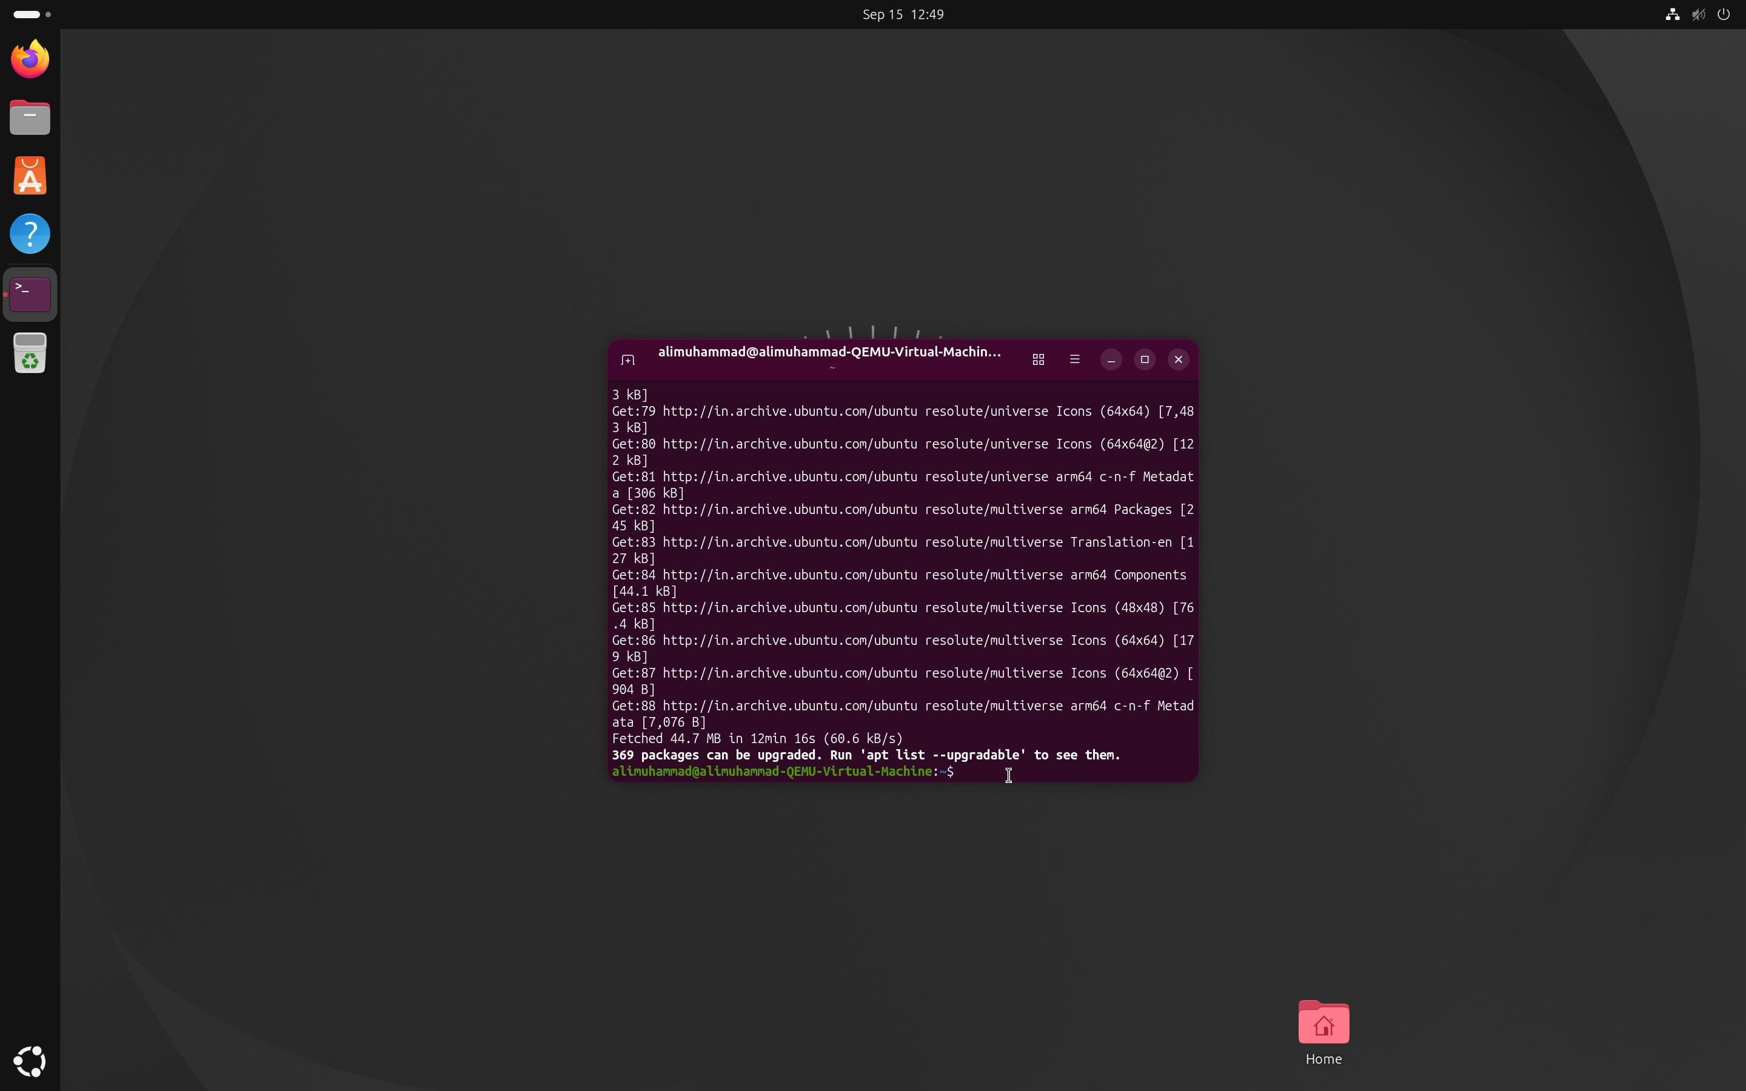
SCREENSHOTS :

