[1]

STRESS ANALYSIS FOR TWITTER POST USING NATURAL LANGUAGE PROCESSING’S SENTIMENT ANALYSIS

Joenalyn S. Sigua, Author , IEEE

*Abstract*— It is of significant importance to detect and manage stress before it turns into severe problems. However, existing stress detection methods usually rely on psychological scales or physiological devices, making the detection complicated and costly. In this paper, the proponents explored to automatically analyze individuals' stress rate via social media. To achieve this goal we import 7000 words in our database using MS SQL server. The web application was developed using Natural Language Processing’s Sentiment Analysis and Support Vector Machine Algorithm for the classification of tweets that can detect at-risk users with a recall of 0.8750 and a precision of 0.7778. The purpose of this system is to serve as an automatic monitoring of stress and extra diagnostic tool for mental health professionals and to give every concerned individuals the ability to analyze their beloved ones twitter posts who deserve warm help at early stage. The web application also provides information about stress to help users to be aware of the stress in advance, and manage the stress before it becomes severe and starts causing health problems. The development of the application is further discussed in this study.

***Index Terms*— Stress Analysis, Twitter, Sentiment Analysis, and, Machine Learning Algorithm.**

# INTRODUCTION

Aided by the convenience and constant access provided by mobile devices, about 65% of adults and 92% of teens use social networking sites, a nearly tenfold jump in the past decade [1]. We rely on social networks to share our or others’ daily activities with a wide audience. Besides, we use social networks to disclose emotions and moods, happiness and unhappiness, since disclosure is intrinsically rewarding and can improve interpersonal intimacy. Inevitably, the language used in social media postings may signal feelings of exhaustion, sleeping problems, sweating, loss of appetite and difficulty concentrating that characterize the major stress. It is thus feasible to detect users’ psychological stress from social media data. Twitter is a very popular social media platform in today’s digital era. Every second, 600 tweets are approximately published on Twitter [2]. Twitter implements limited character policy, It enables users to convey their message in a short version and as of September 26, 2017 Twitter has started testing 280-character tweets, doubling the previous character limit, in an effort to help users be more expressive [3].This has encouraged the use of short forms to fit into the provided character limit. These short forms involve use of alphabets, digits and exclamations. This has been quite handy for today’s generation. Twitter also has the hashtag feature wherein any phrase or word written after a hashtag is considered as the topic of the tweet. Twitter trends are decided by the highest frequency of similar hashtag phrases all around Twitter. The most discussed topics become trends for the day. Twitter also offers regional trends, mainly country-wise.

Since the boom in the E-commerce section, social media platforms are crucial in customer feedback. Sentiment analysis of a product is a major field of study in this culture. But, along with product sentiment and opinions, human emotions can also be analyzed by tweet contents. Twitter offers a quick self- expression format, which is unique because of features like retweeting, hashtag trending, limited characters etc. Twitter gives a chance for quick updates to everyone. The Twitter behavior pattern of a person can be very useful to study human emotions and changing form of self-expression, along with all its effects on other aspects of social life. For such study, Teen age Twitter users prove to be a good subject. Tweets from such users are mostly spontaneous, unfiltered thoughts expressed without least possible regard for its consequences. This can help in identifying correct emotions of a person at that point. Teen age users are also constantly active, which makes a large chunk of continuous data to analyze. In psychology, stress is our bodies’ response to any kind of frustrations, demand or threat [4] which fill up our modern life. Thereby, stress is so commonplace that it has become a way of life. Some stress is normal and even useful. For example, it can help us win a race or finish an important job on time. But when stress becomes overwhelming or lasts too long, it can damage our health, mood, relationships, and quality of life. Also, it can increase the risk of strokes, ulcers, and mental disorders. It is hence of importance to recognize the signs of stress in advance, which enables us to take proactive care to reduce the harmful effects of stress. It is worth mentioning that few efforts thus far have been dedicated to stress detection by harvesting social media, except the followings [5] and [6] proposed novel methods to detect tweet-level stress and user-level stress over a short time window respectively. Despite great success, they only classified samples into stressed or non-stressed categories, which is incapable of measuring the exact stressor and stress level. Stress is indeed much more complicated, which is composed of two key factors: stressor and stress level. Quite literally, stressor, comprising of stressor event and stressor subject, triggers stress; meanwhile, different stressors incur different stress levels. For instance, a layoff usually makes people more stressed in comparison to a project deadline. In addition, stressor events happening to other subjects can also be someone’s stress trigger, but may have different affects. For instance, “my friend’s father just passed away”. Moreover, stress level depends on the stressor, and is measurable using various psychological stress scales, despite that stress is often thought of as a subjective experience. As claimed by psychologists, detecting stressor and measuring the stress levels are of essential importance to proactive care.

In this paper, we work towards measuring stress via social media data. The goal of this research is to offer social workers the ability to access potential depressive people who deserve warm help at early stage, as well parents of teenagers, and concerned friends alike, the ability to be attentive to their beloved one’s psychological status, without invasion of privacy, to ensure the wellbeing of their friends and relatives. Whilst the work will not claim to replace or represent any type of professional mental health care, it will be useful as a tool to monitor a specific threshold of decline in the perspective of the user. The sentiment result is based on the analysis of texts from the user’s Twitter account. The concept of the work is to rate the user’s level of stress via social media with the use Natural Language Processing’s Sentiment Analysis Techniques with incorporation of Machine Learning Algorithm.

1. **RELATED WORK**

Computer-aided detection, analysis, and application of emotion, especially in social networks, have drawn much attention in recent years [7],[8],[9],[10],[11]. Relationships between psychological stress and personality traits can be an interesting issue to consider [12],[13],[14]. For example, [15] providing evidence that daily stress can be reliably recognized based on behavioral metrics from users mobile phone activity. Many studies on social media based emotion analysis are at the tweet level, using text-based linguistic features and classic classification approaches. [16] proposed a system called MoodLens to perform emotion analysis on the Chinese micro-blog platform Weibo, classifying the emotion categories into four types, i.e., angry, disgusting, joyful, and sad. [17] studied the emotion propagation problem in social networks, and found that anger has a stronger correlation among different users than joy, indicating that negative emotions could spread more quickly and broadly in the network. As stress is generally considered as a negative emotion, this conclusion can help us in combining the social influence of users for stress detection. However, these work mainly leverage the textual contents in social networks. In reality, data in social networks is usually composed of sequential and inter-connected items from diverse sources and modalities, making it be actually cross-media data. Researchers are trying to leverage pervasive devices like personal computers and mobile phones for routine stress detection. [18] proposed StressSense to unobtrusively recognize stress from human voice using smartphones. [19] investigated the initial lab evidence of the use of a computer mouse in the detection of stress. However, such applications rely on collecting one’s real-life data, which is easy to trigger antipathy. It makes stress detection invasive to normal life, and can't be used widely in more people.

Stress monitoring and prediction techniques can be divided into three main kinds according to the stress detection methods being used [20]. The first kind uses subjective questionnaires or individual/group meetings with psychologists to analyze users’ stress situations. This kind of methods needs high cooperation of users and sometimes relies on people’s ability to recall their experiences. Observing human’s physiological and physical signals change with the variation of psychological stress status, in the recent ten years, many researchers used various sensors to objectively monitor the changes and predict the trends of physiological signals and physical signals. For example, [21] used physiological symptoms of GSR signals and accelerometer data about movements to measure user’s stress level, and discovered correlations between the changes in GSR and the characteristics of the events using associative classification in data mining. Compared with these body contact and invasive stress measurements, the open micro-blog arises as another low-cost sensing channel to obtain people’s self-expressed contents and behaviors, from which some emotional signals could be captured and analyzed. For example, [22] evaluated whether people are in the risk of depression by analyzing their twitting behaviors. Recently, [6] investigated a number of teens’ typical tweeting behaviors that may reveal adolescent stress, and applied five classifiers to teens’ stress detection.

# **METHODS**

1. *Project Design*

The project design will have two sides as it is a web based application. These two sides are front-end and back-end. The front-end of this project will be in AngularJS while the C# based RESTful web services will serve as back-end. These front-end and back-end sides can also be referred as client-side and server-side development respectively.

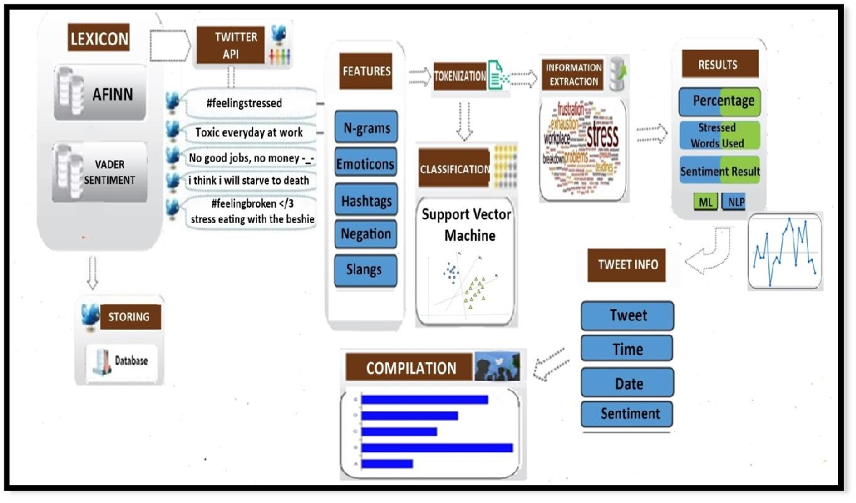

Figure 1. Project Design

1. *Getting Twitter Data*

On the client-side the first page will prompt the user to enter a username for which he/she want to analyze the tweets. The user can also specify the number of previous tweets he/she want to analyze. If the user does not provide any number then by default the last 20 tweets will be picked for analysis. Once the user has provided all the necessary information the client-side will request the server-side or RESTful web services to fetch the required tweets. On receiving the request from client-side, the web- service will fetch the required number of tweets from twitter using the Twitter API. Once the data is fetched, all these tweets and their data will be sent back to the client-side for the analysis.

1. *Analysis*

After having all the required data for analysis, tweets will be tokenized and then each tweet will be individually analyzed for negative, positive and neutral words. Every tweet will have a negative, positive and comparative score after the analysis. If the collective score of the tweet is below 25% then it means that the user has positive posts, and If the collective score of tweets is between 25-60% that means user has normal posts. But if the collective score exceeds 60%, then that user has unusual negative score which points out to the signs of stress.

1. *Information and Result*

The results will be shown back to the user in the results page, along with the collection of negative and positive words used in the list of tweets. The results will also show the time and dates on which these tweets were published.

1. *Project Development*

For the development of the website application project, the proponent utilized the V-Model methodology of SDLC which aims to produce the best quality software by means of testing and verification that takes place in the early stages of the project to make sure that the conversion to the next stage is possible. The development cycle starts in initial planning, the planning will be by defining the problem that every individuals are facing nowadays which is stress as teenagers, teachers, successful people even successful people, parents are all suffering from stress due under the rapid pace of life due to the rapid development of modern society. After defining the problem we then decides what is the best domain to use, we chose twitter as our social media domain because Twitter posts/Tweets are informal, with 500 million tweets per day (Halder, 2017), has a wide array of topics and large vocabulary, contains meta information like retweets, date and time, has special strings such as hashtags, emoticons, internet slangs, and stress sentiments which are the perfect features for having an accurate analysis result. After deciding what social media domain to use, we then planned on what algorithms, and techniques that we can use for the development of the application which is Natural Language Processing’s Sentiment Analysis, Information Extraction with the used of Support Vector Machine Algorithm which is the best approach for text categorization.

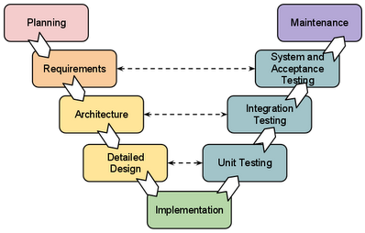

Figure 2. V-Model SDLC

After the initial planning, next phase we used is the requirement analysis. For the requirement analysis we then gathered as much information as possible about the details of our desired software. For gathering information we then decide what features to include on our site plan and what lexicon or datasets to use. After having all the clear and detailed product requirements, it’s time to design the complete system. The design of the system architecture along with its data flow representation should be clearly defined in the design stage, so in this stage we planned all the programming languages to use, the design will have two sides as it is a web based application. These two sides are front-end and back-end.

The front-end of this project will be in AngularJS while the C# based RESTful web services will serve as back-end, and for the database we will use MS SQL database for the storing of our data sets. Actual development starts in the implementation stage where the developer follows the project design and specified programming tools to be used with respect to the development of the system application like which programming language will be used for coding.

For the Testing stage we used the procedural testing methodology, unit testing, system testing and integration testing that helps in the code coverage, debugging, and documentation of the project. It utilizes strict rules for each test level so that each component and function the documentation depicts is tested. A successful testing and meeting client expectations and requirement means the system is ready for the evaluation before the deployment of the system. Though the system was successfully tested and deployed to the client, maintenance of the system must be observed for monitoring and possible upgrading of the system.

1. **RESULTS**
2. *Project Description*

In this project, the proponents have developed a stress recognition system to automatically recognize individual’s psychological stress via social media with the use of a micro-blog called Twitter which is one of the most popular social media that can be publicly accessed that allows individuals to express their opinions, feelings, and thoughts on a variety of topics in the form of short text messages. People can post text with no more than 180 words or have social interactions with others. Employing real online micro-blog data, we investigate the correlations between users’ stress level and their tweeting content by means of Natural Language Processing’s Sentiment Analysis techniques and Information Extraction. The objective of this study is to develop a web based application that will help individuals to be aware of the stress in advance, and manage the stress before it becomes severe and starts causing health problems. The information regarding stress is gathered from many reliable psychological sites and dictionaries. For an additional purpose of this study, we also created a method for automatically rating emotions expressed by Twitter messages. A system developed based on this method could potentially be employed in a large variety of applications, ranging from well-being apps, self-helps, counselors, to community population studies. This project can also be used by healthcare professionals or counseling agencies to monitor and track a patient's emotional states, or to recognize anxiety or systemic stressors of populations (e.g. different student groups on campus). The system can also help commercial agencies to gauge sentiment of buyers or to facilitate targeted product advertisement. In addition, this technology can measure public mood of people in a community, which may help social scientists to understand the quality of life of populations.

**Weka**. Is a collection of machine learning algorithms for data mining tasks. The algorithms can either be applied directly to a dataset or called from your own Java code. Weka contains tools for data pre-processing, classification, regression, clustering, association rules, and visualization. It is also well-suited for developing new machine learning schemes.

1. *Project Capabilities and Limitations*

Psychological stress detection remains a large problem at the present stage. Detecting and managing stress before it turns into severe problems is of significant importance. Recent decades, many efforts have been devoted to stress detection by researchers from diverse areas. They have developed many methods to measure psychological stress, including psychological questionnaire based interviews, self-reported surveys, Forum membership and physiological signal based measuring stress. However, these methods have their limitations in many aspects. Psychological questionnaires and surveys often contain a range of questions designed by psychologists. People are usually unwilling to do these questionnaires unless they have to and this process is time-consuming and costly. Physiological methods usually require professional devices to measure users’ physiological and biochemical properties and need specialists to analyze the acquired data. Thus, it is very important and useful to find a way to detect user’s stress state reliably, automatically and non-invasively. With the help of natural language processing’s technology and support vector machine algorithm, this project is capable to use social media data to automatically analyze individuals’ stress rate via social media.

This project can analyze a maximum of 20 tweets. By clicking the analyze button at the homepage the users can analyze their twitter accounts and the system will automatically direct them to the page of the application where it has the percentage results of all the tweets, the graph with specific dates of their tweets, the negative words they used, and by clicking the “show tweets” button, the users will be able to see if their tweets are positive and negative. This application also provides a site link that has some helpful information for stress people, such as causes, symptoms, prevalence, and treatment of stress. This application also has a page with hotlines that gives free counseling for people who are feeling depressed, stressed and lonely that needs support and a free, anonymous, confidential online text chat with compassionate trained listeners, counselors, and online therapists for users to develop new skills to solve their problems. This application analyzes not just ordinary text but also retweets, mentions, and captions in Twitter. This project also has limitation because there are limitations to what NLP algorithms can handle today. For instance, the tweeted phrase \You're killing it!" may either mean \You're doing great!" or \You're a terrible gardener!" No automated sentiment analysis that currently exists can handle this level of nuance. Furthermore, certain expressions (\ima") or abbreviations (\#lmfao") fool the program, especially when people have maximum 140 characters to express their opinions, or when they use slang, profanity, misspellings and neologisms. This project is also limited to English words only.

1. *Project Evaluation*
2. *Features Selection*

The first objective of the study is to identify the features used to classify the tweets. The factors in analyzing the stress rate of tweets is the sentiment score of every tweets. In order to measure the sentiment score of a tweet, we represent each tweet into a vector of features. We need to capture features that describe the emotion expressed by each tweet. Feature selection plays an important role in the effectiveness of the classification process. For this study, we explore the usage of different features. We use single words, also known as unigrams as the baseline features for comparison. Other features explored included the presence of emoticons, punctuations, capitalization and negations, as elaborated below:

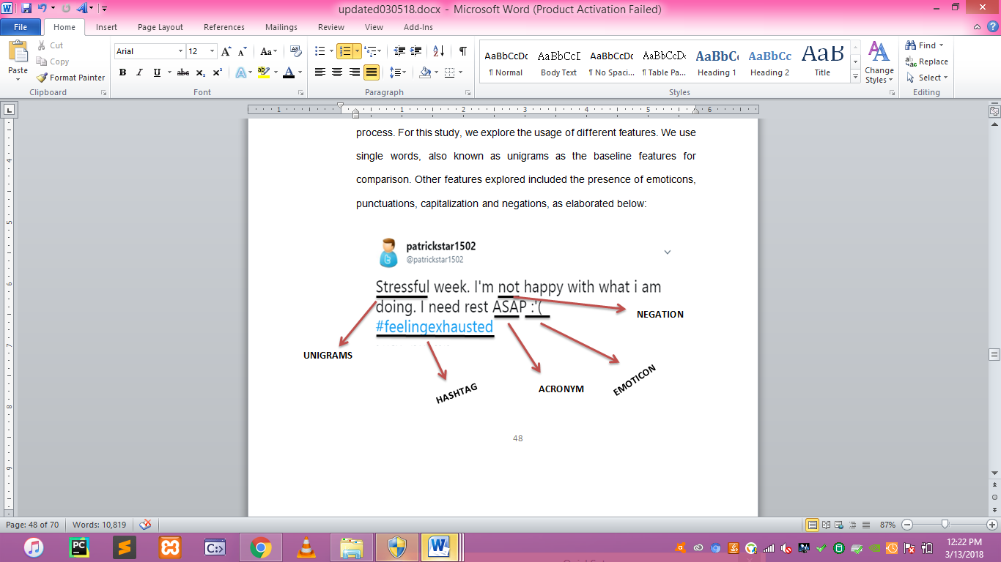

Figure 3. Sample tweet with the used features

1. *Unigram Features*

Unigrams or Single word features have been widely used to capture the sentiment of a tweet (Let (f1, f2, ..., fm) be our predefined set of unigrams that can appear in a tweet. Each feature fi in this vector is a word from the dictionary of words in our dataset. Text messages can be classified into emotion categories based on the presence of affect words like ”annoyed”, and ”happy”. Therefore, the problem of high dimensional feature vector can be solved by identifying an appropriate emotion lexicon. We effectively design a domain-specific dictionary by using the lexicon of emotions, instead of all the words in our input dataset.

1. *Negation Features*

The need negation detection in sentiment analysis can be illustrated by the difference in the meaning of the phrases, "This is good" vs. "This is not good" However, the negations occurring in natural language are seldom so simple. Handling the negation consists of two tasks – Detection of explicit negation cues and the scope of negation of these words.

1. *Hashtag Features*

Twitter message features such as hash-tags and emoticons are likely to be useful features for sentiment and emotion classification. The usage of hashtags in tweets is very common, and Twitter dataset contains millions of different user-defined hash-tags. A study of a sample of 0.6 million tweets by (Wang et al., 2015) showed that 14.6% of tweets in their sample had at least one hashtag.

1. *Internet Slangs*

Slang is a type of language of non-standard words and phrases (Wikipedia, 2014), such as GR8, SMH, CHALE and XOXO. The primary motivation behind the using of Slang words is its usefulness, because usually easy for other to interpret and save a lot of time. Large number of Slangs with positive or negative sentiments are used in chat, Twitter and Facebook messages (Asghar MZ et al., 2014). It has become very important to detect, translate and identify Slang’s polarity for determining the sematic orientation (SO) of the entire review.

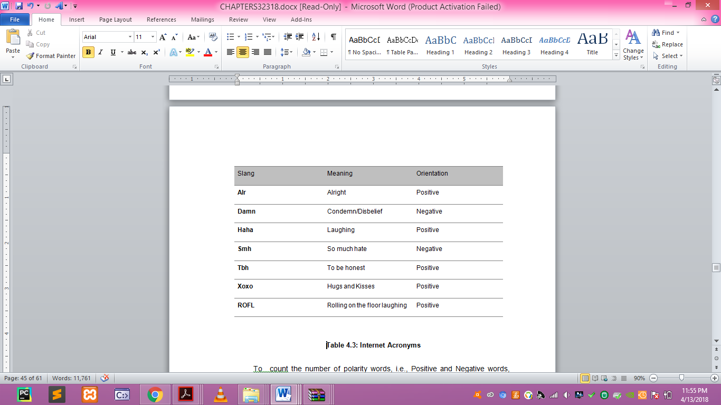

Figure 4. Internet Slangs

To count the number of polarity words, i.e., Positive and Negative words, we first need to define which words are positive and which words are negative. For this we used AFINN-165. AFINN is a list of English words rated for valence with an integer between -5 (negative) and +5 (positive). The words are manually labeled by Finn Arup Nielsen. The AFINN-165 contains a list of 3382 words and phrases. We process AFINN-165 to obtain 4 features. vNegativeTerms (score -5, -4), NegativeTerms (score -3, -2, -1), PositiveTerms (score 1, 2, 3), and vPositiveTerms (score 4, 5). To count polarity words, documents/tweets are first tokenized. Tokenization means to break a sentence into words. In our implementation, tokens are split by space, punctuation and numbers. For example, the sentence \Been awake since 6am for no reason" contains 8 tokens (see Table 4.4). Once we have tokens, we can simply count the polarity words among these tokens and store them as feature counts.

1. *Emoticon Features*

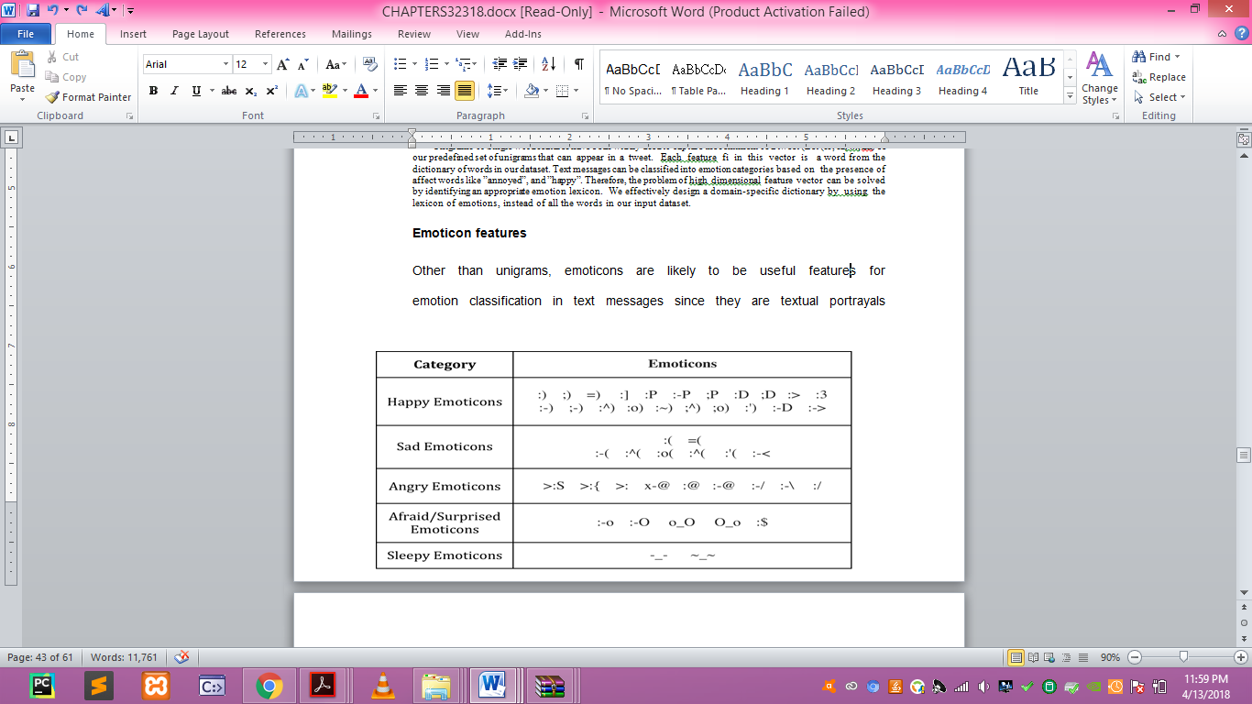

Figure 6. Emoticons

Other than unigrams, emoticons are likely to be useful features for emotion classification in text messages since they are textual portrayals of a writer’s emotion in the form of icons. These features tend to be widely used in sentiment analysis. For example, ”:)” and ”:-)” both express happy emotion.

*B) Support Vector Machine*

To prove the third objective that is to implement algorithm and techniques that will analyze signs of stress from twitter data. The proponents used Linear Support Vector Machine Algorithm for the text classification of every tweet.

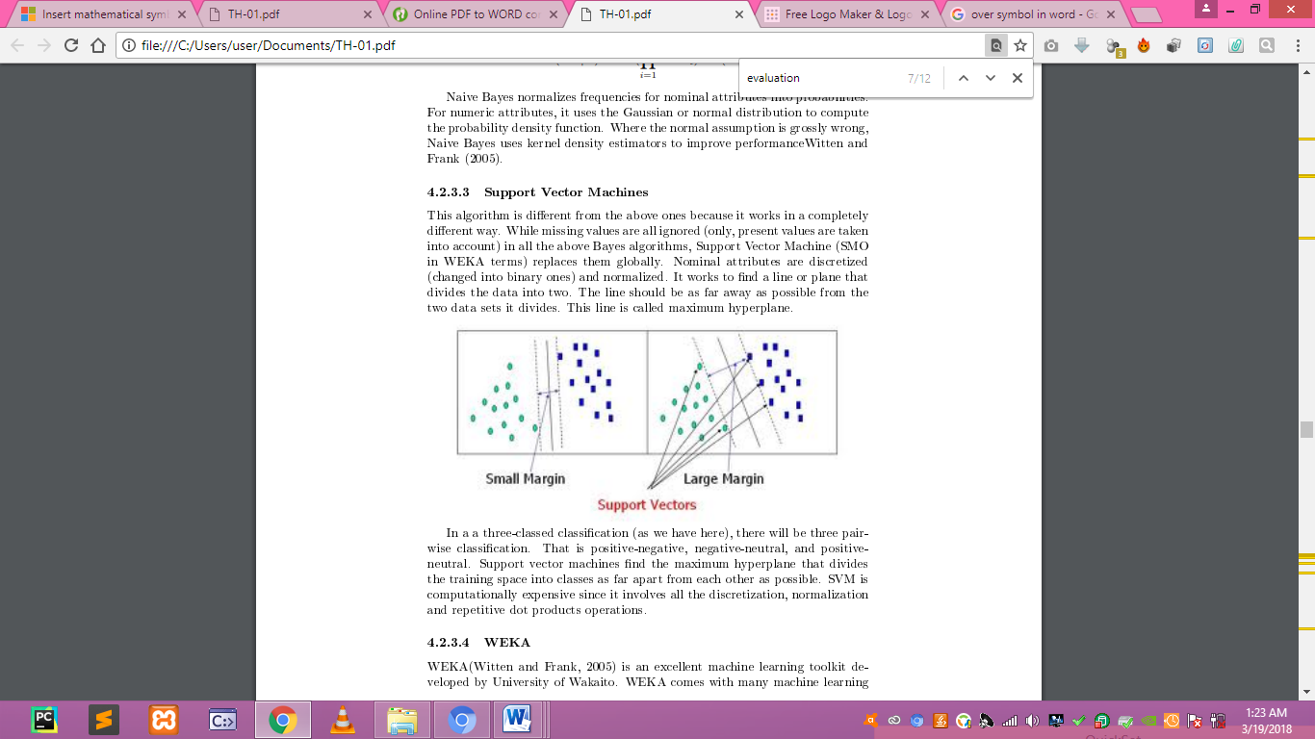

Figure 6. Support Vector Machine

For the text classification we used the supervised learning algorithm called Support Vector Machine. We use the SVMlight software with a linear kernel. Our input data are 3 sets of vectors of size m. Each entry in the vector corresponds to the presence a feature. For example, with a unigram feature extractor, each feature is a single word found in a tweet. If the feature is present, the value is 1, but if the feature is absent, then the value is 0. We use feature presence, as opposed to a count, so that we do not have to scale the input data, which speeds up overall processing.

*C) Confusion Matrix*

This part proves the proponents last objective that is to evaluate the accuracy of the developed application in terms of precision, f-measure, recall.

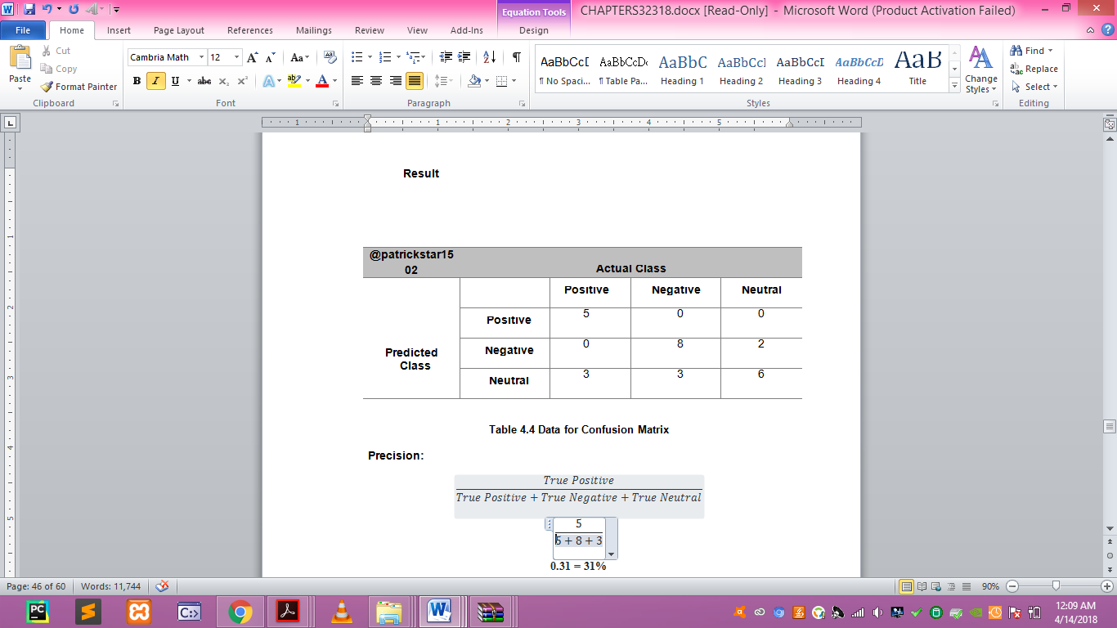

Table 1. Data for Confusion Matrix

1. *Precision*

**0.31 = 31%**

*2) Recall*

**0.62 = 62%**

*3) F-Measure*

**0.41 = 41%**

1. *Accuracy*
   1. **= 76%**

*D) Usability*

The respondents of the usability evaluation are the Registered Psychometricians who has a great knowledge about our study which is related to Psychology. The proponents used an evaluation form to get the usability of the system. The formula used to get the usability result is:

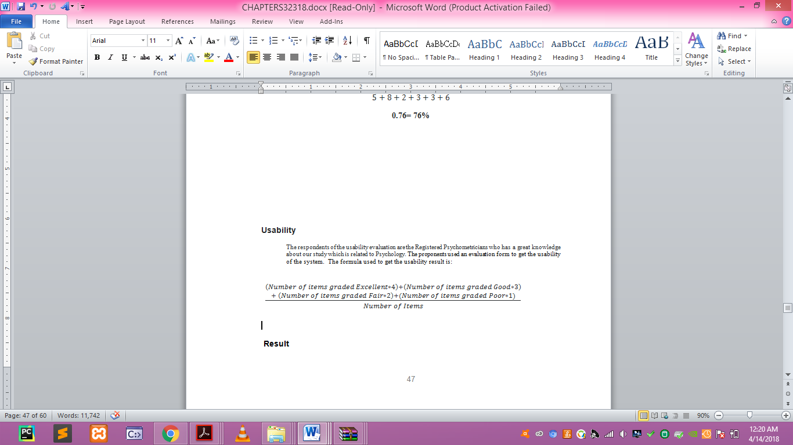

1. *Usability Result*

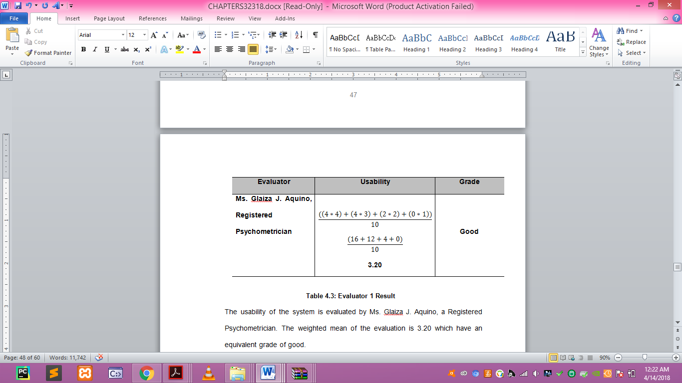

Table 2. Evaluator 1 Result

The usability of the system is evaluated by Ms. Glaiza J. Aquino, a Registered Psychometrician. The weighted mean of the evaluation is 3.20 which have an equivalent grade of good.

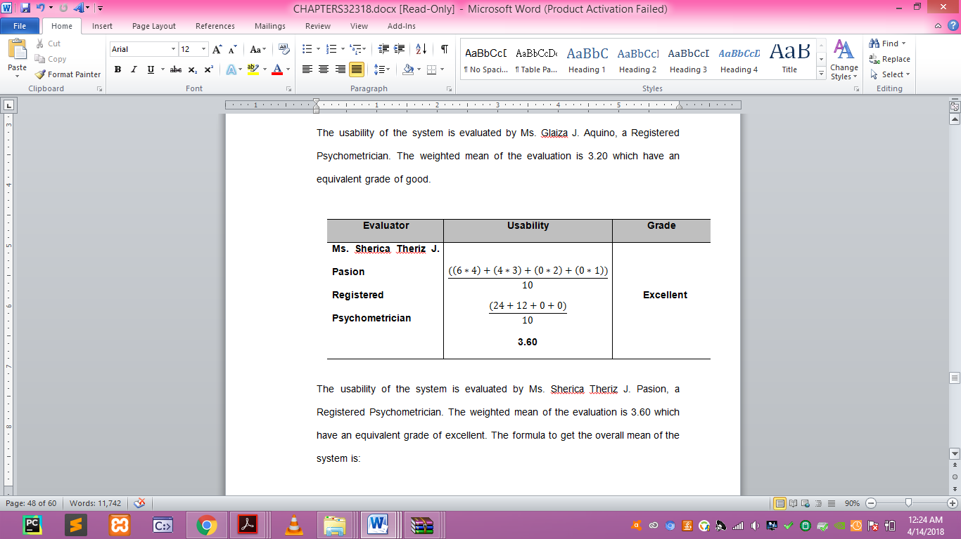

Table 3. Evaluator 2 Result

The usability of the system is evaluated by Ms. Sherica Theriz J. Pasion, a Registered Psychometrician. The weighted mean of the evaluation is 3.60 which have an equivalent grade of excellent. The formula to get the overall mean of the system is:

**Total Mean =**

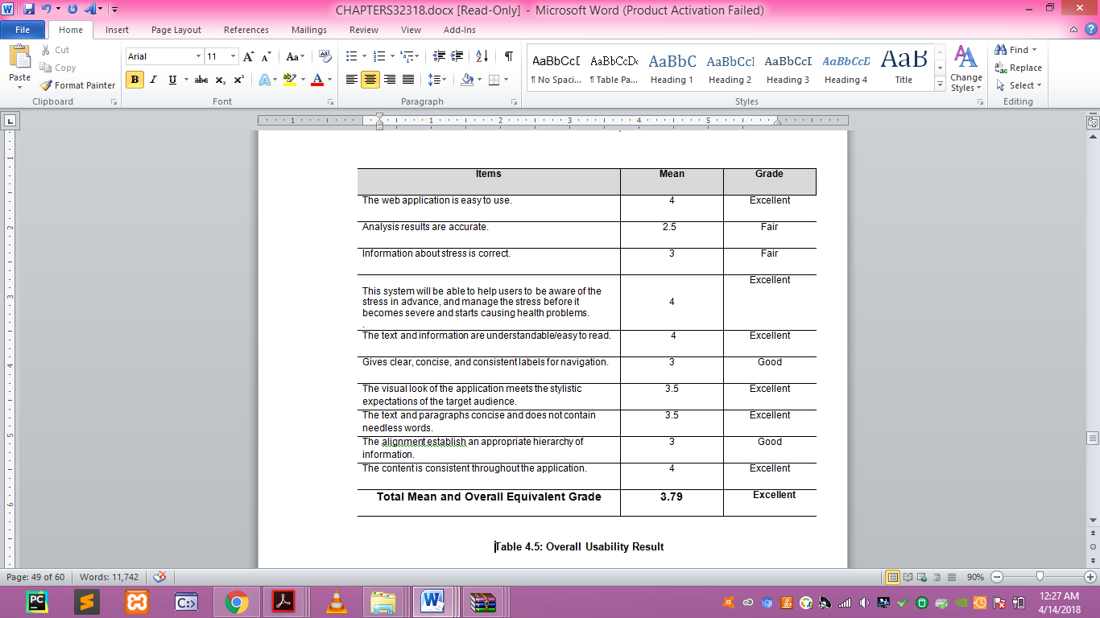

Table 5: Overall Usability Result

The overall mean is 3.79 which have an equivalent grade of Excellent.

1. **SUMMARY AND CONCLUSION**

Advances in natural language processing and machine learning are making the prospect of large-scale screening of social media for at-risk individuals a near-future possibility. This paper focuses on the broadest view of digital health with a comprehensive scheme for stress level estimation based on social media information. This study makes it feasible to analyze stress and other emotions on several online environments, specially twitter.

Our technique serves as an extra diagnostic tool for psychologists to help detect stress and monitor the emotions of patients, this developed application will also help every individual especially teenagers who are more active on social media to be aware of the stress in advance, and manage the stress before it becomes severe and starts causing health problems. To develop the system that can analyze stress from Twitter, the proponents used Natural Language Processing’s Sentiment Analysis with the help of a supervised machine learning algorithm called Support Vector Machine Algorithm for text classification. The proponents also used sentiment dictionaries like AFINN and Vader Sentiments with a total of 7000 words including emoticons, slangs, and hashtags for a more accurate analysis result. Analysis Results includes the Stressed words used by the twitter account, Sentiment Result, Percentage Rate, a Graph with the date and a total polarity count of every tweets, It also has a show tweets button that will show the recent tweets, the time and date it was published. The application also has a compilation feature that will compile the recent groups that was recently analyzed which may help social scientists to understand the quality of life of populations and measures public mood of people in a community, The system also provides facts and information about stress that can help every user to be aware of stress before it becomes severe and turns to depression. The application has proved to be useful with a usability grade of excellent that was evaluated by Registered Psychometricians and accuracy result of 76%.

**REFERENCES**

1. Perrin, A. (2015, October 8). *Social Media Usage: 2005-2015*.Retrieved from http://www.pewinternet.org/2015/10/08/social-networking-usage-2005-2015
2. Yiping Li, Jing Huang, Hao Wang, Ling Feng ‘Predicting Teens’ Future Stress Level from Microblog’, 2015
3. Newton, C. (2017, September 26). *Twitter just doubled the character limit for tweets to 280*
4. .Retrieved from https://www.theverge.com/2017/9/26/16363912/twitter-character-limit-increase-280-test
5. Segal, J., Smith, M., Segal, R., Lawrence, R. (2018, February). Stress Symptoms, Signs, and Causes. Retrieved from URL
6. Huijie Lin, Jia Jia, Quan Guo, Yuanyuan Xue, Jie Huang, Lianhong Cai, and Ling Feng. Psychological stress detection from cross-media microblog data using deep sparse neural network. In Proceedings of International Conference on Multimedia and Expo, pages 1–6. IEEE, 2014.
7. Yuanyuan Xue, Qi Li, Ling Feng, Gari D Clifford, and David A Clifton. Towards a micro-blog platform
8. for sensing and easing adolescent psychological pressures. In Proceedings of the ACM conference on Pervasive and ubiquitous computing adjunct publication, pages 215– 218. ACM, 2013.
9. Selye and others, 2016] Hans Selye et al. A syndrome produced by diverse nocuous agents. Nature, 138(3479):32, 2016.
10. [Lin et al., 2014b] Huijie Lin, Jia Jia, Quan Guo, Yuanyuan Xue, Qi Li, Jie Huang, Lianhong Cai, and Ling Feng. Userlevel psychological stress detection from social media using deep neural network. In Proceedings of ACM International Conference on Multimedia, pages 507–516. ACM, 2014.
11. Glen Coppersmith, Craig Harman, and Mark Dredze. Measuring post traumatic stress disorder in twitter. In Proceedings of the
12. International Conference on Weblogs and Social Media, pages 579–582, 2014.
13. Rui Fan, Jichang Zhao, Yan Chen, and Ke Xu. Anger is more influential than joy: Sentiment correlation in weibo. PLoS ONE,2014.
14. H. Lin, J. Jia, Q. Guo, Y. Xue, J. Huang, L. Cai, and L. Feng. Psychological stress detection from cross-media microblog data using deep sparse neural network. In proceedings of IEEE International Conference on Multimedia & Expo, 2014.
15. Mike Thelwall, Kevan Buckley, Georgios Paltoglou, Di Cai, and Arvid Kappas. Sentiment strength detection in short informal text. Journal of the American Society for Information Science and Technology, 61(12):2544–2558, 2015.
16. Yuan Zhang, Jie Tang, Jimeng Sun, Yiran Chen, and Jinghai Rao. Moodcast: Emotion prediction via dynamic continuous factor
17. graph model. 2013 IEEE 13th International Conference on Data Mining, pages 1193–1198, 2015.
18. Jichang Zhao, Li Dong, Junjie Wu, and Ke Xu. Moodlens: an emoticon-based sentiment analysis system for chinese tweets. In Proceedings of the 18th ACM SIGKDD international conference on Knowledge discovery and data mining, pages 1528–1531, 2013.
19. Golnoosh Farnadi, Geetha Sitaraman, Shanu Sushmita, Fabio Celli, Michal Kosinski, David Stillwell, Sergio Davalos, Marie Francine Moens, and Martine De Cock. Computational personality recognition in social media. User Modeling and User- Adapted Interaction, pages 1–34, 2016.
20. Jennifer Golbeck, Cristina Robles, Michon Edmondson, and Karen Turner. Predicting personality from twitter. In Passat/socialcom
21. 2011, Privacy, Security, Risk and Trust, pages 149–156, 2011.
22. Ben Verhoeven, Walter Daelemans, and Barbara Plank. Twisty: A multilingual twitter stylometry corpus for gender and personality profiling. In Proceedings of the Tenth International Conference on Language Resources and Evaluation LREC, pages 1632–1637, 2016.
23. Andrey Bogomolov, Bruno Lepri, Michela Ferron, Fabio Pianesi, and Alex Pentland. Daily stress recognition from mobile phone
24. data, weather conditions and individual traits. In ACM International Conference on Multimedia, pages 477–486, 2014.
25. Jichang Zhao, Li Dong, Junjie Wu, and Ke Xu. Moodlens: an emoticon-based sentiment analysis system for chinese tweets. In
26. Proceedings of the 18th ACM SIGKDD international conference on Knowledge discovery and data mining, pages 1528–1531, 2012.
27. Rui Fan, Jichang Zhao, Yan Chen, and Ke Xu. Anger is more influential than joy: Sentiment correlation in weibo. PLoS ONE, 2014.
28. Lu, H., Frauendorfer, D., Rabbi, M., Mast, M. S., Chittaranjan, G. T., Campbell, A. T., ... & Choudhury, T. (2012, September). StressSense: Detecting stress in unconstrained acoustic environments using smartphones. In Proceedings of the 2012 ACM Conference on Ubiquitous Computing (pp. 351-360). ACM.
29. Paredes, P., Sun, D., & Canny, J. (2013, May). Sensor-less sensing for affective computing and stress management technology. In Pervasive Computing Technologies for Healthcare (PervasiveHealth), 2013 7th International Conference on (pp. 459-463). IEEE.

1.