

**STRESS ANALYSIS FOR TWITTER POST USING**

**NATURAL LANGUAGE PROCESSING’S SENTIMENT ANALYSIS**

**INSTALLATION MANUAL**

Dr. Marc P. Laureta

Thesis Adviser, CCS

New Era University

Joenalyn S. Sigua Kurt Russel Palines

Proponent 1 Proponent 2

CCS, New Era University CCS, New Era University

Dr. Marc P. Laureta

Thesis Adviser, CCS

New Era University

Joenalyn S. Sigua Kurt Russel Palines

Proponent 1 Proponent 2

CCS, New Era University CCS, New Era University

Dr. Marc P. Laureta

Thesis Adviser, CCS

New Era University

Joenalyn S. Sigua Kurt Russel Palines

Proponent 1 Proponent 2

CCS, New Era University CCS, New Era University

Joenalyn Sigua

Proponent, CCS

New Era University

1. First, you’ll need to download and install Microsoft Visual Studio 2015 Community Edition. It is free and you can download it from the following link if you don’t have it.

<https://imagine.microsoft.com/en-us/Catalog/Product/101>

1. You’ll also need to register for Twitter API. To do that follow the following link: <https://dev.twitter.com/rest/public>
2. You’ll need to create an account and then create an App. You’ll be provided with 4 keys which are the following
   1. Consumer Key
   2. Consumer Secret
   3. Access Token
   4. Access Token Secret
3. Once you have all the keys, open the folder named BackEnd, open folder named Twitter and open file named Twitter.csproj. Make sure it runs in your Microsoft Visual Studio 2015. It will look like this once opened.

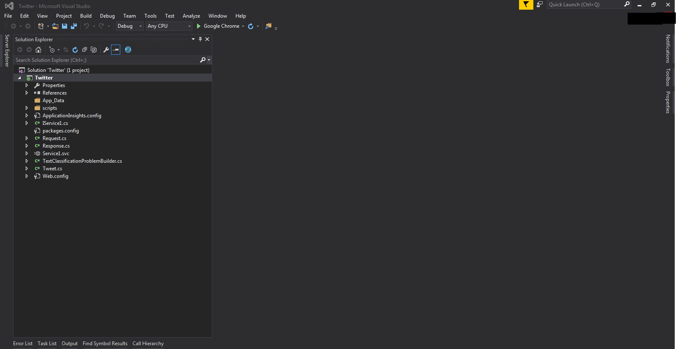

1. Click on item from the list on left hand side which says Service1.svc

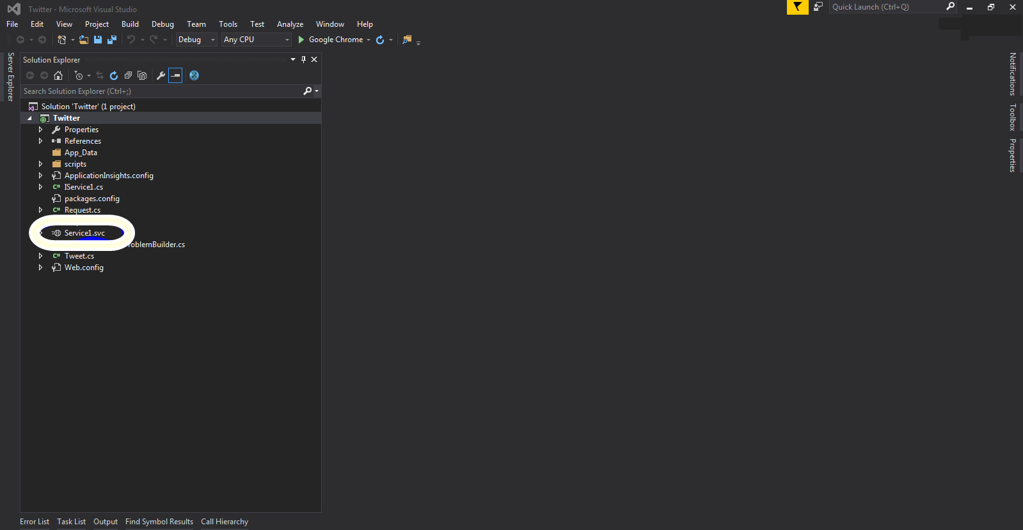

1. When you open the file, you have to enter you Twitter API keys you got in step 3 in the section circled below. Do keep in mind you have to enter every key against its name and inside the double quotes (“”). You just have to replace the wording insides the quotes with your keys.

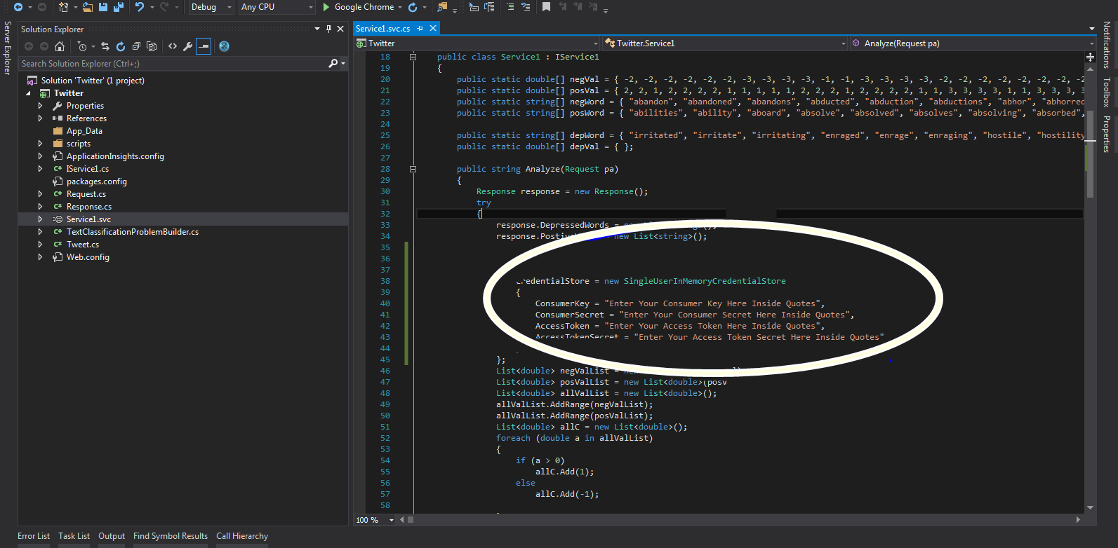

1. You can add your words to the following list named negWord just follow the syntax. For each word you add you have to add its corresponding score in the list named negVal.

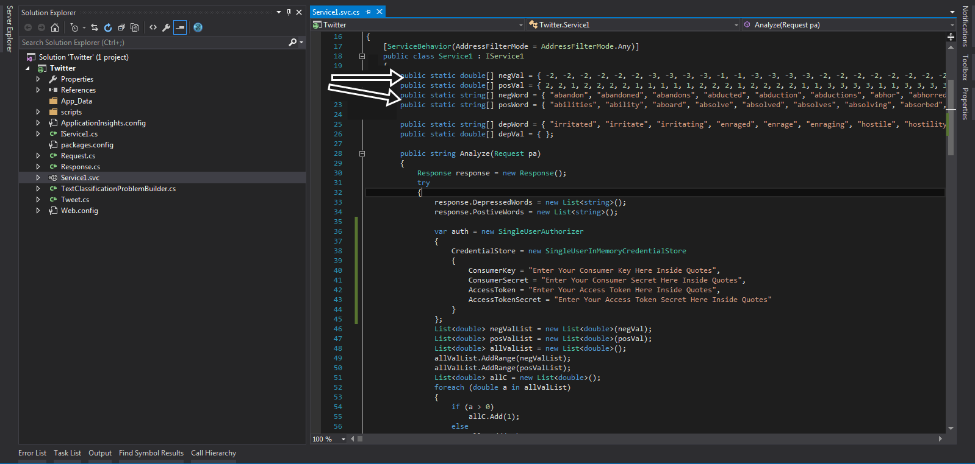

1. As you can see, all the words are given a weight depending upon their severity. But the current implemented logic does not classify them in only 2 values i.e., Positive and Negative. You can easily change that. Just find the lines shown in the following images. You need to replace the text in the section encircled in the image below

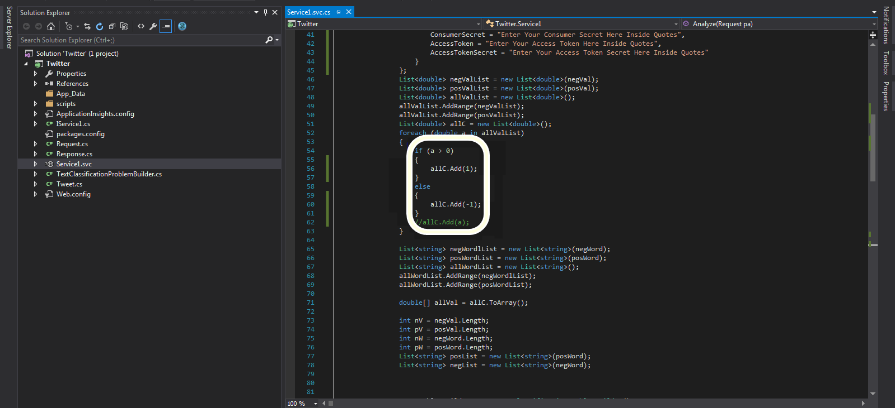

With the text in the image below.

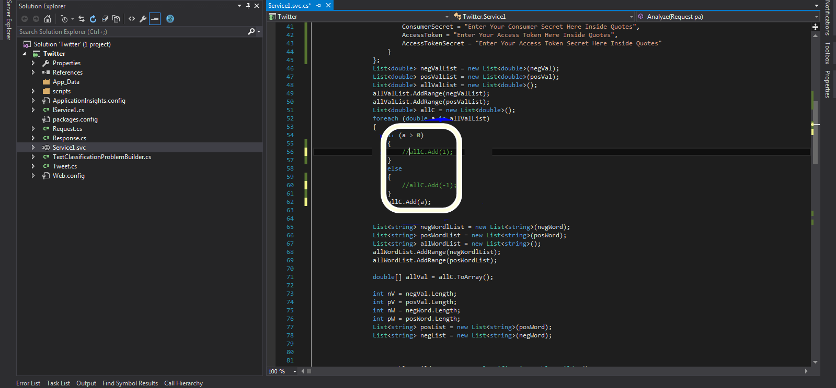

Similarly, replace the text in this one

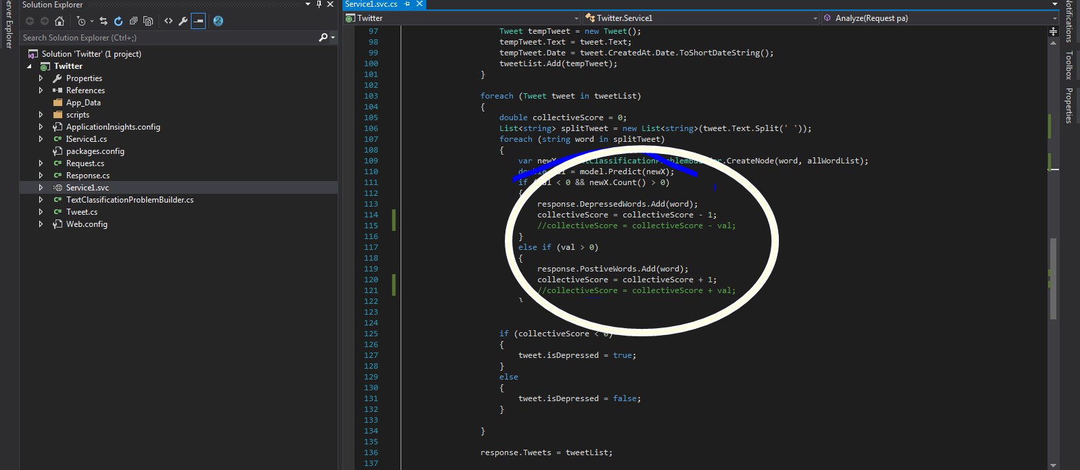

With the following

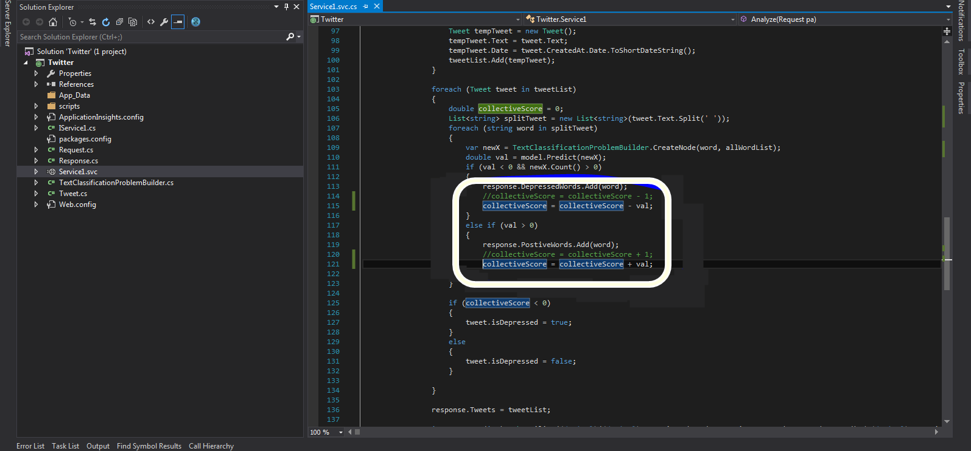

1. Once done, all you need now is to run the project and your backend will be ready. To run the project, you’ll need to press Ctrl+F5
2. You’ll see a window like the following, that means you have successfully run your project.

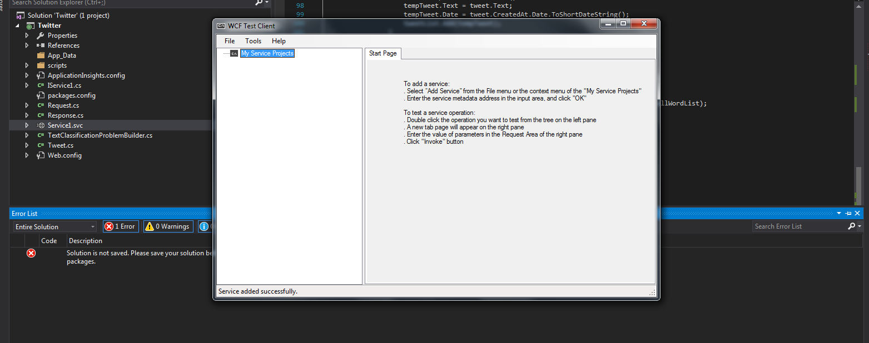

1. Before we head to the front end. Click on the Main project twitter as shown in the image below

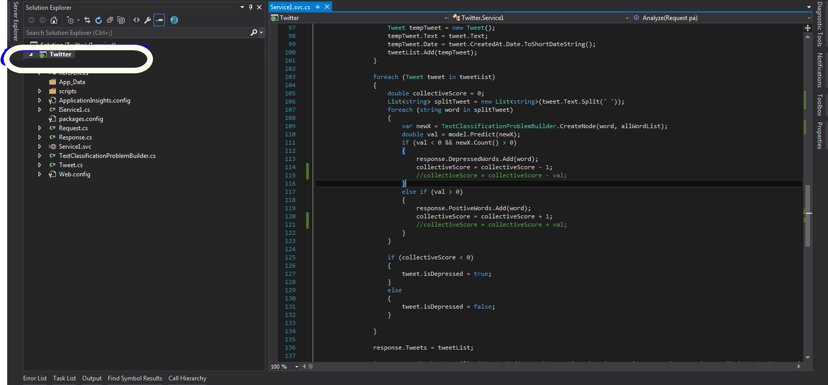

1. After clicking there, you need to click on the properties tab on the right hand side and note the URL as shown in following image

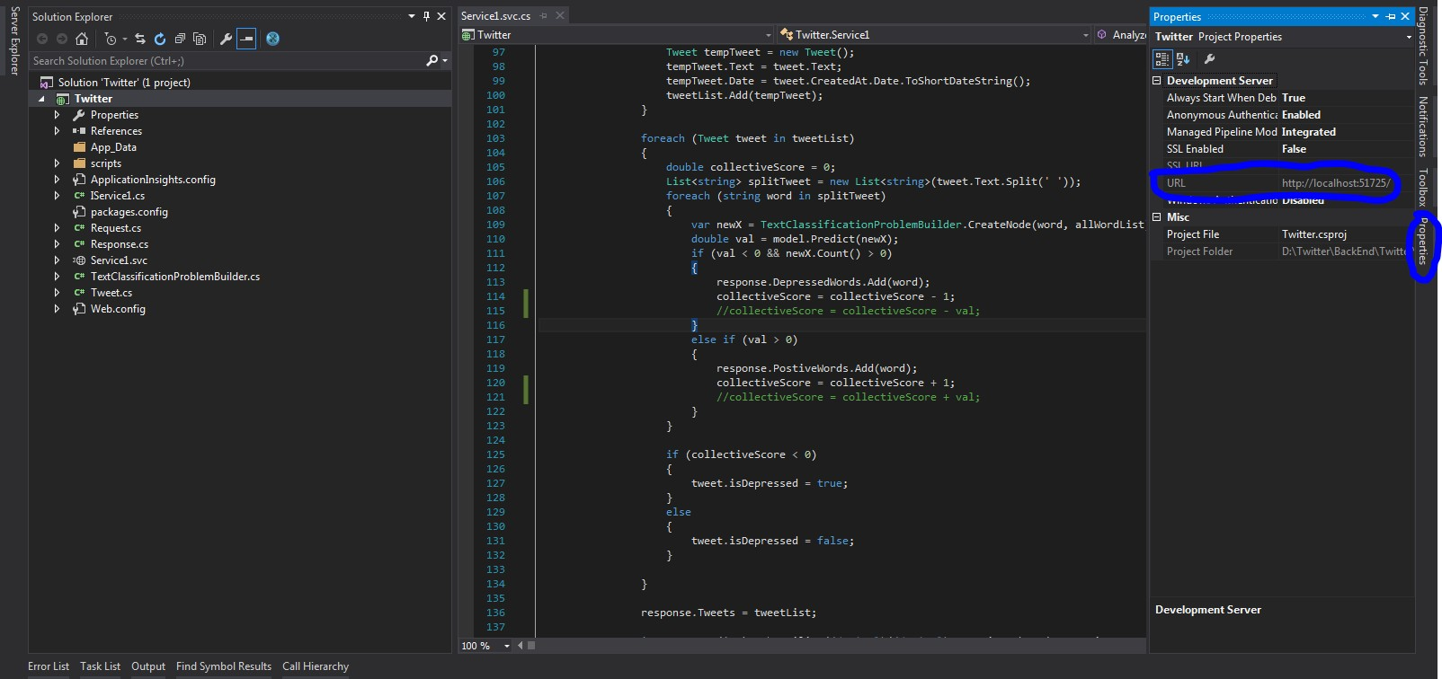

Save the url. You just have to change this url in the front end and you’ll be good to go.

1. Now open the folder named FrontEnd, go to folder named AngularPatient and open file named Twitter.csproj. Again make sure it runs in Microsoft Visual Studio 2015

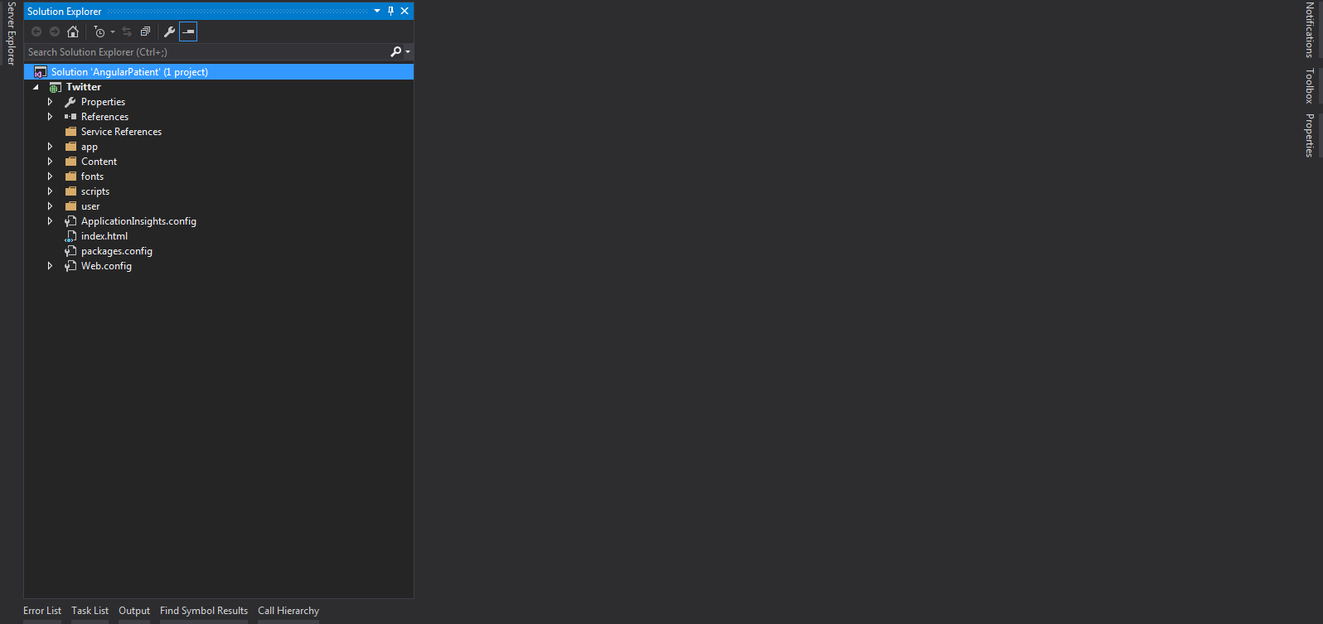

1. Expand the folder named user.

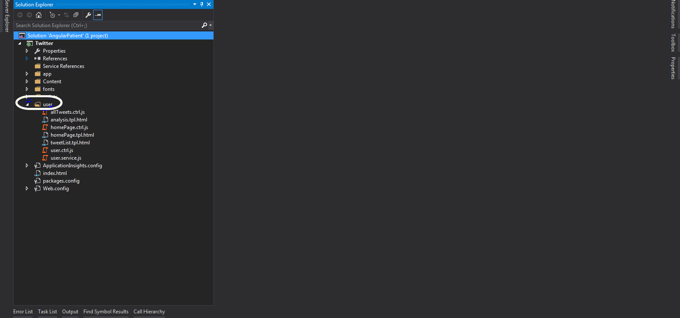

1. Open the file named user.service.js inside the user folder

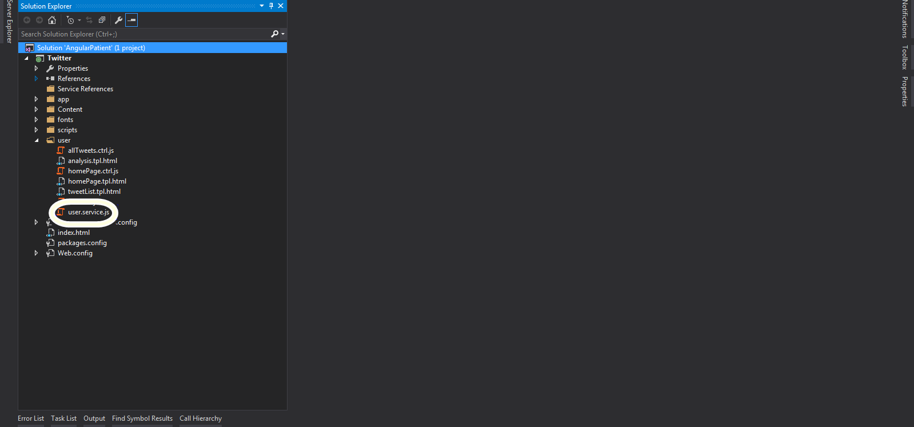

It will look like this

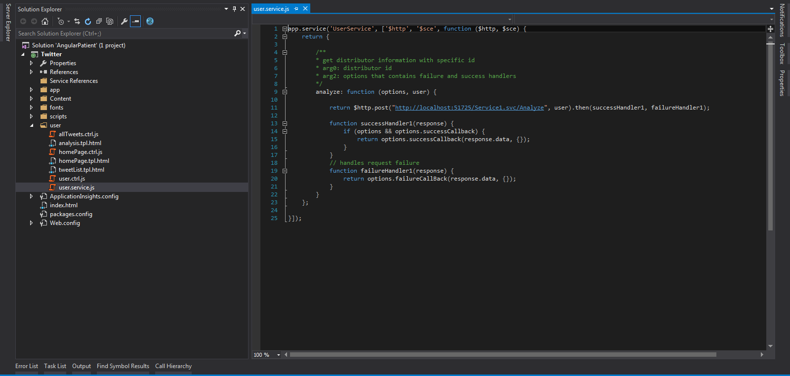

1. All you need to do is to replace the number encircled with the number in the url you saved earlier.

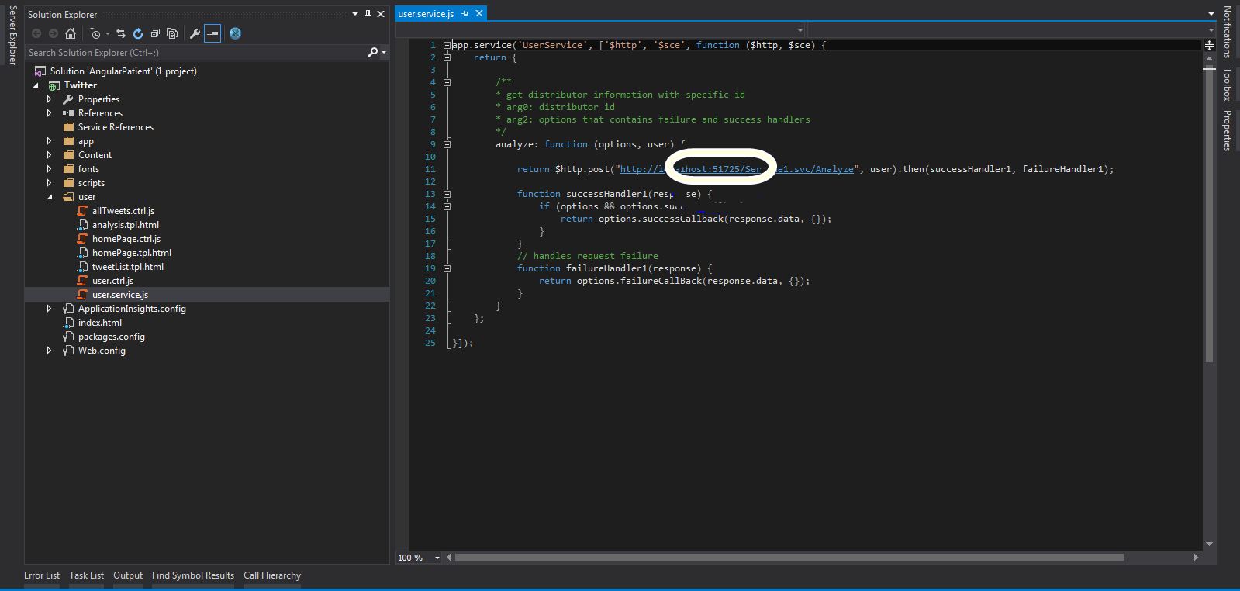

1. After replacing the number, just press Ctrl+F5 and your application will run in your default browser. Keep in mind the previous project should be running the background for your application to run properly.
2. First of all you need to repeat the step 16 for all the urls in the user.service.js
3. Install SQL Server Management Studio 2012 along with SQL Server
4. Open the SQL Server Management Studio
5. Click on the encircled icon

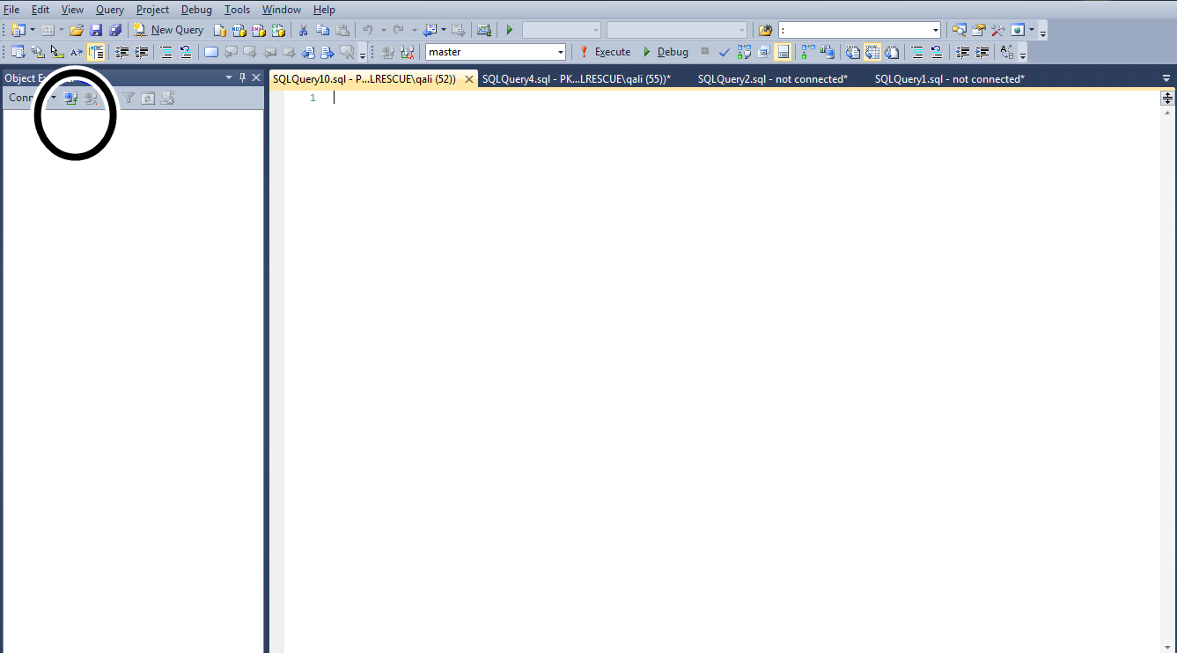

1. A pop-up will open. Against ‘Server Name’ it should display the name of the sql server installed on your system. Note it down. Against ‘Authentication’ it should be ‘Windows Authentication’. If everything is fine click connect.

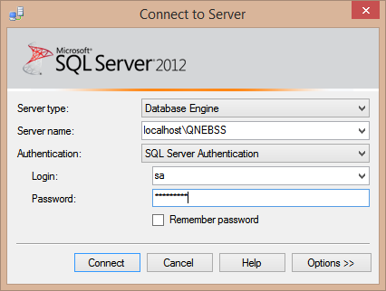

1. You’ll see the details of your sql server on the left side pane of Management Studio.

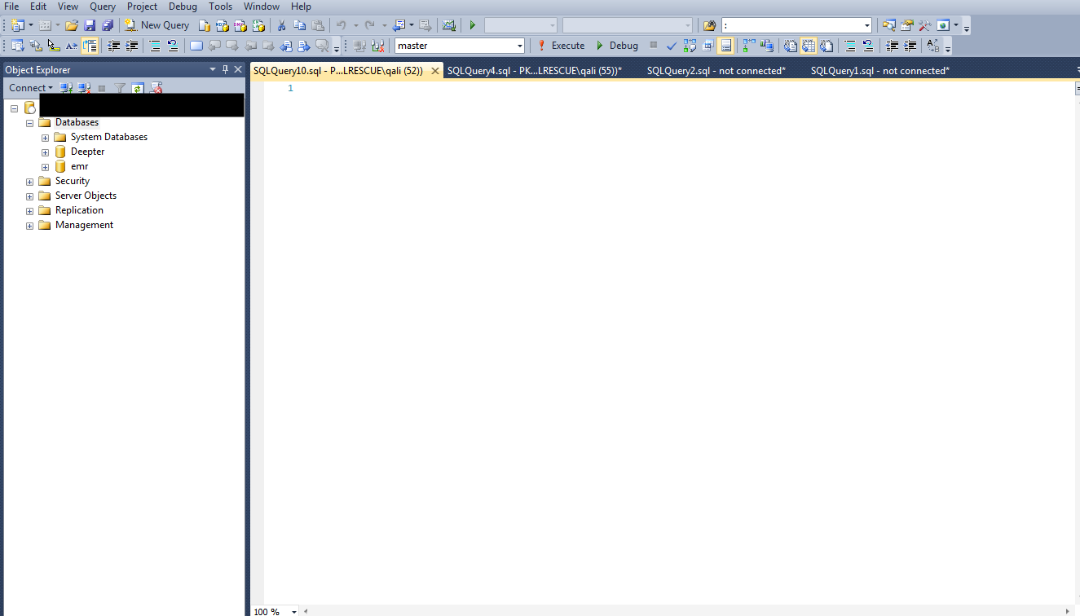

1. Right Click on the Databases folder shown in the image above. A menu will open, select ‘New Database’ from the menu. Another pop-up will open, enter ‘Deepter’ in the encircled box. *Make sure you enter Deepter as it is*

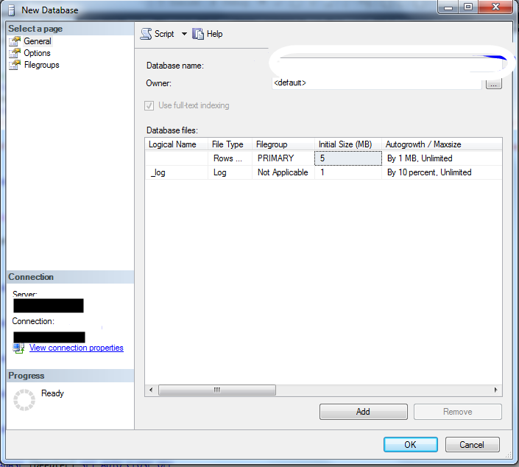

1. Again right on the Databases folder and select ‘Refresh’. Now if you expand the Databases folder, you’ll see ‘Deepter’ there. Expand ‘Deepter’.

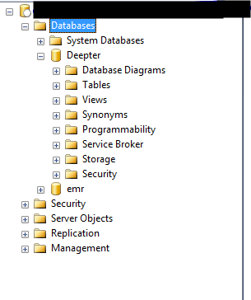

1. Right click on Deepter folder and click ‘New Query’. Another tab will open. You’ll find three .sql files in the folder given to along with the images. Open these files one by one in text file and copy paste all the contents in the tab that was opened on clicking ‘New Query’.

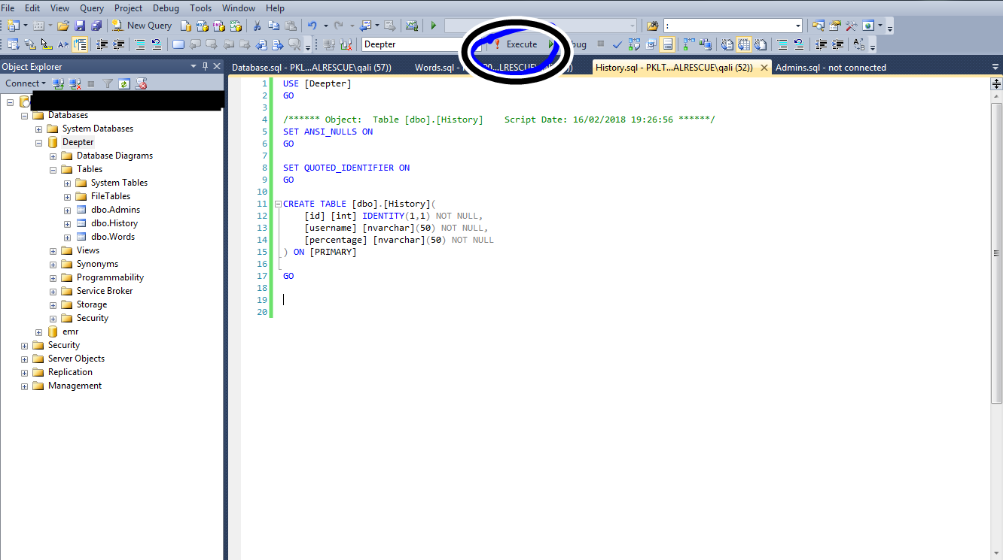

1. After you successfully all the queries from the three .sql files you should be able to see the three tables under Tables folder of Deepter as you can see in above image.
2. You have to run another query to create an admin record. Just execute the following query in the query window and execute it. Use [Deepter] insert into admins (username, password) values(‘Your Username’,’Your Password’);
3. Your database is successfully setup. Now go to the Backend Project and replace “KRQP” with your server name that you noted down from step 22.
4. Keep in mind the following points:
   1. You have to go to admin panel first and click on import button.
   2. Don’t click any button multiple times especially Import button (It will duplicate the record)