**Labeling Twitter Users as Stressed or Non-Stressed Using Core Affect Model**

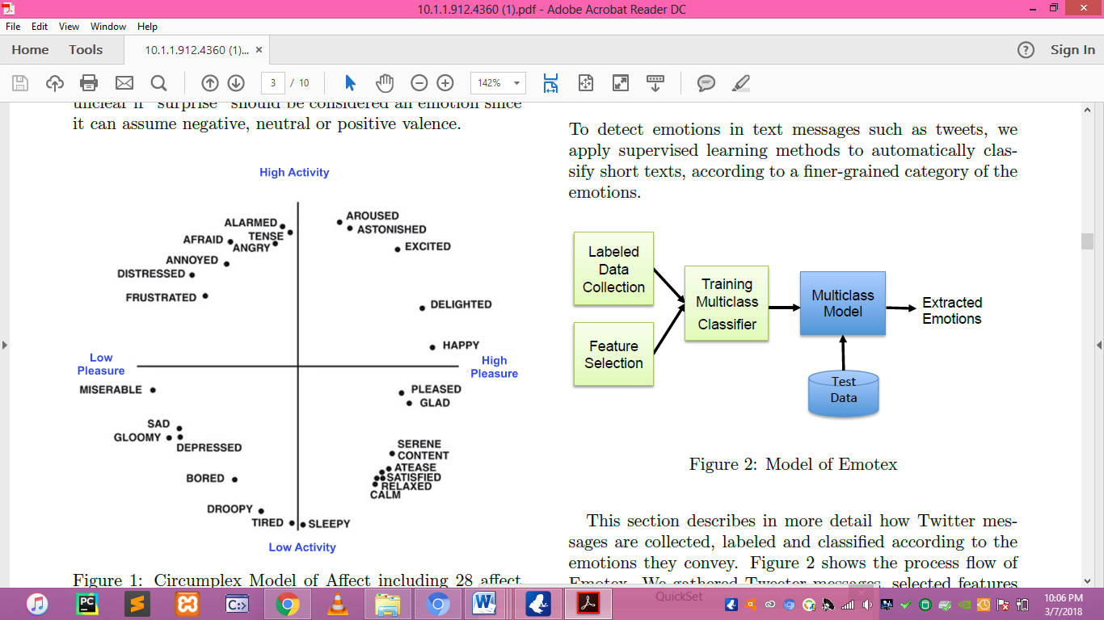

**Figure (**Circumplex Model of Affect including 28 affect words)

Despite of the basic emotions model which defines discrete emotions, the core affect model defines emotion on a continuous scale. Core affect model of emotion characterizes human emotions by defining their positions along two or three dimensions. That is, most dimensional models incorporate valence and arousal dimensions. One of the very first practical models of core affect is Russell's Circumplex Model of Affect As shown in Figure 4.4, the model suggests that emotions are distributed in a two-dimensional circular space, containing pleasure and activation dimensions. The activation dimension measures if one is likely to take an action in a mood state. The pleasure dimension measures how positive or negative a person feels. The vertical axis represents activation or arousal, and horizontal axis represents pleasure or valence. The center of the circle represents a neutral valence and a medium level of arousal.’

The Circumplex model has been well validated and widely used in other studies. We utilize the Circumplex model by considering four major classes of emotions: Happy- Active, Happy-Inactive, Unhappy-Active, and Unhappy- Inactive. This model is simple, and describes a wide range of emotional states we have selected for our work. Moreover the four classes of emotions are very distinct, because each class constitutes emotions which are quite different com- pared with the emotions of other classes.

In order to collect labeled data, we identified the list of keywords corresponding to each class of emotions. As we mentioned, we selected 4 classes of emotions namely Happy-Active, Happy-Inactive, Unhappy-Active, and Unhappy-Inactive. First we selected an initial set of keywords for each category from the Circumplex model as shown in the Figure below. We only selected those keywords which are very distinct and distinguishable from other classes. We ignored the keywords that are located close to the boundary of four dimensions. The initial list of keywords are listed below:

|  |  |
| --- | --- |
| Class | Hash-tags |
| Happy- | overjoyed, enjoy, excited, |
| Active | proud, joyful, happy,so happy, |
|  | veryhappy, happy, #superhappy, |
|  | #happytweet, blessed, |
|  | amazing, wonderful, excelent, |
|  | delighted, enthusiastic |
|  | example: Thankful for unex- |
|  | pected time with one of my best |
|  | friends #happy |
| Happy- | calm, calming, peaceful, quiet, |
| Inactive | silent, serene, convinced, consent, |
|  | contented, contentment, satisfied, |
|  | relax, relaxed, relaxing, sleepy, |
|  | sleepyhead, asleep, resting, rest- |
|  | ful, placid |
|  | example: ready for a relaxing |
|  | day of doing nothing #relaxing |
| Unhappy- | nervous, anxious, tension, afraid, |
| Active | fearful,angry, annoyed, annoying, |
|  | stress, distressed, distress, stressful |
|  | stressed, worried,tense, bothered, |
|  | disturbed, irritated, mad, furious |
|  | example: I have my speech in |
|  | less than minutes #nervous |
| Unhappy- | sad, #ifeelsad, #feelsad, sosad, |
| Inactive | Very sad, sorrow, disappointed, |
|  | Super sad, miserable, hopeless, |
|  | depress, depressed, depression, |
|  | fatigued, gloomy, nothappy, |
|  | unhappy, suicidal, downhearted, |
|  | hapless, dispirited |
|  | example: Sometimes people let |
|  | you down and it hurts. #sad |

Table : List of keywords for each emotion class

3 sample twitter accounts with the keywords used in their last 20 tweets

|  |  |
| --- | --- |
| Username: Patrickstar1502 | Keywords |
| Happy-Active | Excited, Thank, Love, Best |
| Happy-Inactive | Rest, sleep, |
| Unhappy-Active | Stressed, Toxic, Hectic, Pissed, Stressful, Tired |
| Unhappy- Inactive | Annoying, Swallowed, Killing, Overwhelming |

|  |  |
| --- | --- |
| Username: djeanfox | Keywords |
| Happy-Active | Good, Thank, Happiness(2) |
| Happy-Inactive | Live, Cherish, Extended |
| Unhappy-Active | Stressed, Hungry, Ugly, Miss, Worry |
| Unhappy- Inactive | Pain |

Identifying Emotion Results

|  |  |  |  |
| --- | --- | --- | --- |
| **Username** | **Number of tweets** | **Class** | **Label** |
| **@patrickstar1502** | **20** | **Unhappy-Active** | **Stressed** |
| **@djeanfox** | **20** | **Happy- Inactive** | **Non-stressed** |

**Labeling Twitter Posts**

For labeling the data we used the result that was shown at the graph figure 4. Table 4 represents the result of emotion used by the 2 twitter account samples. @djeanfox labeled as Non-Stressed and @patrickstar1502 labeled as Stressed.

For computing the emotion used by the two twitter accounts, we used the formula below:

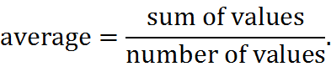

**Result:**

happy-active – 8/20 = 40%

happy-Inactive - 6/20 = 30%

Unhappy –Active – 10/20 = 50%

Unhappy - Inactive – 5/10 = 25%

The result showed that the average emotion used by @Patrickstar1502 and @djeanfox in their 20 tweets is Happy-Inactive with the words, stressed, worry, hectic, toxic and other words, with 50% average result in their overall tweets.