

**STRESS ANALYSIS FOR TWITTER POST USING**

**NATURAL LANGUAGE PROCESSING’S SENTIMENT ANALYSIS**

**USER MANUAL**

Dr. Marc P. Laureta

Thesis Adviser, CCS

New Era University

Joenalyn S. Sigua Kurt Russel Palines

Proponent 1 Proponent 2

CCS, New Era University CCS, New Era University

Dr. Marc P. Laureta

Thesis Adviser, CCS

New Era University

Joenalyn S. Sigua Kurt Russel Palines

Proponent 1 Proponent 2

CCS, New Era University CCS, New Era University

Dr. Marc P. Laureta

Thesis Adviser, CCS

New Era University

Joenalyn S. Sigua Kurt Russel Palines

Proponent 1 Proponent 2

CCS, New Era University CCS, New Era University

Joenalyn S. Sigua

Proponent

CCS, New Era University

1. **Getting Twitter Data**

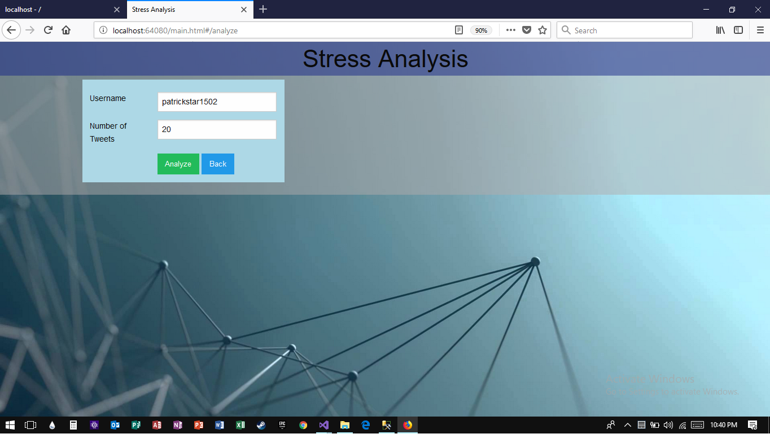

To analyze a Twitter Account. The user first need to input the *Twitter username* and the *number of tweets* he/she wants to analyze.

Choose the:

* *Analyze button:* to analyze the Twitter account
* *Back button:* to go back to the home page

**\* Note:** The system can only access public Twitter account.

1. **Analysis Result**

After clicking the analyze button, the following results will show at the right side of the screen:

* Overall sentiment result of the analyzed tweets

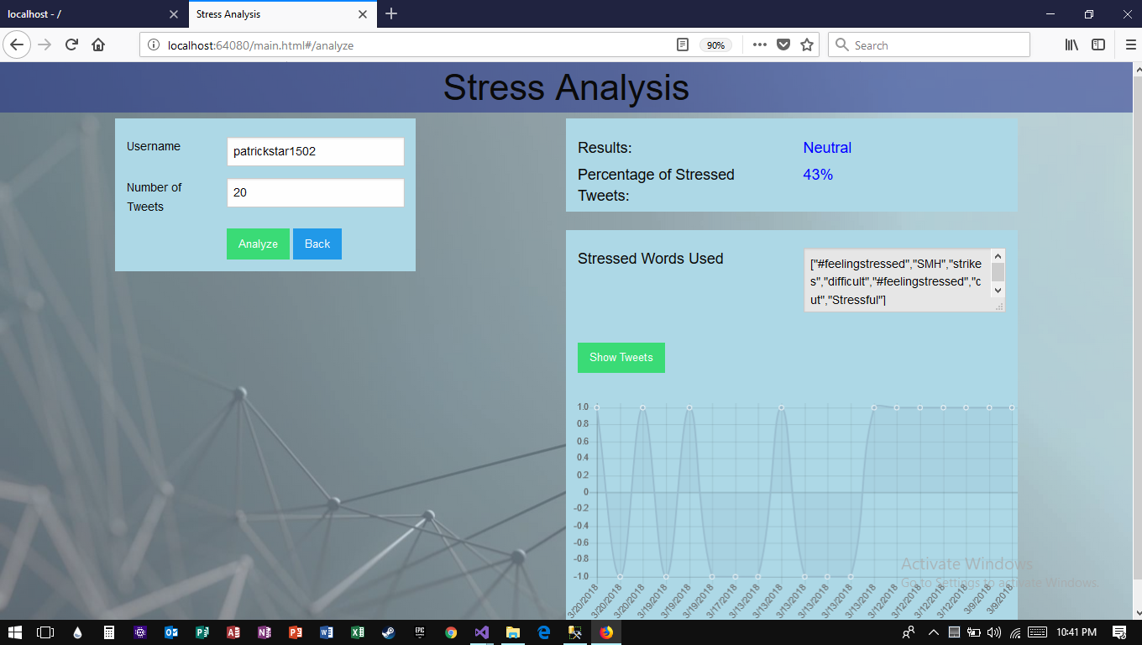

Results:

* Positive: *1% 20%*
* Neutral: *20% 60%*
* Negative: *60% and above*
* Stressed words used



* **Graph**



At the bottom part of the Analysis result, is a Graphical Representation

that shows the *date tweets were posted* and the *polarity result of every tweet*.

Click the *show tweets button* on top of the Graph to view all the information and result of all the tweets.

1. **Show Tweets**

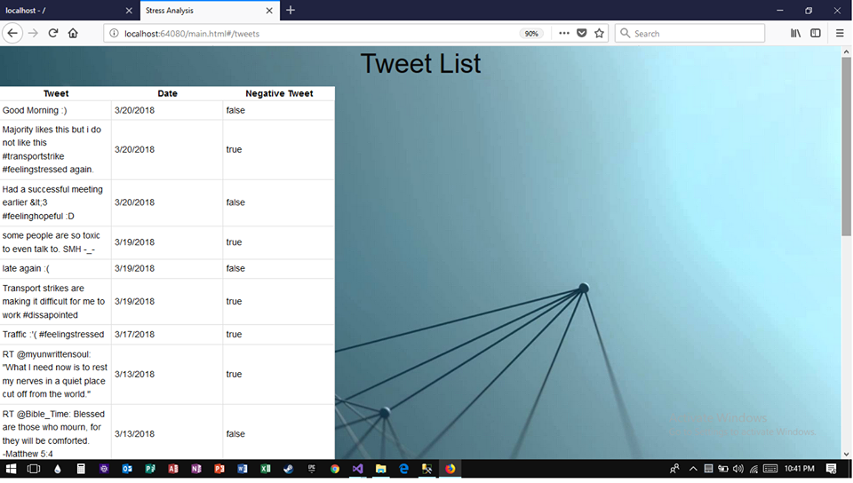

After clicking the Show Tweets Button, this page will show the user the following:

* *Tweets*
* *Date*
* *Is Negative Tweet (True if it is a negative tweet, and False if it is a positive tweet)*

1. **Stress Information Link**

This link is divided into 8 Stress Information Categories:

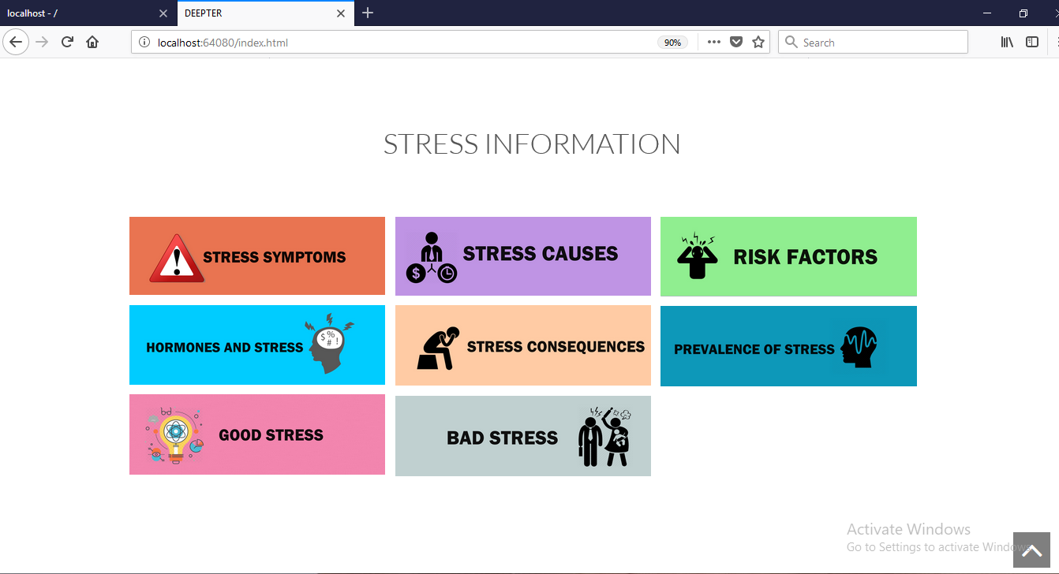

This link will help the users of the web app to be aware of the stress in advance, and manage the stress before it becomes severe and starts causing health problems.

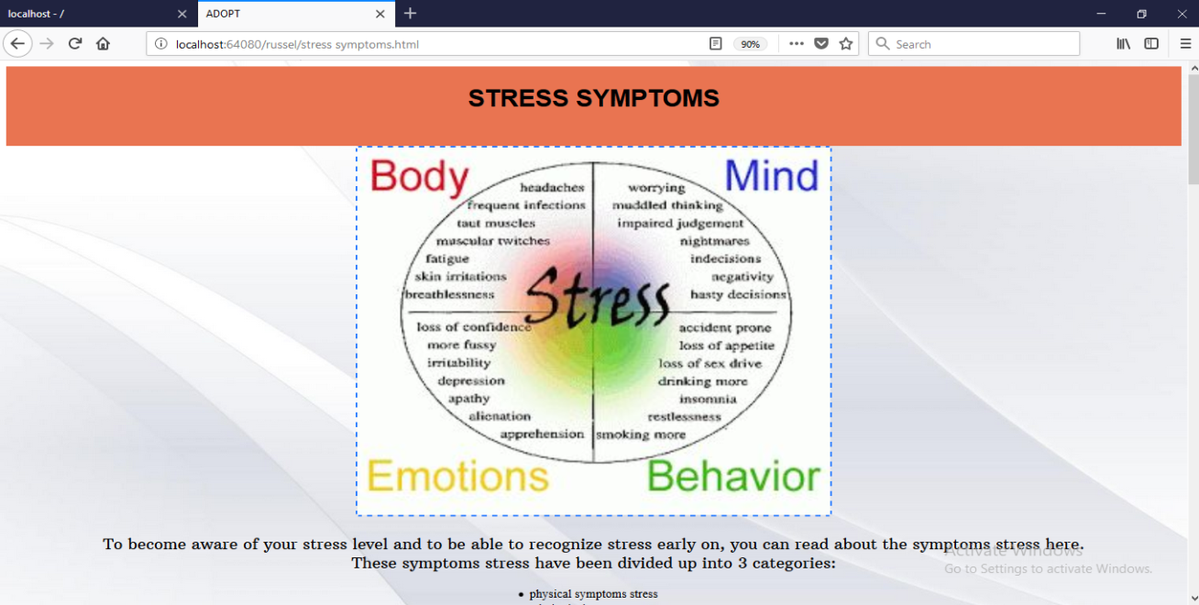

The information regarding stress is gathered from many reliable psychological sites and dictionaries.

1. **Stress Facts**

This link contains the *tips* and a *‘must know’* facts for the user that will help them manage and fight Stress.

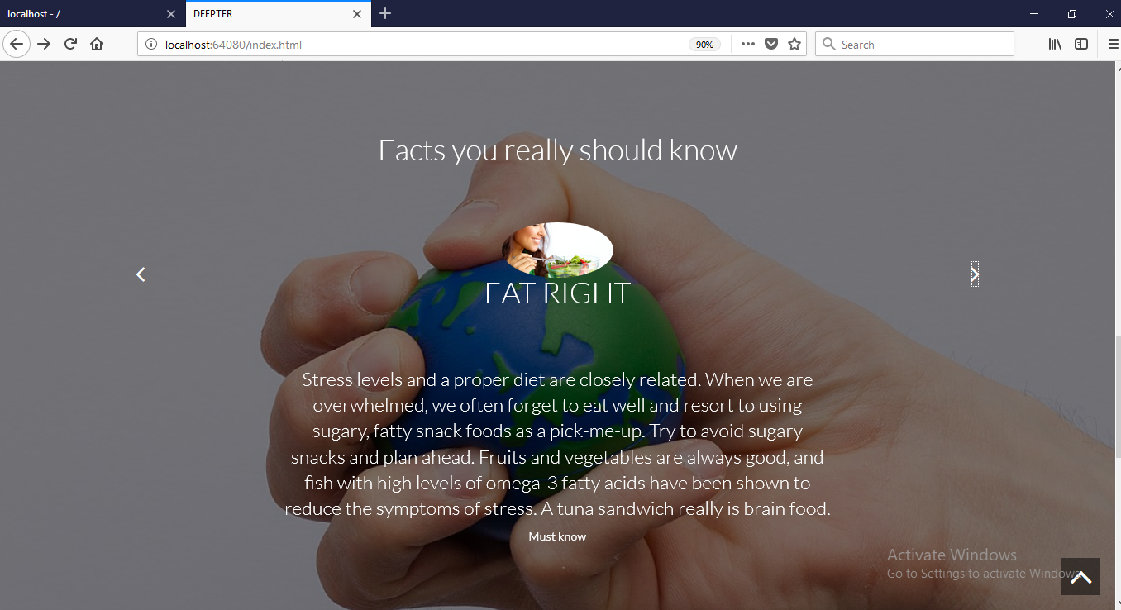

1. **Compilation Result**

This page will show the user the graph of recently analyzed Twitter Accounts with their Percentage Result.

