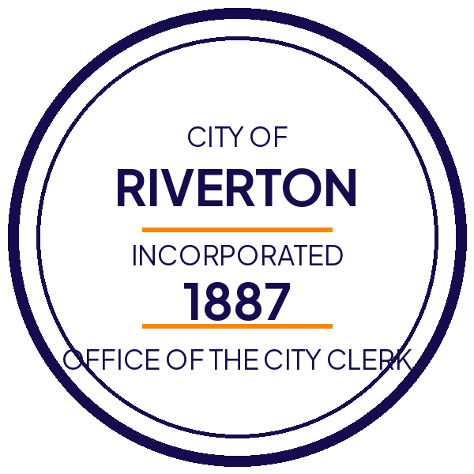
City of Riverton
Regular meeting of the City Council
Thursday, March 12, 2026 · 6:00 p.m. · Council Chambers, 200 Main Street
Attending the meeting
- Chambers open to the public at 5:45 p.m.
- Overflow seating in the lobby with live audio
- Accessible entrance on the Water Street side
- Requests for accommodation: contact the Clerk 48 hours ahead
Agenda items
# | Item | Presenter | Time
1. | Call to order and roll call | Mayor Álvarez | 6:00 p.m.
2. | Approval of minutes, February 26 | City Clerk | 6:05 p.m.
3. | Public comment on non-agenda items | Chair | 6:10 p.m.
4. | Ordinance 2026-14, sidewalk repair program | Public Works | 6:30 p.m.
5. | Fiscal year 2027 budget presentation | Finance | 6:50 p.m.
6. | Parks master plan update | Parks & Rec | 7:15 p.m.
7. | Council member reports | All | 7:35 p.m.
8. | Adjournment | Chair | 7:50 p.m.
Watch or participate remotely
To join the meeting online or watch the recording afterward, click here.
Posted by the Office of the City Clerk, March 5, 2026.

