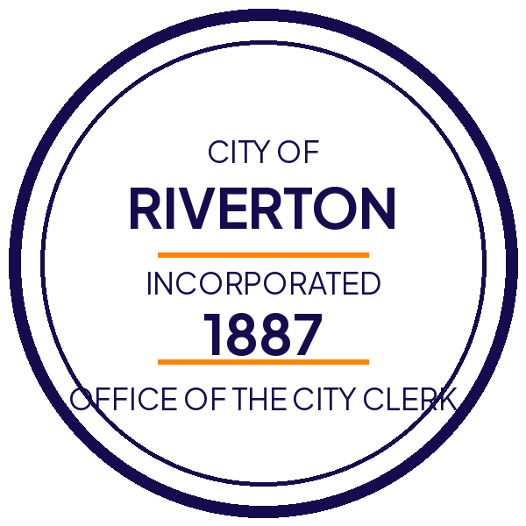

Public notice: water main replacement on Mill Street
Posted March 20, 2026 by the Department of Public Works

What is happening
The city will replace roughly 1,800 feet of water main under Mill Street between Water Street and Rail Avenue. The pipe dates to 1954 and has failed three times since 2023. Work begins Monday, April 6 and is expected to finish by Friday, May 15.

What to expect
- Water service will be interrupted for up to six hours on the day your block is connected. You will get a door hanger 48 hours ahead.
- Mill Street will be one lane, alternating, from 7:00 a.m. to 5:00 p.m. on weekdays.
- Parking on the east side of Mill Street is suspended for the duration.
- Trash and recycling collection stays on its normal schedule. Place carts at the curb as usual.

Schedule by block
Block | Service interruption | Detour in effect
100 to 199 Mill | April 6 to April 10 | April 6 to April 17
200 to 299 Mill | April 13 to April 17 | April 6 to April 24
300 to 399 Mill | April 20 to April 24 | April 17 to May 1
400 to 499 Mill | April 27 to May 1 | April 24 to May 15

Questions and accommodations
Call Public Works at (555) 555-0142, or read the full Mill Street project page. If you need this notice in another format or another language, contact the City Clerk at least 48 hours in advance.

