School: BMAT Epping St Johns & Royal Docks

Date: 16.03.22
Report: Remote consultation
DPE: Lindsey Smith
School member: Julia Warner & Deb McFarlane

Thank you, Julia & Debbie, for taking the time to meet with me today. As you both explained to me there’s no previous experience of being responsible for GDPR and we agreed to take small steps on regular intervals to embed the practice.

Priorities from the consultation are detailed below:
- Policies and Procedures
- Logging onto GDPRiS and recording of Breaches/Data Rights Requests
- Staff Training
- Data Retention

- Policies and Procedures
I conducted a review of the data protection documents published on both schools’ websites and they have up to date Data Protection Policies, Privacy Notices for Pupils & Parents and an FOI Policy.

DP Policy Epping St Johns – up to date | DP Policy Royal Docks – up to date
Privacy Notices Epping St Johns – pupils and parents, up to date | Privacy Notices Royal Docks – pupils and parents, up to date
FOI Policy & Publication Scheme Epping – up to date | FOI Policy & Publication Scheme Royal – up to date

I would recommend having internal procedures in place for reporting and recording data breaches and SARs. Attached to this report are some model documents for you to adopt.

- Logging onto GDPRiS and recording of breaches/data rights requests
- Follow this link to sign in: GDPRiS Sign In If you have forgotten your credentials, follow steps to ‘forgotten my password’ and reset. (I’ve checked both logins and there are active accounts for Julia & Debbie at your respective schools).
- Go to ‘Administration’ > ‘User Management’
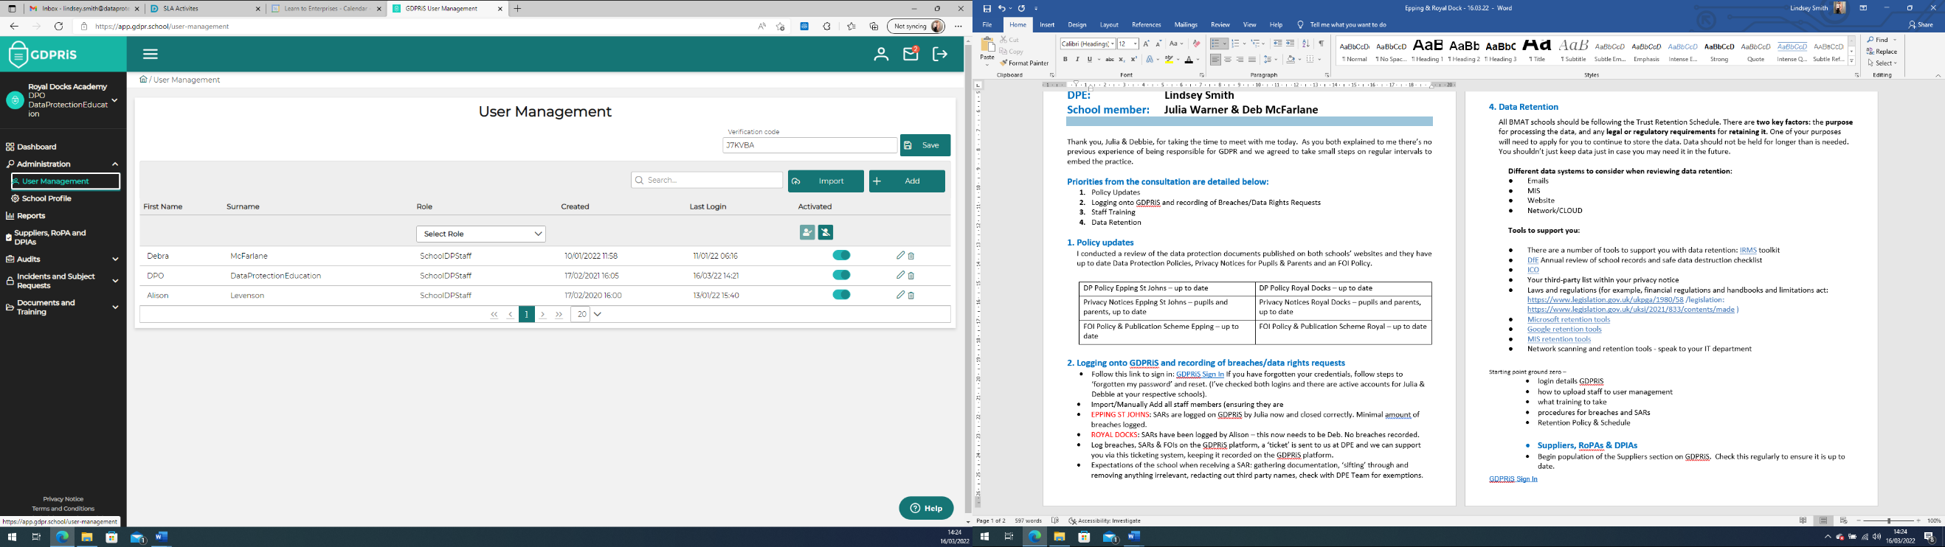

- Import/Manually Add all staff members (ensuring their ‘role’ is set to ‘General Staff’, only yourselves and the Headteacher should have ‘SchoolDPStaff’ access).
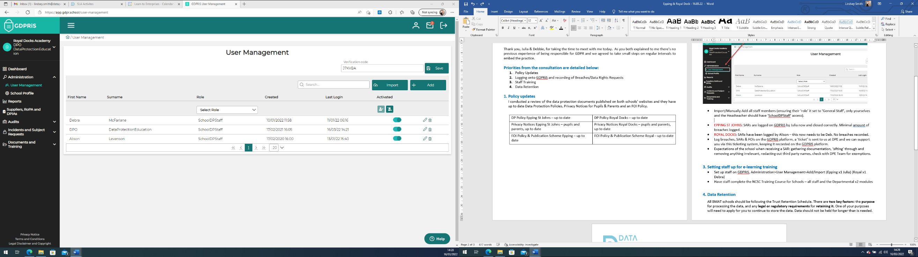

- This will email everyone a link to login and set a password.

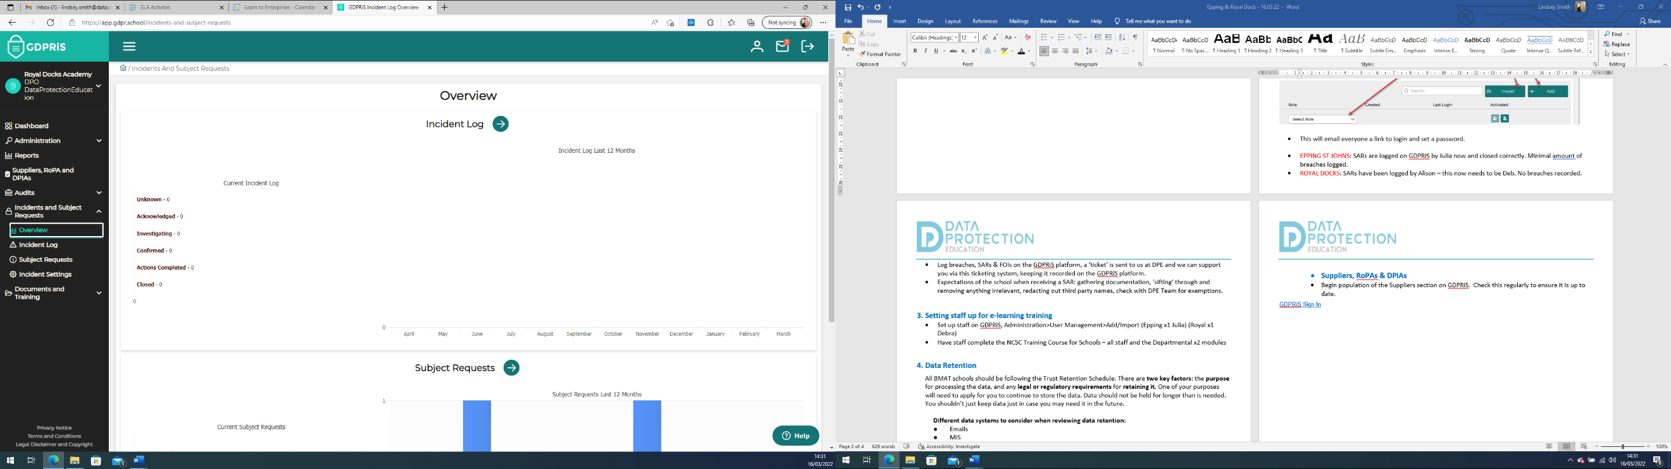
- You should log data breaches, & SARs here; a ‘ticket’ is sent to us at DPE and we can support you via this ticketing system, keeping it recorded on the GDPRiS platform.

- Subject Requests > Add Subject Request

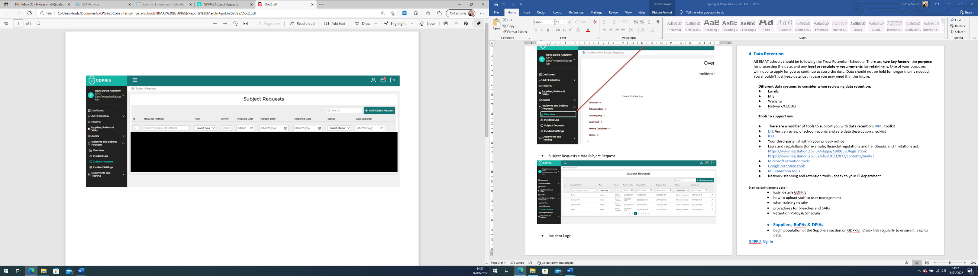
- Incident Log > Add Incident

- Setting staff up for e-learning training
- Once all staff emails are imported to GDPRiS everyone will receive a login and can access the training courses.
- We recommend completion of the NCSC Training Course for Schools – all staff and the Departmental x2 modules

- Data Retention
BMAT are currently reviewing their Retention Policy and Schedule. This will be circulated as soon as it is ratified. This document should be accessible by all staff to ensure they are retaining data for the appropriate timescales and destroying data no longer required in a secure manner.

There are two key factors: the purpose for processing data, and any legal or regulatory requirements for retaining it. One of your purposes will need to apply for you to continue to store the data. Data should not be held for longer than is needed. You shouldn’t just keep data just in case you may need it in the future.

Different data systems to consider when reviewing data retention:
- Emails
- MIS
- Website
- Network/CLOUD

Tools to support you:

- There are a number of tools to support you with data retention: IRMS toolkit
- DfE Annual review of school records and safe data destruction checklist
- ICO
- Your third-party list within your privacy notice
- Laws and regulations (for example, financial regulations and handbooks and limitations act: https://www.legislation.gov.uk/ukpga/1980/58 /legislation: https://www.legislation.gov.uk/uksi/2021/833/contents/made )
- Microsoft retention tools
- Google retention tools
- MIS retention tools
- Network scanning and retention tools - speak to your IT department

When we will discuss third-party suppliers when we meet next. You are welcome to take a look at this area on GDPRiS under ‘Suppliers, RoPA and DPIAs’ where you will add all suppliers who you share personal data with for processing. Once this area is populated it will provide a Record of Processing information asset register and can produce data protection risk assessments (DPIA) should they be required.

