School: BMAT Freshwaters Primary Academy

Date: 21.03.22
Report: Remote consultation
DPE: Lindsey Smith
School member: Debbie Burns

Priorities from the consultation are detailed below:
- Policy Updates
- Logging Breaches/Data Rights Requests
- Staff Training
- Suppliers, RoPAs & DPIAs
- Data Retention
- Best Practice Checklist?

- Policy updates
- Document review from the website: GDPR section under School Info
  - DP Policy – up to date and published
  - Privacy Notices – Parents & Pupils is up to date and published
    - Would suggest separate ones in addition for Employees & Visitors + Child Friendly available (model notices attached to this report)
  - FOI Policy & Publication Scheme – up to date and published

- Logging of breaches/data rights requests
- Log breaches, SARs & FOIs on GDPRiS Sign In If you have forgotten your credentials, follow steps to ‘forgotten my password’ and reset. A ‘ticket’ is sent to us at DPE and we can support you via this ticketing system, keeping it recorded on the GDPRiS platform.
- x1 SAR is still in progress on GDPRiS which I believe was undertaken by the DSL (Tracey?) and my colleague will close this case in the absence of the Trust Information Officer. Any Subject Access Requests going forward will be logged by the school (Debbie has been delegated the responsibility for GDPR at Freshwaters)
- The school will also be responsible for collating the data to satisfy a SAR and remove any irrelevant documents – the DPE team can advise on redaction and exemptions if the school is unsure.

- Setting staff up for e-learning training
- To set up staff on GDPRiS, follow the steps below:
Go to ‘Administration’ > ‘User Management’
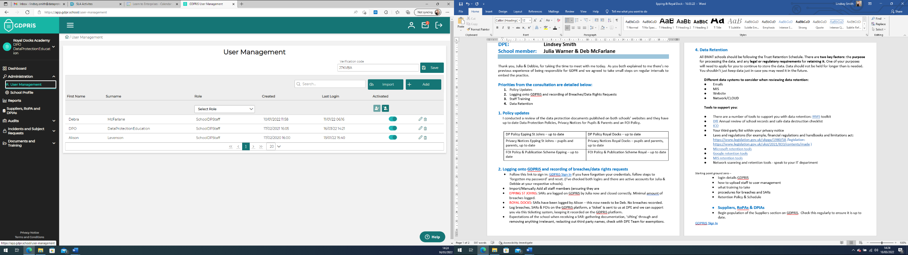
Import/Manually Add all staff members (ensuring their ‘role’ is set to ‘General Staff’, only yourself and the Headteacher should have ‘SchoolDPStaff’ access).
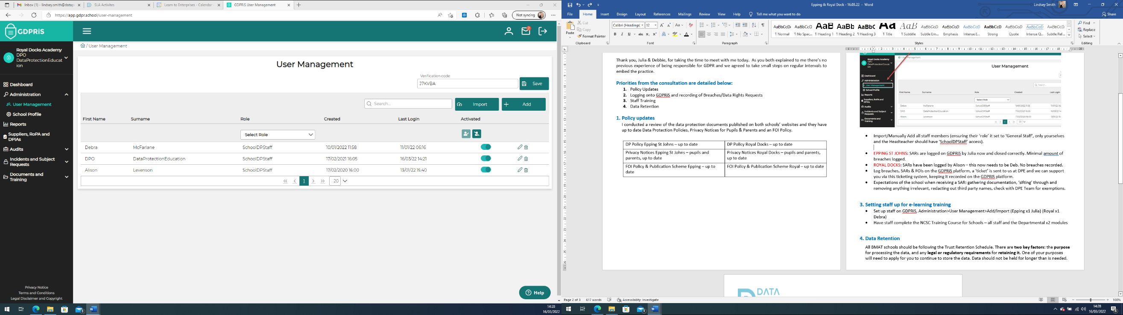

- This will email everyone a link to login and set a password.

- Have staff complete the NCSC Training Course for Schools – all staff and the Departmental x2 modules

- Suppliers, RoPAs & DPIAs
- Population of the Suppliers section on GDPRiS has taken place. Check this regularly to ensure it is up to date.
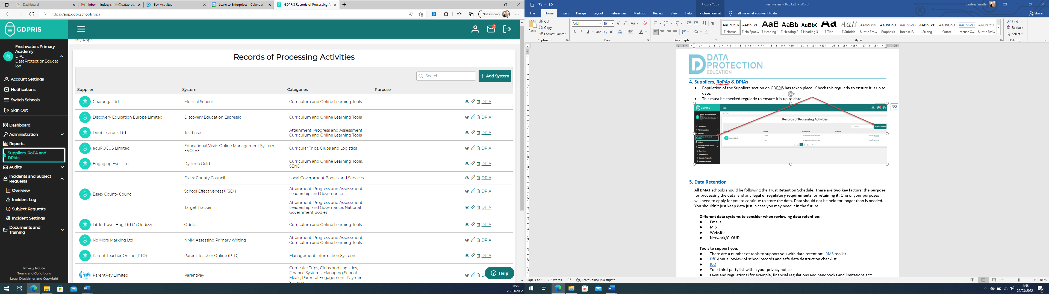

- Data Retention
All BMAT schools should be following the Trust Retention Schedule. There are two key factors: the purpose for processing the data, and any legal or regulatory requirements for retaining it. One of your purposes will need to apply for you to continue to store the data. Data should not be held for longer than is needed. You shouldn’t just keep data just in case you may need it in the future.

Different data systems to consider when reviewing data retention:
- Emails
- MIS
- Website
- Network/CLOUD

Tools to support you:
- There are a number of tools to support you with data retention: IRMS toolkit
- DfE Annual review of school records and safe data destruction checklist
- ICO
- Your third-party list within your privacy notice
- Laws and regulations (for example, financial regulations and handbooks and limitations act: https://www.legislation.gov.uk/ukpga/1980/58 /legislation: https://www.legislation.gov.uk/uksi/2021/833/contents/made )
- Microsoft retention tools
- Google retention tools
- MIS retention tools
- Network scanning and retention tools - speak to your IT department

