School: Necton VA Primary School

Date: 06.06.22

Report: Remote consultation
DPE: Lindsey Smith
School member: Tania Freestone

Consultation details
- Staff training
- Compliance Manager
- Best Practice Checklist
- DPE Events

- Staff training
Excellent uptake on staff training across all areas. Some courses have been started and a few are incomplete. The previous GDPR 101 has been broken down into two modules, now titled: An Introduction to GDPR & How to avoid a data breach – it would be good practice to include these in the induction process for new members of staff, along with Stay Safe Online NCSC course for all staff.

- Compliance Manager
The compliance manager tool is being used well. Some staff are yet to read some published documents – you are able to assign these using the ‘to do’ list – apologies, I should’ve demonstrated this during our meeting – it’s a small icon in the bottom right corner of the dashboard:
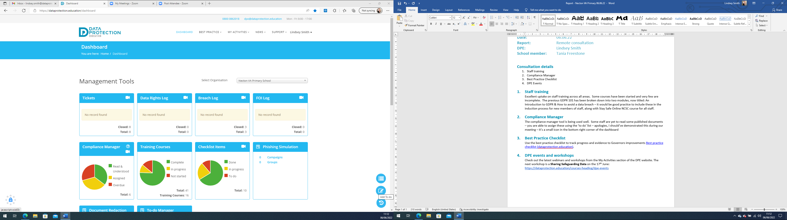

This allows you to assign reminders to members of staff to read documents and take training etc

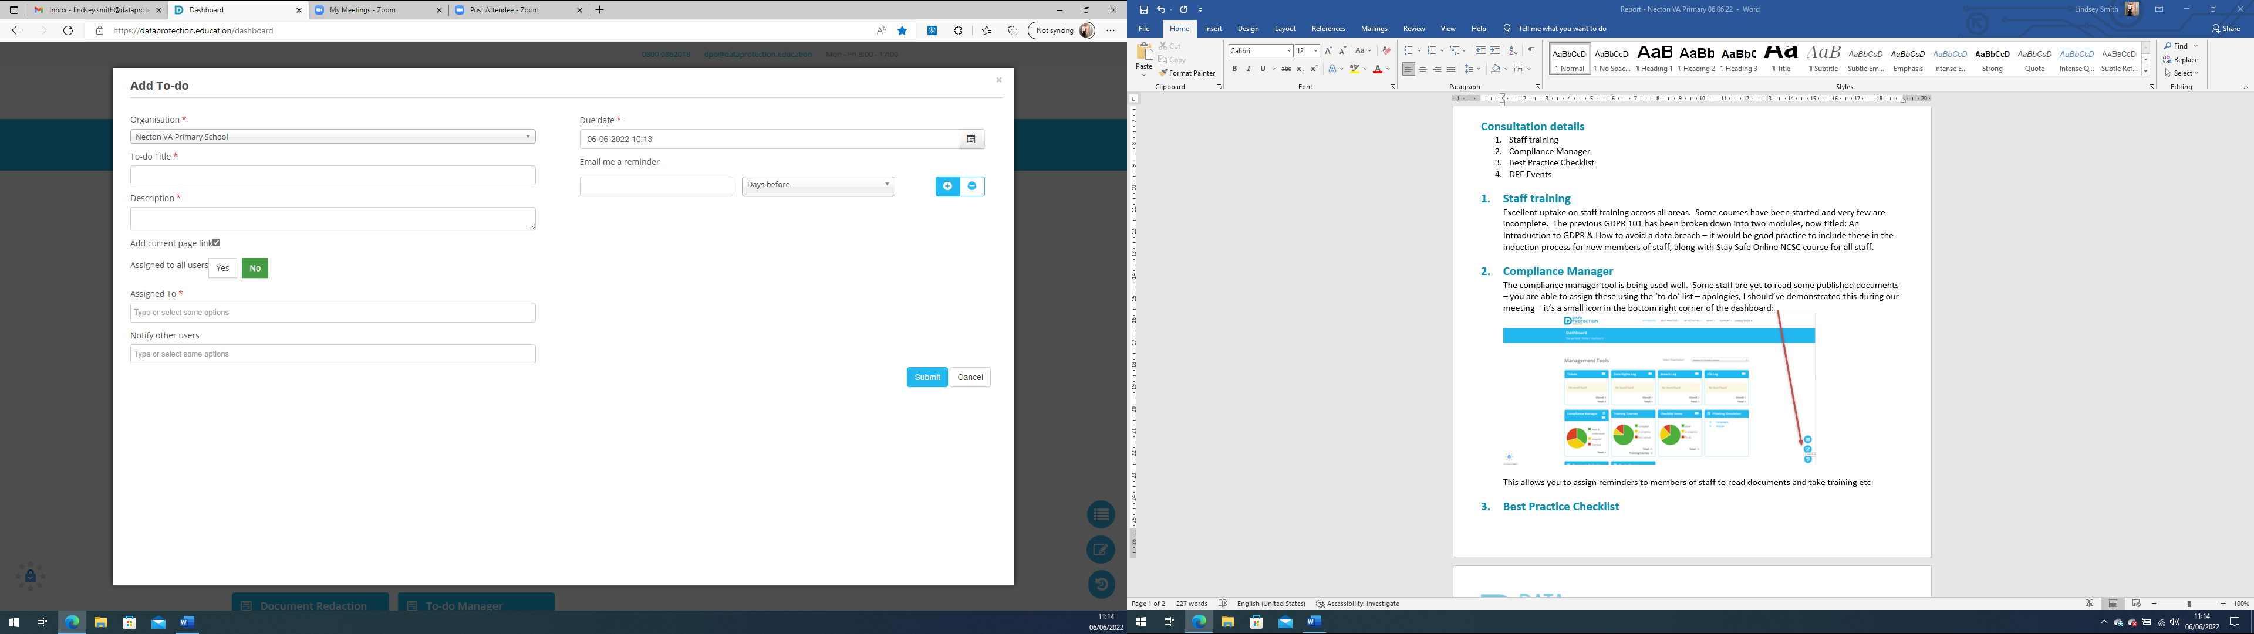

- Best Practice Checklist
Use the best practice checklist to track progress and evidence to Governors improvements Best practice checklist (dataprotection.education).

- DPE events and workshops
Check out the latest webinars and workshops from the My Activities section of the DPE website. The next workshop is a Sharing Safeguarding Data on the 17th June: https://dataprotection.education/courses-heading/dpe-events

Today’s session was used to meet with Tania following Linda’s recent retirement, for us to build a relationship and begin to look at where Necton are on the GDPR journey. Excellent progress throughout and all published documents are up to date.

Contact will be made early September to book another appointment in the Autumn Term.

