School: Holly Meadows Primary School

Date: 06.06.22

Report: Remote consultation
DPE: Lindsey Smith
School member: Suzanne/Gemma

Consultation details
- Staff changes – housekeeping and staff training
- Review of GDPR status, compliance documents; website and internal documentation
- Compliance Manager
- Best Practice Checklist
- Data retention
- Raising staff awareness and audit walks
- DPE events and webinars

- Staff changes – housekeeping and staff training
Check new staff are set up on the DPE website and leavers removed Manage Staff (dataprotection.education). If not already, I would recommend GDPR training is part of the Induction process for new staff. The GDPR 101 has been split into two modules, now named: An Introduction to GDPR & How to Avoid a Data Breach. The Stay Safe Online NCSC course would also be beneficial for any future training.

- Review of GDPR status, compliance documents, website and internal documentation
Although some of these documents below are not statutory to have on your website, for transparency and ease of managing these documents could be grouped into a Data Protection section on the website.

Website document review:
- Data Protection Policy – not published on the website, a template is available here: Commitment to compliance (dataprotection.education)
- Privacy Notice – not published on the website, templates are available here: Transparency (dataprotection.education) We do recommend that 3 separate notices are used for Pupils/Parents, Workforce and General Visitors as the data collected is very different.
- FOI Policy and publication scheme – up to date and published on the website

Other useful internal documents:
- Work away from school policy Work out of school (dataprotection.education)

- Compliance Manager
The compliance manager can be used to upload documents and assign to staff to read, as demonstrated during the consultation. Compliance Manager (dataprotection.education) – Upload document, complete fields, Save & Next (there’s an option for ‘Read & Understood’ and another for ‘Used in Practice’ if you wish to also include that). Once the document is uploaded you have the option to assign staff using this icon
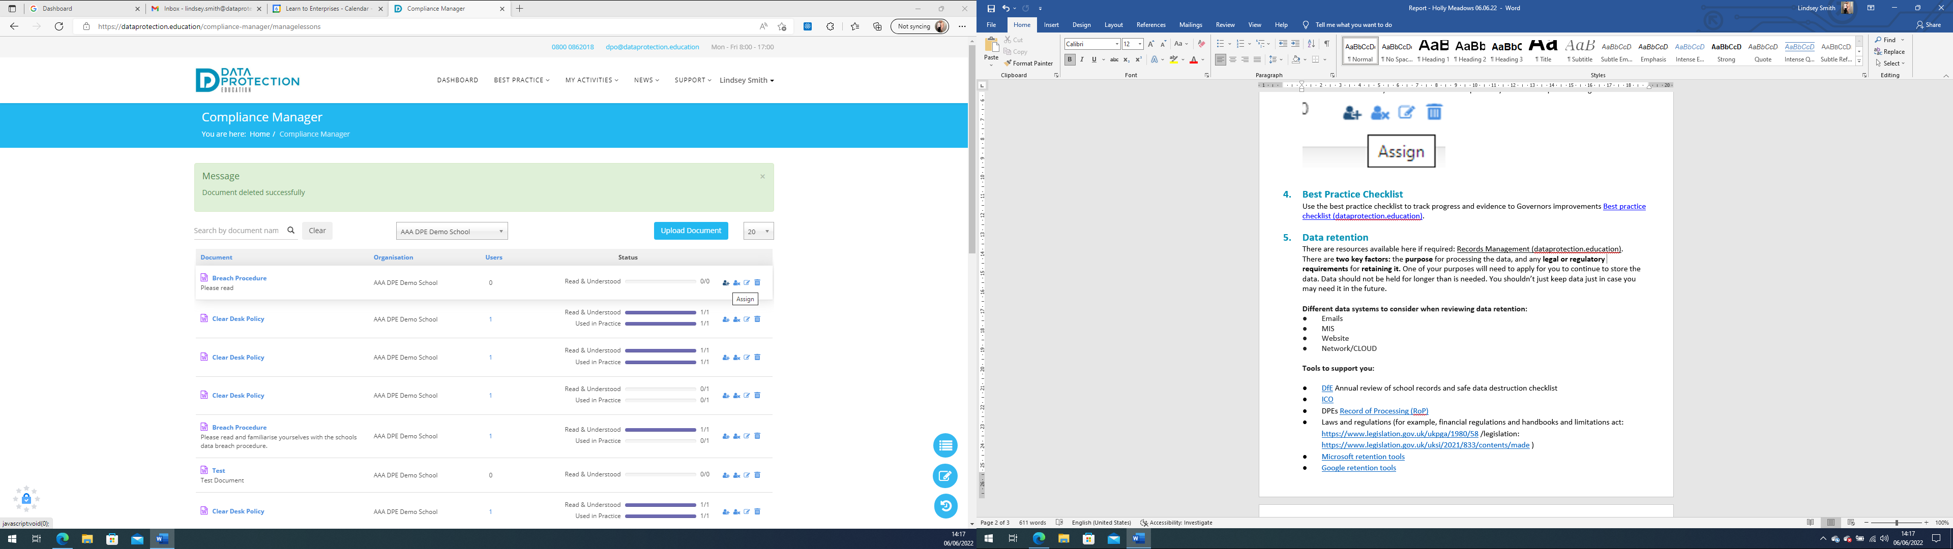 you can also select a ‘due date’ deadline.

- Best Practice Checklist
Use the best practice checklist to track progress and evidence to Governors improvements Best practice checklist (dataprotection.education).

- Data retention
There are resources available here if required: Records Management (dataprotection.education).
There are two key factors: the purpose for processing the data, and any legal or regulatory requirements for retaining it. One of your purposes will need to apply for you to continue to store the data. Data should not be held for longer than is needed. You shouldn’t just keep data just in case you may need it in the future.

Different data systems to consider when reviewing data retention:
- Emails
- MIS
- Website
- Network/CLOUD

Tools to support you:

- DfE Annual review of school records and safe data destruction checklist
- ICO
- DPEs Record of Processing (RoP)
- Laws and regulations (for example, financial regulations and handbooks and limitations act: https://www.legislation.gov.uk/ukpga/1980/58 /legislation: https://www.legislation.gov.uk/uksi/2021/833/contents/made )
- Microsoft retention tools
- Google retention tools

- Raising staff awareness and audit walks
‘Making the Rounds’ tool is available on the Knowledge Bank if you wish to use it. By completing this electronically, allows you to log and keep a record and is accessible via the My Activities tab on the DPE website: https://dataprotection.education/courses-heading/making-the-rounds-log

If you wish to have a monthly focus i.e. clear desks and locking laptops etc. this is an ideal way to keep staff focused with the latest data protection issues, posters are available here: Drip Feeds - posters (dataprotection.education)

- DPE events and workshops
Check out the latest webinars and workshops from the My Activities section of the DPE website. The next workshop is a Sharing Safeguarding Data on the 17th June: https://dataprotection.education/courses-heading/dpe-events

