Trust: Corvus Education Trust Date: 27/06/2022

Report: Corvus Education audit report and action plan
DPE: Stuart Lee Staff member: Jane Raine

Introduction and approach
The Corvus Education Trust is working closely with Clarion Education Trust and may merge at some point in the future. Corvus Educational Trust previously used outside consultancy for support. Clarions CEO is also currently the CEO of Corvus Education Trust. Clarion Educational Trust buy into Data Protection Education’s (DPE) DPO service.

DPE were tasked with completing a data protection audit. This included reviewing current GDPR compliance documents, completion of the ICO accountability tracker and audit walks at two of the Trust schools (Watton Westfield and Watton Junior). From this it was possible to produce a gap analysis to determine the Trust's follow up actions and next steps. The ICO accountability tracker can continue to be used in conjunction with this report to progress the privacy programme and monitor compliance:

The report is broken down into 2 sections:
- Gap analysis from information obtained from remote sessions, the ICO accountability tracker and the onsite visit.
- Physical audit walk findings and recommendations.

- Gap analysis, recommended actions and next steps
ICO accountability tracker current status:
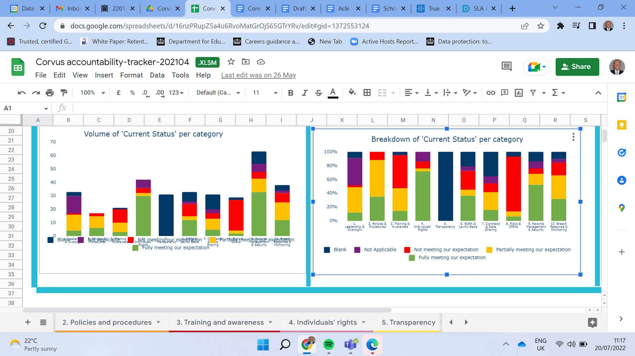

Gap analysis highlighting current status and key actions (plan) that can be used in conjunction with the ICO accountability tracker.
Accountability area | Current state | Difference | Required actions | Actions taken
Leadership and oversight | Partially completed. Refer to the ICO accountability tracker for a full breakdown.  The current situation (awaiting appointment of new staff members with GDPR responsibilities) has resulted in GDPR not being given full focus (time constraints for the school SBM). | There are gaps in the Trusts reporting for managing data protection and information governance.  Organisational structure, including roles and responsibilities are not defined. | Priority: High  Develop reporting at Trustee level and at staff level to allow reporting upwards and down to general staff i.e. Trustees and class teachers.  New staff member responsible for data protection to be supported and trained.  Communicate and raise awareness across the Trust as to who the DPO is. | New staff members will have GDPR responsibilities which should be incorporated in any new contract so that responsibilities are defined.
Policies and procedures | Partially completed. Refer to the ICO accountability tracker for a full breakdown.  The Trust has a data protection policy, FOI policy, publication scheme, retention policy, privacy notices and acceptable use policies. | Not all GDPR policies were available for review.  Some internal documents i.e. SAR and data breach procedures had not been communicated to key staff and/or were not available.  Existing data protection policies and procedures are not reviewed, up to date and risk not being fit for purpose. | Priority: High  Share best practice with the Clarion Trust by cross checking key GDPR documents displayed on the Clarion Education Trust website.  Review documents and procedures listed in the 13 March 2022 initial JE Corvus Education Trust Audit March 2022 letter.
Training and awareness | Not completed/partially completed. Refer to the ICO accountability tracker for a full breakdown.  Not all staff had completed data protection and information security training. | Not all staff had completed data protection and information security training.  Monitoring of existing training or reviews is not comprehensive and/or does not take place.  There was a marked difference in data protection knowledge and awareness of handling, processing and displaying data between the two schools visited. | Priority: High  All staff to complete data protection and information security training and this should be included as part of induction for new staff.  The Trust to raise staff awareness using different media, including staff meetings/briefings.  Assign a person responsible for managing training and the Trust to keep a documented record of training completed. | Staff awareness for data protection to be added to INSET training.  Note: the Trust has the option of contacting DPE for a price to access DPEs e-learning modules.
Transparency and Individual rights | Partially completed. Refer to the ICO accountability tracker for a full breakdown.  The Trust has the privacy notice for students and acceptable use displayed on the Trust website.  Privacy notices are available for parents, general and workforce.  On the job training is completed for handling subject access requests. | It is not evident that a SAR procedure exists and that staff complete specialised documented training for handling data requests.  Monitoring reports were previously produced but are not at present. | Priority: High  Update privacy notices including text for ICO complaints for:  Parents, general  and the workforce.  Communicate to all stakeholders.  Develop a documented SAR procedure and communicate to key staff.  Consider specialized training for key staff responding to subject access requests and all staff training/awareness.  Develop a process and maintain a log for recording requests.  Build in capacity for producing monitoring reports for senior leaders.
Record of processing, risks, DPIAs and lawful basis | Not completed. | Not completed.  It is not evident if any document risk assessments are completed for high risk processing i.e. moving from paper to electronic records.  Not all lawful bases for processing will be documented.  Note: the Trust has a BCP that is risk based. | Priority: High  Trust to wait for new legislation for the completion of the RoP which includes documenting lawful basis.  The Trust should develop systems, documents and methods for assessing and mitigating risks. | Note: current legislation (UK GDPR) still requires the completion and maintaining of a record of processing and DPIAs (risk assessments) to be completed.
Contracts and data sharing | Partially completed. Refer to the ICO accountability tracker for a full breakdown.  Third party processor list is maintained.  Checks are completed of suppliers' privacy documentation and the Trust uses educational specific suppliers.  Contracts are approved at CEO/HT level. | Not all data sharing policies and procedures are in place.  There is no procedure in the procurement process for a full due diligence check of suppliers. | Priority: Medium  Develop appropriate policies and procedures.  Review of current contracts.  Develop process of due diligence checks of existing/new suppliers.  Staff training and awareness for staff responsible for contracts.
Records management and security | Partially completed. Refer to the ICO accountability tracker for a full breakdown.  Data retention and information asset registers/schedules exist.  BCP - RISK based.  Relevant staff are trained up for data transfers.  Minimisation is practiced where possible and the data collection process is refreshed yearly.  Laptops are encrypted.  Access controls are in place to prevent unauthorized access to systems and applications. | Policies, procedures and mechanisms are not in place to manage the security risks of using mobile devices or remote working and removable media.  It is not evident if remote wiping of equipment mechanisms were in place.  No policies and procedures exist for data/information classification.  It is not clear if policies for home working exist.  Not all staff have completed data protection and information security training.  No dedicated server rooms at the sites visited. | Priority: High  Develop appropriate policies and procedures.  Liaise with the Trusts IT department to check technical measures that should be in place.  Complete staff training and awareness.  Consider a phishing simulation or similar to test IT systems. | Servers are being phased out.
Breach response and monitoring | Completed/partially completed. Refer to the ICO accountability tracker for a full breakdown.  Individual departments review and monitor breaches to identify if breaches are from a particular department.  There is a procedure for assessing and monitoring breaches.  Fraud and data breach logs are maintained and there is a dedicated team for security instances. | There are no performance indicators (KPIs), monitoring and review so the Trust is unable to assess relevant information.  Not all staff have completed data protection and information security training.  There is no dashboard to give a high level summary.  Note: COVID restrictions will have restricted internal walks. | Priority: High/Medium  DPE audits and reports to be completed to support the Trust compliance status.  The data breach procedure to be reviewed and circulated to key individuals. This should also include DPO details.  Reviewing and monitoring reports to be produced and disseminated to senior staff to support assessing breaches/incidents.  Consider high level dashboards being developed. | The Trust will use the results of the DPE audit report to support its internal privacy programme.

Onsite physical audit

An onsite physical audit was completed at Watton Westfields and Watton Junior School.
As would be expected when visiting during normal working hours, some sensitive data will have been observed as staff will be working in the areas audited. The main outcomes from the walks are about improved data handling and information security. The audit walk supports in the identification of where sensitive data is easily accessible; information that should be filed securely that is left on open display and therefore could be accessible to unauthorised users.
Audit walk(s) feedback and recommendations:
Watton Westfield had very good privacy practices in place with minimal data on display. Data protection best practice signage was displayed in prominent areas. The school has processes in place for the caretaker to lock up classrooms and offices at night. Forename only was predominantly used and folders were not left on open display. Watton Westfield utilised their MIS and Cloud solutions for sharing sensitive data rather than physical folders. Classrooms audited had secure storage/cupboard spaces for the storing of sensitive data.
Watton Junior school had more data on general display and there appeared to be a general lack of routines for handling sensitive data and staff awareness of what was and was not sensitive data, for example, unlocked cabinets, SEND folders, interventions and IEPS etc on open display.
More detailed observations and recommendations from the walks are detailed below:
Visitor privacy information recommendation - both sites:
There was no statement to inform visitors how their data is stored and used (Privacy Notice).
Recommendation: Add the following statement or similar near to the visitor sign in systems: If you would like to know more about how we protect and store visitor information, please refer to the GDPR section of the Trust/school website for the school's general privacy notice and GDPR policy.
VIsitor book - both sites:
An open book system is used at each site audited and the visitor book is on open display.
Recommendation: As each visitor can see other’s visitor information, consider updating to a secure carbon book system. The Trust can initially operate a closed book system, with just the 1 sheet and have the privacy information added to the front cover. The electronic system at Watton Westfield can be utilised to allow visitors to sign in electronically.
Parent/student sign out sheet - both sites:
Parents signing pupils out can see each other's information, including reasons for absence.
Recommendation: School(s) to trial a single entry sign out system (parents will have a blank slip to complete and information can be added to the MIS) to avoid parents seeing each other's details.

Leadership team offices (Watton Junior School) recommendation:
Some LT offices, including the headteacher's office at Watton Junior school did not have any locks on doors.
Recommendation:
Consider adding locks/key code entry to improve security.
Reminder to staff to check folders for outdated information and where there is sensitive data do not leave on open display.
Add folders with sensitive data to secure storage as appropriate.
Classrooms:
It was evident that staff GDPR awareness and correct data handling and storing of data was more prominent at Watton Westfield. Watton Westfield did have the occasional list that had full names, although these were in a contained area.
Watton Junior school had more sensitive data and information on general display. Some observations from the Junior school classroom audit are detailed below:
- Lists on general display containing full names with gender
- Full Names with password information
- SEND registers with status, need type and DOB on desks
- CPOMS upload list left on desk
- Full Names generally used for lists
- SEND folder and intervention on open display
- SEND cabinet (in mobile) left open with no staff present
- Intervention - 3 x folders IEP with child plans
Recommendations:
Raise awareness at Watton Junior school and all Trust schools so that it aligns with that of Watton Westfields.
All staff to complete data protection and information security training.
Develop and make staff aware of policy and procedural documentation.
SRB, Safeguarding and SEND areas - Watton Junior School:
Recommendations:
Ensure sensitive data is not left on open display.
Reminder to lock cabinets containing sensitive data when not in the work area.
Investigate additional physical security - i.e. add secure codes/locks to doors where needed.
All staff to complete data protection and information security training.
Medical book - Watton Westfield:
An accident book was observed on open display.
Recommendation: Reminder to staff to use a closed book system.

