School: The Bawburgh School

Date: 27.09.22

Report: Remote consultation
DPE: Lindsey Smith
School member: Carol Watton

Consultation details
- Staff changes – housekeeping and staff training
- Review of GDPR status, compliance documents; website and internal documentation
- Best Practice Checklist
- Data retention
- Raising staff awareness and audit walks
- DPE events and webinars

- Staff changes – housekeeping and staff training
Set up any new members of staff on the Knowledge Bank -Login into DPE dashboard, scroll down to users
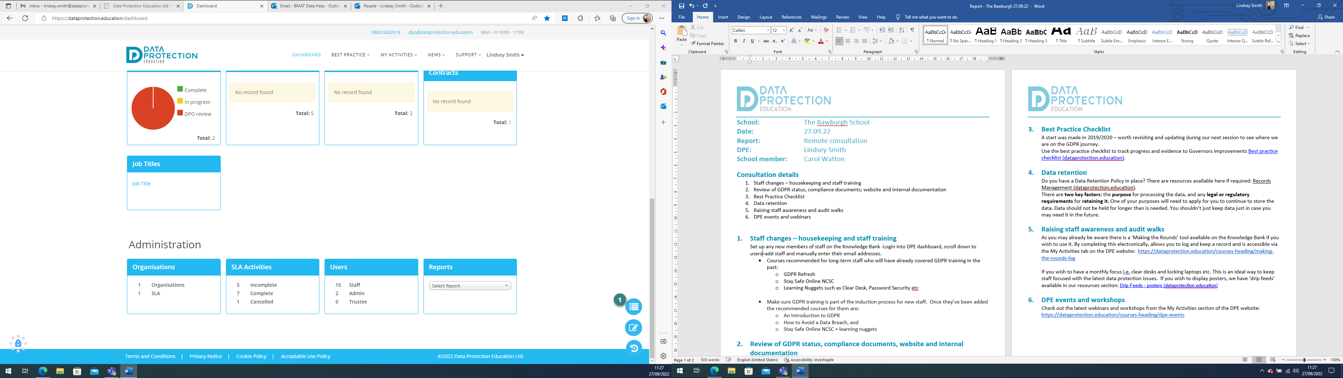

Add staff and manually enter their email addresses and ensure their ‘Role’ is set to ‘staff’.

Training courses recommend for long-term staff who will have already covered GDPR training in the past:
  - GDPR Refresh
  - Stay Safe Online NCSC
  - Learning Nuggets such as Clear Desk, Password Security etc

Make sure GDPR training is part of the induction process for new staff. Once they’ve been added the recommended courses for them are:
  - An Introduction to GDPR
  - How to Avoid a Data Breach, and
  - Stay Safe Online NCSC + learning nuggets

- Review of GDPR status, compliance documents, website and internal documentation
Although some of these documents below are not statutory to have on your website, for transparency and ease of managing these documents are grouped into a Data Protection section on the schools’ website.

Website document review:
- GDPR Policy – up to date and published on the website
- Privacy Notice – up to date and published on the website
- FOI Policy and publication scheme – up to date and published on the website

- Best Practice Checklist
A start was made in 2019/2020 – worth revisiting and updating during our next session to see where we are on the GDPR journey.
Use the best practice checklist to track progress and evidence to Governors improvements Best practice checklist (dataprotection.education).

- Data retention
Do you have a Data Retention Policy in place? There are resources available here if required: Records Management (dataprotection.education).
There are two key factors: the purpose for processing the data, and any legal or regulatory requirements for retaining it. One of your purposes will need to apply for you to continue to store the data. Data should not be held for longer than is needed. You shouldn’t just keep data just in case you may need it in the future. I have attached a template Retention Schedule to the report. You may have access to the NCC Retention Policy and Schedule.

- Raising staff awareness and audit walks
As we briefly discussed there is a ‘Making the Rounds’ tool available on the Knowledge Bank if you wish to use it. By completing this electronically, allows you to log and keep a record and is accessible via the My Activities tab on the DPE website: https://dataprotection.education/courses-heading/making-the-rounds-log

If you wish to have a monthly focus i.e. clear desks and locking laptops etc. This is an ideal way to keep staff focused with the latest data protection issues. If you wish to display posters, we have ‘drip feeds’ available in our resources section: Drip Feeds - posters (dataprotection.education)

- DPE events and workshops
Check out the latest webinars and workshops from the My Activities section of the DPE website: https://dataprotection.education/courses-heading/dpe-events

