School: Woodside Group Date: 31.10.2022
DPE: Lindsey Smith Staff member: Dan Long

Agenda

- Review of Compliance Documents
- Staff changes - housekeeping
- DPE Knowledge Bank updates
- Information security
- Record of Processing and supplier due diligence
- Data retention (IRMS)
- Staff training and raising staff awareness

- Review of Compliance Documents

Although the documents below are not all statutory to have on your website, for transparency and ease of managing these documents, it is good practice to have a data protection section on your website and consider including the following documents:

Website documents:
- GDPR/data protection policy – up to date and published on website
- Privacy notice(s) – up to date and published on website
- SAR and data breach procedure – internal procedure?
- FOI and publication scheme
- Supplier/third party list

Other useful documents to review and check that you have are:
- Work away from school policy
- Information Security/Passwords
- Review of consent documentation. Consent guidance and consent withdrawal can also be added to the GDPR section of the school website

- Staff changes – housekeeping

Woodside Group upload staff users to the Knowledge Bank as a matter of routine when inducting new employees. Uptake of staff training for GDPR is good. If you have any issues adding a new member of staff Kalina at DPE (client support) is here to help you and can be contacted for support at: kalina.voyvodova@dataprotection.education.

- Knowledge Bank updates

The ‘Making the Rounds’ tool can be used on a regular basis to identify any visible risks. The DPE consultant can discuss the outcome of these reports at the next session to support you in mitigating any risks identified and share best practice advice. https://dataprotection.education/courses-heading/making-the-rounds-log/add-log

There is also a new ‘to-do list’ function where the administrator can assign tasks to members of staff and define a deadline date for completion. This feature is located in the bottom right-hand corner of the main dashboard
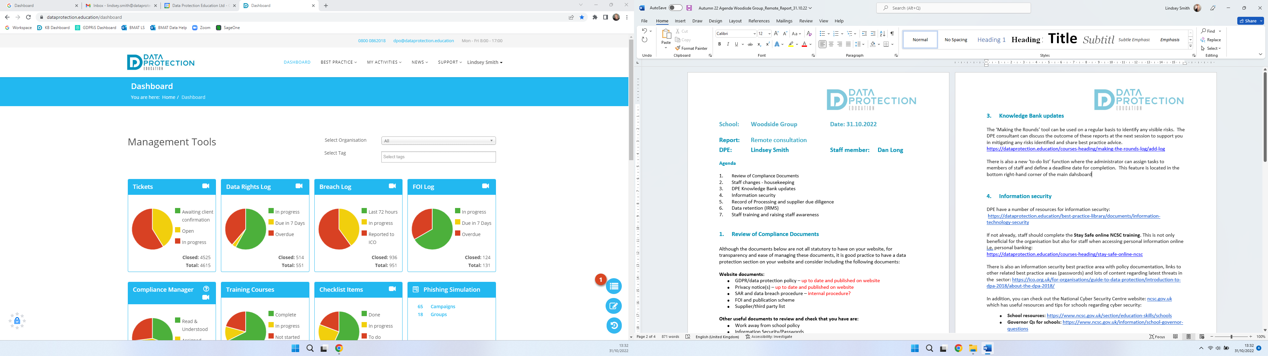

- Information security

DPE have a number of resources for information security:
https://dataprotection.education/best-practice-library/documents/information-technology-security

If not already, staff should complete the Stay Safe online NCSC training. This is not only beneficial for the organisation but also for staff when accessing personal information online i.e. personal banking:
https://dataprotection.education/courses-heading/stay-safe-online-ncsc

There is also an information security best practice area with policy documentation, links to other related best practice areas (passwords) and lots of content regarding latest threats in the sector: https://ico.org.uk/for-organisations/guide-to-data-protection/introduction-to-dpa-2018/about-the-dpa-2018/

In addition, you can check out the National Cyber Security Centre website: ncsc.gov.uk which has useful resources and tips for schools regarding cyber security:
- School resources: https://www.ncsc.gov.uk/section/education-skills/schools
- Governor Qs for schools: https://www.ncsc.gov.uk/information/school-governor-questions

- Record of Processing and supplier due diligence

The controller is responsible for assessing that any third-party processors (suppliers etc) are competent to process personal data in line with the UK GDPR’s requirements. This assessment should take into account the nature of the processing and the risks to the data subjects. This is because Article 28(1) says a controller must only use a processor that can provide “sufficient guarantees” (in particular in terms of its expert knowledge, resources and reliability) to implement appropriate technical and organisational measures to ensure the processing complies with the UK GDPR and protects the rights of individuals.

Some work on the Record of Processing has been previously carried out by Victoria Barker & Linda Mortimer (former DPE Consultant).

Things to consider:
- Privacy notice/third party/supplier list - is this up to date, do you know all the organisations/suppliers you share information with?
- Due diligence form - this can be sent to new suppliers
- Make sure that current and future contracts include data protection
- Risks - what you should be thinking of when purchasing and using new products and suppliers

DPEs best practice area and the due diligence form for suppliers is located here: https://dataprotection.education/index.php/best-practice-library/best-practice/due-diligence-best-practice-area

- Data retention

Organisations can set deadlines, document and justify timeframes they have set for retaining data. There are two key factors: the purpose for processing the data, and any legal or regulatory requirements for retaining it. One of your purposes will need to apply for you to continue to store the data. Data should not be held for longer than is needed. You shouldn’t just keep data just in case you may need it in the future.
Different data systems to consider when reviewing data retention:
- Emails
- MIS
- Website
- Network/CLOUD

Tools to support you:
There are a number of tools to support you with data retention: IRMS toolkit
- DPE’s record management best practice area
- DfE Annual review of school records and safe data destruction checklist
- ICO
- DPEs Record of Processing (RoP)
- Your third party list within your privacy notice
- Laws and regulations (for example, financial regulations and handbooks and limitations act: https://www.legislation.gov.uk/ukpga/1980/58 /legislation: https://www.legislation.gov.uk/uksi/2021/833/contents/made )
- Microsoft retention tools
- Google retention tools
- MIS retention tools
- Network scanning and retention tools - speak to your IT department

- Staff training and raising staff awareness

Why not use staff briefings and having a monthly focus i.e., clear desks and locking laptops etc. This is an ideal way to raise awareness and keep staff focused with the latest data protection issues. We also have a bank of ‘drip feed’ posters available in our resources area to help with the focus: https://dataprotection.education/best-practice-library/documents/drip-feeds

