School: Hunstanton Primary School Date: 09.11.2022
DPE: Lindsey Smith Staff member: Gemma Tandy

Agenda

- Review of Compliance Documents
- Staff changes – housekeeping
- DPE Knowledge Bank updates
- Data retention (IRMS)
- Staff training and raising staff awareness

- Review of Compliance Documents

Hunstanton Primary School have a GDPR section on their website, however some of the following policies are due for review:

Website documents:
- GDPR/data protection policy – website gives an error, not found. Template policy available here: https://dataprotection.education/best-practice-library/best-practice/commitment-to-compliance
- Privacy notice(s) – due for renewal. Template privacy notices available here: https://dataprotection.education/best-practice-library/best-practice/transparency
- FOI and publication scheme – not found. Template documents available here: https://dataprotection.education/best-practice-library/best-practice/freedom-of-information

Other useful documents to review and check that you have are:
- Work away from school policy
- Information Classification
- Review of consent documentation. Consent guidance and consent withdrawal can also be added to the GDPR section of the school website

Template documents for all of the above are available here: https://dataprotection.education/best-practice-library/best-practice/commitment-to-compliance

- Staff changes – housekeeping

Check the staff list on the Knowledge Bank to ensure all staff have a user account and are able to access training: https://dataprotection.education/student-list/users?filter[agencies]=2
If you have any issues adding a new member of staff, Kalina at DPE (client support) is here to help you and can be contacted for support at: kalina.voyvodova@dataprotection.education.

- Knowledge Bank updates

The ‘Making the Rounds’ tool can be used to identify any visible risks. The DPE consultant can discuss the outcome of these reports at the next session to support you in mitigating any risks identified and share best practice advice. https://dataprotection.education/courses-heading/making-the-rounds-log/add-log

There is also a new ‘to-do list’ function where the administrator can assign tasks to members of staff and define a deadline date for completion. This feature is located in the bottom right-hand corner of the main dashboard
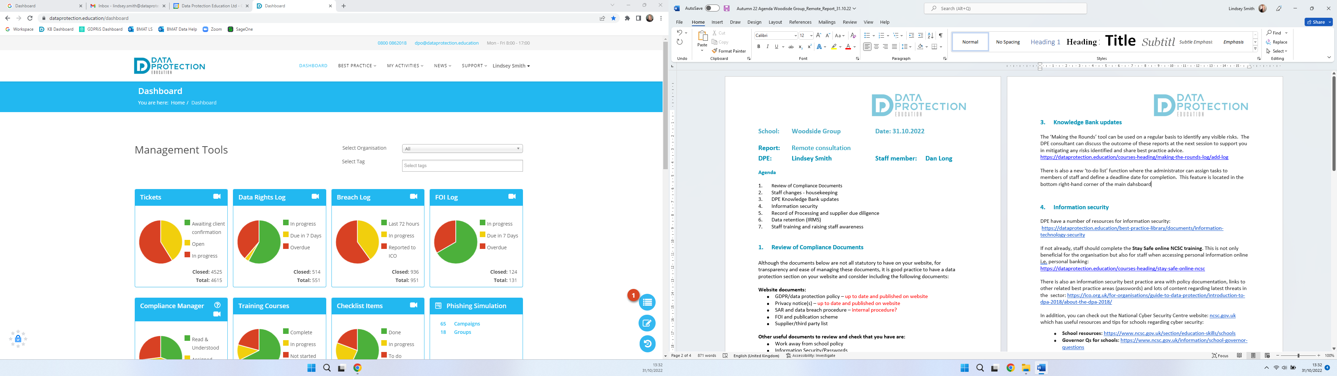

- Data retention

Organisations can set deadlines, document and justify timeframes they have set for retaining data. There are two key factors: the purpose for processing the data, and any legal or regulatory requirements for retaining it. One of your purposes will need to apply for you to continue to store the data. Data should not be held for longer than is needed. You shouldn’t just keep data just in case you may need it in the future. Norfolk County Council will have a Retention Schedule if you wish to adopt it, or alternatively we have one within out template Records Management Policy: https://dataprotection.education/best-practice-library/best-practice/records-management
Different data systems to consider when reviewing data retention:
- Emails
- MIS
- Website
- Network/CLOUD

Tools to support you:
There are a number of tools to support you with data retention: IRMS toolkit
- DPE’s record management best practice area
- DfE Annual review of school records and safe data destruction checklist
- ICO
- DPEs Record of Processing (RoP)
- Your third party list within your privacy notice
- Laws and regulations (for example, financial regulations and handbooks and limitations act: https://www.legislation.gov.uk/ukpga/1980/58 /legislation: https://www.legislation.gov.uk/uksi/2021/833/contents/made )
- Microsoft retention tools
- Google retention tools
- MIS retention tools
- Network scanning and retention tools - speak to your IT department

- Staff training and raising staff awareness

Why not use staff briefings and having a monthly focus i.e., clear desks and locking laptops etc. This is an ideal way to raise awareness and keep staff focused with the latest data protection issues. We also have a bank of ‘drip feed’ posters available in our resources area to help with the focus: https://dataprotection.education/best-practice-library/documents/drip-feeds

