School: Great Dunham Primary Date: 15.11.2022
DPE: Lindsey Smith Staff member: Cheryl Marshall

Agenda

- Review of Compliance Documents
- Staff changes – housekeeping
- DPE Knowledge Bank updates
- Information security
- Record of Processing and supplier due diligence
- Data retention (IRMS)
- Staff training and raising staff awareness

- Review of Compliance Documents

Although the documents below are not all statutory to have on your website, for transparency and ease of managing these documents, it is good practice to have a data protection section on your website and consider including the following documents:

Website documents:
- GDPR/data protection policy – published due for review Dec 22 – updated documents are available here: https://dataprotection.education/best-practice-library/best-practice/commitment-to-compliance
- Privacy notice(s) – published and up to date (review date 2023)
- SAR and data breach procedure
- FOI and publication scheme – published due for review Autumn 22 – updated documents are available here: https://dataprotection.education/best-practice-library/best-practice/freedom-of-information
- Supplier/third party list – published and up to date (review date 2023)

Other useful documents to review and check that you have are:
- Work away from school policy
- Information Security/Passwords
- Review of consent documentation. Consent guidance and consent withdrawal can also be added to the GDPR section of the school website

- Staff changes – housekeeping

Great Dunham upload staff users to the Knowledge Bank as a matter of routine when inducting new employees. Uptake of data protection training is good. We highly recommend Stay Safe Online NCSC for any upcoming inset, in addition to How to avoid a data breach and An introduction to GDPR. We’re also aware that Unity request training on Smartlog which may be repetitive of those courses available on the Knowledge Bank.

- Knowledge Bank updates

The ‘Making the Rounds’ tool can be used on a regular basis to identify any visible risks. The DPE consultant can discuss the outcome of these reports at the next session to support you in mitigating any risks identified and share best practice advice. https://dataprotection.education/courses-heading/making-the-rounds-log/add-log

There is also a new ‘to-do list’ function where the administrator can assign tasks to members of staff and define a deadline date for completion. This feature is located in the bottom right-hand corner of the main dashboard
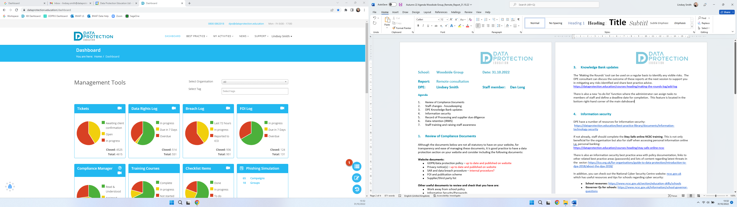

- Information security

DPE have a number of resources for information security:
https://dataprotection.education/best-practice-library/documents/information-technology-security

If not already, staff should complete the Stay Safe online NCSC training. This is not only beneficial for the organisation but also for staff when accessing personal information online i.e. personal banking:
https://dataprotection.education/courses-heading/stay-safe-online-ncsc

There is also an information security best practice area with policy documentation, links to other related best practice areas (passwords) and lots of content regarding latest threats in the sector: https://ico.org.uk/for-organisations/guide-to-data-protection/introduction-to-dpa-2018/about-the-dpa-2018/

In addition, you can check out the National Cyber Security Centre website: ncsc.gov.uk which has useful resources and tips for schools regarding cyber security:
- School resources: https://www.ncsc.gov.uk/section/education-skills/schools
- Governor Qs for schools: https://www.ncsc.gov.uk/information/school-governor-questions

- Record of Processing and supplier due diligence

The controller is responsible for assessing that any third-party processors (suppliers etc) are competent to process personal data in line with the UK GDPR’s requirements. This assessment should take into account the nature of the processing and the risks to the data subjects. This is because Article 28(1) says a controller must only use a processor that can provide “sufficient guarantees” (in particular in terms of its expert knowledge, resources and reliability) to implement appropriate technical and organisational measures to ensure the processing complies with the UK GDPR and protects the rights of individuals.

Some work on the Record of Processing has been previously carried out by with Linda Mortimer (former DPE Consultant). During our next meeting we will work on the ‘top 10’ RoPs.

Things to consider:
- Privacy notice/third party/supplier list - is this up to date, do you know all the organisations/suppliers you share information with?
- Due diligence form - this can be sent to new suppliers
- Make sure that current and future contracts include data protection
- Risks - what you should be thinking of when purchasing and using new products and suppliers

DPEs best practice area and the due diligence form for suppliers is located here: https://dataprotection.education/index.php/best-practice-library/best-practice/due-diligence-best-practice-area

- Data retention

Organisations can set deadlines, document and justify timeframes they have set for retaining data. There are two key factors: the purpose for processing the data, and any legal or regulatory requirements for retaining it. One of your purposes will need to apply for you to continue to store the data. Great Dunham Primary has good procedures in place now to destroy data no longer necessary and clearly labels documentation for shredding.
Different data systems to consider when reviewing data retention:
- Emails
- MIS
- Website
- Network/CLOUD

Tools to support you:
There are a number of tools to support you with data retention: IRMS toolkit
- DPE’s record management best practice area
- DfE Annual review of school records and safe data destruction checklist
- ICO
- DPEs Record of Processing (RoP)
- Your third party list within your privacy notice
- Laws and regulations (for example, financial regulations and handbooks and limitations act: https://www.legislation.gov.uk/ukpga/1980/58 /legislation: https://www.legislation.gov.uk/uksi/2021/833/contents/made )
- Microsoft retention tools
- Google retention tools
- MIS retention tools
- Network scanning and retention tools - speak to your IT department

- Staff training and raising staff awareness

Why not use staff briefings and having a monthly focus i.e., clear desks and locking laptops etc. This is an ideal way to raise awareness and keep staff focused with the latest data protection issues. We also have a bank of ‘drip feed’ posters available in our resources area to help with the focus: https://dataprotection.education/best-practice-library/documents/drip-feeds

- Best Practice Checklist

The checklist was updated during the session to reflect the work done and identify any areas outstanding. This will be further updated during our next session.

