School: Redcastle Family School Date: 05.12.2022
DPE: Lindsey Smith Staff member: Frances/Emma & Maria

Agenda

- Review of Compliance Documents
- Staff changes – housekeeping
- DPE Knowledge Bank updates
- Information security
- Record of Processing and supplier due diligence
- Data retention (IRMS)
- Staff training and raising staff awareness

- Review of Compliance Documents

Although the documents below are not all statutory to have on your website, for transparency and ease of managing these documents, we do recommend a data protection section on your website, which Redcastle Family School already have.

Website documents:
- GDPR/data protection policy – due for review Feb 2022 Updated version available here: https://dataprotection.education/best-practice-library/best-practice/commitment-to-compliance
- Privacy notice(s) – due for review Feb 2022 Updated versions available here (we recommend separate policies for Pupils & Parents/Employees/Visitors): https://dataprotection.education/best-practice-library/best-practice/transparency
- CCTV Policy – up to date and published on website

All procedures below are recommended for internal use, but can be published on the website for transparency. Template documents are available here: https://dataprotection.education/best-practice-library/best-practice/commitment-to-compliance
- SAR and data breach procedure
- FOI and publication scheme
- Supplier/third party list
- Work away from school policy
- Information classification
- Review of consent documentation – Photo and Video Consent

- Staff changes – housekeeping

Check the ‘Users’ section to ensure all current staff are added and leavers have been removed.
Please see screenshots below for instructions on how to check this:

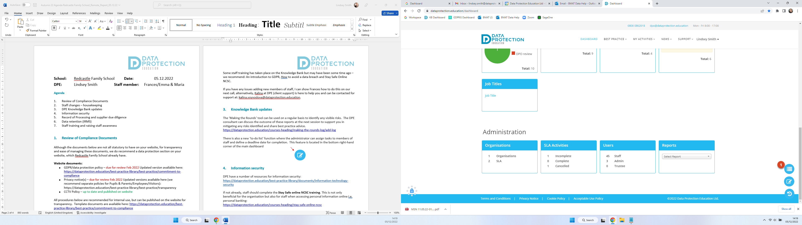
On the main dashboard, scroll down to ‘Users’
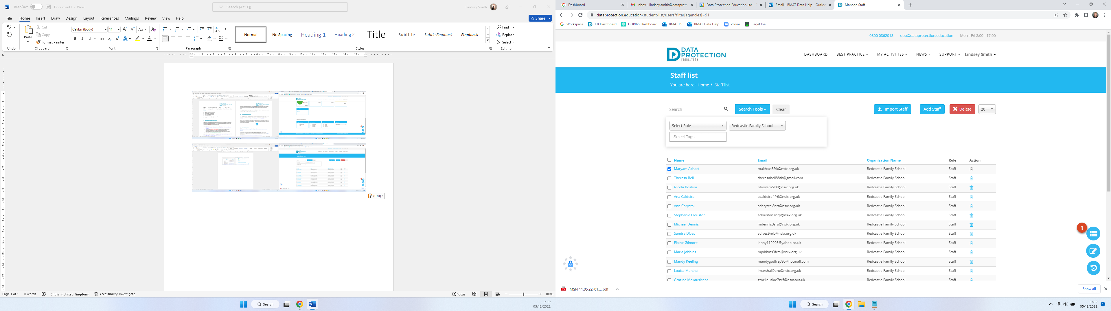
To delete a person, select the box to the left of their name and click the ‘bin’ icon under ‘Action’

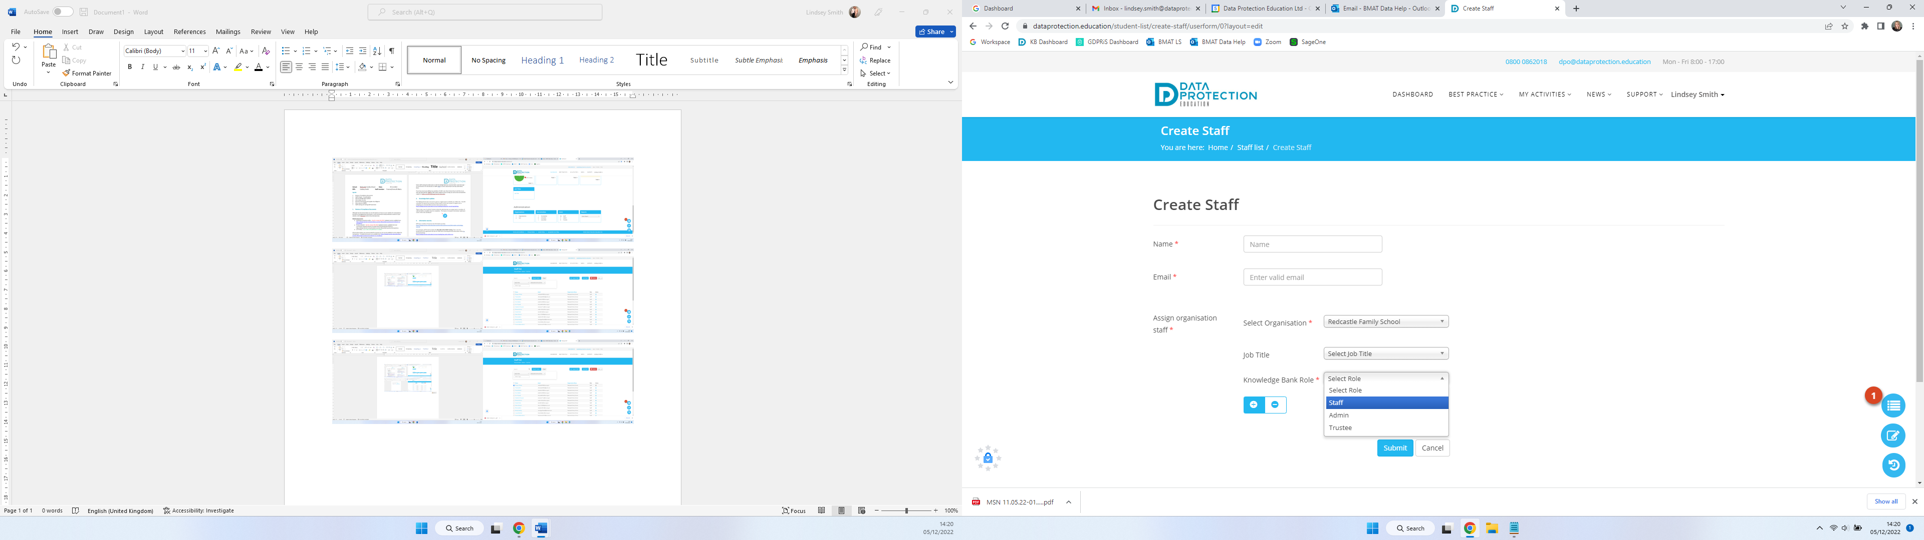
To add a new person, click the ‘Add Staff’ button.
Insert their forename & surname, work email address, job title and ensure the ‘Knowledge Bank Role’ is set to ‘Staff’ (unless they need access to view/log breaches, SARs, FOIs etc, then they would need to be set as ‘Admin’)

Some staff training has taken place on the Knowledge Bank but may have been some time ago – we recommend: An introduction to GDPR, How to avoid a data breach and Stay Safe Online NCSC.

If you have any issues adding new members of staff, I can show Frances how to do this on our next call, alternatively, Kalina at DPE (client support) is here to help you and can be contacted for support at: kalina.voyvodova@dataprotection.education.

- Knowledge Bank updates

As demonstrated during our session, the ‘Making the Rounds’ tool can be used on a regular basis to identify any visible risks. The DPE consultant can discuss the outcome of these reports at the next session to support you in mitigating any risks identified and share best practice advice. https://dataprotection.education/courses-heading/making-the-rounds-log/add-log

There is also a ‘to-do list’ function where the administrator can assign tasks to members of staff and define a deadline date for completion. This feature is located in the bottom right-hand corner of the main dashboard
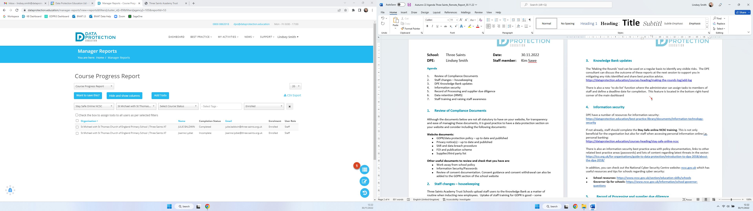

- Information security

DPE have a number of resources for information security:
https://dataprotection.education/best-practice-library/documents/information-technology-security

If not already, staff should complete the Stay Safe online NCSC training. This is not only beneficial for the organisation but also for staff when accessing personal information online i.e. personal banking:
https://dataprotection.education/courses-heading/stay-safe-online-ncsc

There is also an information security best practice area with policy documentation, links to other related best practice areas (passwords) and lots of content regarding latest threats in the sector: https://ico.org.uk/for-organisations/guide-to-data-protection/introduction-to-dpa-2018/about-the-dpa-2018/

In addition, you can check out the National Cyber Security Centre website: ncsc.gov.uk which has useful resources and tips for schools regarding cyber security:
- School resources: https://www.ncsc.gov.uk/section/education-skills/schools
- Governor Qs for schools: https://www.ncsc.gov.uk/information/school-governor-questions

- Record of Processing and supplier due diligence

Some Record of Processing has been previously carried out with Linda Mortimer (former DPE Consultant), in business areas for Finance, HR & Management of the School. Further RoP’s will be copied over for Pupil Management for completion at the next session.

Things to consider:
- Privacy notice/third party/supplier list - is this up to date, do you know all the organisations/suppliers you share information with?
- Due diligence form - this can be sent to new suppliers
- Make sure that current and future contracts include data protection
- Risks - what you should be thinking of when purchasing and using new products and suppliers

DPEs best practice area and the due diligence form for suppliers is located here: https://dataprotection.education/index.php/best-practice-library/best-practice/due-diligence-best-practice-area

- Data retention

Organisations can set deadlines, document and justify timeframes they have set for retaining data. There are two key factors: the purpose for processing the data, and any legal or regulatory requirements for retaining it. One of your purposes will need to apply for you to continue to store the data. Redcastle Family School use NCC’s records management schedule.
Different data systems to consider when reviewing data retention:
- Emails
- MIS
- Website
- Network/CLOUD

Tools to support you:
There are a number of tools to support you with data retention: IRMS toolkit
- DPE’s record management best practice area
- DfE Annual review of school records and safe data destruction checklist
- ICO
- DPEs Record of Processing (RoP)
- Your third party list within your privacy notice
- Laws and regulations (for example, financial regulations and handbooks and limitations act: https://www.legislation.gov.uk/ukpga/1980/58 /legislation: https://www.legislation.gov.uk/uksi/2021/833/contents/made )
- Microsoft retention tools
- Google retention tools
- MIS retention tools
- Network scanning and retention tools - speak to your IT department

- Staff training and raising staff awareness

Why not use staff briefings and having a monthly focus i.e., clear desks and locking laptops etc. This is an ideal way to raise awareness and keep staff focused with the latest data protection issues. We also have a bank of ‘drip feed’ posters available in our resources area to help with the focus: https://dataprotection.education/best-practice-library/documents/drip-feeds

