Date | 06.10.2022
Time of day | 10:00
Member of staff | Claire Watson (Deputy Head)

Overview

Organisation | Kimberley Primary School (EMET)
Date and time | 06.10.2022
Time spent | 1hr
Conducted by | Lindsey Smith & Claire Watson
Governor participation | No
Reason for making the rounds | As part of a regular schedule
Comments/Notes

Building and Visitor Information

Are all site entrances secure? | Yes / No
Are entrances left unlocked and unsupervised? | Yes / No
Observations
Is the visitor sign in system: | Paper / Electronic / Other
Is the staff/pupil sign-in system: | Paper / Electronic / Other
Is the visitor sign-in information secure and not available to others? | Yes / No
Are visitors asked for their ID? | Yes / No / Where Required
Are visitors asked for a DBS certificate? | Yes / No / Where Required
Is there a privacy statement to inform visitors what you do with their data? | Yes / No  Privacy Statement on the sign-in screen.
Does it include track and trace information? | Yes / No No longer applicable
Observations

Locations and Observations

Location | Reception Office
Is there personal information on display? | Yes / No
Are any of these types of data visible or easily accessible? | Admin Files, Allergy Information, Behaviour Files, Care Plans, CCTV monitors, Club or Trip lists, DOB, Full Names, HR or Finance Files, Interventions, Medical, Parental Contacts, Payslips, Photographs, Pick-up times/Secret Words, Usernames & Passwords, Safeguarding Files, SENDCO Files, Student Files.
Is the room secure/locked? | Yes / No
Are any computers unlocked? | Yes / No / NA (being worked on by admin team)
Do unlocked computers have applications open? | Yes / No / NA (being worked on by admin team)
Is there adequate secure storage? | Yes / No / NA
Are filed kept securely? | Yes / No / NA
Are photocopiers and printers password protected? | Yes / No / NA
How is confidential waste treated? | Secure Bins / Confidential Waste Bags / Shredders / General Recycling / Other
Observations | Main reception is a very small area where two members of staff are situated. There is a large lockable cupboard underneath a desk which the admin team use to lock away their in-trays at the end of each day. The entrance door to this office has a pin-code lock. Staff lock their computer screens as a matter of routine when left unattended.
Severity | Low / Medium / High / NA / Positive Observation

Location | Admin Managers Office
Is there personal information on display? | Yes / No
Are any of these types of data visible or easily accessible? | Admin Files, Allergy Information, Behaviour Files, Care Plans, CCTV monitors, Club or Trip lists, DOB, Full Names, HR or Finance Files, Interventions, Medical, Parental Contacts, Payslips, Photographs, Pick-up times/Secret Words, Usernames & Passwords, Safeguarding Files, SENDCO Files, Student Files.
Is the room secure/locked? | Yes / No
Are any computers unlocked? | Yes / No
Do unlocked computers have applications open? | Yes / No
Is there adequate secure storage? | Yes / No
Are filed kept securely? | Yes / No
Are photocopiers and printers password protected? | Yes / No / NA
How is confidential waste treated? | Secure Bins / Confidential Waste Bags / Shredders / General Recycling / Other
Observations | The printer in this office is only accessible by the office manager, therefore password protection is not necessary. Entrance into the office has a pin-code lock, staff member lock their computer screen as a matter of routine when left unattended. Pupil data is stored in a lockable cupboard.
Severity | Low / Medium / High / NA / Positive Observation

Location | Headteachers Office
Is there personal information on display? | Yes / No
Are any of these types of data visible or easily accessible? | Admin Files, Allergy Information, Behaviour Files, Care Plans, CCTV monitors, Club or Trip lists, DOB, Full Names, HR or Finance Files, Interventions, Medical, Parental Contacts, Payslips, Photographs, Pick-up times/Secret Words, Usernames & Passwords, Safeguarding Files, SENDCO Files, Student Files.
Is the room secure/locked? | Yes / No / NA
Are any computers unlocked? | Yes / No
Do unlocked computers have applications open? | Yes / No
Is there adequate secure storage? | Yes / No / NA
Are filed kept securely? | Yes / No / NA
Are photocopiers and printers password protected? | Yes / No / NA
How is confidential waste treated? | Secure Bins / Confidential Waste Bags / Shredders / General Recycling / Other
Observations | The Headteachers office is locked when unattended. HR files are kept in a locked filing cabinet and keys are stowed in an undisclosed location. The printer is only accessible by the Head and therefore password protection is not necessary. There is CCTV externally on the playground and entrances to the site – this is accessed via the Headteachers PC, however this is currently not working – IT provider is aware.
Severity | Low / Medium / High / NA / Positive Observation

Location | Copying room
Is there personal information on display? | Yes / No
Are any of these types of data visible or easily accessible? | Admin Files, Allergy Information, Behaviour Files, Care Plans, CCTV monitors, Club or Trip lists, DOB, Full Names, HR or Finance Files, Interventions, Medical, Parental Contacts, Payslips, Photographs, Pick-up times/Secret Words, Usernames & Passwords, Safeguarding Files, SENDCO Files, Student Files.
Is the room secure/locked? | Yes / No
Are any computers unlocked? | Yes / No
Do unlocked computers have applications open? | Yes / No / NA
Is there adequate secure storage? | Yes / No
Are filed kept securely? | Yes / No
Are photocopiers and printers password protected? | Yes / No
How is confidential waste treated? | Secure Bins / Confidential Waste Bags / Shredders / General Recycling / Other
Observations | The photocopying room is located off the hall behind a curtained doorway. Although accessible by pupils this area only contains resources and no personal data is stored here. There is a computer which remains switched off unless in use by a member of staff. The photocopier does not have password protection, staff must go to it for printing. I would advise a password system is used to mitigate any risk to confidential printing.
Severity | Low / Medium / High / NA / Positive Observation

Location | Staffroom
Is there personal information on display? | Yes / No
Are any of these types of data visible or easily accessible? | Admin Files, Allergy Information, Behaviour Files, Care Plans, CCTV monitors, Club or Trip lists, DOB, Full Names, HR or Finance Files, Interventions, Medical, Parental Contacts, Payslips, Photographs, Pick-up times/Secret Words, Usernames & Passwords, Safeguarding Files, SENDCO Files, Student Files.
Is the room secure/locked? | Yes / No
Are any computers unlocked? | Yes / No
Do unlocked computers have applications open? | Yes / No / NA
Is there adequate secure storage? | Yes / No
Are filed kept securely? | Yes / No / NA
Are photocopiers and printers password protected? | Yes / No / NA
How is confidential waste treated? | Secure Bins / Confidential Waste Bags / Shredders / General Recycling / Other
Observations | The staff room is sometimes used for hosting parental meetings and a holding place for visitors and therefore no personal data is stored here or displayed on the walls.
Severity | Low / Medium / High / NA / Positive Observation

DPO Feedback and Actions Taken

DPO Feedback
The overall security of personal data within the school is good. There is no visible or accessible data to public/parents. The site security is good, having secure doors into the school, an electronic sign-in system and CCTV outside. There are privacy notices on the external fencing advising of CCTV in operation.
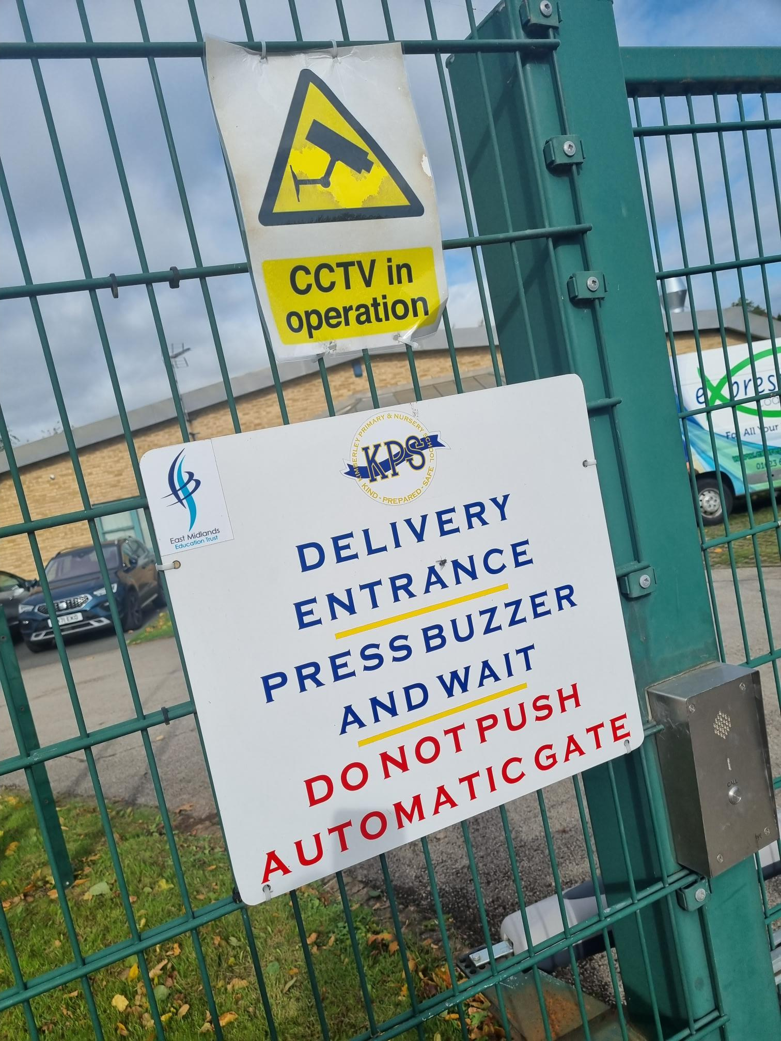

I would recommend the photocopier being password protected as it could be easily accessed by pupils.

Staff lock computers as a matter of routine when they are left unattended.

