School: Three Saints Date: 17.01.2023
DPE: Lindsey Smith Staff member: Kim Sawe

Agenda

- Review of Compliance Documents
- Staff changes – housekeeping
- DPE Knowledge Bank updates
- Information security
- Record of Processing and supplier due diligence
- Data retention (IRMS)
- Best Practice Checklist

- Review of Compliance Documents

Compliance documents are all up to date and published on the website as follows:

- GDPR/data protection policy – up to date and published
- Privacy notice(s) – up to date and published
- SAR and data breach procedure

Other useful documents to review and check that you have are:
- FOI and Publication Scheme
- Work away from school policy
- Information Security/Passwords
- Review of consent documentation. Consent guidance and consent withdrawal can also be added to the GDPR section of the school website

- Staff changes – housekeeping

Three Saints Academy Trust Schools upload staff users to the Knowledge Bank as a matter of routine when inducting new employees. Uptake of staff training for GDPR is good – some incomplete.

We recommend the latest courses: An introduction to GDPR, How to avoid a data breach and Stay Safe Online NCSC.

- Knowledge Bank updates

The ‘Making the Rounds’ - last walk carried out in September 2021. Conducting annual walk arounds can be beneficial in early identification of visible risks and mitigating these through staff training and policies.

There is also a new ‘to-do list’ function where the administrator can assign tasks to members of staff, including staff training courses, and define a deadline date for completion. This feature is located in the bottom right-hand corner of the main dashboard.
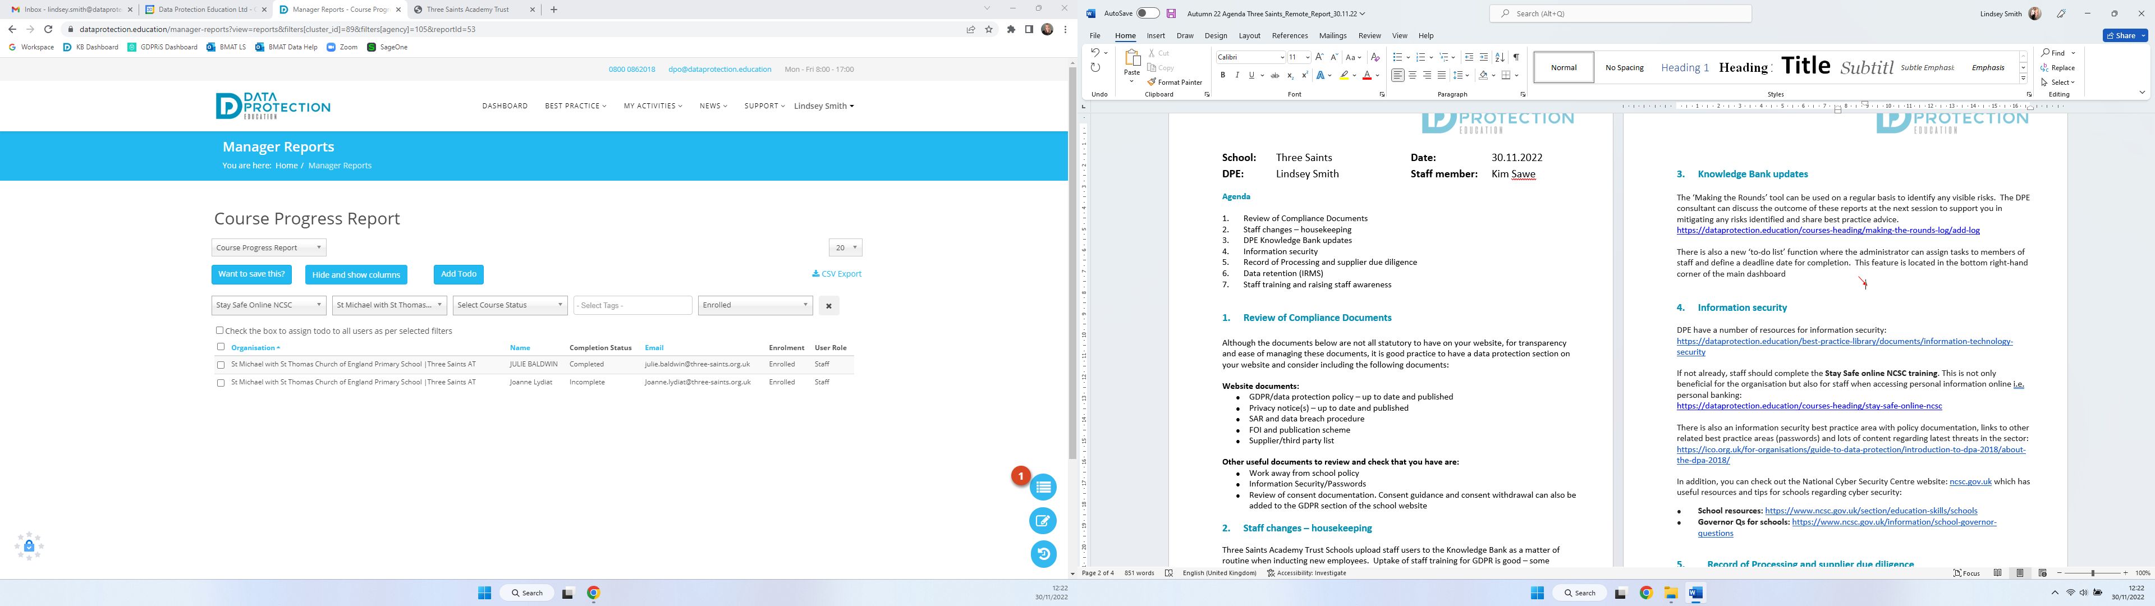

- Information security

DPE have a number of resources for information security:
https://dataprotection.education/best-practice-library/documents/information-technology-security

If not already, staff should complete the Stay Safe online NCSC training. This is not only beneficial for the organisation but also for staff when accessing personal information online i.e. personal banking:
https://dataprotection.education/courses-heading/stay-safe-online-ncsc

There is also an information security best practice area with policy documentation, links to other related best practice areas (passwords) and lots of content regarding latest threats in the sector: https://ico.org.uk/for-organisations/guide-to-data-protection/introduction-to-dpa-2018/about-the-dpa-2018/

In addition, you can check out the National Cyber Security Centre website: ncsc.gov.uk which has useful resources and tips for schools regarding cyber security:
- School resources: https://www.ncsc.gov.uk/section/education-skills/schools
- Governor Qs for schools: https://www.ncsc.gov.uk/information/school-governor-questions
Is your school running the most recent Windows? 8.1 may still be used on many devices, it came with a free upgrade to Windows 10 – see here for details https://dataprotection.education/infosec/302-end-of-windows-8-support

- Record of Processing and supplier due diligence

A significant amount of work on the Record of Processing has been previously carried out with Linda Mortimer (former DPE Consultant), in business areas for Finance, HR & Management of the School. No further RoPs identified as necessary at the current time, until further information is confirmed following de-regulation and DPE’s RoP lighter version.

Things to consider:
- Privacy notice/third party/supplier list - is this up to date, do you know all the organisations/suppliers you share information with?
- Due diligence form - this can be sent to new suppliers
- Make sure that current and future contracts include data protection
- Risks - what you should be thinking of when purchasing and using new products and suppliers

DPEs best practice area and the due diligence form for suppliers is located here: https://dataprotection.education/index.php/best-practice-library/best-practice/due-diligence-best-practice-area

- Data retention

The Three Saints Trust has a Retention of Records Management Policy, which may be in need of updating to offer clarity on all data held.
Different data systems to consider when reviewing data retention:
- Emails
- MIS
- Website
- Network/CLOUD

Tools to support you:
There are a number of tools to support you with data retention: IRMS toolkit
- DPE’s record management best practice area
- DfE Annual review of school records and safe data destruction checklist
- ICO
- DPEs Record of Processing (RoP)
- Your third party list within your privacy notice
- Laws and regulations (for example, financial regulations and handbooks and limitations act: https://www.legislation.gov.uk/ukpga/1980/58 /legislation: https://www.legislation.gov.uk/uksi/2021/833/contents/made )
- Microsoft retention tools
- Google retention tools
- MIS retention tools
- Network scanning and retention tools - speak to your IT department

- Best Practice Checklist

The checklist has been updated by Lindsey and will be further updated during the session booked for April to reflect the work done and identify any areas outstanding.

