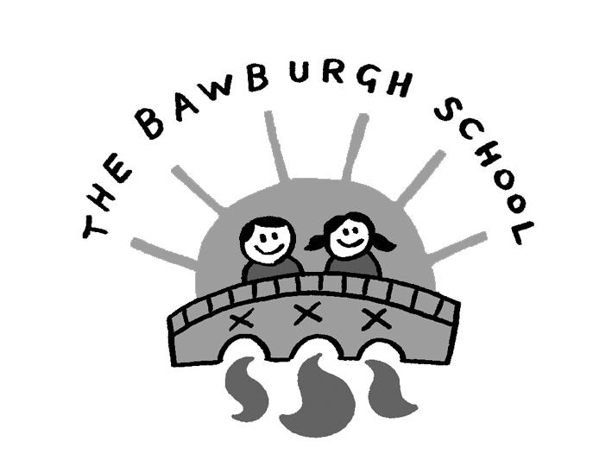

Images and videos parental consent form

This form explains the reasons why and how The Bawburgh School may use images and videos of your child. Please read the form thoroughly and outline your agreement as appropriate.

Name of parent:
Name of pupil:
Year:

Why do we need your consent?

The Bawburgh School requests the consent of parents on an annual basis to use images and videos of their child for a variety of different purposes.

Without your consent, the school will not use images and videos of your child. Similarly, if there are only certain conditions under which you would like images and videos of your child to be used, the school will abide by the conditions you outline in this form.

Why do you we use images and videos of your child?

The Bawburgh School uses images and videos of pupils as part of school displays to celebrate school life and pupils’ achievements; to promote the school on social media and on the school’s website; and for other publicity purposes in printed publications, such as newspapers.

Each class also has a Dojo account, accessible only by parents/carers of that class where photos/videos will be shared.

Where the school uses images of individual pupils, the full name of the pupil will not be disclosed. Where an individual pupil is named in a written publication, a photograph of the pupil will not be used to accompany the text.

If, for example, a pupil has won an award and their parent would like their name to be published alongside their image, separate consent will be obtained prior to this.

The Bawburgh School may take images or videos of individual pupils and groups of pupils to use on Twitter, the school website, in the school brochure and other printed publications, such as a newsletter.

Who else uses images and videos of your child?

On occasions the school may be visited by local media and press, who take images or videos of school events. Pupils will appear in these images and videos, and these may be published in local or national newspapers, or on approved websites.

The following organisations may use images and videos of your children:
Local press:
- The Bawburgh News
- Eastern Daily Press

Other third parties:
- Richard Jarmy Photography

Where any organisations other than those above intend to use images or videos of your child, additional consent will be sought before any image or video is used.

What are the conditions of use?

- This consent form is valid for 2023-2024
- It is the responsibility of parents to inform the school, in writing, if consent needs to be withdrawn or amended.
- The school will not use the personal details or full names of any pupil in an image or video, on our website, in our school prospectuses or any other printed publications.
- The school will not include personal emails or postal addresses, telephone or fax numbers on images or videos on our website, in our school brochure or any other printed publications.
- The school may use pictures of pupils and teachers that have been drawn by pupils.
- The school may use work created by pupils.
- The school may use group or class images or videos with general labels, e.g. ‘sports day’.
- The school will only use images and videos of pupils who are suitably dressed, i.e. it would not be suitable to display an image of a pupil in swimwear.
- The school will take class images of your child which are available to purchase annually.
Providing your consent

Please read the following conditions thoroughly and provide your consent as appropriate by ticking either ‘Yes’ or ‘No’ for each criteria.

The school will only publish images and videos of your child for the conditions that you provide consent for.

I provide consent to: | Yes | No
Using images of my child on the school website.
Using videos of my child on the school website.
The local media using images of my child to publicise school events and activities (only including the organisations outlined above).
Using images of my child in marketing material, e.g. the school brochure, newsletter and prospectus.
I am happy for my child’s photograph to be used in the school yearbook (photos will be shared with yearbook production team)

The local media using videos of my child to publicise school events and activities (only including the organisations outlined above).
I am happy for photos of my child to be displayed in school (such as corridors, classrooms)
I am happy for Images/videos of my child to be displayed on the class Dojo page
Using images/videos of my child on social media. Generic comments will be used to describe photos/videos/work such as 'Jackdaws were creating models of Stonehenge using bourbon and custard cream biscuits'. Children's names will not be used. The school can only provide control of the school social media accounts and cannot guarantee, nor control any re-publication, sharing or household or personal use that follows the publication on social media
I am happy for first names to be shared with other parents for celebration items such as birthdays, Christmas cards and birthday lunches
I am happy for first names to be shared with The Friends such as discos, Christmas card and other celebrations

Note: The school can only provide control of the school social media accounts and cannot guarantee, nor control any re-publication, sharing or household or personal use that follows the publication on social media.

The school securely shares a child’s name and class with a school-appointed external photography company for official school images, for example, for identification purposes on the schools Management Information System. Photo’s will not be shared outside of the school setting and/or for another purpose unless additional information is provided to you and consent is obtained.

Refreshing your consent

This form is valid for the entire academic year, 2022/23 – it will be updated on an annual basis. Parents are required to fill in a new form for their child every academic year.

Consent will also be refreshed where any changes to circumstances occur – this can include, but is not limited to, the following:

- New requirements for consent, e.g. an additional social media account will be used to share pupil images and videos
- Changes to a pupil’s circumstances, e.g. safeguarding requirements mean a pupil’s image cannot be used
- Changes to parental consent, e.g. amending the provisions for which consent has been provided for
Where you would like to amend the provisions for which consent has been provided, you must submit your request in writing to Miss C. Stedman, the Executive Headteacher. A new form will be supplied to you to amend your consent accordingly and provide a signature.

Withdrawing your consent

Parents have the right to withdraw their consent at any time. Withdrawing your consent will not affect any images or videos that have been shared prior to withdrawal.

If you would like to withdraw your consent, you must submit your request in writing to the Miss C. Stedman, Executive Headteacher.
Declaration

I, ___________________ (name of parent), understand:

- Why my consent is required.
- The reasons why The Bawburgh School uses images and videos of my child.
- Which other organisations may use images and videos of my child.
- The conditions under which the school uses images and videos of my child.
- I have provided my consent above as appropriate, and the school will use images and videos of my child in line with my requirements.
- Consent is refreshed on an annual basis and I must re-provide consent if I consent to images and videos of my child being used in other academic years.
- I will be required to re-provide consent where any circumstances change.
- I can amend or withdraw my consent at any time and must do so in writing to Miss C. Stedman, Executive Headteacher.
Name of parent: | ––––––––––––––––––––––––––––––––
Signature: | ––––––––––––––––––––––––––––––––
Date: | ––––––––––––––––––––––––––––––––

If you have any questions regarding this form, please do not hesitate to contact the Miss C. Stedman, Executive Headteacher at office@bawburgh.norfolk.sch.uk or 01603 742329.

