Using GIT

This document explains how to setup and use GIT on your Ubuntu System

Introduction to GIT
What is GIT ?
How Git works ?
Why to use GIT ?
Which are the GIT repositories?
Installing & Setting up GIT
Git Installation
Git Setup
Commands that you must run
Setting up & Cloning repository
Adding SSH keys
How to get existing remote repository on your machine?
Cloning the repository on your local machine
Setting up a working area in your local server (Linked Copy)
Creating new repository
Having existing project to add in git?
Starting new project ?
Basic GIT commands
Commit & Push
Tagging in GIT
Listing tags
Check current tag
Apply tag
Adding pre-commit hooks
Adding hook to your repository
Troubleshooting
Cloning the repository without adding ssh keys.
Trying to push before pull
Merging issue due to working on same files by multiple users
Merging issue due to working on same files and same lines by multiple users
Needing to stash
Common git terms in simple words
Other useful Resources

Introduction to GIT

What is GIT ?

Git is a distributed revision control system. Unlike SVN, each ‘clone’ of a GIT repository has the full history of commits. You can work and commit while being offline.

How Git works ?

The basic Git workflow goes something like this:
- You modify files in your working directory.
- You stage the files, adding snapshots of them to your staging area.
- You do a commit, which takes the files as they are in the staging area and stores that snapshot permanently to your Git directory.
- TIP : Modifications include changes to files as well as deletes, rename and chmod
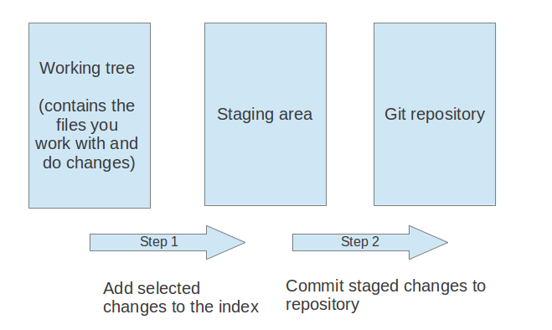

Why to use GIT ?

- Git prevents against lost changes when concurrent development takes place
- Easy to track changes
- Can revert to a previous commit
- Can create a new branch from any point in the tree

GIT Hosting ?

Usually, we use any of the 3 repository hosting services :

1. git.tekdi.net (Uses Gitlab)
If it is a private/client project then you need to use this.

2. github.com
If it is public project or client has opted for using a paid github account, then you will use github. The joomla project and several other open source projects are hosted on github.com

3. Bitbucket.org
Similar to github, but use only if client has opted for using bitbucket account.

Installing & Setting up GIT

Git Installation

1. Check if GIT is already installed on your pc using command :
$ git --version
2. If it returns version, it means GIT is installed already.

Git Setup
Open terminal (Ctrl+Alt+T on most Ubuntu systems) and type following commands

1. Install GIT
$ sudo apt-get install git-core

2. Set configuration values for your user name
$ git config --global “Mukta Damale”

3. Set configuration values for your email
$ git config --global user.email “mukta_d@tekdi.net”

4. Go to home folder

5. Go to .ssh folder as
$ cd tws87/.ssh
Note : tws87 is the directory under home folder. (check yours and use it). .ssh folder is hidden folder. To check if folder exists use (Ctrl+h). If folder does not exist, create one with name .ssh.

6. Create rsa keys that will generate id_rsa and id_rsa.pub . Email will be your Tekdi email id.
$ ssh-keygen -t rsa -C “mukta_d@tekdi.net”

Output will be :
Generating public/private rsa key pair.
Enter file in which to save the key (/home/tws87/.ssh/id_rsa):
Enter passphrase (empty for no passphrase):
Enter same passphrase again:
Your identification has been saved in /home/tws87/.ssh/id_rsa.
Your public key has been saved in /home/tws87/.ssh/id_rsa.pub.
The key fingerprint is:
73:5f:7c:a5:c6:74:69:2c:97:76:a0:87:ef:24:f8:d5 mukta_d@tekdi.net
The key's randomart image is:
+--[ RSA 2048]----+
| . |
| o..o|
| o.oB+|
| . *=+o|
| S o . X E|
| o o B . |
| o . |
| |
| |
+-----------------+

7. Execute following command :

$ ssh-add ~/.ssh/id_rsa

If this throws an error saying “Could not open a connection to your authentication agent”
You might need to start ssh-agent before you run the ssh-add command
execute below command

eval `ssh-agent -s`
then again
ssh-add ~/.ssh/id_rsa

Commands that you must run
$ git config --global user.name “your name”
$ git config --global user.email “your tekdi email id”
$ git config --global core.fileMode false

(This is compulsory, otherwise GIT will show chmod as a change)

Setting up & Cloning repository

Adding SSH keys

You should have account and repository access in case of github / bitbucket. If you are using git.tekdi.net, you can sign in using your tekdi account and request access to the repository.

- Go to home folder.
- Go to the users folder ex. tws87
- Show hidden folders (Ctrl + h)
- You will see .ssh folder. Open it.
- Search for id_rsa.pub file. Open the file.
- Copy the contents of the file.
- Now, go to your git account where your project is there .
- In the ‘Settings’ section of any of the git account, there is one section ‘Add SSH keys’.
- Open it. Click on create new key.
- Add name of the key and paste the content of id_rsa.pub there.

How to get existing remote repository on your machine?

Cloning the repository on your local machine

- Ensure you have added the SSH key
- Open folder where you want to clone repository
- Ideally, open Documents folder. Create new folder ‘git’.
- Open terminal. (Ctrl +Alt +t).
- Go to the folder Documents/git
- Now, you will need to get the clone url from your git account. On your git account, you will see ‘ssh clone url’. Copy that url.
- In terminal, write : git clone [your clone url]
$ git clone git@github.com:aims-ashwin/osianama.git
- The repository will be cloned and you will be able to see the files

Setting up a working area in your local server (Linked Copy)

- After cloning is completed, you will see project folder under Documents/git/[your project folder].
- Open the folder. It may have different folders such as documentation, database, www etc depending on your project’s structure.
- Check the folder where actually joomla / project related files are there.
- Right click on that folder. Click on ‘make link’.
- Cut-Paste the created link inside var/www. (In case if you have ubuntu 14.04, paste it under var/www/html)
- Rename the link to a more suitable name
- If latest database exists under the database folder, import that database into phpmyadmin. Make sure you read this document carefully & do/verify required things.
- Setup Joomla or any other application’s configuration file.
- Finally you are done. Open the browser. Enter url as localhost/(folder name of your project).
- You will see your site on your local copy.
- If you see a forbidden or any such error make sure the permissions of the files are set up correctly.

Creating new repository
In case you have started working on a project that does not have a repository yet, navigate to the folder that you want to use as a GIT repo, then run these commands after making sure

- $ git init
- $ touch README
- $ touch .gitignore
- $ git add readme
- $ git commit -m “first commit”
- $ git remote add origin git@git.tekdi.net:mukta_d/osian.git
- $ git push -u origin master

Having existing project to add in git?

- If you have project already, which is not on git and you are now adding it to git.
- Add .gitignore file.
- Recommended way is to check the joomla version of a project. Let’s say it is joomla 2.5.14.
- Get the fresh joomla files of that version.
- Create the folder say www in git project folder (Documents/git/your project folder).
- Copy all files under that folder. Push those files
- Now copy all your project files on that fresh joomla files and push them too.
- Export your current project database and keep it under database folder (Documents/git/your project/database)
- Link your copy and use it.

Starting new project ?

- As you are starting new project, obviously,you will not have any developed code on local.
- Add .gitignore file.
- Get the joomla version in which you are developing project.
- Setup joomla under linked folder.
- Push those files to git.
- And start working on same.

GIT for Windows

Installing & Setting up GIT

Git Installation

1. Download windows git setup from here: https://git-scm.com/download/win

2. Install Git-2.11.0-64-bit.exe

3. Open git CMD

4. Create rsa keys that will generate id_rsa and id_rsa.pub . Email will be your Tekdi email id.

ssh-keygen -t rsa -b 4096 -C "mukta_d@tekdi.net"

Output will be :
Generating public/private rsa key pair.
Enter a file in which to save the key (/Users/you/.ssh/id_rsa): [Press enter]
Enter passphrase (empty for no passphrase): [Type a passphrase]
Enter same passphrase again: [Type passphrase again]
5. You will see .ssh folder. Open it.

6. Search for id_rsa.pub file. Open the file.

7. Copy the contents of the file.

8. Now, go to your git account where your project is there .

9. In the ‘Settings’ section of any of the git account, there is one section ‘Add SSH keys’.

10. Open it. Click on create new key.

11. Add name of the key and paste the content of id_rsa.pub there.

How to get existing remote repository on your machine?

Cloning the repository on your local machine

- Ensure you have added the SSH key
- Open folder where you want to clone repository
- Ideally, open Documents folder. Create new folder ‘git’.
- Open terminal. (Ctrl +Alt +t).
- Go to the folder Documents/git
- Now, you will need to get the clone url from your git account. On your git account, you will see ‘ssh clone url’. Copy that url.
- In terminal, write : git clone [your clone url]
$ git clone git@github.com:aims-ashwin/osianama.git
- The repository will be cloned and you will be able to see the files.

Basic GIT commands

Commit & Push

Before start working on the local copy , Use following command to pull remote files
$ git pull
This will pull all latest changes pushed by others, to your local copy in order to avoid conflicts.

To see the status of your working tree, i.e. view which files are changed etc
$ git status

Add files to be committed
$ git add *
OR
$ git add filepath
where filepath will be path of the file as per shown in git status.

If you have physically deleted files, then it will show it under deleted files. In that case you need to use git rm command rather than using git add command.

$ git rm filepath
where filepath is the path of the files showing as deleted in git status.

Files that have been staged can be committed by the following command. Note that removing files from repository also needs to be “committed” for the remote repository to know that those files have been deleted
$ git commit -m “comment”
where comment is short information about this modified files

Committing is a local action, so once you commit, you need to push the changes to the remote repository
$ git push origin master
Where origin is the name of the remote repo, and master is the branch you need to push

Tagging in GIT
Git has the ability to tag specific points in history as being important. Typically people use this functionality to mark release points (v1.0, and so on).

Listing tags
$ git tag

Check current tag
$ git describe --tags

Apply tag
$ git tag 10.69 -m “Add the comment considering your releases/deployment etc.”
Where v10.69 is the name of the tag

Here is the command to add tag for previous commit
$git tag -a v2.6 fff5f57 -m "Quick2cart 2.6 release"

After creating the tag you have to push tag to your remote
#git push origin 2.6

Reference https://git-scm.com/book/en/v2/Git-Basics-Tagging

Adding pre-commit hooks

We have a pre-commit hook that does not allow anyone to commit your changes if your files have codesniffer errors. When you create new repository or add your project to git then you must have this pre-commit hook.

Adding hook to your repository

- Go to the folder where your git cloned repository is present. Ex. Documents/git/osian.
- Show hidden files (Ctrl + h)
- You will see .git folder. Open it.
- Open hooks folder.
- Add hook files ie. pre-commit and config under that folder.
- Open config file.
- Search for PHPCS_IGNORE.
- Add your template path. If you are using template ‘construct5’, then replace templates/* with templates/construct5/html.
- In case of teams who are not using joomla, set value to PHPCS_CODING_STANDARD from joomla to your standard. Check first if codesniffer package is available for it.

Troubleshooting

Cloning the repository without adding ssh keys.
Error :
Permission denied (publickey). fatal: The remote end hung up unexpectedly.

Reason :
You have not added your ssh keys to your git account.

Solution :
Add the ssh keys to your github account. If you have not generated keys yet, follow the instructions here.

Trying to push before pull
Error :
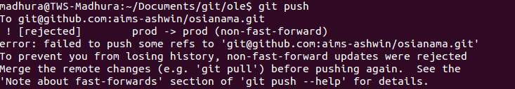

Reason :
Someone has pushed some files to git and you haven’t pulled it yet. And before that you are pushing your changes.

Solution :
You need to do git pull first. and do ‘git push’ to push your changes.

Merging issue due to working on same files by multiple users

Error :
Please, commit your changes or stash them before you can merge.
www/components/com_osian/models/abc.php
Aborting
Reason :
You are working on a file say abc.php and the file is yet to commit from your side. Someone changed same file and pushed to git. Now, when you try to do git pull, it shows above error.
Solution :
- You need to commit your file first.
- Then do ‘git pull’.
- Then do ‘git push’.

Merging issue due to working on same files and same lines by multiple users

Error :
Auto-merging www/components/com_osian/models/test.php
CONFLICT (content): Merge conflict in www/components/com_osian/models/test.php
Automatic merge failed; fix conflicts and then commit the result.

Reason :
You are doing changes on the line say 1 to 5 in the file test.php. You have committed your changes, but not pushed yet. Now, another dev adds some code within the same lines and push it to git. And, when you do ‘git pull’, you face this error.

In this case, Git automatically adds conflict markers to the affected areas. A conflict-marked area begins with <<<<<<< and ends with >>>>>>>. These are also known as the conflict markers. The two conflicting blocks themselves are divided by a =======.

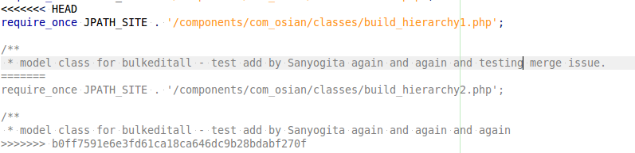

Here error occurred due to different changes on same line.
require_once JPATH_SITE . '/components/com_osian/classes/build_hierarchy1.php';
require_once JPATH_SITE . '/components/com_osian/classes/build_hierarchy2.php';

and,

model class for bulkeditall - test add by Sanyogita again and again and testing merge issue.
model class for bulkeditall - test add by Sanyogita again and again and again

Solution :
You can either keep your changes, take another dev’s changes, or make a brand new change. Whatever you do, you need to make sure to resolve the conflict such that the file makes sense, and everyone is happy.
In this case, you'll put in a whole new version of the line that reflects what happened. The goal is to get the file to look exactly how you want it. You'll delete the conflict markers, and just type out a new change.

So after merging, updated lines will be like this :
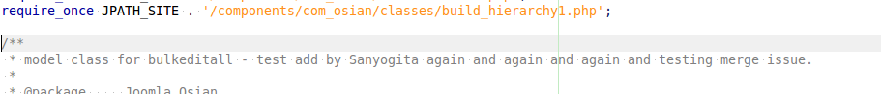

Now, when you say ‘git status’, you will see the same file as :
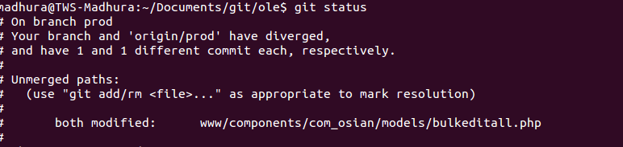

Now, just do ‘git add’, commit and push that file and you are done.

Needing to stash

Suppose, you are working on a project and are in the middle of something. You are not ready to commit your changes, because your tests don’t pass yet or your work is not in the state that you should commit it. Then your client calls with a bug report that needs to be fixed right now. So what will you do?

You just stash your changes away, and make the patch! Afterward you grab your changes back and continue work.

How to do it?

- Check your all untracked files using git status.
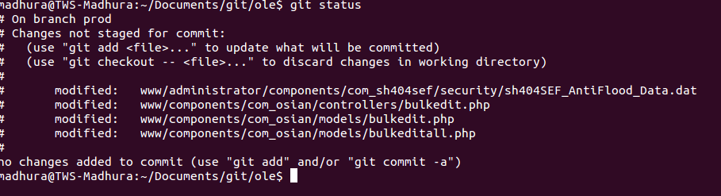

- Now stash your changes using
git stash
- Now your git changes are empty. So if you do git status, you will see no file.

- If you want to add comment for git stash for future reference, then use :
git stash save "your comment"

And, now you are free to do your priority changes.

Again, you want to work on stashed changes ?
Do this :
- List current stashes
git stash list
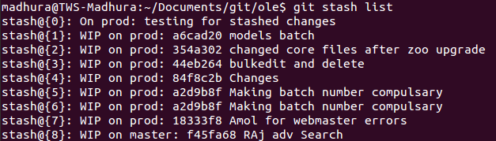

This shows you the past stashes you have done. It works like a stack. Every time you save a new stash, it’s put on top of the stack.

- Apply a stash
git stash apply stash@{0}
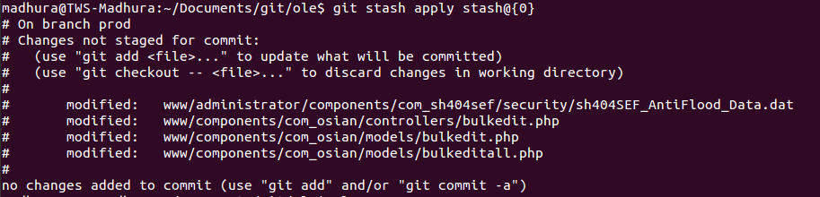
Your changes are back again .

Common git terms in simple words
Here's an attempt to complete your glossary :

- repo, repository: This is your object database where your history and configuration is stored. May contain several branches. Often it contains a worktree too.
- index, staging area: This is a 'cache' between your worktree and your repository. You can add changes to the index and build your next commit step by step. When your index content is to your likes you can create a commit from it. Also used to keep information during failed merges (your side, their side and current state)
- clone: A clone of a repository ("just another repository") or the act of doing so ("to clone a repository (creates a new clone)")
- commit: A state of your project at a certain time. Contains a pointer to its parent commit (in case of a merge: multiple parents) and a pointer to the directory structure at this point in time.
- branch: A different line of development. A branch in git is just a "label" which points to a commit. You can get the full history through the parent pointers. A branch by default is only local to your repository.
- HEAD: A symbolic name to describe the currently checked out commit. Often the topmost commit
- version: Might be the same as a commit. Could also mean a released version of your project.
- tag: A descriptive name given to one of your commits (or trees, or blobs). Can also contain a message (eg. changelog). Tags can be cryptographically signed with GPG.
- stash: Git allows you to "stash away" changes. This gives you a clean working tree without any changes. Later they can be "popped" to be brought back. This can be a life saver if you need to temporarily work on an unrelated change (eg. time critical bug fix)
- history: Describes all ancestor commits prior to a commit going back to the first commit.

Other useful Resources

http://www.git-tower.com/learn/videos

