Read me – Instruction for running the application .

1. Open the folder predict .
2. Run file name “project.m”
3. You will see GUI as this

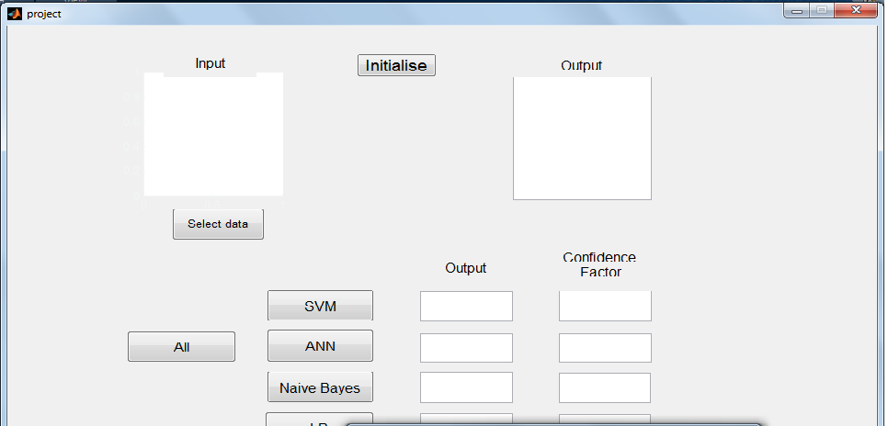

d)Select the ‘intialise’ button and then select ‘select data ‘ button ‘

e) You will see a picture of digit in the input section.

f) To recognize the image through all techniques press all other wise indicidual buttons.

e)Final Result:

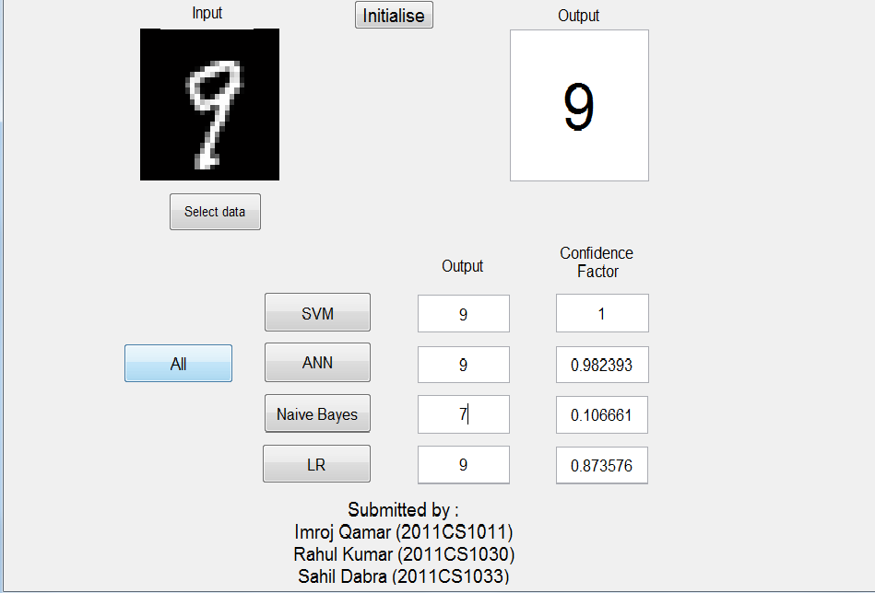

To run the files in the training folder , these are the files using which we have trained different classfiers .

1. Download the image data from <http://yann.lecun.com/exdb/mnist/train-images-idx3-ubyte.gz>.
2. Download the label data from <http://yann.lecun.com/exdb/mnist/train-labels-idx1-ubyte.gz>
3. Uncompress both these files .
4. Paste it in the logistic regession folder and run logisticRegression.m
5. Similarly paste the content of into other folders and run neuraknetwork.m,naiveBayes.m or svm.m.
6. Make sure the data files are in the specific classifier folder before running the classifier .

After running these file you will get a .mat file containing the trained model .