Trader Behavior & Market Sentiment
An Analysis of Hyperliquid Trading Performance Against the Bitcoin Fear & Greed Index
Data Science Assignment — Web3 Trading Insights
Prepared: July 2026

Executive Summary
This analysis merges 211,224 individual trade records from 32 Hyperliquid accounts (May 2023 – May 2025) with the daily Bitcoin Fear & Greed Index to test whether crowd sentiment is associated with measurable differences in trading behavior and outcomes. The data shows a clear and consistent pattern: traders are not simply more or less profitable in one regime — they behave differently, and those behavioral shifts are visible across position sizing, directional bias, and realized win rates.
Three findings stand out. First, win rates and average PnL per trade are highest in Extreme Greed (89.2% win rate) and Fear (87.3% win rate), and lowest in the transitional/ambiguous regimes of Extreme Fear and Greed — suggesting traders on this venue perform best at sentiment extremes and struggle more in mixed conditions. Second, traders flip their directional bias with sentiment: long positions dominate (63–69%) during Fear and Extreme Fear, while short positions dominate (55–58%) during Greed and Extreme Greed — a contrarian, buy-the-dip / fade-the-rally pattern rather than a momentum-chasing one. Third, position sizing is not uniform: the largest 1% of trades are heavily concentrated in Fear (46% of big trades vs. a 29% baseline share), while Extreme Greed sees traders shrink size (avg. $2,780 vs. $5,000–8,000 elsewhere) — consistent with aggressive risk-taking during fear and profit-protective caution at euphoric tops.
These patterns imply a workable strategy heuristic: this trader population is rewarded for leaning long into fear and leaning short (or de-risking) into greed, rather than following the herd. The report below details the methodology, supporting evidence, and caveats.

1. Datasets & Methodology

1.1 Data Sources
- Hyperliquid Historical Trade Data: 211,224 executions across 32 accounts and 246 traded symbols, spanning 1 May 2023 to 1 May 2025. Fields used: Account, Coin, Execution Price, Size (Tokens/USD), Side, Direction, Timestamp, Closed PnL, and Fee.
- Bitcoin Fear & Greed Index: a daily classification (Extreme Fear, Fear, Neutral, Greed, Extreme Greed) plus a 0–100 sentiment score, covering 1 Feb 2018 to 2 May 2025 (2,644 days).

1.2 Processing Steps
- Parsed trade timestamps and extracted the calendar date (IST) of each execution.
- Left-joined each trade to the Fear & Greed classification for that calendar date. Match rate was 99.997% (211,218 of 211,224 rows); the 6 unmatched rows fall outside the index's date coverage and were excluded from sentiment-conditioned analysis.
- Defined a 'closed' trade as any row with non-zero Closed PnL (104,408 of 211,224 rows) — this isolates realized outcomes from position-opening entries that carry zero PnL by definition.
- Computed win rate, average/median/total PnL, position-size behavior, and long/short skew, each grouped by sentiment classification.
- Note on scope: a 'leverage' field was referenced in the assignment brief but was not present in the underlying export; leverage-specific analysis was substituted with trade-size and risk-appetite proxies (Size USD, and size normalized to each account's own median) instead.

2. Profitability & Win Rate by Sentiment
Grouping all realized (non-zero PnL) trades by the sentiment regime active on their trade date reveals a non-linear relationship — performance is not simply better in 'good' sentiment and worse in 'bad' sentiment. Instead, the best outcomes cluster at the emotional extremes.
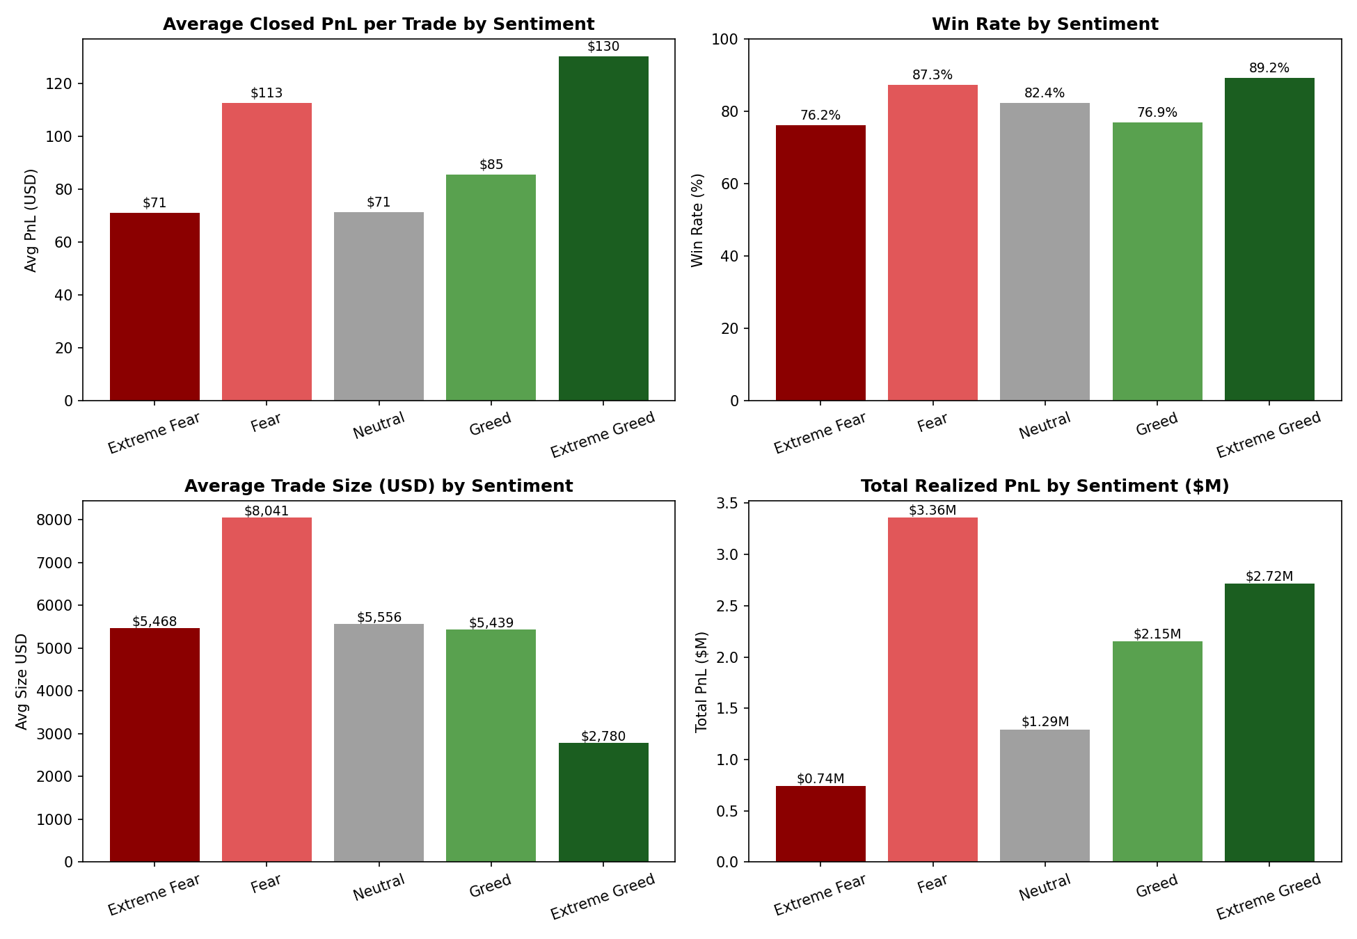
Figure 1. Average PnL per trade, win rate, average trade size, and total realized PnL, by sentiment regime.
Sentiment | Trades | Total PnL | Avg PnL/Trade | Win Rate | Avg Size (USD)
Extreme Fear | 10,406 | $739,110 | $71.03 | 76.2% | $5,467.57
Fear | 29,808 | $3,357,155 | $112.63 | 87.3% | $8,041.14
Neutral | 18,159 | $1,292,921 | $71.20 | 82.4% | $5,556.44
Greed | 25,176 | $2,150,129 | $85.40 | 76.9% | $5,438.67
Extreme Greed | 20,853 | $2,715,171 | $130.21 | 89.2% | $2,779.56

Extreme Greed produced the highest win rate (89.2%) and highest average PnL per trade ($130.21), despite the smallest average trade size — suggesting selective, high-conviction trades rather than broad exposure. Fear was the single largest contributor of total realized PnL ($3.36M, ~30% of all realized profit) driven by high trade volume and the largest average trade size ($8,041). Extreme Fear and Greed, by contrast, show the weakest win rates (76.2% and 76.9%) — these appear to be the regimes where sentiment is actively reversing and positioning is most contested.

3. Directional Positioning: A Contrarian Pattern
Looking only at newly opened positions (Open Long vs. Open Short), traders' directional bets shift meaningfully with sentiment, and the shift runs counter to the prevailing mood rather than with it.
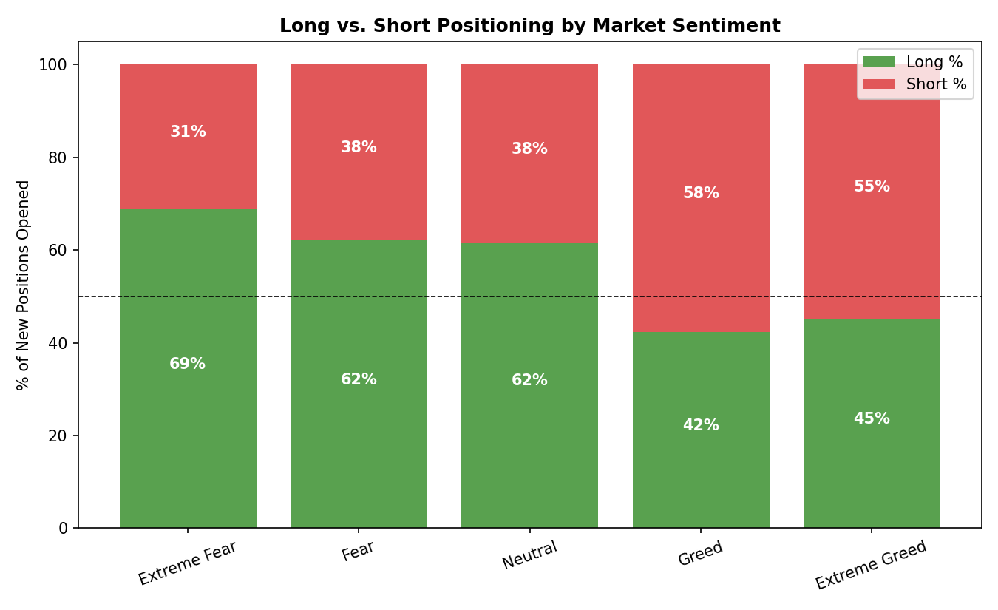
Figure 2. Share of new long vs. short positions opened, by sentiment regime.
During Extreme Fear, 68.8% of new positions were long — traders were buying into weakness. That long bias fades through Fear (62.1%) and Neutral (61.7%), then inverts during Greed (42.3% long / 57.7% short) and Extreme Greed (45.1% long / 54.9% short), where short positions become the majority. This is a textbook contrarian pattern: fading crowd euphoria and buying capitulation, rather than chasing momentum in the direction of the prevailing sentiment.

4. Risk Appetite & Position Sizing
Average trade size alone (Figure 1) shows sizing peaks in Fear and troughs in Extreme Greed. Isolating just the largest trades sharpens this picture: the top 1% of trades by USD size are heavily overrepresented in Fear (46.4% of all outsized trades, vs. a 29.3% baseline share of all trades) and underrepresented in Extreme Greed (6.0% vs. an 18.9% baseline share). In other words, when this population makes its biggest bets, it disproportionately does so while the market is fearful, and it scales back most sharply once sentiment turns euphoric — behavior consistent with disciplined risk management rather than sentiment-driven overexposure at tops.

5. PnL Distribution and Trader Dispersion
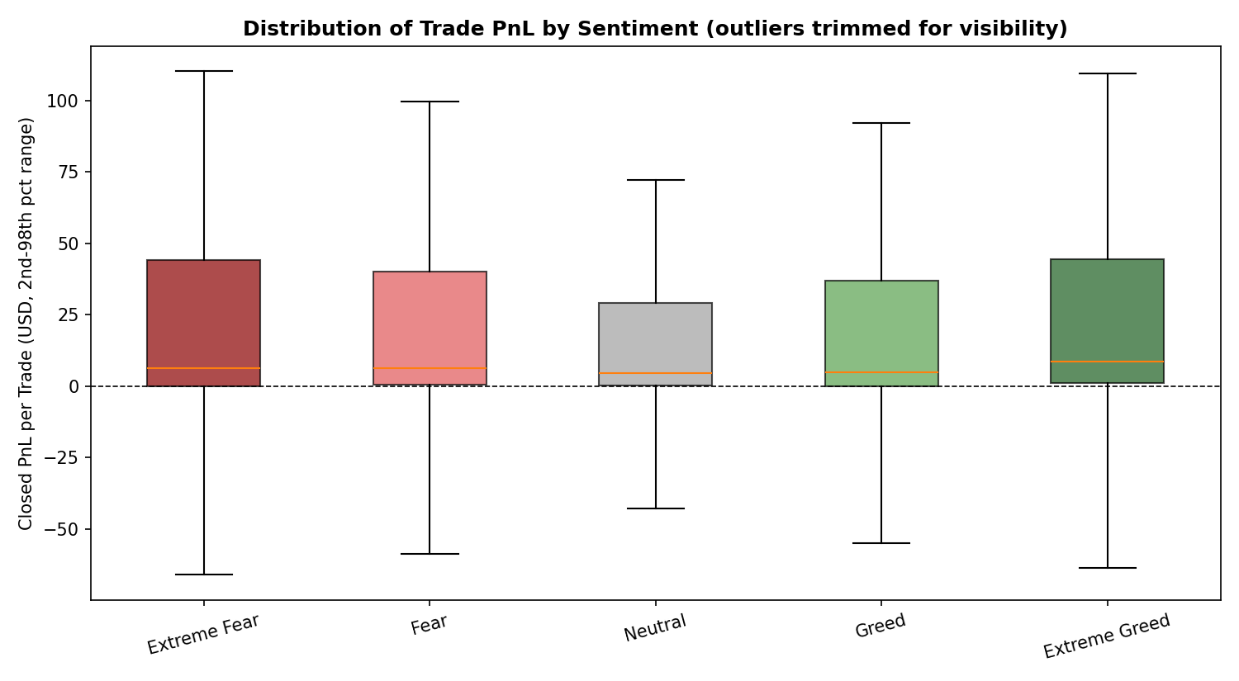
Figure 3. Distribution of per-trade PnL by sentiment (2nd–98th percentile range shown; extreme outliers trimmed for readability only).
PnL dispersion is widest in Fear and Greed (std. dev. ≈ $1,340–$1,630) and narrowest in Neutral (≈ $743), indicating that ambiguous or transitional sentiment produces more erratic outcomes, while calmer periods produce steadier, lower-variance results. This aligns with the win-rate findings: Neutral sentiment is 'safe but unremarkable', while Fear and Greed are higher-stakes regimes with wider outcome spread.
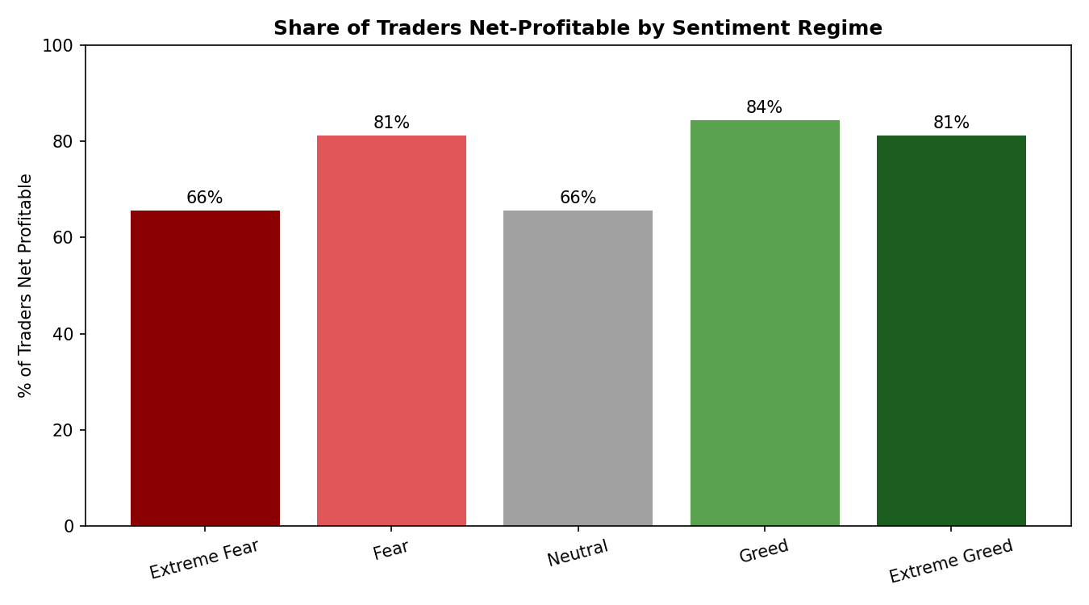
Figure 4. Share of the 32 tracked accounts that were net-profitable within each sentiment regime.
At the trader level, 84.4% of accounts were net-profitable during Greed and 81.3% during both Fear and Extreme Greed, compared to only 65.6% during Extreme Fear and Neutral. Skill and profitability on this venue are concentrated: the top 2 accounts alone generated over $3.7M in combined realized PnL, while the bottom 3 accounts lost a combined ~$270K — most of that concentrated in Extreme Fear/Fear regimes, implying weaker traders are disproportionately hurt by fear-driven volatility.

6. Sentiment and Aggregate Market Timing
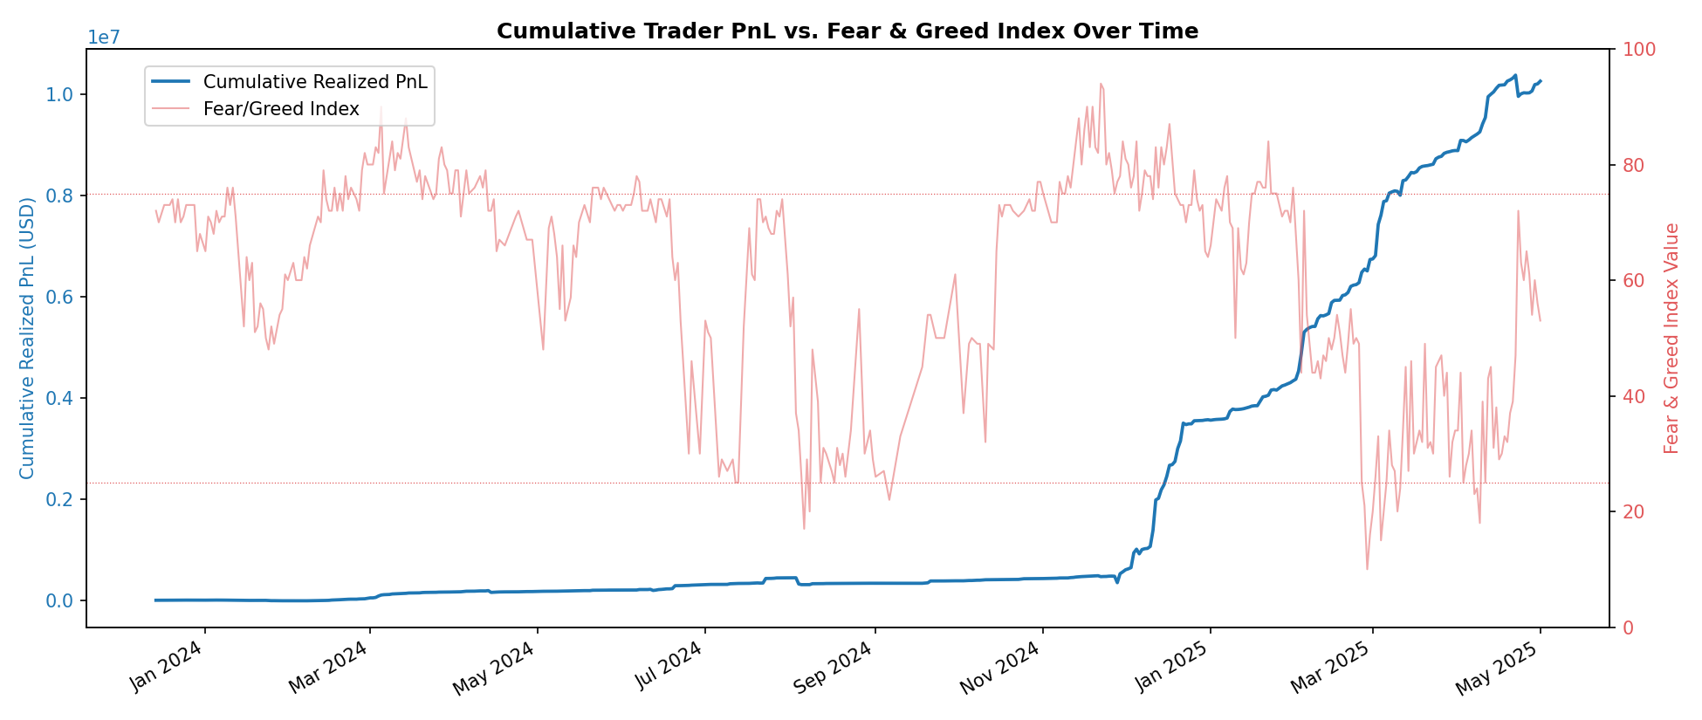
Figure 5. Cumulative realized PnL across all tracked accounts (left axis) vs. the daily Fear & Greed Index value (right axis).
At the daily aggregate level, the correlation between the Fear & Greed Index value and same-day total realized PnL is weak and slightly negative (r ≈ -0.10), and the correlation with daily trade count is also weak and negative (r ≈ -0.25) — trading activity ticks up modestly as sentiment cools. Neither relationship is strong enough to trade on the index value alone; the more actionable signal is the categorical/behavioral pattern (Sections 2–4), not a linear index-to-PnL relationship.

7. Coin-Level Heterogeneity
The sentiment relationship is not uniform across assets. Two examples illustrate the range of behavior observed:
- A frequently-traded perpetual (ticker '@107') showed strongly momentum-aligned PnL: an average loss of -$153.60/trade in Extreme Fear widening to an average gain of +$313.61/trade in Extreme Greed — this asset rewarded riding sentiment, not fading it.
- ETH showed the opposite, contrarian-friendly pattern: average PnL of +$472.73/trade in Fear versus -$58.93/trade in Extreme Greed — consistent with the account-level contrarian bias described in Section 3.
This suggests that any sentiment-based strategy should be asset-aware rather than applied uniformly — the same sentiment signal can call for opposite positioning depending on the instrument.

8. Strategic Recommendations
- Size up selectively into Fear, not indiscriminately: the data supports larger positions during Fear given strong historical win rates (87.3%) and total PnL contribution, but Extreme Fear's lower win rate (76.2%) argues for scaling in gradually rather than deploying maximum size immediately at the depths of panic.
- Treat Extreme Greed as a de-risking signal for exposure, not a reason to stop trading: win rates were highest here, but average size was smallest — the data supports smaller, higher-conviction, often short-biased positions rather than large directional bets.
- Use Neutral sentiment for capital preservation, not alpha generation: the lowest PnL variance and mid-pack win rate suggest this regime is best used to manage existing risk rather than initiate large new positions.
- Segment strategy by asset class: momentum-style assets (e.g., '@107') and mean-reversion-style assets (e.g., ETH) responded to sentiment in opposite directions — a single sentiment rule should not be applied across all traded symbols.
- Monitor trader-level concentration risk: a small number of accounts drive most realized profit; if this is a fund or copy-trading context, performance attribution should track these accounts specifically rather than relying on population averages.

9. Limitations & Caveats
- Sample size at the account level is small (32 accounts); trader-level conclusions (Section 5) are directional, not statistically robust.
- A leverage field was not available in the underlying data; trade size (USD) was used as the closest available proxy for risk appetite.
- Sentiment is measured once per day (Bitcoin-wide) and applied to all trades that day regardless of asset or intraday sentiment shifts; this may understate faster-moving, intraday sentiment effects.
- Correlation shown in Section 6 is at daily aggregate level and does not imply causation; sentiment and trading outcomes may both be driven by shared underlying market conditions.
- Six trade rows (of 211,224) fell outside the Fear & Greed Index's date coverage and were excluded from sentiment-conditioned results.

