**Parts list:**

R1-R4 are 1k resistors

D1-D4 are diodes **note that diodes have a colored band on one end, insert according to the image above!

Q1-Q3 are NPN transistors

Q2-Q4 are PNP transistors

your transistors are in a different case than the ones in the image, you'll need to locate the corresponding pins to place the transistor properly in your circuit

note the metal tag on the body of the transistor, yours are in a package called **t0-18**

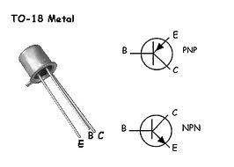 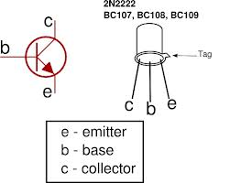

the package of the transistors in the circuit image is called a **t0-92**, this is a standard transistor package. note the flat side of the head.

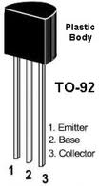

compare and transpose:

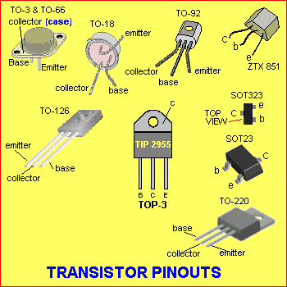

now build the h-bridge, call me over when you're done so i can take a look, then

connect the 5vdc (red) wire from the ATX to the very top row of the board (+VDC). Connect the ground of the ATX (any black wire) to the very bottom row of the board (+GND).

connect the ground (gnd) of your arduino to the ground of the breadboard.

**the + from the arduino will never connect to the + of the breadboard!!!**

**test it (you don't need the arduino yet):**

t0 try it out, connect a wire from GND to the right-side of R2.

then, connect a wire from +VDC to the left-side of R3.

the motor should spin forward.

yes?

ready for some [code](http://www.rouvelle.com/ramm_fa_12/hbridge_basic.txt)?

arduino connections (use the image above as a guide):

**pin 9 - R1  
pin 10 - R2  
pin 11 - R3  
pin 12 - R4**

speeding up/slowing down in different directions?