

Computer Science and Engineering
YELP DATASET CHALLENGE
Project Report -Version 1.0
Document Number: ProjectReport-001

- Team Name: Team ANR
- Team Members:

Names | NET ID
Aditya Kulai | ark526
Navneet Jain | nj798
Rushabh Patel | rgp296

Revision History

Date | Version | Description of change
05/10/2017 | 1.0 | Final Documentation

TABLE OF CONTENTS
CHAPTER NO. TITLE PAGE NO.
1 INTRODUCTION 1
1.1 Purpose 1
1.2 Objectives 1
1.3 Deliverable Dates 1
1.4 Dataset 1
2 ANALYSIS 2
2.1 Impact of weather on customer visits. 2
2.2 Classifying restaurants further into relevant categories based on ambiance 3
2.3 Rank all available states of US based on their average rating 3
2.4 To find top 3 business in top 3 states based on review count 4
2.5 Does number of reviews have impact on the business average ratings 4
2.6 Rank cities of USA based on no of check-ins in Restaurant 6
2.7 Eating Pattern: US vs UK vs Germany 8
2.8 Does check-ins depends on income and population of states? 9
2.9 Analysing no of check-ins during different hours of restaurants 10
2.10 Google Natural language processing to analyse sentiment on business reviews Script: 11

This Page Intentionally Left blank

INTRODUCTION

Purpose
Yelp is one of the big player in publishing crowd-sourced reviews about local businesses. This business report highlights our analysis on the Yelp dataset. We did a fusion of dataset provided by yelp with other publicly available dataset for population, income and weather to observe various interesting pattern about people, cultural trend, seasonal trends on local businesses.

Objectives
- To utilized the various tools and technologies available to efficiently analyze the big datasets.
- Provide meaningful information in decisive way to address various business problems and future perspective of business behaviors.
- Observe cultural, seasonal trends and their impact on businesses.

Deliverable Dates
Sr. No | Date | Deliverables
1 | 04/05/2017 | Project Proposal
2 | 05/10/2017 | Final Analysis and Presentation

Dataset
- Yelp Dataset
- 4.1M reviews and 947k tips by 1M users for 144k business
- 1.1M business attributes, e.g., hours, parking available, ambience.
- Weather
- Income
- Population

ANALYSIS

Impact of weather on customer visits.
Script:
import org.apache.spark.sql.functions.explode
import org.apache.spark.sql.functions.expr
var business = spark.read.json("/FileStore/tables/nlpmwbpi1493755425122/yelp_academic_dataset_business.json")
business.createOrReplaceTempView("business_table1")
val MainData = spark.sql("select business_id, state, categories from business_table1")
val flattened = MainData.select($"business_id", $"state", explode($"categories").as("cat_flat"))
flattened.createOrReplaceTempView("flattened_table")
val filter_data = spark.sql("Select * from flattened_table where cat_flat = 'Restaurants'")
filter_data.createOrReplaceTempView("business_table")
val reviews = spark.read.json("/FileStore/tables/5rgsav7f1494285261654/review.json")
reviews.createOrReplaceTempView("reviews_table")
val JoinedData = spark.sql("select business_table.business_id, business_table.state, business_table.cat_flat, reviews_table.date from business_table, reviews_table where business_table.business_id = reviews_table.business_id and state = 'AZ'")
val monthtable = JoinedData.select($"business_id", expr("(split(date, '-'))[1]").cast("integer").as("month"))
monthtable.createOrReplaceTempView("months_table")
val counting = spark.sql("select business_id, month, count(*) as chk from months_table group by business_id, month")

counting.createOrReplaceTempView("counting_table")
val counting1 = spark.sql("select business_id, month, chk*100 as visitor from counting_table")
display(counting1)
counting1.createOrReplaceTempView("business_table1")
Visualization

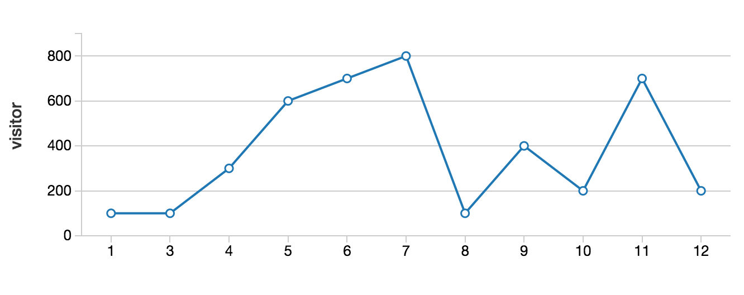

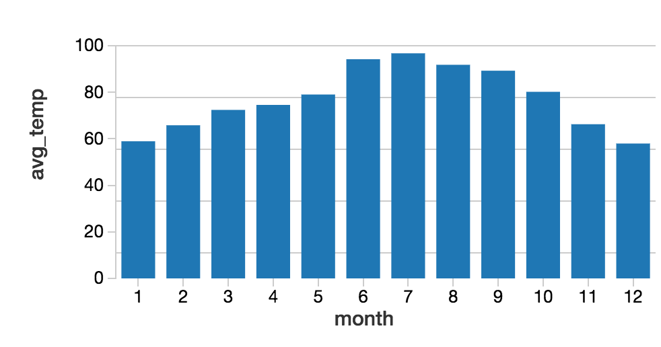

Classifying restaurants further into relevant categories based on ambiance
Script:
import org.apache.spark.sql.functions.explode
import org.apache.spark.sql.functions.expr
var business = spark.read.json("/FileStore/tables/nlpmwbpi1493755425122/yelp_academic_dataset_business.json")
business.createOrReplaceTempView("business_table")
val reviews = spark.read.json("/FileStore/tables/5rgsav7f1494285261654/review.json")
reviews.createOrReplaceTempView("reviews_table")
val JoinedData = spark.sql("select business_table.business_id, business_table.city, business_table.categories, business_table.attributes, reviews_table.stars from business_table, reviews_table where business_table.business_id = reviews_table.business_id")
val flattened = JoinedData.select($"business_id", $"city", explode($"categories").as("cat_flat"), $"attributes", $"stars" )
flattened.createOrReplaceTempView("flattened_table")
val resultData = spark.sql("Select * from flattened_table where cat_flat = 'Restaurants'")
val flattened2 = resultData.select($"business_id", $"city", explode($"attributes").as("attribute_flat"), $"stars" )
flattened2.createOrReplaceTempView("flattened_table2")

val resultData2 = spark.sql("Select * from flattened_table2 where attribute_flat LIKE '%Ambience%'")
val result3 = resultData2.select($"business_id", $"city" , expr("(split(attribute_flat, 'Ambience: '))[1]").cast("string").as("Ambience"), $"stars")
val finalresult = result3.select($"business_id", $"city", expr("(split(Ambience, ', '))[0]").cast("string").as("Romantic"), expr("(split(Ambience, ', '))[1]").cast("string").as("Intimate"), expr("(split(Ambience, ', '))[2]").cast("string").as("Classy"), expr("(split(Ambience, ', '))[3]").cast("string").as("Hipster"), expr("(split(Ambience, ', '))[4]").cast("string").as("Touristy"), expr("(split(Ambience, ', '))[5]").cast("string").as("Trendy"), expr("(split(Ambience, ', '))[6]").cast("string").as("Upscale"), expr("(split(Ambience, ', '))[7]").cast("string").as("casual"),$"stars")
val finalresult1 = finalresult.select($"business_id", $"city" , expr("(split(Romantic, ': '))[1]").cast("string").as("Romantic"), expr("(split(Intimate, ': '))[1]").cast("string").as("Intimate"), expr("(split(Classy, ': '))[1]").cast("string").as("Classy"), expr("(split(Hipster, ': '))[1]").cast("string").as("Hipster"), expr("(split(Touristy, ': '))[1]").cast("string").as("Touristy"), expr("(split(Trendy, ': '))[1]").cast("string").as("Trendy"), expr("(split(Upscale, ': '))[1]").cast("string").as("Upscale"), expr("(split(casual, ': '))[1]").cast("string").as("casual"), $"stars")
final result1.createOrReplaceTempView("result_table")
val result2 = spark.sql("Select business_id, city avg(stars) as avg_stars from result_table where Romantic = 'True' and city = 'Las Vegas' group by business_id, city order by avg_stars desc")
Visualization:
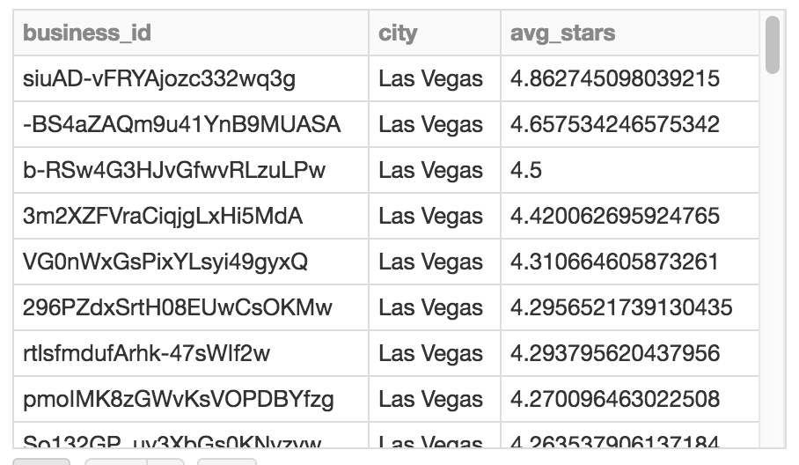

Rank all available states of US based on their average rating
Scripts:
import org.apache.spark.sql.functions.explode
import org.apache.spark.sql.functions.expr
var business = spark.read.json("/FileStore/tables/nlpmwbpi1493755425122/yelp_academic_dataset_business.json")
business.createOrReplaceTempView("business_table")
val counting = spark.sql("select state, count(business_id) as no_of_business, sum(review_count) as total_review, avg(stars) as avg_stars from business_table where latitude<49.384472 AND latitude>24.520833 AND longitude<-66.950 AND longitude>-124.766667 and is_open = 1 group by state order by avg_stars desc")

Visualization:
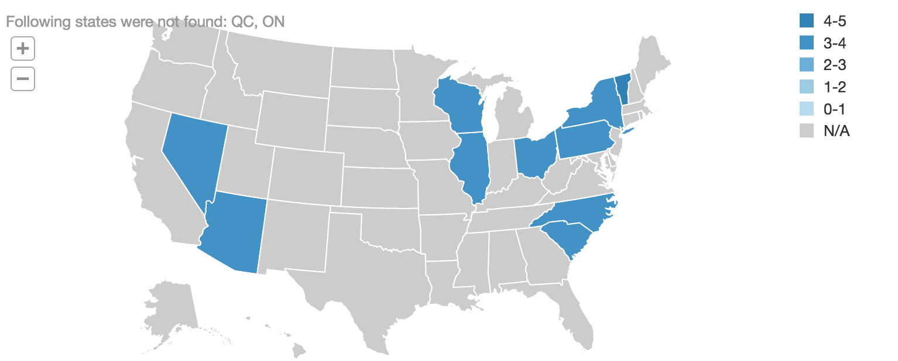

To find top 3 business in top 3 states based on review count
Scripts:
import org.apache.spark.sql.functions.explode
import org.apache.spark.sql.functions.expr

var business =
spark.read.json("/FileStore/tables/nlpmwbpi1493755425122/yelp_academic_dataset_business.json")
business.createOrReplaceTempView("business_table")

val MaxReviews = spark.sql("select state, sum(review_count) as total_reviews from business_table where latitude<49.384472 AND latitude>24.520833 AND longitude<-66.950 AND longitude>-124.766667 and state != 'ON' and state != 'QC' group by state order by total_reviews desc limit 3")
MaxReviews.createOrReplaceTempView("MaxReviews_Table")

val topbusiness = spark.sql("select business_table.business_id, business_table.name, business_table.state, business_table.review_count from business_table, MaxReviews_Table where MaxReviews_Table.state = business_table.state")
topbusiness.createOrReplaceTempView("topbusiness_table")

val top_business = spark.sql("SELECT * FROM (SELECT business_id, name, state, review_count, dense_rank() OVER (PARTITION BY state ORDER BY review_count DESC) as rank FROM topbusiness_table) tmp WHERE rank <= 3")

Visualization:
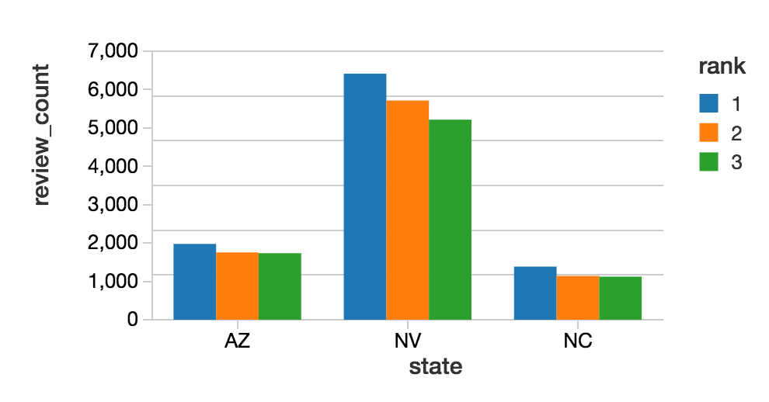

Does number of reviews have impact on the business average ratings
Scripts:
import org.apache.spark.sql.functions.explode
import org.apache.spark.sql.functions.expr
var business = spark.read.json("/FileStore/tables/nlpmwbpi1493755425122/yelp_academic_dataset_business.json")
business.createOrReplaceTempView("business_table")
val MainData = spark.sql("select business_id, city, state, postal_code, categories, stars, review_count from business_table")
val flattened = MainData.select($"business_id", $"state", $"postal_code", explode($"categories").as("cat_flat"), $"stars", $"review_count")
flattened.createOrReplaceTempView("flattened_table")
val filter_data = spark.sql("Select * from flattened_table where cat_flat = 'Restaurants'")
filter_data.createOrReplaceTempView("filter_data_table")
Visualization:

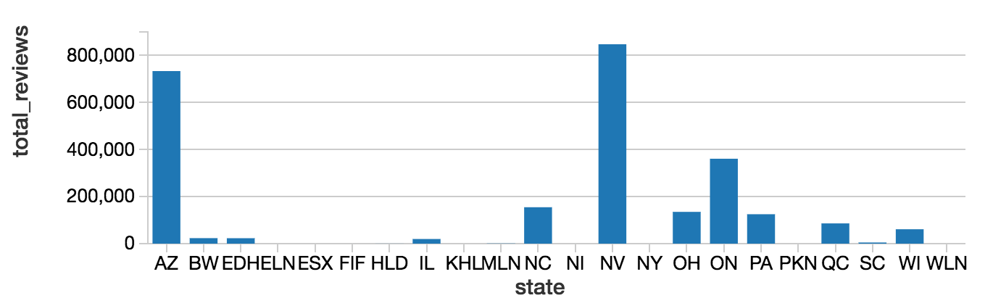
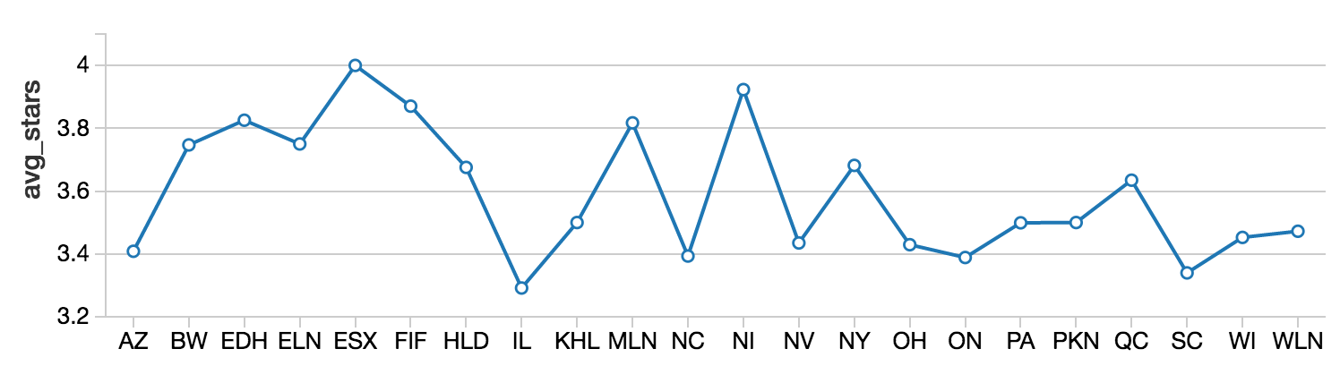
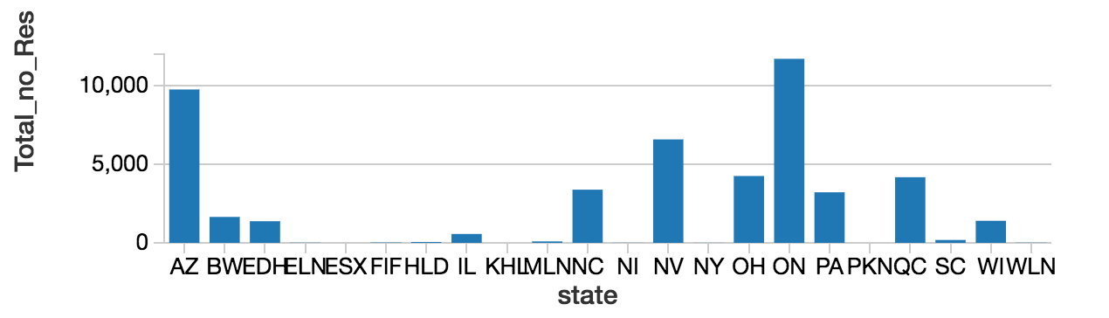

Rank cities of USA based on no of check-ins in Restaurant
Scripts:
import org.apache.spark.sql.functions.explode
import org.apache.spark.sql.functions.expr
var business = spark.read.json("/FileStore/tables/nlpmwbpi1493755425122/yelp_academic_dataset_business.json")
business.createOrReplaceTempView("business_table")
val FilteredData = spark.sql("select business_id, city, categories from business_table where city = 'Las Vegas' OR city = 'Phoenix'")
val flattened1 = FilteredData.select($"business_id", $"city", explode($"categories").as("cat_flat"))
flattened1.createOrReplaceTempView("flattened_business_table")
var checkin = spark.read.json("/FileStore/tables/opxair3p1493746853047/yelp_academic_dataset_checkin.json")
val flatten_checkin = checkin.select($"business_id", explode($"time").as("time_flatten"))
val res = flatten_checkin.select($"business_id", expr("(split(time_flatten,'-'))[1]").cast("string").as("time_hours"))

val checkin_split = res.select($"business_id", expr("(split(time_hours,':'))[0]").cast("integer").as("time_interval"), expr("(split(time_hours,':'))[1]").cast("integer").as("total_checkin"))
checkin_split.createOrReplaceTempView("checkin_split_table")
val JoinedData = spark.sql("select flattened_business_table.city, flattened_business_table.cat_flat, checkin_split_table.time_interval, sum(checkin_split_table.total_checkin) as total_user from flattened_business_table, checkin_split_table where flattened_business_table.business_id = checkin_split_table.business_id and cat_flat = 'Restaurants' group by flattened_business_table.city, flattened_business_table.cat_flat, checkin_split_table.time_interval")
JoinedData.createOrReplaceTempView("JoinedData_table")
val result = spark.sql("select city, time_interval, total_user from JoinedData_table order by time_interval")
display(result)

Visualization:
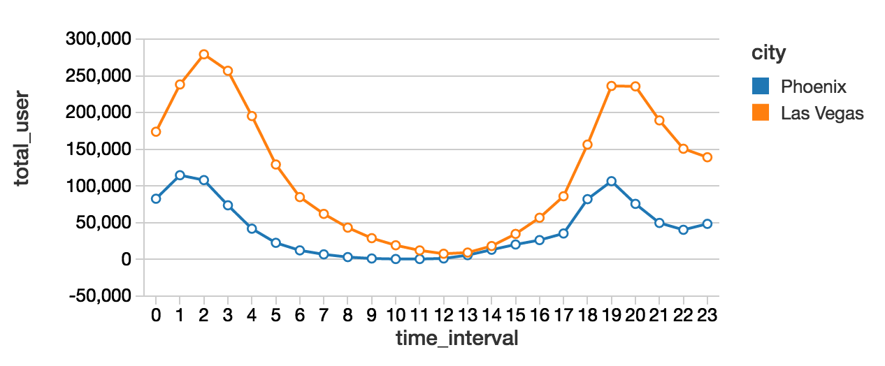
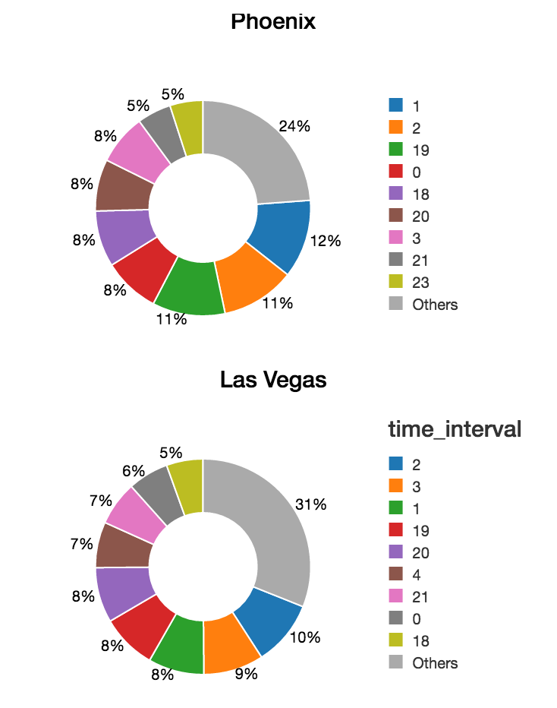

Eating Pattern: US vs UK vs Germany
Scripts:
import org.apache.spark.sql.functions.explode
import org.apache.spark.sql.functions.expr
var business = spark.read.json("/FileStore/tables/nlpmwbpi1493755425122/yelp_academic_dataset_business.json")
business.createOrReplaceTempView("business_table")
val FilteredData = spark.sql("select business_id, city, categories from business_table where city = 'Las Vegas' OR city = 'Phoenix'")
val flattened1 = FilteredData.select($"business_id", $"city", explode($"categories").as("cat_flat"))
flattened1.createOrReplaceTempView("flattened_business_table")
var checkin = spark.read.json("/FileStore/tables/opxair3p1493746853047/yelp_academic_dataset_checkin.json")
val flatten_checkin = checkin.select($"business_id", explode($"time").as("time_flatten"))
val res = flatten_checkin.select($"business_id", expr("(split(time_flatten,'-'))[1]").cast("string").as("time_hours"))

val checkin_split = res.select($"business_id", expr("(split(time_hours,':'))[0]").cast("integer").as("time_interval"), expr("(split(time_hours,':'))[1]").cast("integer").as("total_checkin"))
checkin_split.createOrReplaceTempView("checkin_split_table")
val JoinedData = spark.sql("select flattened_business_table.city, flattened_business_table.cat_flat, checkin_split_table.time_interval, sum(checkin_split_table.total_checkin) as total_user from flattened_business_table, checkin_split_table where flattened_business_table.business_id = checkin_split_table.business_id and cat_flat = 'Restaurants' group by flattened_business_table.city, flattened_business_table.cat_flat, checkin_split_table.time_interval")
JoinedData.createOrReplaceTempView("JoinedData_table")
val result = spark.sql("select city, time_interval, total_user from JoinedData_table order by time_interval")

Visualization:
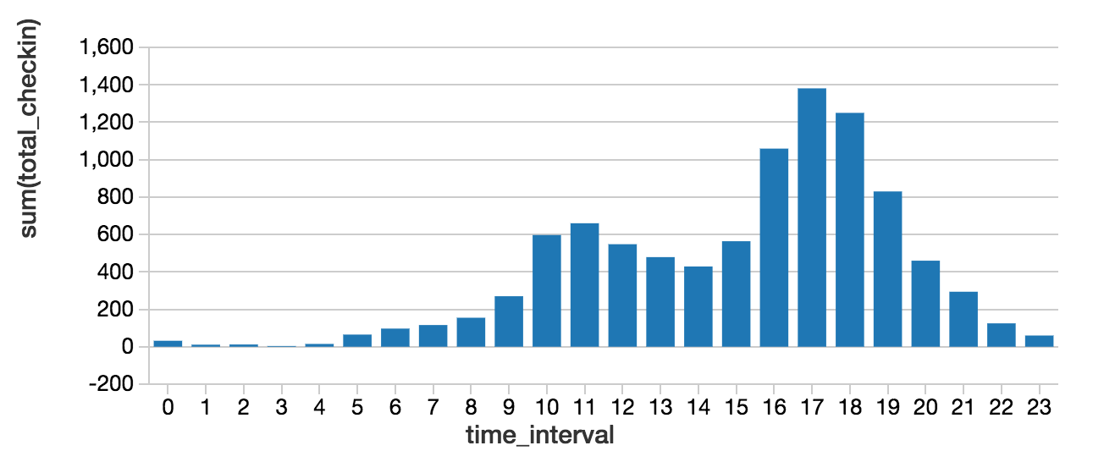

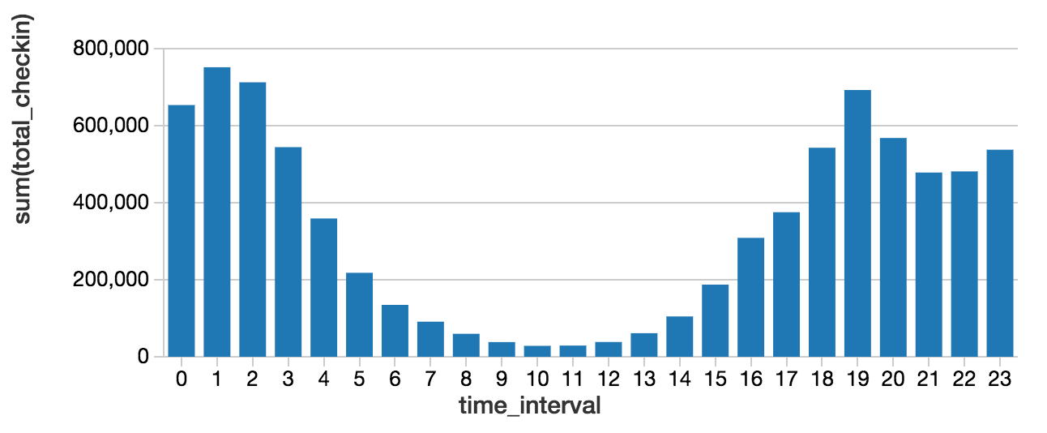

Does check-ins depends on income and population of states?
Scripts:
import org.apache.spark.sql.functions.explode
import org.apache.spark.sql.functions.expr
var business = spark.read.json("/FileStore/tables/nlpmwbpi1493755425122/yelp_academic_dataset_business.json")
business.createOrReplaceTempView("business_table")
val FilteredData = spark.sql("select business_id, city, state,categories from business_table where latitude<49.384472 AND latitude>24.520833 AND longitude<-66.950 AND longitude>-124.766667 and state <> 'QC' and state <> 'ON'")

val flattened1 = FilteredData.select($"business_id", $"city", $"state", explode($"categories").as("cat_flat"))
flattened1.createOrReplaceTempView("flattened1_table")
val businessRestaurants = spark.sql("Select * from flattened1_table where cat_flat = 'Restaurants'")
businessRestaurants.createOrReplaceTempView("business_Restaurants")
//checkin file
var df = spark.read.json("/FileStore/tables/opxair3p1493746853047/yelp_academic_dataset_checkin.json")

val flatten_checkin = df.select($"business_id", explode($"time").as("time_flatten"))
val res = flatten_checkin.select($"business_id", expr("(split(time_flatten,'-'))[1]").cast("string").as("time_hours"))
val res1 = res.select($"business_id", expr("(split(time_hours,':'))[0]").cast("integer").as("time_interval"), expr("(split(time_hours,':'))[1]").cast("integer").as("total_checkin"))
res1.createOrReplaceTempView("checkin_result")
val JoinedData = spark.sql("select business_Restaurants.city, business_Restaurants.state, sum(checkin_result.total_checkin) as totalcheckin from business_Restaurants,checkin_result where business_Restaurants.business_id = checkin_result.business_id and checkin_result.time_interval>18 and checkin_result.time_interval<23 group by business_Restaurants.city, business_Restaurants.state order by totalcheckin desc limit 10")

Visualization:

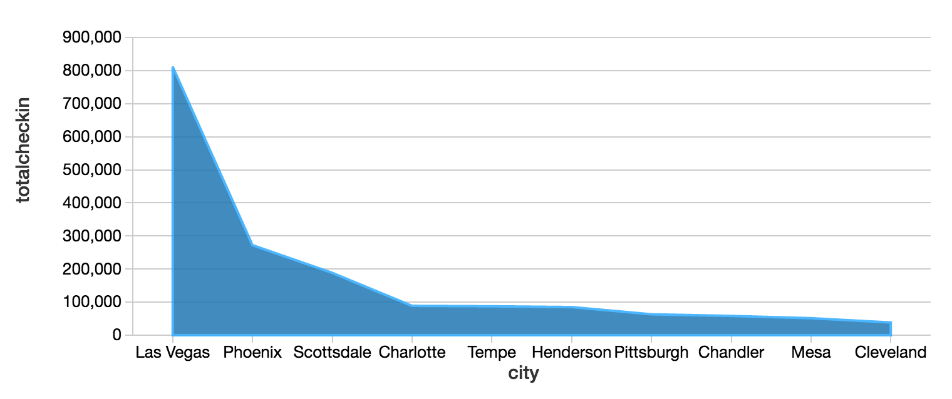
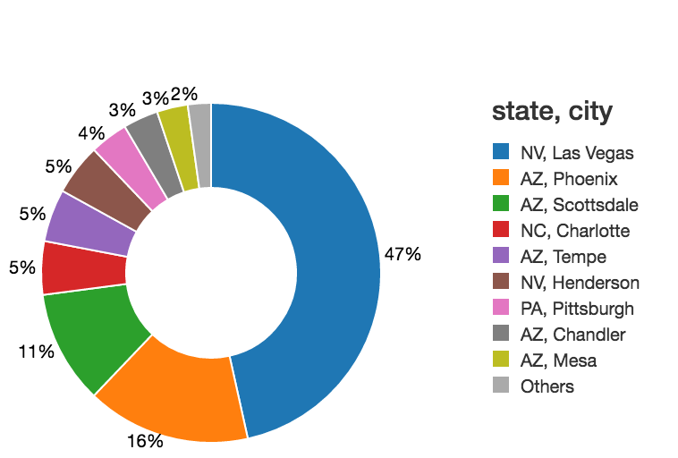

Analysing no of check-ins during different hours of restaurants
Scripts:
import org.apache.spark.sql.functions.explode
import org.apache.spark.sql.functions.expr

var business = spark.read.json("/FileStore/tables/nlpmwbpi1493755425122/yelp_academic_dataset_business.json")
business.createOrReplaceTempView("business_table")
val FilteredData = spark.sql("select business_id, city, state, categories from business_table where city ='Las Vegas' or city = 'Madison' or city = 'Phoenix' or city = 'Charlotte' or city = 'Pittsburgh' or city = 'Cleveland'")

val flattened1 = FilteredData.select($"business_id", $"city", $"state", explode($"categories").as("cat_flat"))
flattened1.createOrReplaceTempView("flattened1_table")
val businessRestaurants = spark.sql("Select * from flattened1_table where cat_flat = 'Restaurants'")
businessRestaurants.createOrReplaceTempView("business_Restaurants")
//checkin file
var df = spark.read.json("/FileStore/tables/opxair3p1493746853047/yelp_academic_dataset_checkin.json")
val flatten_checkin = df.select($"business_id", explode($"time").as("time_flatten"))
val res = flatten_checkin.select($"business_id", expr("(split(time_flatten,'-'))[1]").cast("string").as("time_hours"))
val res1 = res.select($"business_id", expr("(split(time_hours,':'))[0]").cast("integer").as("time_interval"), expr("(split(time_hours,':'))[1]").cast("integer").as("total_checkin"))
res1.createOrReplaceTempView("checkin_result")
val JoinedData = spark.sql("select business_Restaurants.city , sum(checkin_result.total_checkin) as totalcheckin from business_Restaurants,checkin_result where business_Restaurants.business_id = checkin_result.business_id group by business_Restaurants.city")
display(JoinedData)
JoinedData.createOrReplaceTempView("businessfinal_table")
var income = spark.read.csv("/FileStore/tables/jgfdj90m1494188664808/income.csv")
income.createOrReplaceTempView("income_table")
val JoinedData1 = spark.sql("Select _c0 as city, _c1 as population, _c5 as income from income_table where _c0 ='Las Vegas' or _c0 = 'Madison' or _c0 = 'Phoenix' or _c0 = 'Charlotte' or _c0 = 'Pittsburgh' or _c0 = 'Cleveland'")

JoinedData1.createOrReplaceTempView("incomefinal_table")

Visualization:

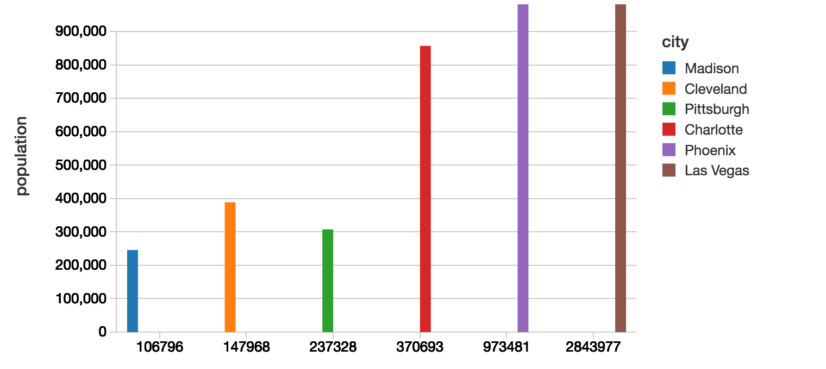
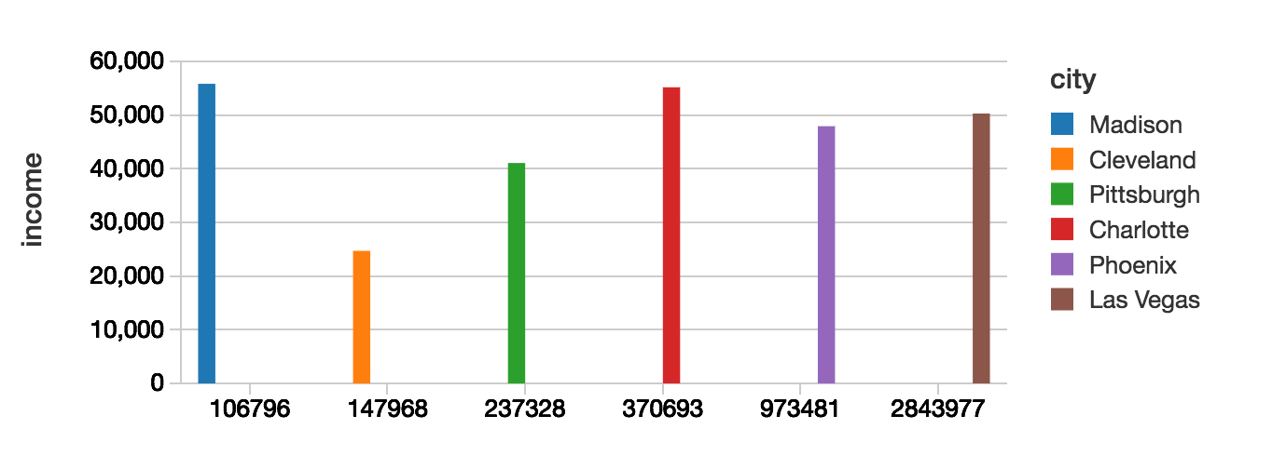

Google Natural language processing to analyse sentiment on business reviews
Script:
#import argparse
from google.cloud import language
import six
import json
from pprint import pprint
with open('C:\\Users\\Navneet\\Desktop\\yelp_review.json') as data_file:
data = json.load(data_file)
def sentiment_text(text):
"""Detects sentiment in the text."""
language_client = language.Client()
if isinstance(text, six.binary_type):
text = text.decode('utf-8')
# Instantiates a plain text document.
document = language_client.document_from_text(text)
#Detects sentiment in the document. You can also analyze HTML with:
document.doc_type == language.Document.HTML
sentiment = document.analyze_sentiment().sentiment
#print('Score: {}'.format(sentiment.score))
#print('Magnitude: {}'.format(sentiment.magnitude))
score = format(sentiment.score)
magnitude = format(sentiment.magnitude)
return score,magnitude
// Creating a new json file to store the score and magnitude after the Natural language processing on reviews by google.
with open('data.json','w') as f:
for i in data:
txt = i["text"]
review_id = i["review_id"]
scre,magnitud = sentiment_text(txt)
d = {'review_id':review_id,'text': txt,'score':scre,'magnitude':magnitud}
json.dump(d,f)
f.write('\n')

Sample Output:
{"review_id": "NxL8SIC5yqOdnlXCg18IBg", "text": "If you enjoy service by someone who is as competent as he is personable, I would recommend Corey Kaplan highly. The time he has spent here has been very productive and working with him educational and enjoyable. I hope not to need him again (though this is highly unlikely) but knowing he is there if I do is very nice. By the way, I'm not from El Centro, CA. but Scottsdale, AZ.", "score": "0.5", "magnitude": "2.1"}

Thank You.

