Your operational key to live, up to the moment data giving you the power to make the best decisions for your business on time and at the right time.

iMS Overview

iMS Systems is a business operations tool which helps you incorporate your business operations with your legal, regulatory and compliance standards.
It has been designed to help improve operational efficiencies and reduce the need for manual spreadsheets for capturing information and reporting. iMS systems will improve the organisations performance and decision making by ensuring that the most vulnerable areas are visible to leaders of organisations, so that they can invest in the right areas to mitigate organisational risks or vulnerabilities that can lead to reputational damage or financial losses.



Our aim is to help organisations have full visibility of their organisation from one contextual dashboard.  
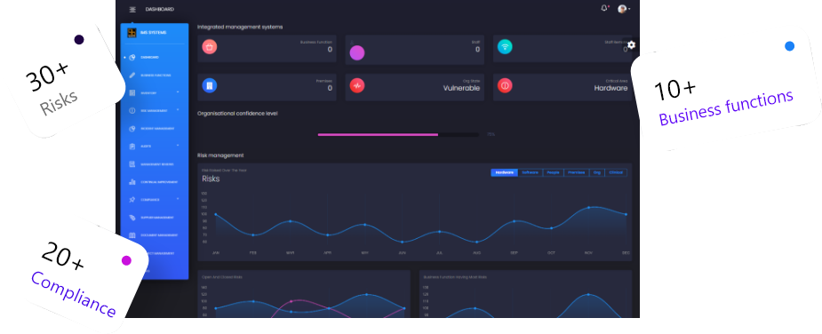

iMS Dashboard

Live dasboard reports for contextual, real time and up to the minute view of all risks and incidents within your organisation.
Reducing time to generate reports and the need for manual spreadsheets to manage your organisation.
We look forward to discussing how iMS systems can help your organisation by improving the flow of information.

What can iMS bring to the board room?

The present-day business must contend with a range of complex, interdependent challenges to stay relevant, efficient, profitable, and competitive in any market.
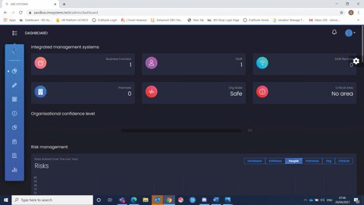

Business processes are at the core of all business output, and with an underper- forming or stagnant yield, workflows need to be addressed by companies as one of the most crucial variables on the road to business evolution. To be more productive workflows must be streamlined, and in the digital age, this requires business process automation with iMS.

 Reduce Cost
People
Process
Technology
 Increase Efficiency  Increase Productivity  Increase Compliance

 Effective Risk Management Effective Incident Management

All giving you Transparency and Accountability to your business function leaders across your operations.

Risk Management

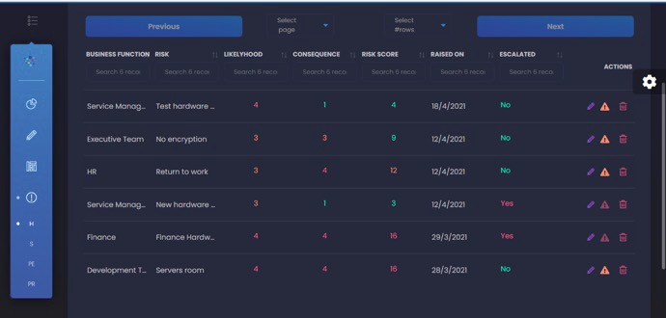

All areas of your organisation will have clear accountability and ownership of all risks, enabling each function to escalate risks and make leadership teams aware of any organsational risks.


Manage risks from all business
or operational areas
01
Identify risks to your business
Analyse and measure impact
06
Monitor and regularly review
02
Decide which risks are unacceptable
Contingency planning for risks that can not be managed

05
03
Miligate or transfer unacceptable risks

04



Conduct risk assessments Assign risk owners
 Have visibility of mitigating actions

 Escalate and accept risks

 Full visibility of the risk life-cycle from raising to closure


Real time reporting of risks

Incident management

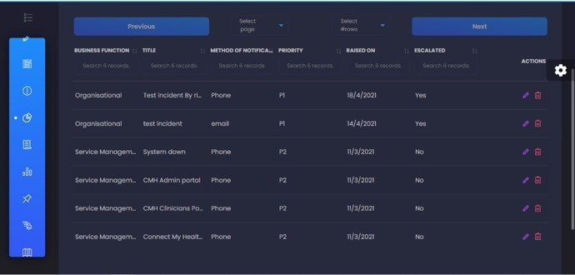

Manage all types of incidents i.e security, information incidents and organisational. Further to that you can:-

 Have real time Incident reporting
Prevent
Lessons Learned
Incident management Lifecycle
Defect
Recover
Respond

 Set resolution times for your incidents and priority levels

 Make the wider organisation aware of major incidents

Document Management

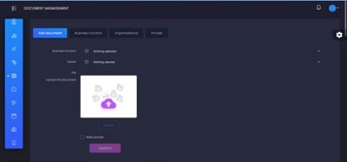

Store all your organisations policies and document under one system. Our functionality allows you to:-

 Have ownership of policies  Notification of review dates
Create
Withdraw
Review
 Organisational policies visible to all staff
Document
Lifecycle
Use
Release
Approve
Distribute
Train

 Automated version control

 Operational areas to store and share documents with their teams


View historic versions

Get in Touch

There is so much more iMS can offer, used as a daily operational tool will see your business in the best position with the opportunity to make the right decisions all from the data fed upwards to the contextual dashboard giving you and the leadership team precise up to the moment data to make those all important decisions, directing resources to the appropriate functions on a needs basis where weaknesses have been realised.

 hello@imssystems.tech 0208 0166027
Clive House, Clive street, Bolton, BL1 1ET



