This is to certify that:
[Company Name]

Registered Address: [Registered Address]

Certified Site:

has been assessed and certified as meeting the requirements of standard(s): [COC Reference FSC]

Scope: [Certificate Scope FSC free text]

Type of Certification: Full [Certification type FSC]Certification

Certificate Number: [COC/FSC]

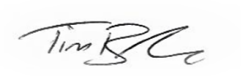
For and on behalf of Interface NRM Ltd

Tim Barker
Director, Interface NRM Ltd.

Issue Date: [FSC Issue Date]

