This is to confirm that:

[Company Name]

[Registered Address]

has been assessed as meeting the requirements of the Interface NRM Legal Forest Products Trade process. The schemes & verification programmes shown below are included in the scope of this assessment:

- Bureau Veritas: origin and Legality Du Bois (OLB)
- SGS : Generic Chain of Custody Scheme
- Sistem Verifikasi Legalitas Kayu (SVLK)
- Certisource Programme

Scope: [Certificate Scope FSC free text]

Type of Certification: [Certification type FSC]

Certificate Number: INT-LFPT-00

For and on behalf of Interface NRM Ltd
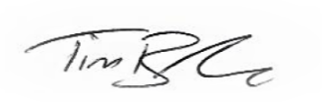

Tim Barker
Director, Interface NRM Ltd.

Original Issue Date:
First Issue Date: [FSC Issue Date]
Latest Issue Date:
Certificate Expiry Date: [FSC Expiring Date]
Issue No:

Sites covered by this Certification:

Name | Address | Sub Code

