This is to certify that:

[Certificate Holder]

Registered Address: [Registered Address]

Certified Site:

has been assessed and certified as meeting the requirements of standard(s) : [COC Reference FSC] for FSC® Chain of Custody Certification

Scope: [Certificate Scope FSC free text]

Type of Certification: [Certification type FSC]

Method: [FSC Method]

Certificate Number: [COC/FSC]

For and on behalf of Interface NRM Ltd
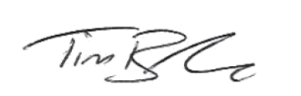
Tim Barker
Director, Interface NRM Ltd.

First Issue Date: [FSC Issue Date]
Latest Issue Date:
Certificate Expiry Date: [FSC Expiring Date]
Issue No:

Sites covered by this Certification:

Name | Address

