This is to certify that:

{organisation.name}

{organisation.addressBuilding}, [Street Address 2], [City], [Province/State], [Post Code], [Country]

has been assessed and certified as meeting the requirements of the Programme for the Endorsement of Forest Certification: [COC reference PEFC] (as amended – www.pefc.org)

Scope of the Certificate: {scope_of_the_certificate}

Type of Certification: [Certification type PEFC]

Type of Products: [PEFC Product Group/description]

Method: [PEFC method(s)]

Certificate Number: [COC/PEFC]

For and on behalf of Interface NRM Ltd
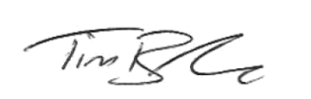
Tim Barker
Director, Interface NRM Ltd.

Certificate Start Date: [PEFC Issue Date]
Certificate Expiry Date: [PEFC Expiring Date]
Issue No:

