This is to certify that:

{organisation.name}

{address_line_1}, {address_line_2}, {city}, {province_state}, {post_code}, {country}

has been assessed and certified as meeting the requirements of the Programme for the Endorsement of Forest Certification: {coc_reference_pefc} (as amended – www.pefc.org)
Scope of the Certificate: {certificate_scope}

Type of Certification: {certification_type}

Type of Products: {type_of_products}

Method: {pefc_methods}

Certificate Number: {certificate_number}

For and on behalf of Interface NRM Ltd
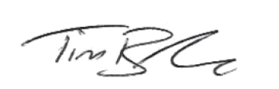
Tim Barker
Director, Interface NRM Ltd.

Certificate Start Date: {issue_date}
Certificate Expiry Date: {expiry_date}
Issue No: {issue_number}

Sites covered by this Certification:

Name | Address | Sub Code
{#locations}{name} | {address} | {sub_code}{/locations}

