This is to certify that:
[Related Carbon Certificate Holder]
[Address (line 1)]
[Address (line 2)]
[Address (line 3)]
[City]
[Post Code]
United Kingdom

Has achieved UKAS accredited ISO 14064-1:2018 verified status for the quantification of their Greenhouse Gas Inventory under the:

Specification with guidance at the organization level for quantification and reporting of greenhouse gas emissions and removals

The company activities have been verified for boundaries, quantification, quality management and reporting of GHG emissions to a limited level of assurance for the periods [reporting period].

For and on behalf of Interface NRM Ltd
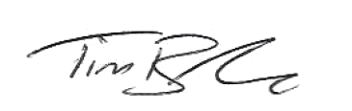
Tim Barker
Director

Certificate Number: [Certificate Number]
Issue Date: DD/MM/YYYY (Last Verification Date)
Recommended Renewal: DD/MM/YYYY (Next Verification Date)

