This is to certify that:

{organisation_name}

{address_line_1}
{address_line_2}
{city}
{province_state}
{post_code}
{country}

Holds Certificate No: {certificate_number}

and operates an Environmental Management System which complies with the requirements of ISO 14001:2015 for the following scope:

{certificate_scope}

For and on behalf of Interface NRM Ltd:

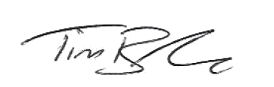

Tim Barker
Director

First Issued: {first_issue_date}
Interface First Issued: {interface_issue_date}
Latest Issue Date: {issue_date}
Certificate Expiry Date: {expiry_date}

