This is to certify that:

[Related ISO Certificate Holder]

[Address (line 1)]
[Address (line 2)]
[Address (line 3)]
[City]
[County]
[Post Code]
[Country]

Holds Certificate No: [Certificate Number]

and operates a Health & Safety Management System which complies with the requirements of ISO 45001:2018 for the following scope:

[ISO Certificate Scope]

For and on behalf of Interface NRM Ltd:

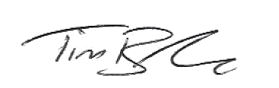

Tim Barker
Director

First Issued: [First Issue Date]
Interface First Issued: [Interface Issue Date]
Latest Issue Date: DD/MM/YYYY
Certificate Expiry Date: [Expiry Date]

