This is to certify that:

[ISO Certificate Holder]

Holds Multi-Site Certificate No: [Certificate Number]

and operates a Health & Safety Management System which complies with the requirements of ISO 45001:2018 for the following scope:

[ISO Certificate Scope]

Sites and activities are listed on the additional page(s)

For and on behalf of Interface NRM Ltd:

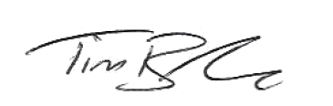

Tim Barker
Director

First Issued: [First Issue Date]
Interface First Issued: [Interface Issue Date]
Latest Issue Date: DD/MM/YYYY
Certificate Expiry Date: [Expiry Date]

Certificate No.[Certificate Number]

Location | Registered Activities
[Related ISO Certificate Holder]  [Address (line 1)]  [Address (line 2)]  [Address (line 3)]  [City]  [Post Code]  [Country] | [ISO Certificate Scope]
[Additional Addresses] | [ISO Certificate Scope]
Company Name
Address
Address
Address
Post Code
Country
Company Name
Address
Address
Address
Post Code
Country

