This is to certify that:

Carbon Calculator

123 Eco Street, Innovation Park, Birmingham, West Midlands, B1 2AB, United Kingdom

has been assessed and certified as meeting the requirements of the Programme for the Endorsement of Forest Certification: COC-12025-UK-0372 (as amended – www.pefc.org)
Scope of the Certificate: The provision of environmental consulting and auditing services across commercial and industrial sectors.

Type of Certification: PEFC

Type of Products: Wood

Method: PEFC-12025-UK-0372

Certificate Number: PEFC-12025-UK-0372

For and on behalf of Interface NRM Ltd
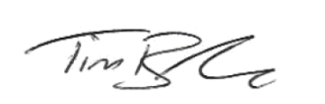
Tim Barker
Director, Interface NRM Ltd.

Certificate Start Date: 17/06/2025
Certificate Expiry Date: 30/10/2025
Issue No: 1234567890

Sites covered by this Certification:

Name | Address | Sub Code

