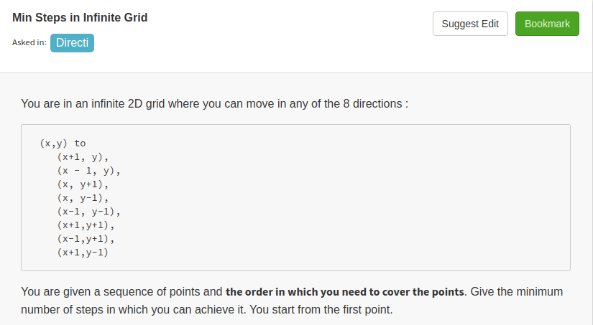

public class Solution {
public int coverPoints(ArrayList<Integer> A, ArrayList<Integer> B) {
int x=A.get(0);
int y=B.get(0);
int l=0;
int s1,s2;
s1=s2=0;
for(int i=1;i<A.size();i++){
int m=A.get(i);
int n=B.get(i);
s1=Math.abs(m-x);
s2=Math.abs(n-y);
l+=Math.max(s1,s2);
x=m;
y=n;
}
return l;
}
}

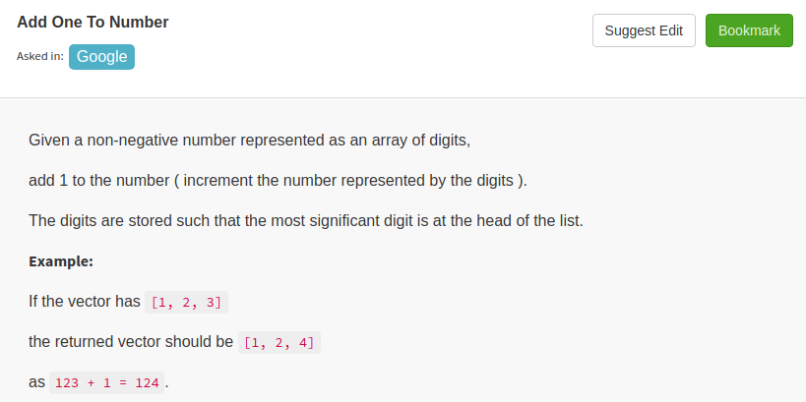
public class Solution {
public ArrayList<Integer> plusOne(ArrayList<Integer> A) {
ArrayList<Integer> res=new ArrayList<Integer>(A);
int c=1;
for(int i=A.size()-1;i>=0;i--){
if(c==0){
break;
}
else{
int x=A.get(i)+1;
A.set(i,x%10);
c=x/10;
}
}
if(c==1){
A.add(0,1);
}
int index=0;
while(index<A.size() && A.get(index)==0){
A.remove(index);
}
return A;
}
}

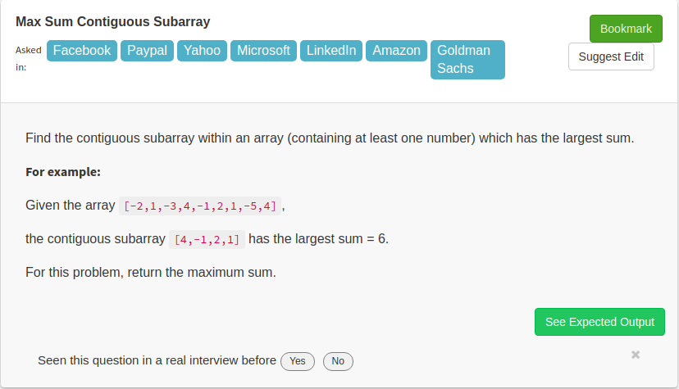

public class Solution {
// DO NOT MODIFY THE LIST. IT IS READ ONLY
public int maxSubArray(final List<Integer> A) {
int sum=0;
int max=A.get(0);
for(int i=1;i<A.size();i++){
sum+=A.get(i);
if(sum>max){
max=sum;
}
if(sum<0){
sum=0;
}
}
return max;
}
}

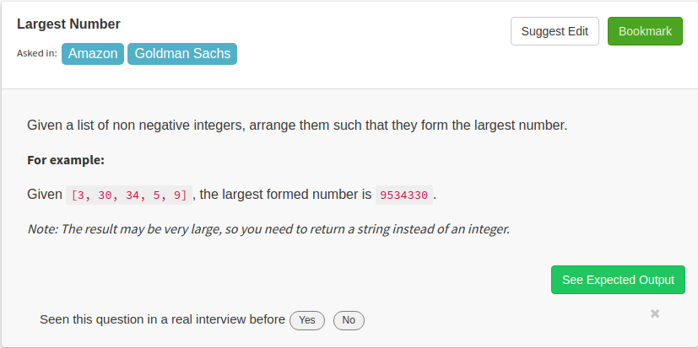

public class Solution {
// DO NOT MODIFY THE LIST. IT IS READ ONLY
public String largestNumber(final List<Integer> A) {
String[] a=new String[A.size()];
for(int i=0;i<A.size();i++){
a[i]=String.valueOf(A.get(i));
}
Arrays.sort(a,new Comparator<String>(){
public int compare(String a,String b){
return (b+a).compareTo(a+b);
}
});

StringBuilder sb=new StringBuilder();
for(String s:a){
sb.append(s);
}

while(sb.charAt(0)=='0' && sb.length()>1){
sb.deleteCharAt(0);
}

return sb.toString();
}
}

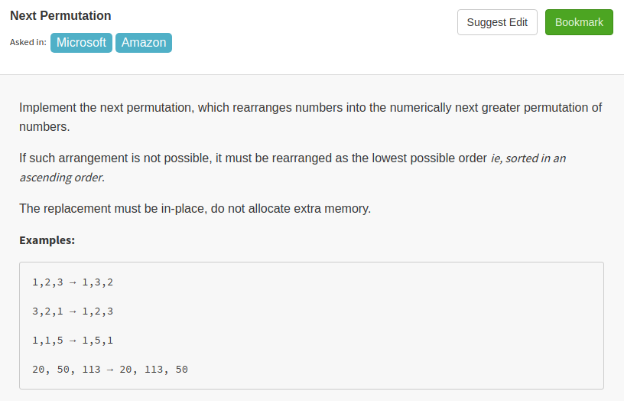

My idea is for an array:
- Start from its last element, traverse backward to find the first one with index i that satisfy num[i-1] < num[i]. So, elements from num[i] to num[n-1] is reversely sorted.
- To find the next permutation, we have to swap some numbers at different positions, to minimize the increased amount, we have to make the highest changed position as high as possible. Notice that index larger than or equal to i is not possible as num[i,n-1] is reversely sorted. So, we want to increase the number at index i-1, clearly, swap it with the smallest number between num[i,n-1] that is larger than num[i-1]. For example, original number is 121543321, we want to swap the '1' at position 2 with '2' at position 7.
- The last step is to make the remaining higher position part as small as possible, we just have to reversely sort the num[i,n-1]
public class Solution {
public void nextPermutation(ArrayList<Integer> num) {
int n=num.size();
if(n<2)
return;
int index=n-1;
while(index>0){
if(num.get(index-1)<num.get(index))
break;
index--;
}
if(index==0){
reverseSort(num,0,n-1);
return;
}
else{
int val=num.get(index-1);
int j=n-1;
while(j>=index){
if(num.get(j)>val)
break;
j--;
}
swap(num,j,index-1);
reverseSort(num,index,n-1);

return;
}
}

public void swap(ArrayList<Integer> num, int i, int j){
int temp=0;
temp=num.get(i);
num.set(i,num.get(j));
num.set(j,temp);
}

public void reverseSort(ArrayList<Integer> num, int start, int end){
if(start>end)
return;
for(int i=start;i<=(end+start)/2;i++)
swap(num,i,start+end-i);
}
}

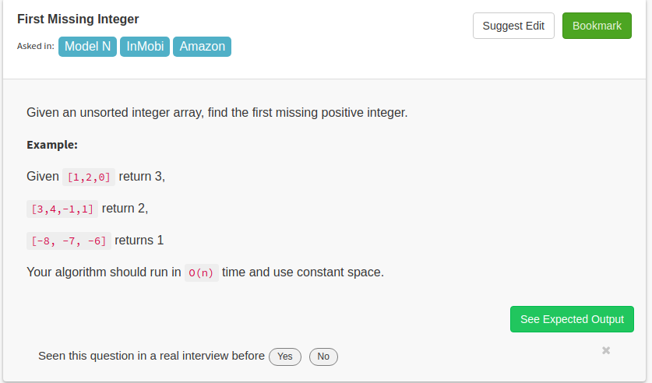

public class Solution {
public int firstMissingPositive(ArrayList<Integer> A){
boolean[] a=new boolean[A.size()+1];
int n=0;
for(int i=0;i<A.size();i++){
if(A.get(i)>0 && A.get(i)<=A.size()){
n++;
a[A.get(i)]=true;
}
}
if(n==0){
return 1;
}
for(int i=1;i<=n;i++){
if(!a[i]){
return i;
}
}
return n+1;
}
}
Repeat Missing Number:
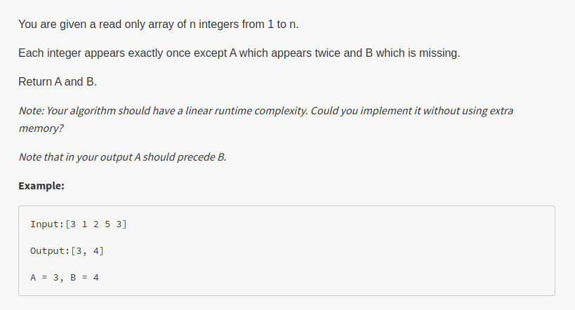
public class Solution {
public ArrayList<Integer> repeatedNumber(final List<Integer> A) {
ArrayList<Integer> result=new ArrayList<Integer>();
int x=1;
boolean a[]=new boolean[A.size()+1];
for(int i=0;i<A.size();i++){
if(a[A.get(i)]){
result.add(A.get(i));
}
a[A.get(i)]=true;
}
for(int i=1;i<A.size()+1;i++){
if(!a[i]){
result.add(i);
break;
}
}
return result;
}
}

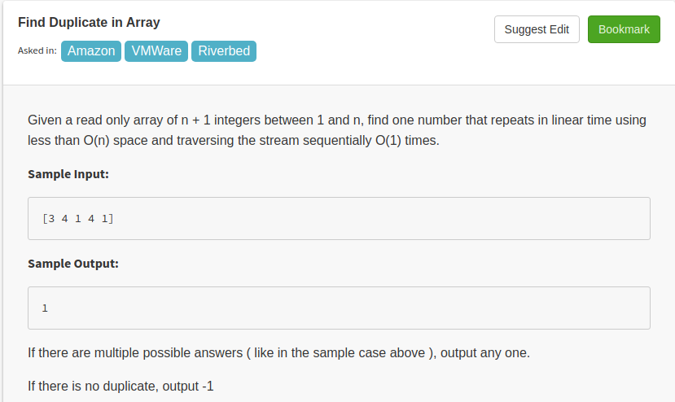
public class Solution {
// DO NOT MODIFY THE LIST
public int repeatedNumber(final List<Integer> A) {
int temp[]=new int[A.size()];
for(int i=0;i<A.size();i++){
if(temp[A.get(i)]==1){
return A.get(i);
}
else
{
temp[A.get(i)]=1;
}
}
return -1;
}
}

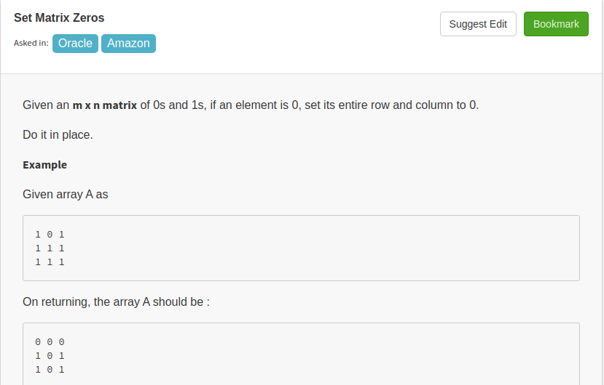
public class Solution {
public void setZeroes(ArrayList<ArrayList<Integer>> a) {
int m=a.size();
int n=a.get(0).size();
boolean fr[]=new boolean[m];
boolean fc[]=new boolean[n];
for(int i=0;i<m;i++){
for(int j=0;j<n;j++){
if(a.get(i).get(j)==0){
fr[i]=true;
fc[j]=true;
}
}
}
for(int i=0;i<m;i++){
if(fr[i]){
nullRow(a,i);
}
}

for(int i=0;i<n;i++){
if(fc[i]){
nullCol(a,i);
}
}

}
void nullRow(ArrayList<ArrayList<Integer>> a,int r){
for(int i=0;i<a.get(0).size();i++){
a.get(r).set(i,0);
}
}

void nullCol(ArrayList<ArrayList<Integer>> a,int c){
for(int i=0;i<a.size();i++){
a.get(i).set(c,0);
}
}
}
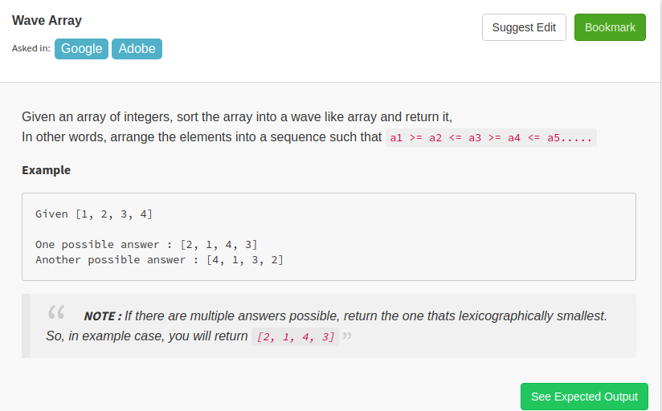
public class Solution {
public ArrayList<Integer> wave(ArrayList<Integer> A) {
Collections.sort(A);
int i=0;
while(i<=A.size()-2){
int temp=A.get(i);
A.set(i,A.get(i+1));
A.set(i+1,temp);
i+=2;
}
return A;
}
}

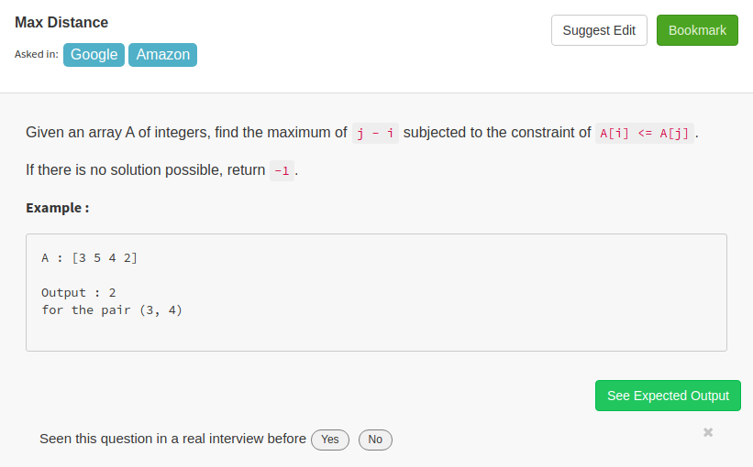
public class Solution {
// DO NOT MODIFY THE LIST. IT IS READ ONLY
public int maximumGap(final List<Integer> A) {
int n=A.size();
int[] a=new int[n];
int[] b=new int[n];
a[0]=A.get(0);
for(int i=1;i<n;i++){
a[i]=Math.min(a[i-1],A.get(i));
}
b[n-1]=A.get(n-1);
for(int i=n-2;i>=0;i--){
b[i]=Math.max(b[i+1],A.get(i));
}
int i,j;
i=j=0;
int max=-1;
while(i<n && j<n){
if(a[i]<=b[j]){
max=Math.max(max,j-i);
j++;
}
else{
i++;
}
}
return max;
}
}

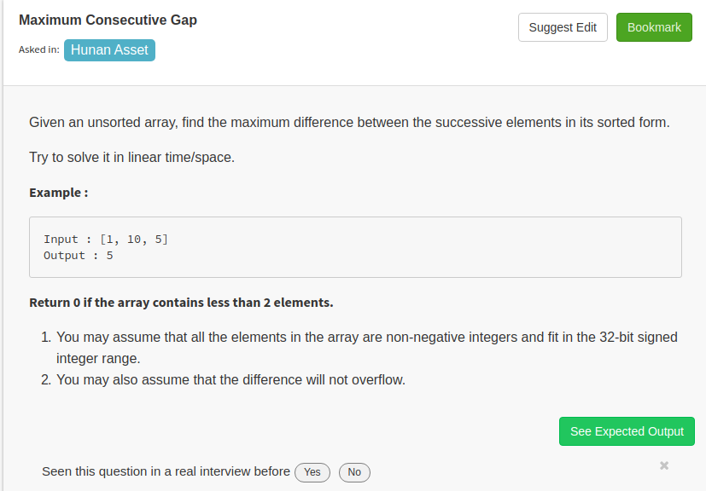

public class Solution {
// DO NOT MODIFY THE LIST. IT IS READ ONLY
public int maximumGap(final List<Integer> A) {
int n=A.size();
if(n<2){
return 0;
}
Set<Integer> hs=new TreeSet<Integer>();
for(int i=0;i<n;i++){
hs.add(A.get(i));
}

int max=Integer.MIN_VALUE;
int x=hs.iterator().next();
for(Integer i:hs){
if(i-x>max){
max=i-x;
}
x=i;

}
return max;
}
}

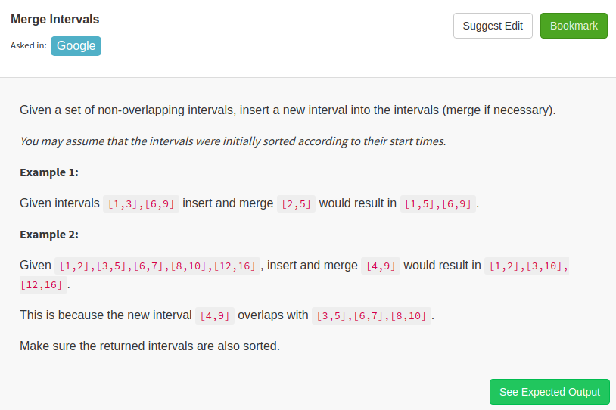

/**
* Definition for an interval.
* public class Interval {
* int start;
* int end;
* Interval() { start = 0; end = 0; }
* Interval(int s, int e) { start = s; end = e; }
* }
*/
public class Solution {
public ArrayList<Interval> insert(ArrayList<Interval> intervals, Interval newInterval) {
intervals.add(newInterval);
ArrayList<Interval> res=new ArrayList<Interval>();
Collections.sort(intervals, new Comparator<Interval>(){
public int compare(Interval a, Interval b){
if(a.start!=b.start){
return a.start-b.start;
}
else
{
return a.end-b.end;
}
}});
Interval prev=intervals.get(0);
for(int i=1;i<intervals.size();i++){
Interval next=intervals.get(i);
if(next.start>prev.end){
res.add(prev);
prev=next;
}
else
{
Interval merge=new Interval(prev.start,Math.max(prev.end, next.end));
prev=merge;
}
}
res.add(prev);
return res;
}
}

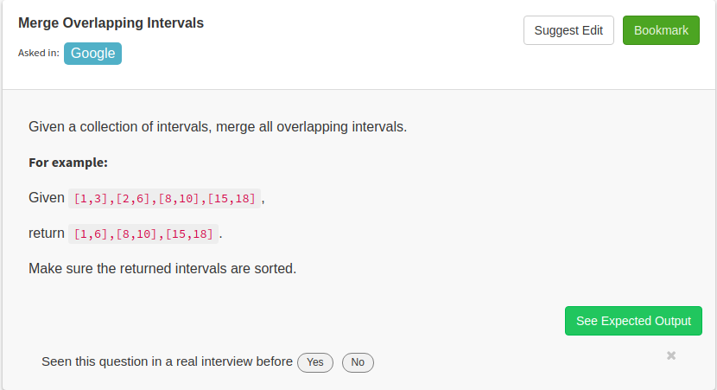

/**
* Definition for an interval.
* public class Interval {
* int start;
* int end;
* Interval() { start = 0; end = 0; }
* Interval(int s, int e) { start = s; end = e; }
* }
*/
public class Solution {
public ArrayList<Interval> merge(ArrayList<Interval> v) {
ArrayList<Interval> res=new ArrayList<Interval>();
Collections.sort(v, new Comparator<Interval>(){
public int compare(Interval a, Interval b)
{
if(a.start!=b.start){
return a.start-b.start;
}
else
{
return a.end-b.end;
}
}});

Interval pre=v.get(0);
for(int i=1;i<v.size();i++){
Interval cur=v.get(i);
if(cur.start>pre.end){
res.add(pre);
pre=cur;
}
else
{
Interval merge=new Interval(pre.start,Math.max(pre.end, cur.end));
pre=merge;
}
}
res.add(pre);
return res;

}
}

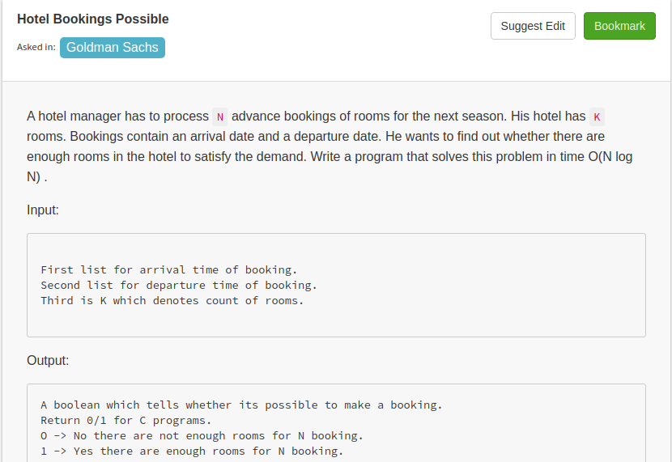

public class Solution {
public boolean hotel(ArrayList<Integer> a, ArrayList<Integer> d, int K) {
Collections.sort(a);
Collections.sort(d);
int temp,max,i=1,j=0;
temp=max=1;
int n=a.size();
while(i<n && j<n){
if(a.get(i)<d.get(j)){
++temp;
if(temp>max){
max=temp;
}
i++;
}
else{
--temp;
j++;
}
}
return K>=max;

}
}

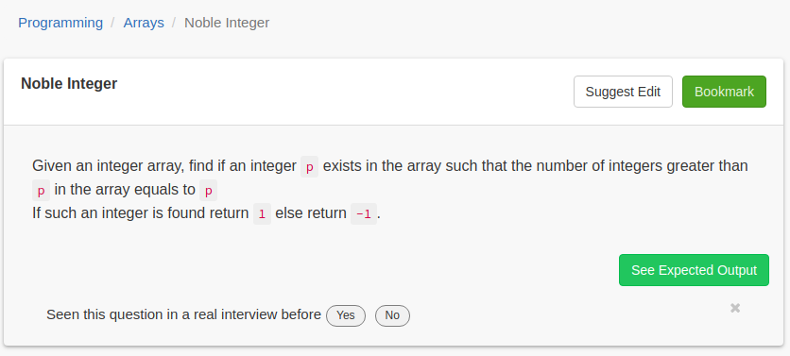

public class Solution {
public int solve(ArrayList<Integer> A) {
int n=A.size();
Collections.sort(A);
for(int i=0;i<n-1;i++){
if(A.get(i)==A.get(i+1)){
continue;
}

if(A.get(i)==n-i-1){
return 1;
}
}
if(A.get(n-1)==0){
return 1;
}
return -1;
}
}

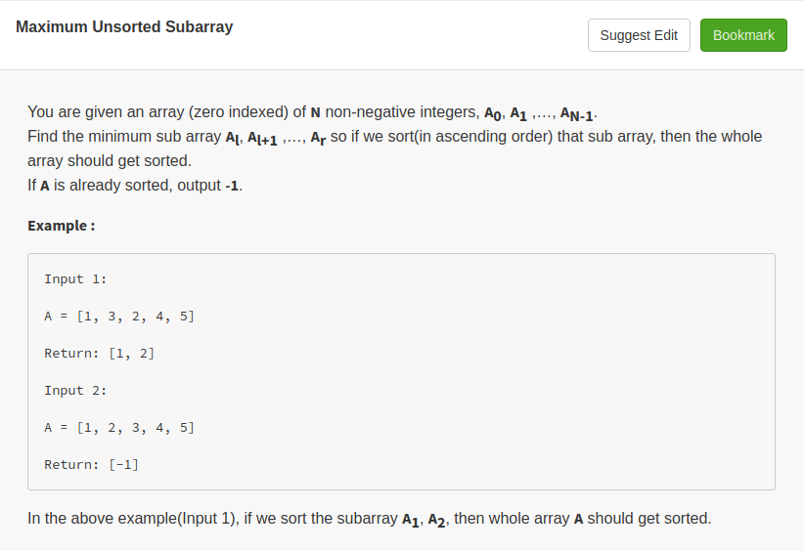

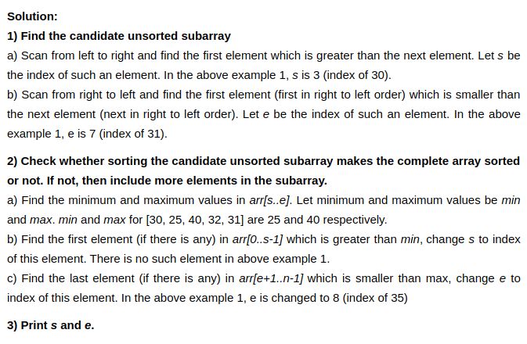
public class Solution {
public int[] subUnsort(int[] arr) {

int n=arr.length;
int s = 0, e = n-1, i, max, min;
int[] res=new int[2];
res[0]=-1;
res[1]=-1;
int[] nf={-1};

// step 1(a) of above algo
for (s = 0; s < n-1; s++)
{
if (arr[s] > arr[s+1])
break;
}
if (s == n-1)
{

return nf;
}

// step 1(b) of above algo
for(e = n - 1; e > 0; e--)
{
if(arr[e] < arr[e-1])
break;
}

// step 2(a) of above algo
max = arr[s]; min = arr[s];
for(i = s + 1; i <= e; i++)
{
if(arr[i] > max)
max = arr[i];
if(arr[i] < min)
min = arr[i];
}

// step 2(b) of above algo
for( i = 0; i < s; i++)
{
if(arr[i] > min)
{
s = i;
break;
}
}

// step 2(c) of above algo
for( i = n -1; i >= e+1; i--)
{
if(arr[i] < max)
{
e = i;
break;
}
}
res[0]=s;
res[1]=e;
// step 3 of above algo
return res;
}
}
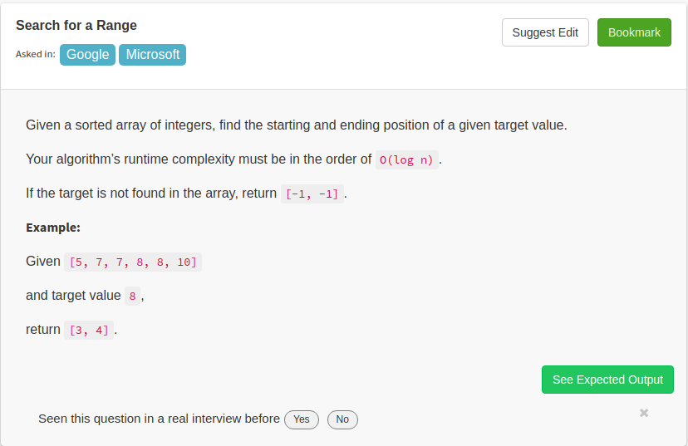
public class Solution {
// DO NOT MODIFY THE LIST
public ArrayList<Integer> searchRange(final List<Integer> a, int b) {
ArrayList<Integer> r=new ArrayList<Integer>();
if(a.size()<=1){
r.add(0);
r.add(0);
return r;
}
int x=findfirst(a,b);
int y=findlast(a,b);
r.add(x);
r.add(y);
return r;
}
public int findfirst(final List<Integer> a, int b){
int index=-1;
int start=0;
int end=a.size()-1;
int indx=-1;
while(start<=end){
int mid=start+(end-start)/2;
if(a.get(mid)>=b){
end=mid-1;
}
else
{
start=mid+1;
}
if(a.get(mid)==b){
indx=mid;
}
}
return indx;
}
public int findlast(final List<Integer> a, int b){
int start=0;
int end=a.size()-1;
int indx=-1;
while(start<=end){
int mid=start+(end-start)/2;
if(a.get(mid)<=b){
start=mid+1;
}
else
{
end=mid-1;
}
if(a.get(mid)==b){
indx=mid;
}
}
return indx;
}
}
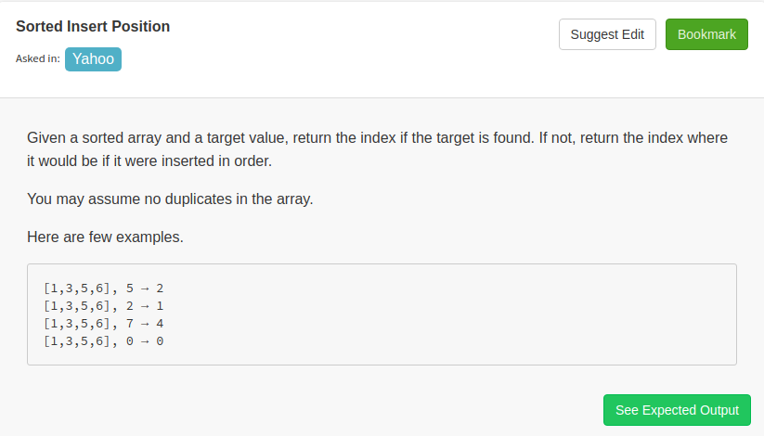
public class Solution {
public int searchInsert(ArrayList<Integer> a, int b) {
if(b==0){
return 0;
}
if(b>a.get(a.size()-1)){
return a.size();
}
int start=0;
int end=a.size();
while(start<end){
int mid=start+(end-start)/2;
if(b>a.get(mid))
{
start=mid+1;
}
else
{
end=mid;
}
}
return end;
}
}

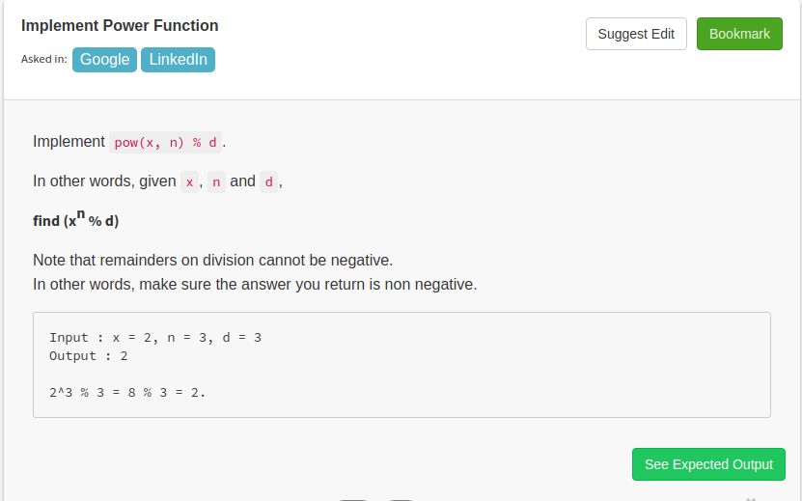
public class Solution {
public int pow(int x, int n, int d) {
if(n==0){
return x==0?0:1;
}else if(n==1){
x = x%d;
if(x<0){
x += d;
}
return x;
}
long smaller = pow(x,n/2,d);
long result = (smaller*smaller)%d;
if(result<0){
result += d;
}
if(n%2!=0){
result = (result*x)%d;
if(result<0){
result+=d;
}
}
return (int)(result%d);
}
}

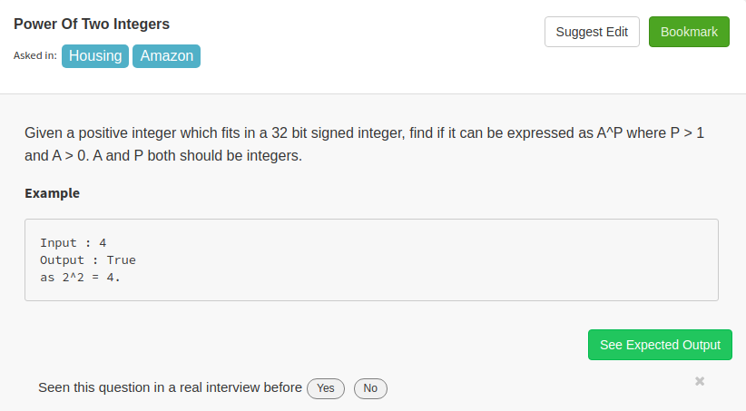

public class Solution {
public int isPower(int A) {
if(A==1){
return 1;
}
int m=2;
while(m<A){
int n=2;
while(n<A){
int x=(int)Math.pow(m,n);
if(x==A){
return 1;
}
else if(x>A){
break;
}
else{
n++;
}
}
m++;
}
return 0;
}
}

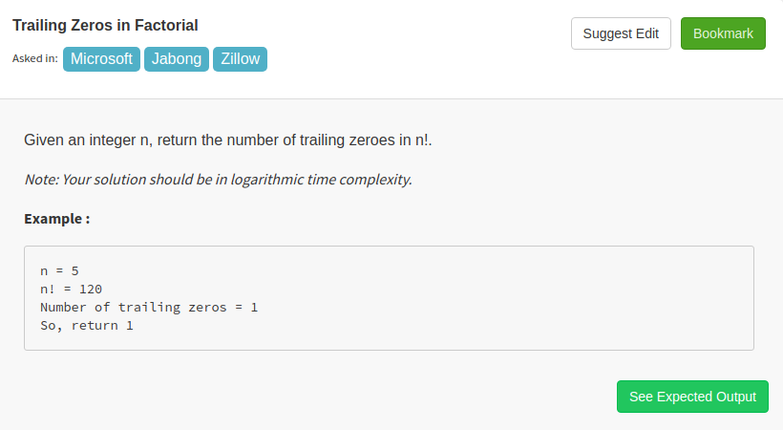
public class Solution {
public int trailingZeroes(int n) {
int i=5;
int flag=0;
while(n/i>=1){
flag+=Math.floor(n/i);
i*=5;
}
return flag;
}
}
Great candidates usually are not about the money, they are about the opportunity, they will take the job as an opportunity to meet their personal life plans, ambitions, and goals. So when you talk to the right candidates, remember to give them an offer to grow at your company, and meet their goals and don't make it all about the money. Thoughts?
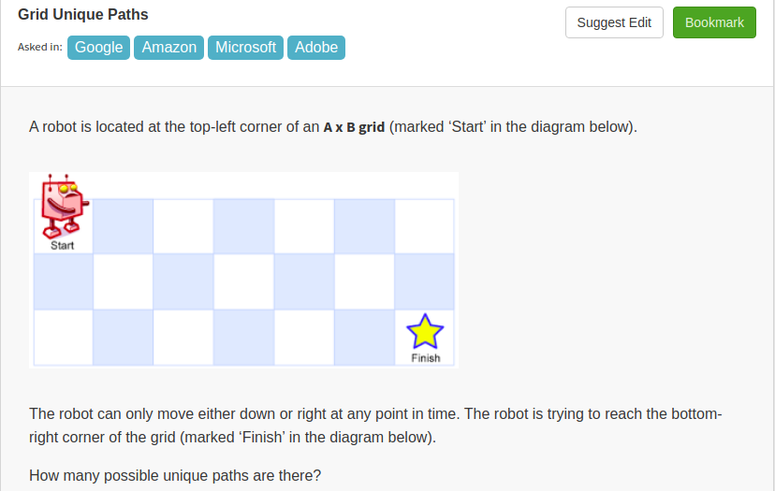
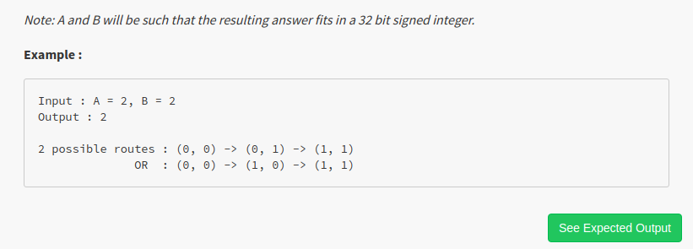
public class Solution {
public int uniquePaths(int A, int B) {
int[][] r=new int[A][B];
for(int i=0;i<A;i++){
r[i][0]=1;
}
int i;
for(i=0;i<B;i++){
r[0][i]=1;
}
for(i=1;i<A;i++){
for(int j=1;j<B;j++){
r[i][j]=r[i-1][j]+r[i][j-1];
}
}
return r[A-1][B-1];
}
}
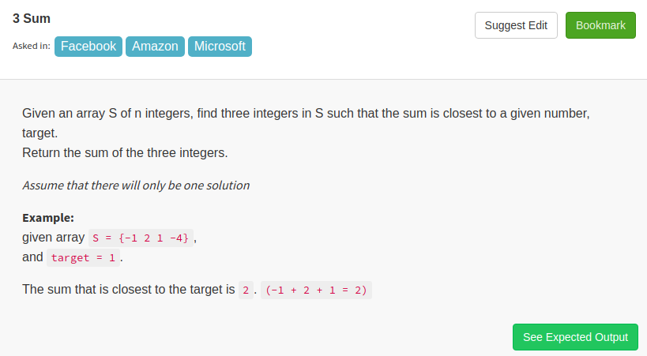
public class Solution {
public int threeSumClosest(ArrayList<Integer> a, int b) {
int r=0;
int min=Integer.MAX_VALUE;
Collections.sort(a);
for(int i=0;i<a.size()-2;i++){
int j=i+1;
int k=a.size()-1;
while(j<k){
int sum=a.get(i)+a.get(j)+a.get(k);
int d=Math.abs(sum-b);
if(d==0){
return sum;
}
if(d<min){
r=sum;
min=d;

}
if(sum<b){
j++;
}
else{
k--;
}
}
}
return r;
}
}

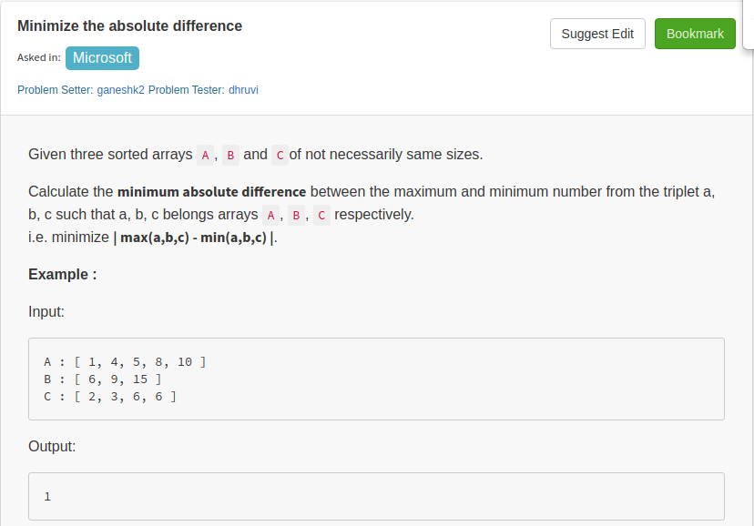
public class Solution {
public int solve(ArrayList<Integer> a, ArrayList<Integer> b, ArrayList<Integer> c) {
int i=a.size()-1;
int j=b.size()-1;
int k=c.size()-1;

int min_diff=Math.abs(Math.max(a.get(i),Math.max(b.get(j),c.get(k)))
-Math.min(a.get(i),Math.min(b.get(j),c.get(k))));
while(i!=-1&&j!=-1&&k!=-1){
int cur_diff=Math.abs(Math.max(a.get(i),Math.max(b.get(j),c.get(k)))
-Math.min(a.get(i),Math.min(b.get(j),c.get(k))));
if(cur_diff<min_diff){
min_diff=cur_diff;
}
int max_num=Math.max(a.get(i),Math.max(b.get(j),c.get(k)));
if(max_num==a.get(i)){
i--;
}
else if(max_num==b.get(j)){
j--;
}
else{
k--;
}
}
return min_diff;
}
}
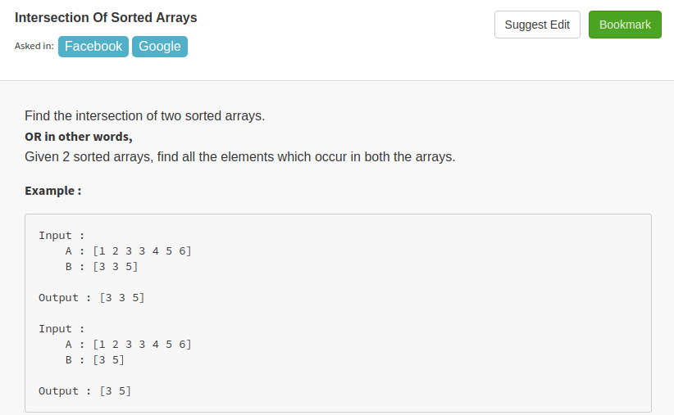
public class Solution {
// DO NOT MODIFY THE LIST. IT IS READ ONLY
public ArrayList<Integer> intersect(final List<Integer> a, final List<Integer> b) {
ArrayList<Integer> result=new ArrayList<Integer>();
int i=0;
int j=0;
while(i<a.size() && j<b.size()){
if(a.get(i)<b.get(j)){
i++;
}
else if(a.get(i)>b.get(j)){
j++;
}
else{
result.add(a.get(i));
i++;
j++;
}
}
return result;

}
}

